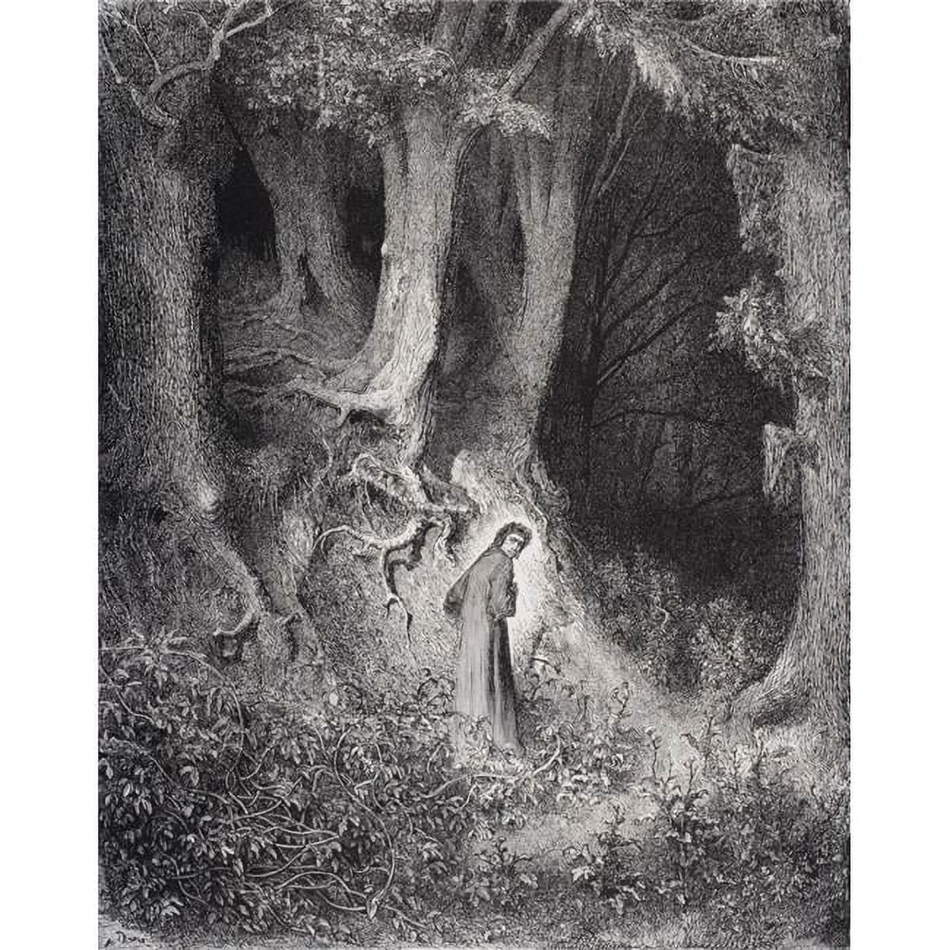
Inferno
A Study Guide
Part one of the Divine Comedy
Dante Alighieri

From Jacob Allee at Study the Great Books

Dante's Inferno from Jacob Allee
A Study Guide
When Dante Alighieri wrote his Divine Comedy1 he did not have just one purpose in mind, rather, he wrote a complex masterpiece of theology, philosophy, and politics. Such complexity in one work could hardly have been achieved with the same force or effect had it been written in prose rather than poetry. The complexity of Dante’s purpose was met by the flexibility of his poetic expression and imagination.

Written from c. 1308-1321, the Comedy in many ways reflects the complex religious and political landscape in which Dante lived. The relationship of the Church to the various nations and rulers of Europe made for a unique situation. Outwardly there was a certain kind of commonality across the western world because all the nations thereof were, at least nominally, Christian. The authority of the church and its sway in European politics was arguably at its height during this time. The pope was regarded as the one who held the keys to the kingdom of Christ and could grant or bar admission at his discretion.2 As such the church’s influence over the kings of Europe was strong and the allegiance of many rulers to the church was binding on their personal affairs and plans even when many of those same kings and nations were hostile to one another.

Study the Great Books is a reader-supported publication. To receive new posts and support my work, consider becoming a free or paid subscriber.

In Italy itself, Dante’s home, there were numerous competing political factions. Dante held strong political convictions and he looked for a political savior to rise up and deliver his own people from the corruption and greed that dominated in the ruling class of his time. Dante saw himself as one concerned for the common good, for the people, rather than for reinforcing the corrupt establishment. One way this is exemplified in the Divine Comedy is in the fact that Dante, though quite competent to write in Latin (the language of scholars), chose to write this work in Italian, the tongue of the common person in his country. He wanted what he had to say to be able to be read by everyone.

Just about 200 years prior to the Protestant Reformation (typically marked at Luther’s nailing of the 95 Theses to the door of the Wittenberg church on October 31,1517) it is easy to see glimpses of the doctrinal issues which would soon divide the church. Dante, for instance, declares that the ultimate reason behind Aeneas’ founding the people who would bring forth Rome, unbeknownst to him, was to “set firmly in place…the holy throne where the successor to great Peter sits.” (Canto Two, lines 23-24) The establishment of the papacy being, from his perspective, a part of God’s plan and purpose for the church. Contrarily, the Westminster Confession of Faith (a classic Reformed confession) states, “There is no other head of the Church but the Lord Jesus Christ; nor can the Pope of Rome, in any sense, be head thereof; but is that Antichrist, that man of sin, and son of perdition, that exalts himself, in the Church, against Christ and all that is called God.” (Ch. 25.6)

In addition to matters concerning church hierarchy and authority there are, of course, other matters of disagreement on display. The role of Mary and other saints in the lives of living believers, the doctrine of justification and the finality of Christ’s work on the cross, and many other Protestant vs. Roman Catholic debates find fertile ground for discussion when reading Dante. The very structure of the Divine Comedy invites discussion as Dante, along with his guide Virgil, descend through Hell, then ascend into Purgatory, before Dante is handed over to Beatrice to ascend all the way to Paradise.

In Inferno, specifically, we meet Dante himself recounting an unexpected and amazing journey that he had. The story begins, interestingly, “Midway upon the journey of our life.” Our life, he says, not “my life.” Why? Because in a very real way what Dante means to tell us about is something that is true for all of us. Much like in C. S. Lewis’ The Great Divorce what we realize as we read Dante is that he is not really telling us about Hell, per se, nor what purgatory would look like, nor again Heaven, he is telling us true things about life right now. The punishments that people are facing in Inferno for their sins are visual illustrations of what the sins that characterize our present lives are actually doing to us, spiritually, at this very moment. Purgatorio, whether you believe such a place exists or not,3 nevertheless teaches us about our need to be sanctified and purified from our sins to see God as he is.

It is not necessary to agree with everything you encounter in a text in order to learn something true and important from it. Christians of every stripe can learn much from Dante’s great works. Even if he merely provides a useful sparring partner for important theological ideas, you’ll find he gives old debates new life and beautiful expression. Often his poetic hand brings light and understanding to that which prose has only made dull and hard to comprehend. If he had only clarified the important debates then he would have done something worthwhile. But he has not only done this, he has also imaginatively written something full of countless “catholic”4 truths to which every Christian should be able to say, “Yes, and amen.”
Inferno 1
Study Guide Questions for Canto 1
Jacob Allee
Apr 23, 2024

Virtues/Vices/Great Ideas: (Find them in the Text)
Light vs. Darkness, Hope vs. Despair, Needing a Guide
Grammar Questions: (The Information of the Text)
- Where was Dante as his story begins?
- What “quieted a bit the dread” which Dante had been feeling?
- What is said about “the pass” which Dante “turned back to gaze again upon?”
- What was the first beast which prohibited (hindered) Dante’s path and how is it described?
- What was the second beast Dante encountered and what is said of it?
- What was the third beast Dante met and how is it described?
- What did Virgil ask Dante when he first spoke?
- What status did Dante ascribe (give) to Virgil?
- What did Virigl say of the wolf that barred Dante’s way?
- Who (or what) did Virgil say would put an end to the wolf?
- Where did Virgil say he would lead Dante?
- What was forbidden to Virgil by the “great Emperor”
Logic Questions: (Interpreting, Comparing/Contrasting, Reasoning)
- In Dante’s opening line he starts, “Midway upon the journey of our life.” Why would he say “our life” instead of “my life?”
- Of what is the path (or pass), which Dante is walking upon, representative?
- What is the significance of the three beasts which Dante encounters? How might each of them represent something different? Does the progression from one beast to another indicate anything?
- Dante said he was driven back “to where the sun is silent evermore.” What does this mean? Where is that place to which he is referring?
- Upon their meeting Virgil asked Dante, “Why do you turn back to such pain? Why don’t you climb that hill that brings delight, the origin and cause of every joy?” What is symbolized by the accent (or climb) of the hill?
- Who (or what) should we understand the “Greyhound” to be?
- Who should we understand “those souls content to wait in fire” to be?
- In what way was Virgil a “rebel” to God’s law?
- Why might Virgil, author of the Aeneid, be a particularly worthy guide for Dante’s adventure into the depths of Hell?
Rhetoric Questions: (The Analysis of Ideas in the Text)
- Dante is using poetry to unfold a story that is rich with theological, philosophical, and political meaning. Why might poetry be a particularly useful medium for this task? What would be its strength over simple prose writing? Contrarily, what strength does prose writing offer when talking about such important matters? What would be another good example of using poetry to express complex ideas about important matters?
Theological Analysis: (Sola Scriptura)
- Read 2 Timothy 2:22. What sin does this verse say is characteristic of youth? How might we connect this to one of the beasts in Dante’s path?
- Read Proverbs 16:18. What does God say about man’s pride? How might this sin be connected to one of the animals Dante encountered?
- Read Proverbs 1:19. What does this verse tell us about the sin of greed? How might this relate to one of the beasts in the story?

Canto 2

Virtues/Vices/Great Ideas: (Find them in the Text)
Doubt, Cowardice, Courage, Fear
Grammar Questions: (The Information of the Text)
- What function did the “dark air” serve for mankind?
- According to Dante, “if we would speak the truth,” what would we say about why Aeneas laid the foundations for Rome?
- What doubts did Dante express to Virgil in regard to undertaking this journey?
- To what vice did Virgil attribute Dante’s doubt?
- What did Virgil tell Dante to comfort and encourage him?
- What did Beatrice tell Virgil were “the only things that justly cause us fear?”
- Through what chain of interactions did Dante’s need for help reach the ears of Virgil in Limbo?
- How did Virgil’s story about how he received his mission affect Dante?
Logic Questions: (Interpreting, Comparing/Contrasting, Reasoning)
- Why did Dante call upon the “Muses” for aid?
- Why did Dante think he was “unfit” for the journey he had just agreed to take?
- What did Virgil mean by comparing Dante’s cowardice to “shadows” which “fool the horse that shies away?”
- What does it mean to ask “for the grace of a command?” How can a command be a grace?
- Why did Beatrice (who is from Heaven) speak so favorably of and to Virgil (who is in Limbo)?
- Why was Beatrice not afraid to leave Heaven and come down to speak with Virgil in Limbo?
- Why did Dante’s aid go through a chain of different people before reaching Virgil? Why didn’t the first person to notice his need (the “Lady of Heaven”) simply go help Dante herself?

Rhetoric Questions: (The Analysis of Ideas in the Text)
- The text of this reading begins, “So the day wore away, and the dark air released the living souls that dwell on earth from all their labors.” We often think of the sun and light with a positive connotation whereas darkness and night often have a negative connotation. Why does darkness and night have such a bad reputation? In what ways might we think of nighttime and darkness as a blessing from God? How might this be especially true in a pre-industrial world before modern technology existed?
- Dante experiences doubt about his fitness for the journey and Virgil attributes this to a kind of cowardice. What is the relationship between doubt and cowardice? Do you think knowledge can replace these vices with the virtue of courage? Why or why not?
Theological Analysis: (Sola Scriptura)
- Read 1 John 4:7-21. How might we connect this passage of Scripture to the person of Beatrice in our story?
- Read James 1:2-8 and make a connection between this passage and Dante’s present situation in Canto Two.

Canto 3

Virtues/Vices/Great Ideas: (Find them in the Text)
Justice, Cowardice, Fate
Grammar Questions: (The Information of the Text)
- According to the inscription above the gateway into Hell, what led the “High Architect” to create Hell in the first place?
- According to Virgil, what have “the souls who dwell in pain” lost?
- What disturbing sounds and scene did Dante encounter as he and Virgil entered through the gate of Hell?
- What torment was being inflicted upon the “worthless wretches” just inside the gateway to Hell?
- What were the “band of people gathered at the banks of a broad river” eager to do?
- What did Charon say to Dante when he first saw him?
- Towards whom and what were the people hurling blasphemies as they were clamoring to board Charon’s boat?
- According to Virgil, what turned the people’s fear into desire?
- What happened when “a lightning bolt” out of Hell flashed before Dante’s eyes?
Logic Questions: (Interpreting, Comparing/Contrasting, Reasoning)
- In describing God, the “High Architect” of Hell, the inscription refers to him as “the Highest Wisdom and the Primal Love.” What does wisdom and love have to do with the creation of Hell?
- What kind of people are being described as simply stuck in the entryway to Hell because “Heaven drives them out – to keep its beauty pure, nor will the deep abyss receive their souls?” What quality was theirs which made them acceptable neither in Heaven nor Hell?
- Why is it said of these in the entryway that “the world allows no rumor of them now. Mercy and justice hold them in contempt?”
- Why was Charon objecting to Dante’s presence there?
- Virgil responded to Charon’s objections by saying, “Be still! No Questions – only know that this is willed where power is power to do whatever it wills.” What did he mean by this?
- What is meant by referring to “the bad seed of Adam?”
Rhetoric Questions: (The Analysis of Ideas in the Text)
- The inscription on the gate of Hell in Dante’s Inferno states that Hell was created by “The Highest Wisdom, and the Primal Love.” Skeptics of orthodox Christianity sometimes challenge the existence of Hell as being inconsistent with an omnibenevolent (all-loving) God. How would you respond to the charge that Hell is unjust and unbefitting of the loving God that Christians claim to believe in?
- Virgil told Dante, concerning the people clambering to cross the Acheron, that “Justice Divine so goads and spurs them on, that what they fear turns into what they desire.” Are there things in this life of which it could be said that people come to desire them when they ought to fear them? What might be a good example of this?
Theological Analysis: (Sola Scriptura)
- Read Revelation 3:14-22. What connection could we make between the warning Jesus gives to the church of Laodicea and the people stuck in the entryway of Hell?

Canto 4

Virtues/Vices/Great Ideas: (Find them in the Text)
Beauty
Grammar Questions: (The Information of the Text)
- What did Dante see in his guide which he mistook for fear?
- What did Dante hear as they entered the “first belt circling the abyss?”
- According to Virgil, what accounted for the kind of people whom they found there?
- What questions did Dante ask concerning those who dwelt in Limbo?
- What was Virgil’s reply to Dante?
- Into what “academy” and whose company was Dante inducted?
- How are the castle and its grounds described?
- Who was described as “sitting by himself?”
- Who stood nearest to “the master of all those who know?”
- What did Dante say as to why he gave “no reckoning of” all the people he met there?
Logic Questions: (Interpreting, Comparing/Contrasting, Reasoning)
- Should we make anything, interpretively, out of the fact that Dante seems to have slept through the ferry ride across the Acheron?
- Why are there “no wails, but only sighs” in Limbo?
- Why would the Old Testament followers of God have been in Limbo until “One of power and might” came for them?
- Why might Dante depict Virgil as “the highest prince of poetry” even over Homer and the other great poets mentioned?
- Why would the shade of Homer be wielding a sword in his right hand?
- What should we infer from the fact that Dante is made a “sixth in that academy” of poets?
- Dante “saw souls whose eyes were grave and slow, whose looks were marked with great authority. Seldom they spoke, and held their voices low.” What might be the significance of their speaking only seldom?
- How might we classify the two main kinds of people mentioned by Dante among those from before the time of Christ?
- What should be inferred from the proximity of Socrates and Plato to “the master of all those who know?”
Rhetoric Questions: (The Analysis of Ideas in the Text)
- The list of people in Limbo are what are typically referred to as “virtuous pagans.” People before Christ and who did not know the God of the Bible but who were essentially “good people.” Do you believe it is possible to be a virtuous person while not knowing the one true God? Why or why not?
Theological Analysis: (Sola Scriptura)
- In Inferno, Limbo is described as being full “of men and women and of infants too” who have died since the time of Christ. Of these Virgil says, “They did not sin. If they had merits, these were not enough – baptism they did not have, the one gate to the faith which you believe.” Compare and contrast these words with the following passages of Scripture. Does Scripture affirm or reject the teachings presented here?
  - Psalm 51:5
  - Ephesians 2:8-10
  - Matthew 23:39-43
  - John 10:1-10
- Virgil also says of some others who dwell in Limbo, “if they lived before the Christian faith, they did not give God homage as they ought, and of these people I myself am one. For such a falling short, and for no crime, we all are lost, and suffer only this: hopeless, we live forever in desire.” In light of the following passages of Scripture, can anyone really be in the position of those described here? Why or why not?
  - Romans 1:18-32
  - Romans 2:12-16

Canto 5

Virtues/Vices/Great Ideas: (Find them in the Text)
Fate, Light vs. Darkness, Indulgence
Grammar Questions: (The Information of the Text)
- How did the souls entering Hell get assigned to their proper place?
- What warning did Minos give to Dante?
- What punishment are the souls enduring in the second circle of Hell?
- Dante said the torment in this part of Hell was “designed for the damned” who committed what kind of sins?
- What was Dante’s reaction to seeing the “innumerable shades” in that place?
- When Dante was able to speak with Francesca what word did she repeat most frequently?
- According to Francesca, what awaited the person who “quenched” her and Paolo’s lives?
- What had Francesca and Paolo been doing which encouraged them toward their sinful deeds?
- What happened to Dante after listening to Francesca’s story?
Logic Questions: (Interpreting, Comparing/Contrasting, Reasoning)
- Where have we seen Virgil respond in the same manner before as he did to Minos?
- What does it mean to have “made reason subject to desire?”
- Of Semiramis it is said that “she altered ‘lust’ to ‘just’ by her decree.” What does that mean?
- What do most of the souls who are named in this circle have in common?
- How is Achilles different from most people in this circle of Hell? Why might it still be fitting for him to be there according to the story?
- Why did Dante refer to the people here as being part of “Dido’s flock?”
- Why do you think Francesca repeated the same word so much in her speech to Dante?
- What should we understand “the realm of Cain” to refer to?
- Why was Lancelot’s story so harmful to Francesca and Paolo?
- Why is the type of punishment seen in Canto Five fitting to the crimes (sins) of those who have been consigned there?
Rhetoric Questions: (The Analysis of Ideas in the Text)
- What does it mean to be led by reason? What does it mean to be led by desire? How can we avoid participating in the kinds of sins which condemned the souls in the second circle of Hell who “made reason subject to desire?”
Theological Analysis: (Sola Scriptura)
- Relate the following passages to our present Canto.
  - Jude 1:10
  - Leviticus 19:17-19
  - Romans 6:1-14

Canto 6

Virtues/Vices/Great Ideas: (Find them in the Text)
Indulgence, Prophecy
Grammar Questions: (The Information of the Text)
- What did Dante see wherever he set his gaze?
- What was the principle form of punishment in the third ring of Hell?
- What would Cerberus do to the souls he laid hold of?
- How did Virgil manage to get Dante and himself past Cerberus?
- What did the shade who spoke to Dante hope he would know?
- According to Ciacco, what kind of political upheaval would come upon their hometown?
- What did Dante learn about the men whom he inquired after by name?
- What request did Ciacco make of Dante?
- According to Virgil when would be the next time Ciacco would awake?
- What did Dante ask Virgil about concerning the future of the condemned souls?
Logic Questions: (Interpreting, Comparing/Contrasting, Reasoning)
- What did Dante mean by saying, “My mind had shut its door?”
- Why would Cerberus be here in this part of Hell?
- What is meant by the phrase, “you were made before I was unmade?”
- For what sin should we infer Ciacco was condemned to the third ring/circle of Hell?
- Why is the kind of punishment that is taking place in the third ring fitting to the sins committed by those placed there?
- What role does Ciacco’s prophecy/prediction play in the story? Why is Dante putting these words in this character’s mouth?
- The list of men given by Dante is comprised of members from both the Guelph and Ghibelline political factions. What might we infer about these factions from what Ciacco says about these men?
- Why would Ciacco want Dante to “remember” him and speak of him to others?
- What is Virgil implying will be the case concerning the torments of Hell after the judgment when “each man…shall reassume his flesh and form?”
Rhetoric Questions: (The Analysis of Ideas in the Text)
- Define the term “gluttony.” What are some different ways the sin of gluttony can present itself? How serious is the sin of gluttony? Why might people be more tempted to turn a blind eye to this particular sin than some others?
- Do you think it is appropriate to make use of pagan mythology when describing elements of, or characters in, Hell? Why or why not?
Theological Analysis: (Sola Scriptura)
- Read Judges 3:12-30 and relate it to our present reading. In what ways was Eglon’s sin similar to our present reading in Canto Six, and how was it disastrous to him?
- What does Proverbs 23:20-21 teach us? How can we take action to obey these principles?

Canto 7

Virtues/Vices/Great Ideas: (Find them in the Text)
Greed, Fate vs. Fortune, Needing a Guide
Grammar Questions: (The Information of the Text)
- What did Virgil tell Plutus when he tried to bar their way?
- What futile activity were the people in the fourth circle of hell engaged in?
- What vocation belonged to the people that Dante saw there?
- According to Virgil, why should Dante not give any thought to recognizing people there?
- What did Virgil describe as “a short jest?”
- What was each “sphere” in the heavens given?
- Why, according to Virgil, can man’s wisdom “not duel” that of fortune’s?
- As they passed into the fifth circle, what was the environment like there?
- What were the two kinds of people who could be seen in the fifth circle of hell?
- What was the punishment assigned to the sins of those in the fifth circle?
Logic Questions: (Interpreting, Comparing/Contrasting, Reasoning)
- What might have been Dante’s purpose in writing a nonsense statement from Plutus into the story?
- What does Plutus have in common with Cerberus, Minos, and Charon?
- What is the “arrogant revolt” referred to in the text?
- How does the activity of the souls in the fourth circle correspond to the sins they are guilty of committing?
- How do the opposing vices (sins) of the fourth circle also have a point of commonality so as to be placed together in the same form of punishment?
- What might we infer about Dante from the fact that he includes some members of the clergy (ministers in the church) among the number of those who are in Hell?
- What did Virgin mean when he said, “He whose transcendent wisdom passes all fashioned the heavens and gave each sphere a Guide?”
- What was the purpose of Virgil’s discourse on “Fortune?” What did Dante mean to communicate to his reader about fortune?
- Why are some of the souls in the fifth circle striking and biting each other?
- Why are some of the other souls in the fifth circle sunken in the mire of Styx?
Rhetoric Questions: (The Analysis of Ideas in the Text)
- What is “fortune?” Is it the same or different from the concept of “fate?” What guides or directs someone’s good or bad fortune? How does fortune relate to human effort and ingenuity?
Theological Analysis: (Sola Scriptura)
- Read Revelation 12:7-12 and explain what the angel Michael has to do with matters related to Satan and Hell.
- Read Romans 12:13. Why are those guilty of either of the sins in the fourth circle not capable of obeying this commandment?
- Read Ephesians 4:26-27 and James 1:19-20. How might we relate these passages to our current reading? How should they affect our own course of action?

Canto 8

Virtues/Vices/Great Ideas: (Find them in the Text)
Arrogance, Doubt
Grammar Questions: (The Information of the Text)
- What did Dante see when they arrived “at the foot of the high tower?”
- What did Phlegyas say as he approached Dante and Virgil?
- What happened when the “spirit full of slime” attempted to grab the skiff?
- What did Dante say he had a “hankering” to see?
- As they approached the city of Dis, what did Dante see?
- Who confronted Dante and Virgil as they approached the entrance of the city?
- What occurred which made Dante believe he “never would return” from his dangerous trip?
- What promise did Virgil make to Dante?
- What did their “adversaries” do to try to keep Dante and Virgil from going further on their journey?
Logic Questions: (Interpreting, Comparing/Contrasting, Reasoning)
- What seems to have been the purpose of the “signal” fires which Dante saw?
- Why might Phlegyas have called Virgil a “traitor?”
- Why did Virgil proclaim to Dante, “Blessed be she whose womb bore fruit in you?”
- Why would there be a fortified city (i.e. Dis) between the fifth and sixth circle of Hell? What inference might be made from that fact?
- What kind of “angels” would be residents of Dis and why might they be trying to impede Dante and Virgil’s progress?
- What event in the past would have brought about the destruction of the “less secret gate whose locks and bars stand broken even now?”
- What kind of being could pass “through all the rings [of Hell] without a guide?”
Rhetoric Questions: (The Analysis of Ideas in the Text)
- Dante said, “Teacher, I’ve got a hankering…to see them dunk that spirit in the swill.” To which Virgil replied, “such a desire is good to satisfy.” What are your thoughts about this exchange? Do you think it is ever appropriate to desire to see someone punished as Dante wants to see happen to Filippo Argeneti? Why or why not?
Theological Analysis: (Sola Scriptura)
- Read Matthew 16:13-20 and make a connection between this passage and our present reading in Canto Eight.

Canto 9

Virtues/Vices/Great Ideas: (Find them in the Text)
Doubt, Fear, Prudence, Fate
Grammar Questions: (The Information of the Text)
- By what was Virgil “dismayed?”
- What question did Dante ask Virgil as they waited for a helper?
- What had previously compelled Virgil to make the journey down to “Judas’ ring?”
- While waiting for help to come, what danger confronted Dante and Virgil?
- What did Virgil tell Dante to do and how did he keep him safe?
- What was the reaction of the “thousand souls destroyed” to the coming of the “herald sent from Heaven?”
- What did their helper use to open the gates of the city of Dis?
- Once inside the city gates, what kind of punishment did Dante witness there?
- According to Virgil, what kind of people are condemned to suffer in this circle?
Logic Questions: (Interpreting, Comparing/Contrasting, Reasoning)
- Dante said, “It could be that I drew from his clipped speech a meaning darker than its true intent.” What did he mean by this?
- Why did Dante want to know if anyone “from the rim” had ever descended into the depth of Hell before?
- What is a logical inference from the fact that Judas is said to be in “the lowest and the blackest place” in Hell?
- Why did Virgil tell Dante “turn your back and cover up your face” but then do it for him?
- What is Dante getting at when he asks his reader to “gaze on the doctrine that is hidden here beneath the unfamiliar verses’ veil?”
- How does this Canto demonstrate, almost simultaneously, the power and weakness of Hell?
- Why might the punishment seen in the sixth circle be fitting to the sins of which its residents are particularly guilty?
- What makes the sin in the sixth circle of a different kind than all of the others we have seen in the previous Cantos?
Rhetoric Questions: (The Analysis of Ideas in the Text)
- Should we think that Dante was in real danger when the “Furies” showed up? Why or why not?
- The entrance into the gates of the city of Dis marks the descent into the lower regions of Hell where the sins being punished are considered by Dante to be more grave (serious) than the previous ones. Do you think some sins are worse than others? If so, what accounts for some sins being worse than others? If not, on what basis do you count all sins as equally serious?
Theological Analysis: (Sola Scriptura)
- Read Matthew 11:20-24 and relate it to Dante’s Inferno.

Canto 10

Virtues/Vices/Great Ideas: (Find them in the Text)
Despair
Grammar Questions: (The Information of the Text)
- What epithet (title) did Dante ascribe to Virgil when he first addressed him in this Canto?
- What claim did Virgil say Epicurus had made concerning the soul?
- What drew Farinata’s attention to Dante?
- What did Farinata proclaim about Dante’s family?
- What did the other man who appeared from out of Farinata’s tomb ask Dante?
- What did Dante learn concerning what those in Hell are able to know about things in the world above?
- What did Dante request that Farinata tell the other soul from his tomb?
- What did Virgil tell Dante to do with the information he learned from Farinata?
Logic Questions: (Interpreting, Comparing/Contrasting, Reasoning)
- Why are the lids not to be bolted onto the tombs until “The day of doom?”
- Why would Virgil tell Dante to “make sure each word you utter counts” when speaking with Farinata?
- Do you think Farinata’s words and behavior suggest he is sorry for his actions in life? Why or why not?
- Why would Guido’s father have expected to see his son with Dante?
- What should be inferred about Farinata from the fact that during the entire time the other man in the tomb was speaking he “never turned his neck, or bent his trunk, or changed his countenance?”
- When Farinata said “Yet fifty times the moon will not re-burn…before you [Dante] find how hard that is to learn,” what did he mean?
- Why would God allow the condemned souls to “see things far away” but not allow them to know what is happening now?
- Dante was told by Virgil that the “sweet soul” whom he would meet later (Beatrice) would show him “the journey of [his] life.” What does this mean?
Rhetoric Questions: (The Analysis of Ideas in the Text)
- Do you think people in Hell are sorry for the things they have done? Why or why not?
Theological Analysis: (Sola Scriptura)
- Read Joel 3:1-16. How does this passage help to make sense of Dante’s reference to the “valley of Jehosophat?”
- Compare and contrast the rich man in Luke 16:19-31 to Farinata. What do you notice they have in common?

Canto 11

Virtues/Vices/Great Ideas: (Find them in the Text)
Indifference
Grammar Questions: (The Information of the Text)
- What did Virgil tell Dante was “down in the pit below these rocks?”
- Who are the “three persons force is used against?”
- What would be an example of a kind of force used against the first person?
- What would be an example of a kind of force used against the second person?
- What would be an example of a kind of force used against the third person?
- According to Virgil, what are the two ways “fraud…can be used” against someone?
- What are some characteristic kinds of activities which relate to the “latter type of fraud?”
- What are some characteristic kinds of activities which relate to the “other fraud?”
- How, according to the “Philosopher,” does God feel about sins of “incontinence?”
- According to Virgil, what did the “Philosopher” teach in his book, Physics, about “Nature?”
Logic Questions: (Interpreting, Comparing/Contrasting, Reasoning)
- Why might the rings/circles of Hell be getting smaller as they continue to descend? What are we meant to take away from that idea?
- What does it mean to say “fraud’s a sin peculiar to mankind” and why would God hate it more for that reason?
- Why did Virgil explain the next three rings of Hell to Dante prior to descending into them?
- What should be inferred about the nature of the sin of violence from the fact that it is subdivided into three sections?
- Virgil said in the first round (division) of the ring of violence that “spoilers and beasts of prey are tortured there.” Who are the spoilers and who are the beasts of prey?
- In the second round (division) of the ring of violence there are, among others, those who “wept for things that should have brought them joy.” What might be an example of this sort of thing?
- What does it mean to “scorn Nature and her generous goods” as some of those in the third round of the ring of violence did?
- What distinction is Virgil making between the two different kinds of Fraud (rings eight & nine)?
- What dilemma does Dante pose to Virgil and how does Virgil answer him?
- Why did Virgil say that the sins of “incontinence” (rings two through five) offend God less than the sins of lower Hell (rings six through nine)?
- What did Dante mean by saying, “no less than knowledge, doubt is a delight?” Why would that be?
- What does it mean to say “human industry is the grandchild of God?”
- What does it mean to say that the “usurer” despises “Nature and her follower?”
Rhetoric Questions: (The Analysis of Ideas in the Text)
- Dante’s Inferno suggests a distinction between sins of upper Hell (all sins of “incontinence”) and the sins of lower Hell (sins of the will) and argues that God is more displeased with the latter than the former. Do you agree or disagree with this idea? Do you think there is any relationship between the sins of upper and lower hell or are they completely different in nature? Explain your answer carefully.
- Dante/Virgil said that Nature is a teacher. Roughly speaking, it may be argued that there are three places people can seek after truth: the natural world, the self (internal powers of reasoning), and special (supernatural) revelation. What kind of things can we learn from each of these sources? In other words, what kind of learning properly proceeds from each of them? Do they each have limitations as to what they can (or do) teach us? Are they all of equal importance as teachers? Are they all interconnected?
Theological Analysis: (Sola Scriptura)
- Read Psalm 19:1-6 and relate it to Virgil’s claim that Nature is a “teacher.”

Canto 12

Virtues/Vices/Great Ideas: (Find them in the Text)
N/A
Grammar Questions: (The Information of the Text)
- What creature did Dante and Virgil encounter as they descended into the seventh circle?
- According to Virgil, what caused the ruins which the “bestial wrath” now guards?
- What kind of punishment was inflicted upon the first group of souls in the seventh circle?
- What kind of “platoon” did Dante and Virgil encounter there?
- What was the responsibility of that platoon?
- What was Nessus told to do for Dante and Virgil?
- What kind of people were “plunged up to the brow?”
- What happened to the depth of the river as Dante and Virgil approached the place to cross over?
Logic Questions: (Interpreting, Comparing/Contrasting, Reasoning)
- Why might it be fitting that the Minotaur guards this particular circle of Hell?
- What is meant by the reference to the Minotaur’s “clever sister and her clue?”
- The text says, “Every side of this deep and stinking hole shivered as if the universe felt love?” What is this referring to?
- Why is the punishment of this part of the seventh circle fitting to the sin of violence against one’s neighbor?
- How are the centaurs similar to, and different from, the Minotaur?
- How did Chiron deduce that Dante was alive?
- What should we infer from the fact that some people are standing in different depths of the river?
Rhetoric Questions: (The Analysis of Ideas in the Text)
- In Inferno we see various figures like Cerberus, the centaurs, and various demons, fulfilling some role in Hell. They seem to be there not only to suffer but to ensure the suffering of others. Do you think that Hell will, in fact, have creatures to facilitate the suffering of damned souls? Why or why not?
Theological Analysis: (Sola Scriptura)
- Read Matthew 25:41 and Revelation 20:7-10 and answer the following question. Is Satan (i.e. the Devil / Lucifer) the ruler of Hell? Why or why not?

Canto 13

Virtues/Vices/Great Ideas: (Find them in the Text)
Despair
Grammar Questions: (The Information of the Text)
- How would you describe the scenery of this new area Dante and Virgil have come to?
- What kind of mythological creatures dwell there?
- What happened when Dante snapped a twig off of one of the trees?
- What was promised to the soul in exchange for his story?
- Who had this soul been in life and what caused him to take his own life?
- What did the soul say would be the case concerning the bodies of those who took their own lives after the yet future resurrection and judgment?
- What interrupted Virgil’s conversation with the soul?
- What did the second soul say his “city changed its patron” from and to?
Logic Questions: (Interpreting, Comparing/Contrasting, Reasoning)
- Why might it be fitting to the sin of suicide that these souls were turned into the state in which Dante found them?
- What did Virgil mean when he told the soul “I made him [Dante] do what I myself regret?”
- The soul said, “I was the guardian of Frederick’s heart, the Emperor’s trusted man who held the keys, locking, unlocking with so soft an art I stole most of the other courtiers from his secrets.” What did he mean by this?
- Why do you think Dante felt particular pity for this soul when with others he has withheld that same sentiment?
- Why will the souls there never resume their bodies like the others in Hell will?
- Speaking of the city of Florence, what was meant by saying “Mars’ art will ever make her grieve?”
Rhetoric Questions: (The Analysis of Ideas in the Text)
- Is it ever permissible to take one’s own life? If so, explain why and under what circumstances such an action would be justified. If not, why not? Be sure to make proper distinctions between killing oneself versus sacrificing oneself for others.
Theological Analysis: (Sola Scriptura)
- How does Exodus 20:13 affect the question of suicide?
- 2 Samuel 17 tells us of an episode in history where Absalom, King David’s son, is trying to overthrow his father. Why do you think Ahithophel killed himself? What should we learn from this story?
- Read Matthew 27:3-10. Why do you think Judas took his own life? Do you consider this an act of repentance? Why or why not?

Canto 14

Virtues/Vices/Great Ideas: (Find them in the Text)
Justice, Arrogance, Revenge
Grammar Questions: (The Information of the Text)
- What was the scenery like as Dante and Virigil entered “the third round?”
- What were the three different “rules” which guided the punishment of souls in this region?
- To what did Dante compare the fire falling upon the souls in the third round?
- How was Capaneus behaving when Dante and Virgil met him there?
- What was “remarkable” about the river Dante and Virgil came across in Hell?
- What was Mount Ida used for by Rhea according to Dante?
- How is the “Old Man” described by Dante?
- What is said to come from the Old Man?
- What did Virgil tell Dante concerning the river Lethe?
Logic Questions: (Interpreting, Comparing/Contrasting, Reasoning)
- Why might there have been “different rules” that the various “naked souls” were subject to in this place?
- Why is someone like Caperneus in this section of Hell where the punishment is for those who did violence against God?
- Why is the “huge Old Man” staring at “Rome as at his looking glass?”
- What is the significance of the “Old Man” being made of different materials?
- What should we make of the fact that the rivers in Hell are from the tears of the “Old Man?” What is Dante trying to say by this?
- Given that Lethe is the river of forgetting, why might it not be in Hell but “where the spirits go to bathe when their repented sins are wiped away?”
Rhetoric Questions: (The Analysis of Ideas in the Text)
- Dante refers to the scene of things in the third round as a “fearful work of justice.” What is the relationship between fear and justice? Can justice exist apart from fear? Why or why not?
Theological Analysis: (Sola Scriptura)
- Read Daniel 2:31-45. What connection is there between Nebuchadnezzar’s dream and the Old Man in Canto 14? How does this affect your thinking about what Dante is doing here?

Canto 15

Virtues/Vices/Great Ideas: (Find them in the Text)
Fate vs. Fortune, Home, Needing a Guide, Gratitude
Grammar Questions: (The Information of the Text)
- To what did Dante compare the “bulwark” that he and Virgil were now walking beside?
- How did Dante describe the manner in which the “band of spirits” were looking at them?
- What did Brunetto say happens to any spirit who “stops for an instant” in that place?
- What did Brunetto first ask Dante?
- What warning did Brunetto give to Dante about “those ungrateful people of ill will?”
- What did Dante say Brunetto “like a father” had taught him?
- What did Dante intend to do with the various “prophecies” he had received during his time in Hell?
- “In a word” what kind of people were all those who were with Brunetto in this place?
- What prevented Brunetto from telling Dante more?
- What request did Brunetto make of Dante?
Logic Questions: (Interpreting, Comparing/Contrasting, Reasoning)
- Reread Canto Eleven, lines 46-51 where Virgil explained the three divisions of the seventh circle of Hell which is for all those who committed “force” or violence “against the deity.” Given that Brunetto is in the second division, what must his sin be, though it is not directly mentioned, which led him to Hell?
- What should be inferred from the fact that Dante was shocked to see his old teacher in Hell and in this place in particular?
- Dante said, of Virgil, “...by the road through Hell he leads me home.” What lesson, by way of allegory, might we infer from these words?
- What did Brunetto mean when he said that those who hate Dante for doing goog do so justly, “for among the bitter sorbs the sweet fig should not bloom?”
- What did Brunetto mean when he told Dante to “let the grass be far from the goat’s tooth?”
- When Dante inquired to know more about others in this same part of Hell, what did Brunetto mean when he said “To know of some is well; it merits praise to pass the rest in silence?”
- Why did Brunetto have to turn back and no longer walk with Dante when he did?
- What did Dante mean when he said that when Brunetto left him “he seemed the one who wins, and not the one who loses?”
Rhetoric Questions: (The Analysis of Ideas in the Text)
- Brunetto warned Dante that some men “will grow to hate you for your doing good.” What does it mean to be good and to do good? Why might some men hate those who do good? Does the fact that we can be hated for doing good, just as much as for doing evil, mean that there is no real difference between these things? Should we be deterred from doing good if people hate us for doing it? Why or why not?
- Dante said Brunetto taught him “how man achieves an everlasting name.” Define the concept of fame. What are some examples of people whose fame is short lived versus others whose is long lasting (or perhaps everlasting)? What do you think makes the difference between fleeting fame and enduring fame? Is enduring a thing which we ought to pursue? Why or why not?
- Even though Dante found his old mentor in Hell he declared that he would have gratitude for him as long as he lived. Ought we to be grateful for the lessons we receive from men who end up in Hell? Or should their fate teach us to eschew (reject) all that they have taught us? Explain your answer thoughtfully.
Theological Analysis: (Sola Scriptura)
- Read Matthew 15:10-20 and 16:1-12 and compare it to lines 61-69 of this Canto. What similarities do you see?
- Read Revelation 21:22-27. How does this passage affect you thinking about the question of enduring fame?

Canto 16

Virtues/Vices/Great Ideas: (Find them in the Text)
Fame
Grammar Questions: (The Information of the Text)
- What did Virgil tell Dante about what would be “less fit” if things were different than they are?
- Once the men reached Danter and Virgil, in what manner did they arrange themselves for their conversation?
- What did Dante say he would have done if he’d had “a covering from the rain of fire?”
- What did Dante tell the Jacopo Rusticucci he had heard concerning his reputation and that of the spirits with him?
- What did Jacopo Rusticucci wish to know from Dante and what did Dante tell him?
- What request did Jacopo Rusticucci make of Dante?
- How quickly did the spirits depart from Dante and Virgil?
- What did Virgil command Dante to give to him and what did Virgil do with that item?
- What did Dante see coming to them in response to the actions of Virgil?
Logic Questions: (Interpreting, Comparing/Contrasting, Reasoning)
- What did Virgil mean by saying “I’d say it was less fit that they should run to you, than you to them?”
- Why did the spirits fashion themselves around Dante and Virgil in the manner they did?
- Why might Jacop Rusticucci have originally assumed that Dante would hold the prayers of the spirits “in scorn?”
- Jacopo tells Dante that Guido Guerra “achieved much by judgment, and by sword.” What might he mean by that?
- Why did the men “change glances” with each other when they heard the truth about their beloved city? What is indicated by this action?
- Why might Jacopo make the request he did to Dante?
- Dante wore a rope for a belt and he said that he had “once or twice considered using it to snare the leopard with the gaudy pelt.” What leopard is he referring to?
- What did Dante mean when he said, “knowing a truth whose face appears a lie, a man should always keep his lips shut tight?”
Rhetoric Questions: (The Analysis of Ideas in the Text)
- The men in this section of Hell are there for the sin of Sodomy and yet Dante and Virgil speak of them as men deserving great honor. Can men be simultaneously guilty of great evil and worthy of great honor? Why or why not?
- Dante had a desire to go, in pity, to the spirits before him but his “fear overpowered the good will” which gave him such an impulse. Should we ever allow fear to overpower our good will? Is it always cowardly to give into fear or is it sometimes prudent to do so? Explain and defend your answers.
Theological Analysis: (Sola Scriptura)
- Read Genesis 19:1-22. How does this passage help explain the sin of Sodomy, for which these particular spirits are in Hell? How does that affect your thinking about the honor that Dante was inclined to show them?

Canto 17

Virtues/Vices/Great Ideas: (Find them in the Text)
Shame, Fear
Grammar Questions: (The Information of the Text)
- How did Dante describe the beast? What are some of his notable features in this story?
- What did Virgil tell Dante to do while he talked with the beast?
- What was each of the men whom Dante saw wearing around their necks?
- What did one of the men tell Dante would happen eventually?
- Where did Virgil place himself on the beast for Dante’s protection?
- What made Dante obey Virgil’s command to board the back of the beast despite his fear?
- In what manner did Geryon descend down to the next ring of Hell?
- What made Dante even “more afraid” than he had been before?
- To what other more natural creature did Dante compare Geryon’s descent and landing?
Logic Questions: (Interpreting, Comparing/Contrasting, Reasoning)
- What might Dante have meant by referring to the beast (Geryon) as having a “disgusting likeness of deceit?”
- Why might Virgil have sent Dante to see those men while he talked to the beast?
- What do you think the items around the necks of those men were for and why did they look upon them as a “feast” of sorts?
- What might be Dante’s purpose in mentioning Vitaliano (a contemporary of Dante’s) through the mouth of this particular man?
- Why might Dante have compared his situation to that of Phaëthon and Icarus?
Rhetoric Questions: (The Analysis of Ideas in the Text)
- Dante, in response to being told to climb on the back of Geryon, expressed his great fear saying, “So did I shudder at his words, but shame rose up against me with its threats which make a servant brave before his valiant lord.” What is the proper role of shame? In other words, what are some goods which can come from an appropriate feeling of shame? What is the result of a culture or nation that abandons having any sense of shame? How might we go about instilling correct feelings about what is and isn’t shameful into the lives of our fellow citizens?
Theological Analysis: (Sola Scriptura)
- Read Genesis 2:21-25 and 1 Corinthians 5. How do these passages relate to the matter discussed in the Rhetoric question? What should we take away from these two passages in regard to the matter of shame?

Canto 18

Virtues/Vices/Great Ideas: (Find them in the Text)
Indifference
Grammar Questions: (The Information of the Text)
- How many divisions are there in “Malebolge,” the eighth circle of Hell?
- What made the sinners in the “first pocket…lift their heels” and move quickly along?
- What did Venedico confess to Dante that he had done to get him “dipped…in so sharp a sauce?”
- According to Virgil, what awful thing had the women at Lemnos done?
- What, according to Virgil, had landed Jason the Argonaut in this part of hell?
- What did Dante observe the people in the “second pouch” doing to themselves?
- Once he was able to better see into the pit, what did he observe that the souls there had been “plunged deep” into?
- What did Alessio Interminei confess as his sin which put him in this place?
- Who else was in the same place as Alessio?
Logic Questions: (Interpreting, Comparing/Contrasting, Reasoning)
- The eighth circle of hell is for the punishment of the sin of fraud. Why might it be subdivided “into ten separate pockets?”
- In what way is the wicked thing which Venedico did an example of fraud?
- In what way was Jason also guilty of fraud?
- In what way are Venedico’s and Jason’s sins similar and how are they different?
- What, if anything, should we make of the fact that the second pouch was “so hollow” that Virgil and Dante struggled to see the bottom of it?
- In what way might the punishment of these particular sinners, in the first pouch, be fitting to their particular kind of sins?
- In what way might the punishment(s) of these particular sinners, in the second pouch, be fitting to their particular kind of sins?
Rhetoric Questions: (The Analysis of Ideas in the Text)
- Offer a definition for the concept of fraud. What are some examples of fraud which occur in our own day? How is committing the sin of fraud different than committing sin like lust or gluttony? Can fraud be something which a person commits on accident or does it require malice aforethought (i.e. premeditation to do someone harm)? If it can be committed by accident, give an example of how it might be. If it can only be committed intentionally, explain why.
- Are sins which are premeditated worse than ones which are not? Explain and defend your answer.
Theological Analysis: (Sola Scriptura)
- Read Mark 7:1-4. How does this passage of Scripture relate to our current reading in Dante?
- Read James 5:1-6. What does James say awaits those who defraud people for personal gain?

Canto 19

Virtues/Vices/Great Ideas: (Find them in the Text)
Prudence, Justice, Prophecy, Truth
Grammar Questions: (The Information of the Text)
- The “third pocket” is for the “disciples” of whom?
- What did Dantes see “on both walls and on the ground” in this place?
- What did Dante say he had to do one time “not many years ago?”
- What was the situation of the souls in torment in the third pocket?
- When Dante spoke to the soul in the hole, for whom did that soul mistake him?
- Who is the soul in the hole and who else is in there with him?
- Who did the soul say would come after him?
- What was Dante’s attitude towards this soul?
- What “prophecy of the Evangelist” did Dante apply to the souls in the hole?
- How did Virgil react to the things which Dante said to the soul?
Logic Questions: (Interpreting, Comparing/Contrasting, Reasoning)
- What did Dante mean when he said, “The things of God should be espoused to righteousness and love, and you rapacious wolves, you pander them for gold, foul them for silver!”
- What was Dante inferring about Pope Boniface (who was still alive while Dante was journeying through hell) given the conversation between himself and the soul in the hole (Orsini)?
- What did Dante mean by referring to Pope Clement V as a “shepherd without laws?”
- What did Dante mean whe he said, “How can we tell you from the idolater? He prays to one god – to a hundred, you?”
- Why was Virgil pleased by what Dante said to Orsini?
- Why is the punishment of the simonists fitting to their sin?
- What might we infer about Dante’s religious convictions from the fact that he placed numerous Popes in Hell in his story?
Rhetoric Questions: (The Analysis of Ideas in the Text)
- Dante said to Virgil, “You are my lord, you know I never part from your will.” Do you think it is ever appropriate to express this level of devotion to another person? Why or why not?
- What do you think of Dante’s practice of declaring who is, or in some case who will be, in Hell? What was his purpose in doing this? Do you think it was a good and just purpose? Can we know for certain whether a person is or isn’t in Hell (or will or won’t be)? If so, how? If not, why not?
Theological Analysis: (Sola Scriptura)
- Read Acts 8:9-24. How does this passage relate to our present reading in Canto Nineteen?
- Compare Acts 2:1-5 to our present reading in Inferno. What is similar and what is different? What should we make of those similarities and differences?
- Read Revelation 12 and 17. Who is “the woman” in these texts? Why does Dante relate the Popes who practiced simony to “the woman” from Revelation (Lines 106-111)?

Canto 20

Virtues/Vices/Great Ideas: (Find them in the Text)
Truth
Grammar Questions: (The Information of the Text)
- What was the physical disposition of the souls in the fourth pouch of Malebolge?
- What was Dante’s initial reaction to seeing the punishment of the souls in the fourth pouch?
- What strange thing is said to have happened to Tiresias?
- What did Dante say the bishops of Brescia, Trent, and Verona could all “bless as theirs?”
- For what purpose had Manto fled from “all human intercourse?”
- What was the city of Mantua built upon?
- What had caused a dramatic decrease in the citizenship of Mantua?
- What did “Michael Scot” claim that he knew?
- What heavenly body did Virgil tell Dante to “recall” to his mind?
Logic Questions: (Interpreting, Comparing/Contrasting, Reasoning)
- What did Virgil mean by telling Dante, “Here pity lives the best when it is dead. Who is more wicked than the man who longs to make God’s judgment yield to human force?”
- Why might Virgil have taken the time to explain the origins of his own hometown, Mantua?
- What is meant by the statement that “when the men of Greece waged war” there was “hardly a boy left in the crib?”
- What do all of the people in the fourth pouch have in common with one another?
- Why is this particular punishment fitting to the sins of those in the fourth pouch?
Rhetoric Questions: (The Analysis of Ideas in the Text)
- Why is the ability to know the future considered so highly desirable? If you could know anything about what will happen in times to come, what would it be? What are the potential goods and the potential dangers that could come from the ability to know the future? Do you think there is any reliable means by which it is possible to determine what will happen in the future? If so, how? If not, why not? Assuming it is possible, should anyone avail themselves of this ability? Why or why not?
Theological Analysis: (Sola Scriptura)
- Read Leviticus 19:26 and Deuteronomy 18:9-14. What do these passages teach followers of Yahweh that they ought not to do?
- Read Acts 16:16-24. What are at least two things which we might infer about fortune telling from this passage of Scripture?

Canto 21

Virtues/Vices/Great Ideas: (Find them in the Text)
Providence, Fear
Grammar Questions: (The Information of the Text)
- Of what did the tar pits of the fifth pouch of Malebolge (the 8th circle of Hell) remind Dante?
- What did Virgil see which caused him to say to Dante, “Look out, look out?”
- What did one devil give over to the other called “Evilclaws?”
- What did the devils say these souls should do if they don’t want to “taste” their hooks?
- What did Virgil tell Dante to do while he talked to the devils?
- What did Virgil say to Eviltail which convinced him to leave Virgil and Dante untouched?
- What was Dante afraid might happen?
- When had the main bridge collapsed?
- What was the band of devils charged to do by their commander?
- What did Dante plead with Virgil that they should do?
Logic Questions: (Interpreting, Comparing/Contrasting, Reasoning)
- Why might Dante mention to the reader that Virigil and he discussed some things which he didn’t “care to sing” within his Comedy?
- What did the devil mean when he said, “A ‘no,’ for money, turns into ‘of course’?”
- What did the devil mean when he said, “The Holy Face has got no business here?”
- Why might a boiling tar pit be an appropriate punishment for those who took bribes?
- Why did Eviltail relent from troubling Virgil after Virgil spoke to him? Why did he care about what Virgil said?
- Given the information about when the bridge collapsed, what should we infer about the date when Dante took his trip into Hell?
- Why should there have been damage caused in Hell’s infrastructure at that specific date?
- Do you think Dante was ever in any particular danger here among the devils? Why or why not?
Rhetoric Questions: (The Analysis of Ideas in the Text)
- In this pouch of Malebolge we see men from Lucca being thrown into the tar pits of hell for the practice of bribery. In many countries around the world, and throughout history, bribery is commonplace and expected. The use of bribes is about the only way to actually accomplish anything in business and government in such places. What should be the Christian response to this kind of situation? Should Christians be willing to pay bribes to officials to conduct business? What if, for instance, a bribe is given to bring Bibles into a country that normally would keep those out of the hands of the people? Does it make a difference if the bribe is for secular versus Christian purposes? Is there a moral difference between paying a bribe and taking one? If so, why? Explain your thoughts carefully.
Theological Analysis: (Sola Scriptura)
- Read Deuteronomy 16:19 and Proverbs 15:27. How do these passages of Scripture address the concept of bribery? What does this tell us about governments where bribery is commonplace? What does this tell us about what God thinks of bribery?
- Read Proverbs 17:8. How should we take what is said here in light of the passages mentioned above?

Canto 22

Virtues/Vices/Great Ideas: (Find them in the Text)
Battle of the Wits, Deception
Grammar Questions: (The Information of the Text)
- Of all the ways Dante had seen a military formation called into order, what had he never seen before that day?
- What did Dante compare to the behavior of dolphins?
- What did Dante see which he said “makes [his] heart shake to this day?”
- According to the soul the devils pulled out of the tar, what was his sin that got him placed here?
- What were the devils doing to the soul while Dante and Virigl were speaking to him?
- What did the soul say he would do for them if Evilclaws would but “step back a bit?”
- What happened the second the devils took their eyes off of the soul?
- What did the demons begin to do after this?
Logic Questions: (Interpreting, Comparing/Contrasting, Reasoning)
- What did Dante mean by the saying “In church with saints, and in the stew with swine?”
- Why would the sinners in the tar risk showing their backsides above the tar since there was such a great risk in doing so?
- Why were the devils so eager to tear apart the sinners in the tar?
- What, ultimately, allowed the soul to get away from his demonic tormentors?
- What is meant by the statement, “his wings could never fly as fast as fear?”
Rhetoric Questions: (The Analysis of Ideas in the Text)
- What is required for a platoon of soldiers to function well? Why was the demonic platoon pictured in this Canto not very effective? What lessons can we learn from this and what is at least one way we could apply that lesson in our own lives?
Theological Analysis: (Sola Scriptura)
- Read Matthew 12:25-26. How might we relate what Jesus says here to our present reading?
- Read Matthew 25:41 and Revelation 20:7-15. How might these passages be used to critique Dante’s portrayal of the role demons play in Hell?

Canto 23

Virtues/Vices/Great Ideas: (Find them in the Text)
Vengeance, Adoption, Anger
Grammar Questions: (The Information of the Text)
- To what did Dante compare the manner of his and Virgil’s walking at the beginning of the canto?
- What did Dante think might happen because the “demons took a hurt” on their account?
- What did Virgil tell Dante concerning his thoughts?
- What did Virgil do when he saw the demons heading their way?
- What had “Providence willed” according to Dante?
- What punishment were the souls in the sixth pouch enduring?
- What was the sin for which these souls had been condemned to this place?
- What did Dante see which interrupted his speech to Catalano?
- What did Virigil ask Catalano?
- What did Virgil and Dante learn that Eviltail had done?
Logic Questions: (Interpreting, Comparing/Contrasting, Reasoning)
- Consider Dante’s reference to Aesop’s fable about the frog and the mouse (see above to read the fable). What does this fable have to do with Dante’s present situation in Canto 23?
- Why might the demons be angry with Dante and Virgil?
- What should be inferred from the fact that the demons were not able to follow Virgil and Dante into the sixth pouch?
- Why was the punishment of these souls fitting to their particular sin?
- Why were there some men being punished differently than others in this pouch?
- What did Dante mean to teach us from the fact that Evilclaws “gave a bad account of things” to Virgil and Dante?
Rhetoric Questions: (The Analysis of Ideas in the Text)
- Give an example of hypocrisy. Is it possible to be a hypocrite unintentionally or can one only be a hypocrite on purpose? What’s the difference, if any, between being a hypocrite and a liar? What might motivate someone to act hypocritically? How can we avoid being hypocritical? Explain your answers thoughtfully and in good detail.
Theological Analysis: (Sola Scriptura)
- Read John 8:31-47. How does this passage relate to the particular sin of those who are being punished in the sixth pouch?

Canto 24

Virtues/Vices/Great Ideas: (Find them in the Text)
Guide, Prudence, Perseverance, Sanctification, Appearance vs. Reality, Proverb, Vengeance, Prophecy
Grammar Questions: (The Information of the Text)
- To what did Dante compare his feelings as he looked to his Teacher’s countenance (expression)?
- What did Dante have to do which caused him such great exertion that his “breath had been milked dry out of the lungs?”
- In summary fashion, what did Virgil tell Dante as he sat there resting?
- What was Dante’s response to Virgil’s words?
- What “honorable request” did Dante make of Virgil?
- What punishment were the souls in the seventh pouch enduring?
- What happened to the sinner when the snake “fixed him with its fangs?”
- What had Vanni Fucci done to get himself placed in this part of Hell?
- What prophecy did Vanni Fucci make concerning the fate of the “White” guelph political party?
Logic Questions: (Interpreting, Comparing/Contrasting, Reasoning)
- What was the purpose of Dante’s analogy about the “peasant lad?”
- Given Dante’s description of Hell’s structure in lines 34-40, what can we know about the structure of Hell as it descends further down?
- Why did Virgil not allow Dante to rest after his exertions?
- What did Virgil mean when he said, “It won’t suffice for you to leave the damned. For you shall have to climb a longer stair?”
- Why did Virgil think “an honorable request ought to be bet with action, silently?”
- Why might the punishment of pouch seven be fitting punishment for thieves?
- Why was Dante confused to see Vanni Fucci in this particular part of Hell?
- Why couldn’t Vanni Fucci “refuse to answer” what Dante asked him?
- Why did Vanni Fucci tell Dante his prophecy?
Rhetoric Questions: (The Analysis of Ideas in the Text)
- Offer a definition for the term “perseverance.” How do we see the idea of perseverance being discussed and achieved in this current reading? How does one learn to do hard things and persevere through adversity? What value is there in making oneself do that which is hard to accomplish? What is the result of giving up when things get hard?
Theological Analysis: (Sola Scriptura)
- Read Revelation 2-3 and the seven letters of Christ to the seven churches of Asia Minor. What do we learn from these letters about the concept of perseverance?

Canto 25

Virtues/Vices/Great Ideas: (Find them in the Text)
Hatred, Arrogance, Doubt
Grammar Questions: (The Information of the Text)
- What was Vanni Fucci’s attitude and behavior towards God?
- Who or what came after Vanni Fucci “mad with rage”
- What sat upon its shoulder and what was it doing?
- Who had killed Cacus and how had he done it?
- What happened to the first soul who was bitten by the “snake with six feet?”
- What happened to the second soul who was bitten by a serpent?
- What happened to the serpent who bit the second soul?
Logic Questions: (Interpreting, Comparing/Contrasting, Reasoning)
- What should be inferred from what happens to Vanni Fucci after his outburst against God?
- Why might Cacus, the centaur, come in pursuit of Vanni Fucci?
- Why did Dante have a hard time believing what he saw when the snakes bit the souls?
- Why did Dante tell Lucan and Ovid to “be silent?”
- Why might these metamorphoses (transformations) be fitting punishment to the sinners in this part of hell?
Rhetoric Questions: (The Analysis of Ideas in the Text)
- Dante said, “It’s no great cause for wonder if you’re slow to trust what I’m about to tell you now, for I, who saw it, hardly can believe.” What kinds of things might cause a person to doubt their senses? Have you ever had an experience where you weren’t sure you believed what you were seeing? If so, why did you feel that way? When, if ever, are we right to not believe our own eyes or ears, etc.? On the other hand, what risks do we run if we don’t trust our senses? Do you think, in general, we ought to trust our senses or are they unreliable? Explain your answer.
- Give at least two other examples from history or literature where a person doubted their senses (for good or ill). What lessons can you draw from each of your examples?
Theological Analysis: (Sola Scriptura)
- Read John 20:24-29. How might we relate this to our Rhetoric questions?
- Read Mark 9:42-50. Connect what Jesus says in this passage to the souls in this canto.

Canto 26

Virtues/Vices/Great Ideas: (Find them in the Text)
Fame, Vengeance, Indifference, Recklessness
Grammar Questions: (The Information of the Text)
- What had spread “throughout the deeps of Hell?”
- To what more pleasant and familiar sight did Dante compare what he then saw in the “eighth pouch” of Hell?
- What did every “flickering light” stow inside it?
- What did Virgil say was the reason why Ulysses and Diomedes were placed in this part of Hell?
- What did Dante say he would “pray again up to a thousand prayers” in order to do?
- What reason did Virigil give to Dante as to why he must hold his “own tongue in restraint?”
- According to Ulysses, what could neither affection, piety, or love drive from him?
- Where did Ulysses and his crew “venture past?”
- According to Ulysses, how did he and his men die?
Logic Questions: (Interpreting, Comparing/Contrasting, Reasoning)
- Speaking of the city of Florence, Italy, Dante said “The more I age, the more your punishment will sadden me.” What does he mean by this? Why might his getting older increase his sorrow?
- Dante said that as they traveled through this area of Hell, “we couldn’t move the foot without the hand.” What did he mean by this?
- Speaking of what he saw in the eighth pouch, Dante said he would need to “hold [his] genius under tighter reign.” What did he mean by that and why did he think it was necessary?
- Why might it be fitting for Ulysses and Diomedes to be “stowed” inside the flame for their punishment?
- Virgil said to Ulysses and Diomedes, “if ever I earned your favor while I lived…” What had Virgil done which might have given him leverage to request something of these particular souls?
- What were Hercules’ “warning signs” supposed to warn people away from?
- What seems to have been the cause of the destruction of Ulysses’ ship?
Rhetoric Questions: (The Analysis of Ideas in the Text)
- Consider the speech which Ulysses gave to his friend in Lines 112-120. What mode or method of persuasion does he use to get his men to do what he desires? What do you think of his speech? Is it noble or base in its sentimentality? Is there any irony which might be detected in what he says in his speech given what we have learned about Ulysses’ own story in this Canto? All things considered, should we praise or censure his speech? Why?
Theological Analysis: (Sola Scriptura)
- Read 2 Kings 2. How does this passage add to your understanding of Dante’s reference to “that prophet who avenged himself” and “the chariot of Elijah?”

Canto 27

Virtues/Vices/Great Ideas: (Find them in the Text)
Doubt, Expectation vs. Reality
Grammar Questions: (The Information of the Text)
- To what did Dante compare the “strange garbled noise” that came from the soul encased in flame?
- What was it that caught the attention of this second flame wrapped spirit which made him come and speak to Virgil and Dante?
- What did the spirit wish to learn about from Dante and Virgil?
- What answer did Dante return to the inquiry?
- What doubt did the soul express which made him willing to share his story with Dante?
- What did the soul blame “the Great Priest” for having done?
- How did the soul describe his “actions” in life?
- Whom did the soul say were the enemies of “the prince of the modern pharisees?”
- What had the Pope promised this soul if he would show him how “to batter Palestrina to the ground?”
- What happened on the day this soul died?
Logic Questions: (Interpreting, Comparing/Contrasting, Reasoning)
- What did Dante mean when he said the soul’s “wretched words converted to the language of fire?”
- What might Dante mean by his various references to “the mastiff and his puppy” and “The Lion Cub in the White Lair?”
- What did Dante mean when he said “The Lion Cub in the White Lair…changes parties when the seasons change?”
- What might we infer about this soul since he is only willing to tell his tale if no one still living hears of it?
- What did the soul mean by saying “all my actions were not those that mark the lion, but the fox?”
- What is implied by referring to the Pope as “the prince of the modern Pharisees?”
- What did the black angel mean by saying “a man cannot repent and will at once?”
- What did the black angel mean by saying to the soul, when he came to collect him, “Perhaps you hadn’t thought that I was a logician?”
- Why might this soul have been assigned to this particular part of Hell?
Rhetoric Questions: (The Analysis of Ideas in the Text)
- The soul in this Canto seems to desire to guard his legacy and keep those still living from knowing the truth about him. Why do you think people care about how they will be remembered after they are dead? How much thought do you think we ought to give to our own legacy? How often do you think people’s legacy doesn’t tell the whole story (or even a true story) about them? How should the possibility of skewed legacies temper our thinking when we learn about “great men of the past?”
- Is it possible to repent for future sins? Why or why not?
- Is it possible to be forgiven for future sins? Why or why not?
Theological Analysis: (Sola Scriptura)
- Read Matthew 16:13-20. In this Canto the Pope claimed to be able to absolve the souls sins he was yet to commit on the basis that he had “the power to bar and unbar heaven.” How is this passage related to that claim? Do you think he is using this passage correctly, why or why not?
- Read 2 Chronicles 33:10-17. The black angel told the wicked soul “One who doesn’t repent can’t be absolved.” What does this passage from 2 Chronicles teach us concerning what true repentance looks like?
- Read Matthew 24:29-31. How does this connect with Canto 27? What is similar and what is different about what Jesus says here in regard to the story of the soul in Hell?
Canto 28

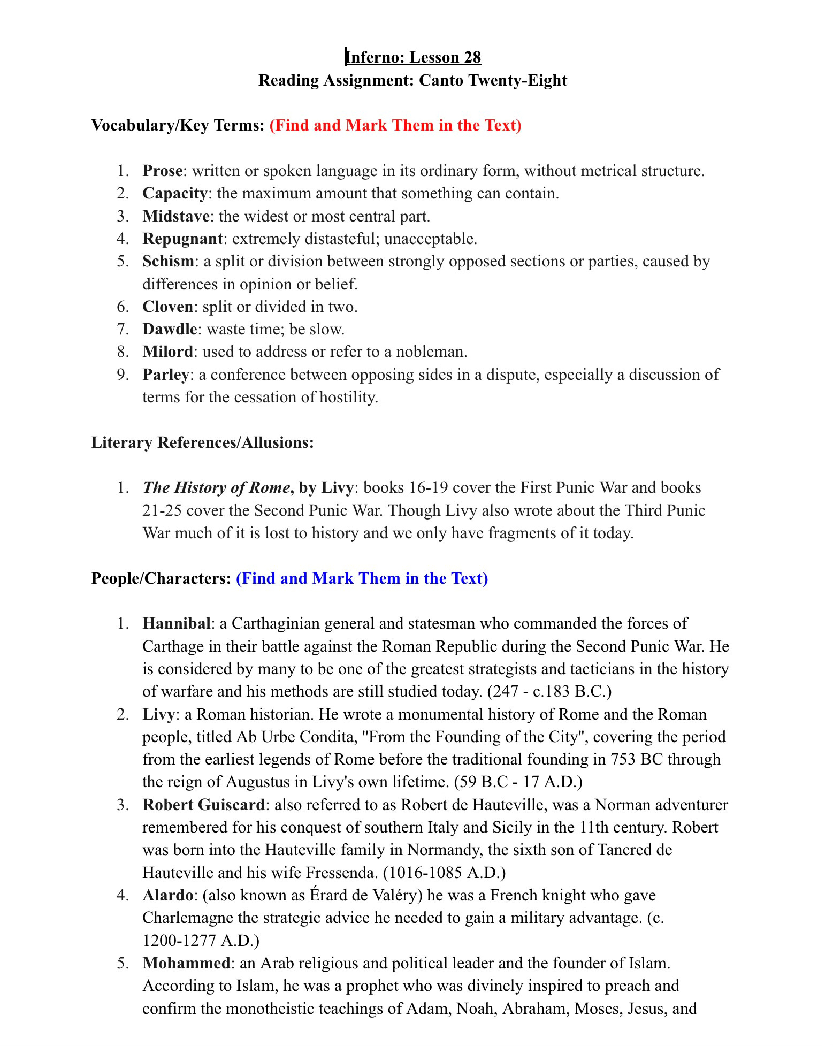

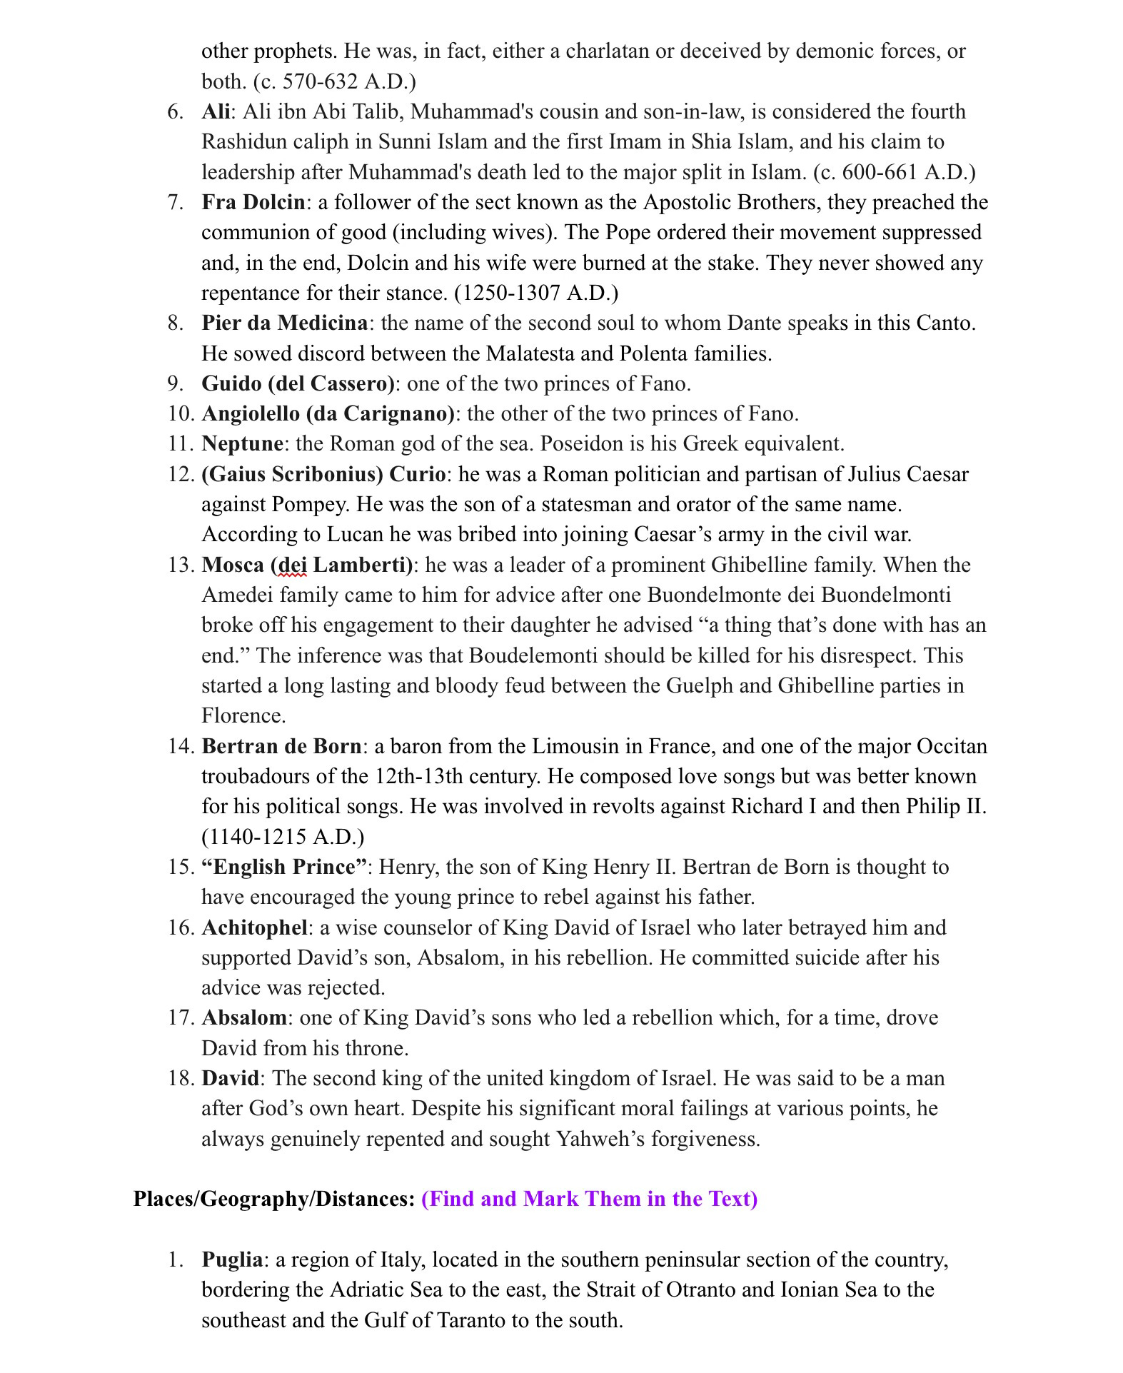

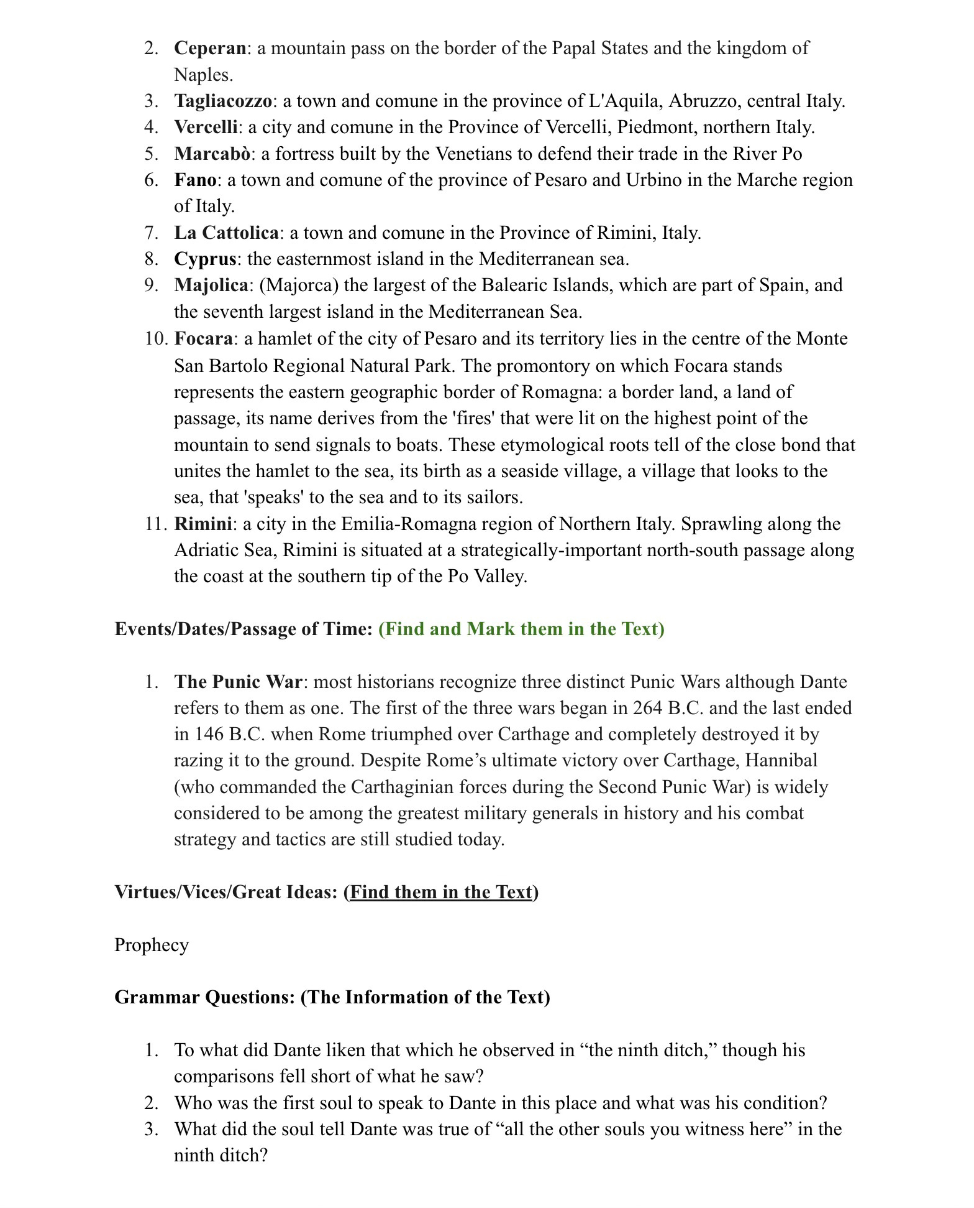

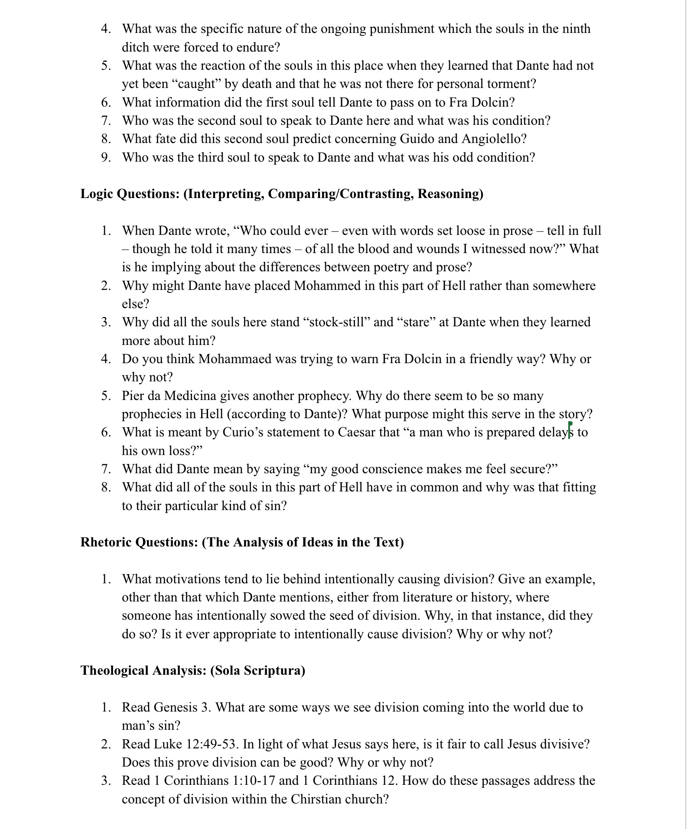

Canto 29

Virtues/Vices/Great Ideas: (Find them in the Text)
Vengeance, Being a Guide
Grammar Questions: (The Information of the Text)
- What did Virgil tell Dante as he stood there weeping for what he saw?
- What did Virgil tell Dante concerning his lingering thoughts about the soul whom he called “a spirit of [his] own blood?”
- What made Dante feel even “more pity” for the fate of Geri del Bello?
- What sin was being punished in this last ditch of the eighth circle?
- How did Dante describe the disgusting scene in the tenth ditch?
- What did Dante offer the souls there in exchange for information about themselves?
- What got the soul from Arezzo burnt at the stake?
- What did Dante claim about the Sienese people?
- What did Capocchio do which placed him in the tenth ditch?
Logic Questions: (Interpreting, Comparing/Contrasting, Reasoning)
- Virgil gently chides Dante for weeping so long over the souls in the ninth ditch saying, “you did not do so at the other moats.” Why might Dante have been more moved by what he saw there than in other places?
- What did Dante mean when he wrote, “I was so stung with arrows of unusual laments, they seemed to steel the tips in sympathy?”
- Why did this area of hell “stink” more than others? What was causing it?
- Dante said, “Tell us if an Italian in this ditch is to be found.” What was Dante specifically looking for Italians?
- What did the soul mean by saying “why I’m damned here isn’t why I died?”
- What does Capocchio mean by saying “you should recall how fine an ape of Nature’s works I was?” Also, what does the wording “you should recall” imply?
- Why is the punishment which these sinners are enduring appropriate to their particular sin?
Rhetoric Questions: (The Analysis of Ideas in the Text)
- Virgil said to Dante, “there is no need…to break your thoughts upon him anymore. Attend to something else, and let him stay where he must stay.” Do you think this is good advice concerning things we cannot change? What profit, if any, is there in applying our thoughts to circumstances outside of our control? If there is no purpose in thinking about what we cannot change, then why did Dante write about people whose fate was sealed? If there is a purpose in thinking about what cannot be changed, what is it?
Theological Analysis: (Sola Scriptura)
- Read Revelation 20:11 through the end of chapter 21. How is it that the judgment of sinners and their final punishment of being delivered to hell (the lake of fire) can stand side by side with the joy of the redemption of Christ’s church and the coming of the New Heavens and the New Earth? In other words, how does this passage address the fact that we can have perfect peace and joy while knowing that others are consigned to unending torment?

Canto 30

Virtues/Vices/Great Ideas: (Find them in the Text)
Deception, Guide, Friendship, Fortune
Grammar Questions: (The Information of the Text)
- What is the first comparison which Dante makes in regard to the “two souls, naked, pale as death” who furiously attacked the other in this ditch?
- What is the second comparison which Dante makes in regard to the “two souls, naked, pale as death” who furiously attacked the other in this ditch?
- What did Giannia Schicchi do to Capocchio?
- What heinous sin had Myrrha committed that got her consigned to this pit?
- What was the soul who looked “like a fat lute” suffering from?
- What had he done which made him suited for the tenth ditch?
- What did Master Adam say he would have done had he been “light enough to go?”
- Who were the two souls close to Master Adam?
- What occurs between Master Adam and Sinon of Troy?
- What strong words did Virgil have for Dante because he was entertained by the interaction between Master Adam and Sinon?
Logic Questions: (Interpreting, Comparing/Contrasting, Reasoning)
- What do the two opening comparisons in Canto Thirty have in common with each other?
- What do Gianni Schicchi and Myrrha have in common?
- Why is the punishment Master Adam is enduring fitting to his sin?
- Why did Master Adam wish to see Guido and Alexander?
- If Master Adam could crawl one inch in a hundred years, and he had to travel eleven miles, how long would it take him to get where he was going?
- What do “the lying woman” and “Sinon of Troy” have in common with one another?
- What lesson should we take away from the bitter interaction between Master Adam and Sinon of Troy?
- Why was Virgil so hard on Dante for being “entirely fixed upon those two” as they fought with one another?
- Dante wrote, “But as a man who dreams disaster or a grievous loss – dreaming, he longs for it to be a dream, yearning for what’s the case, as if it weren’t – So was I then, when I could not reply, wanting to make apology, and I apologized indeed – unwittingly.” What did he mean by this?
- What did Virgil mean by his words to Dante, “Less shame would wash away a greater fault…than yours has been?”
- Why is it a “base desire” to want to watch and listen to other people “brawl?”
Rhetoric Questions: (The Analysis of Ideas in the Text)
- Dante was rebuked for enjoying watching Master Adam and Sinon of Troy brawl with one another. Do people generally seem to take pleasure at watching other people fight with one another? What evidence would you cite for or against this being a natural human tendency? Why might people take pleasure in such a thing? What do you think our responsibility is when we become witness to such discord? How might our responsibility in regard to observing a fight change depending upon the setting in which we encounter it (e.g. in person between two friends, in person between two strangers, on television, in a written story, etc.)? Explain your thoughts carefully.
Theological Analysis: (Sola Scriptura)
- Read Genesis 39. What might we learn from this passage about wicked people who don’t get their way?
- Read Matthew 5:9, 21-26. How do these passages impact your thinking on the Rhetoric question?
- Read 2 Corinthians 5:16-21. How does this passage impact your thinking on the Rhetoric question?
- Read Numbers 23:19 and Proverbs 16:11. What does this teach us about how much value God places on truthfulness?

Canto 31

Virtues/Vices/Great Ideas: (Find them in the Text)
Appearance vs. Reality, Fear, Fame
Grammar Questions: (The Information of the Text)
- To what did Dante compare Virgil’s “tongue?”
- What were the atmospheric conditions like in this part of Hell?
- What did Dante at first think he saw ahead of them and what did they turn out to be?
- What kind of giants did Dante say nature continues to produce (as opposed to the kind he encountered in Hell)?
- To what did Dante compare the face of the first Titan giant he encountered?
- What is the situation of the second giant (Ephialtes) whom Dante saw?
- What did Virgil say some people think would have happened had Antaeus helped in the Titan rebellion against the gods?
- What favor did Virgil ask of Antaeus?
- What did Virgil offer Antaeus in return for this favor?
Logic Questions: (Interpreting, Comparing/Contrasting, Reasoning)
- What did Dante mean when he wrote, “My errors fled from me and my fear grew?”
- Why did Dante say nature deprived “Mars of such executioners” when it stopped making giants?
- What did Dante mean when he wrote, “For where you join to evil will and might the instrument of reason in the mind, no shelter for mankind can ever stand.”
- What did Virgil mean by saying that Nimrod “incriminates himself?” How so?
- Why is it fitting that Ephialtes had his arms chained down?
- What did Virgil mean when he said that Antaeus would “set [them] at the bottom of all crime?”
- Why might Virgil have held on to Dante rather than let Antaeus do it?
Rhetoric Questions: (The Analysis of Ideas in the Text)
- Dante wrote, “The very tongue that stung me with rebuke so that I flushed with shame in either cheek, then brought the medicine to soothe the shame, as I have heard the lance of Peleus and of his son Achilles used to give wounds with the first touch, healing with the next.” How powerful are the things people say to tear down or build up other people? Is it possible to truly destroy someone else with only our words? Is it possible to restore a person who is hurt and broken in spirit by the things we say? Do you think that our words have more power to harm or help or is there equal potency in both directions? In light of all of this, how much thought ought we to give to the things we say to other people?
- Dante’s sight deceived him as he drew near to the giants (whom he mistook for towers). Generally speaking, how reliable are the human senses? How easily can the senses be deceived? Are some of them more easily deceived than others? Is any one of the senses more important than the others? Why or why not? What else has God given to man, beyond the physical senses, which can help him determine the nature of things which exist?
Theological Analysis: (Sola Scriptura)
- Read Genesis 10:8-14 and 11:1-9. How do these passages give further clarity and understanding to Dante’s encounter with Nimrod?
- Read Acts 2:1-13. How does this passage show the work of the Holy Spirit undoing the effects of Babel?
- Read Matthew 12:33-37 and James 3:1-12. What should we take from these passages about the importance of the words we speak? How should we live differently in light of this?

Canto 32

Virtues/Vices/Great Ideas: (Find them in the Text)
Indifference, Despair, Vengeance
Grammar Questions: (The Information of the Text)
- Who are the two souls whom Dante meets at the beginning of this Canto?
- What did Count Ugolino see in his “nightmare?”
- What did Ugolino’s sons ask him for when he awoke?
- What did Ugolino “hear” at the hour “when food was always brought” to them?
- What was Ugolino’s demeanor while his sons wept?
- What did Ugolino’s sons urge him to do?
- What did Dante say Ugolino’s crime was that got him put into the tower?
- As Dante passed further on in Cocytus, what was different about the disposition of the souls further on?
- What did Dante feel (physically) in that place which surprised him?
- What did “Brother Alberigo” desire Dante to do for him?
- What was the strange case of Alberigo which made him unlike most of the souls in Hell?
- What did Dante promise to do for Alberigo and did he do as he promised?
Logic Questions: (Interpreting, Comparing/Contrasting, Reasoning)
- What seems to be Ugolino’s motivation in telling his story to Dante?
- What did Ugolino mean when he said “a nightmare came and tore in two the veil of things to come?”
- Why did Ugolino bite his “hands for grief” when he saw his “own face in the four that looked at” him?
- Why might Ugolino have been “already blind” by the time his last son died in the tower with him?
- What is meant by the statement, “hunger did what sorrow could not do?”
- Why did Dante call the city of Pisa the “vile disgrace of all the folk in the sweet land where sì is uttered” and refer to that city as “Thebes renewed and young?”
- Why were the heads of the latter souls in this Canto forced to have their heads frozen “up and back” as opposed to “bowed” downwards?
- Why did Brother Alberigo refer to Dante and Virgil as “cruel souls, so wicked that
- What is Dante inferring about people who are like Alberigo?
- Why did Dante not clear the ice from Alberigo’s eyes?
Rhetoric Questions: (The Analysis of Ideas in the Text)
- Do you think that the relatives of a wicked man should ever be punished for his sins? If you think in at least some cases it is appropriate, what would be an example of a case where this might be appropriate? If you’d say it is never just to do so, why not?
- Dante portrays Ugolino’s “boys” as “little” in his retelling. In all actuality (historically speaking) they were grown men at the time this all occurred. Why might Dante have related the story in the way he did? How does his telling the story with the suggestion that these were mere children affect your feelings about the tale? Should the age of the people involved in this story affect our feelings about it? Why or why not?
- Do you think Dante was justified in breaking his word to Alberigo? Why or why not?
Theological Analysis: (Sola Scriptura)
- Read Joshua 7 and the account of Achan’s sin and his punishment. How does this affect you thinking about the first Rhetoric question?
- Read Ezekiel 18. How does this add yet another layer to our understanding of what God thinks about the sins of the father being accounted as guilt to his family?

Canto 33

Virtues/Vices/Great Ideas: (Find them in the Text)
Indifference, Despair, Vengeance
Grammar Questions: (The Information of the Text)
- Who are the two souls whom Dante meets at the beginning of this Canto?
- What did Count Ugolino see in his “nightmare?”
- What did Ugolino’s sons ask him for when he awoke?
- What did Ugolino “hear” at the hour “when food was always brought” to them?
- What was Ugolino’s demeanor while his sons wept?
- What did Ugolino’s sons urge him to do?
- What did Dante say Ugolino’s crime was that got him put into the tower?
- As Dante passed further on in Cocytus, what was different about the disposition of the souls further on?
- What did Dante feel (physically) in that place which surprised him?
- What did “Brother Alberigo” desire Dante to do for him?
- What was the strange case of Alberigo which made him unlike most of the souls in Hell?
- What did Dante promise to do for Alberigo and did he do as he promised?
Logic Questions: (Interpreting, Comparing/Contrasting, Reasoning)
- What seems to be Ugolino’s motivation in telling his story to Dante?
- What did Ugolino mean when he said “a nightmare came and tore in two the veil of things to come?”
- Why did Ugolino bite his “hands for grief” when he saw his “own face in the four that looked at” him?
- Why might Ugolino have been “already blind” by the time his last son died in the tower with him?
- What is meant by the statement, “hunger did what sorrow could not do?”
- Why did Dante call the city of Pisa the “vile disgrace of all the folk in the sweet land where sì is uttered” and refer to that city as “Thebes renewed and young?”
- Why were the heads of the latter souls in this Canto forced to have their heads frozen “up and back” as opposed to “bowed” downwards?
- Why did Brother Alberigo refer to Dante and Virgil as “cruel souls, so wicked that
- What is Dante inferring about people who are like Alberigo?
- Why did Dante not clear the ice from Alberigo’s eyes?
Rhetoric Questions: (The Analysis of Ideas in the Text)
- Do you think that the relatives of a wicked man should ever be punished for his sins? If you think in at least some cases it is appropriate, what would be an example of a case where this might be appropriate? If you’d say it is never just to do so, why not?
- Dante portrays Ugolino’s “boys” as “little” in his retelling. In all actuality (historically speaking) they were grown men at the time this all occurred. Why might Dante have related the story in the way he did? How does his telling the story with the suggestion that these were mere children affect your feelings about the tale? Should the age of the people involved in this story affect our feelings about it? Why or why not?
- Do you think Dante was justified in breaking his word to Alberigo? Why or why not?
Theological Analysis: (Sola Scriptura)
- Read Joshua 7 and the account of Achan’s sin and his punishment. How does this affect you thinking about the first Rhetoric question?
- Read Ezekiel 18. How does this add yet another layer to our understanding of what God thinks about the sins of the father being accounted as guilt to his family?

Canto 34

Virtues/Vices/Great Ideas: (Find them in the Text)
Fear, Fortitude, Light vs. Darkness
Grammar Questions: (The Information of the Text)
- To what did Dante compare his first glimpse of Dis (Satan)?
- What was the situation of most of the souls in this innermost area of the ninth circle of Hell (Judecca)?
- What was the Devil said to have “once” possessed?
- What was Dante’s initial reaction to gazing upon the Devil?
- How is Satan’s stature and form described?
- What was said to be the source of the ice and bitter cold?
- Who was Satan chewing upon?
- In what manner did Dante and Virgil exit Hell?
- Where did Dante and Virigil emerge?
- What explanation did Virgil give as to how Satan came to be where they found him?
- What does Dante lay his eyes upon right as Inferno comes to an end?
Logic Questions: (Interpreting, Comparing/Contrasting, Reasoning)
- What idea is Dante trying to communicate to the reader from the fact that in the lowest and innermost part of hell “the shades are all covered up in ice” whereas a little further from the center and bottom the heads of the souls were still exposed?
- Why would Dante refer to Dis (Satan) as “the creature who once had a lovely face?”
- Dante said, upon seeing the devil, “I did not die, did not remain alive. Think for yourself, if wisdom buds in you, what I became, deprived of life and death.” What did he become? What is Dante getting at?
- Why might Dante have imagined Satan with three faces?
- How should the reader interpret the different colors of the three faces of Satan? What might these represent?
- What might be inferred about the three men upon whom Satan is chewing?
- Why did Virgil have to turn himself to “face the devils shanks” as he climbed upon him?
- Dante called Satan “the king of Hell” in the first line of this Canto. Having read the whole Canto, in what ways might this be accurate? In what ways might this title also be considered rather deceiving?
Rhetoric Questions: (The Analysis of Ideas in the Text)
- Virgil proclaimed, “Hell has nothing more for us to see.” Having now gone on this literary tour of Hell with Dante, what do you think the main purpose of this trip was for Dante? What are you as the reader supposed to take away from your time in Hell? Do you think that you and Dante are meant to learn the same thing(s) or different things from this trip? Do you think it has been beneficial to read Dante’s conception of Hell? Why or why not?
Theological Analysis: (Sola Scriptura)
- Read Job 1:1-12, Luke 10:17-20, and Revelation 12. What do you notice about where Satan is in Job and where he ends up upon the coming of Christ into the world? What should be inferred from these things?
- Read Revelation 20:7-10 and Matthew 25:31-46. From these passages, what should we make of calling Satan “the king of Hell?”

