Finding Fact in Fiction VIII

~Reading Schedule ~

~Upper Level Lit Course~ SRCS ~ mr. e

WORKS of C.S. LEWIS

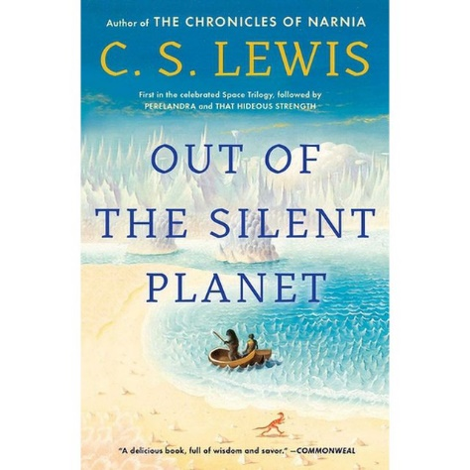 Class 1: intro, syllabus/overview; Lewis’s Space Trilogy intro read in class

Class 2: Out of the Silent Planet read ch1-3

Class 3: OotSP read ch 4-8

Class 4: OotSP read ch 9-12

Class 5: OotSP read ch 13-18\*;

Class 6: OotSP read ch 19-22 & postscript; quiz

Class 7: Perelandra read ch 1,2

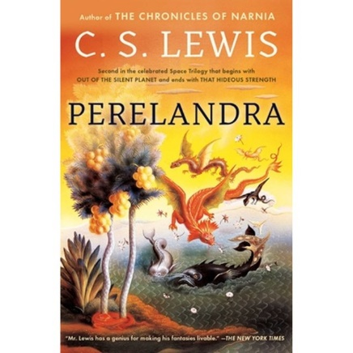 Class 8: P read ch 3,4

Class 9: P read ch 5-8\*

Class 10: P read ch 9,10

Class 11: P read ch 11-13

Class 12: P read ch 14,15

Class 13: P read ch 16,17; quiz

Class 14: That Hideous Srength read ch 1-3\*

Class 15: THS read ch 4

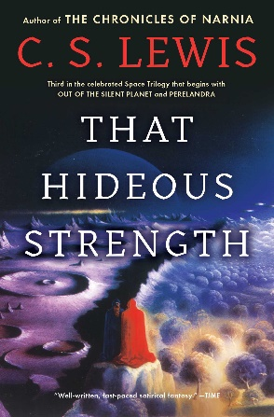 Class 16: THS read ch 5

Class 17: THS read ch 6

Class 18: THS read ch 7

Class 19: THS read ch 8,9

Class 20: THS read ch 10

Class 21: THS read ch 11

Class 22: THS read ch 12

Class 23: THS read ch 13

Class 24: THS read ch 14,15\*

Class 25: THS read ch 16,17

Class 26: THS quiz; discuss

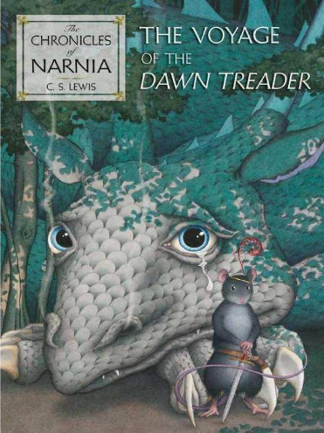 Class 27: watch The Lion, the Witch, & the Wardrobe

Class 28: tLtW&tW

Class 29: tLtW&tW

Class 29: The Voyage of the Dawn Treader ch 1,2\*

Class 30: TVotDT read ch 3,4

Class 31: TVotDT read ch 5,6

Class 32: TVotDT read ch 7,8

Class 33: TVotDT read ch 9-12\*

Class 34: TVotDT read ch 13,14

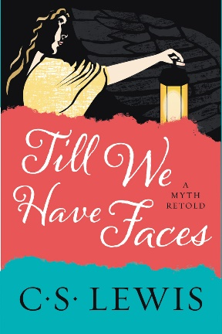 Class 35: TVotDT read ch 15,16

Class 36: TVotDT quiz; watch TVotDT

Class 37: watch TVotDT

Class 38: watch TVotDT; discuss

Class 39: Till We Have Faces read ch1,2

Class 40: TWHF read ch 3,4

Class 41: TWHF read ch 5,6

Class 42: TWHF read ch 7,8

Class 43: TWHF read ch 9-11\*

Class 44: TWHF read ch 12,13

Class 45: TWHF read ch 14,15

Class 46: TWHF read ch 16,17

Class 47: TWHF read ch 18,19

Class 48: TWHF read ch 20,21,PT2 ch 1,2\*

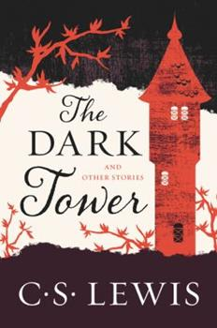Class 49: TWHF read ch 3,4

Class 50: discuss

Class 51: Dark Tower & Other Stories preface

Class 52: DT ch 1,2

Class 53: DT ch 3,4\*

Spring Break

Class 54: DT ch 5,6

Class 55: DT ch 7-end & NOTE

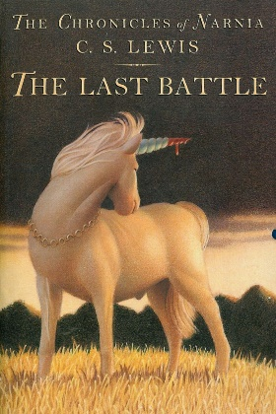Class 56: The Man Born Blind & The Shoddy Lands

Class 57: Ministering Angels

Class 58: Forms of Things Unknown

Class 59: After Ten Years

Class 60: discuss fave short

Class 61: The Last Battle read ch 1,2

Class 62: TLB read ch 3,4

Class 63: TLB read ch 5-7\*

Class 64: TLB read ch 8,9

Class 65: TLB read ch 10,11

Class 66: TLB read ch 12,13

Class 67: TLB read ch 14-16

Class 68: I, Prometheus; read ch 1-3\*; or The Great Divorce

Class 69: IP read ch 4,5

Class 70: IP read ch 6,7

Class 71: IP read 8,9

Class 72: IP read 10-12

Class 73: IP read ch 13-17

Class 74: IP read ch 18-20

Class 75: watch Shadowlands or Freud’s Last Session

Class 76: watch

Class 77: watch

