Finding Fact in Fiction VII

~Reading Schedule ~

~Upper Level Lit Course~ SRCS ~ mr. e

WORKS of JRR TOLKIEN

Class 1: intro, syllabus/overview; The Silmarillion FOREWORD/ LETTER TO M.WALDMAN read in class

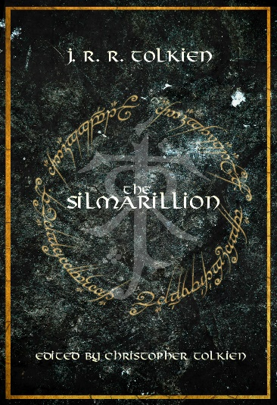 Class 2: tS read AINULINDALË/VALAQUENTA

Class 3: tS read QUENTA SILMARILLION ch 1,2

Class 4: tS read QS ch 3-5; quiz 1

Class 5: tS read QS ch 6-8\*

Class 6: tS read QS ch 9,10

Class 7: tS read QS ch 11-13; quiz 2

Class 8: tS read QS ch 14-16;

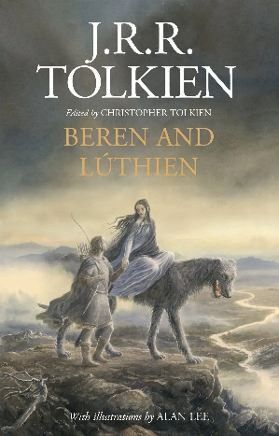Class 9: tS read QS ch 17, 18; quiz 3;

Class 10: B&L read pp9-50\* (as tS ch 19)

Class 11: B&L read pp51-75

Class 12: B&L read ch 76-100

Class 13: B&L read ch 101-125

Class 14: B&L read ch 126-150;

Class 15: B&L read ch 151-200\*;

Class 16: B&L read ch 201-225

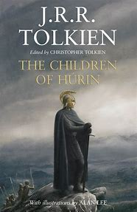Class 17: B&L read ch 226-255

Class 18: tS read QS ch 20; tCoH pp7-29

Class 19: RoP S1Ep1

Class 20: RoP S1Ep1; tCoH (as tS ch 21)read ch 1

Class 21: tCoH read ch 2-4

Class 22: RoP S1Ep2

Class 23: RoP S1Ep2; tCoH read ch 5,6\*

Class 24: tCoH read ch 7,8

Class 25: tCoH read ch 9-11

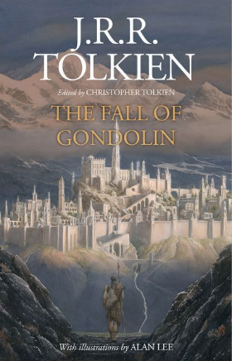Class 26: tCoH read ch 12-14

Class 27: RoP S1Ep3

Class 28: RoP S1Ep3; tCoH read ch 15-18

Class 29: tS read QS ch 22

Class 29: tFoG read pp9-25

Class 30: RoP S1Ep4

Class 31: RoP S1E4; tFoG read pp26-75\*

Class 32: tFoG read pp76-100

Class 33: tFoG read pp101-125

Class 34: tFoG read pp126-150

Class 35: RoP S1Ep5

Class 36: RoP S1Ep5; tS read QS ch 24; AKALLABÊTH

Class 37: RoP S1 Ep6; tS read QS OF THE RINGS OF POWER & THE THIRD AGE\*

Fall Break

Class 38: RoP S1Ep6; summarize tFotR

Class 39: The Two Towers read ch 1,2

Class 40: RoPS1Ep7

Class 41: RoP S1Ep7; tTT read ch 3,4\*

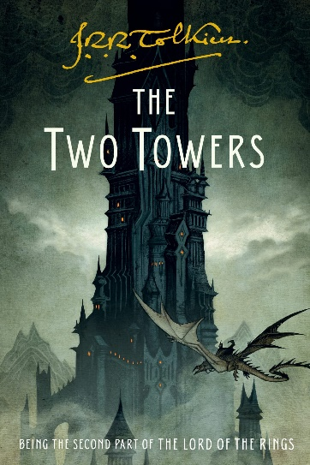Class 42: tTT read ch5

Class 43: tTT read ch 6

Class 44: RoP S1Ep8

Class 45: RoP S1Ep8; tTT read ch7,8\*

Class 46: tTT read ch 9,10

Class 47: tTT read ch 11

Class 48: tTT BOOK IV read ch 1

Class 49: tTT read ch 2

Class 50: tTT read ch 3-5\*

Class 51: tTT read ch 6,7

Class 52: tTT read ch 8

Class 53: tTT read ch 9,10; start film

Class 54: film LoTR: tTT\*

Class 55: film LoTR: tTT

Class 56: film LoTR: tTT

Class 57: film LoTR: tTT

Class 58: film LoTR: tTT

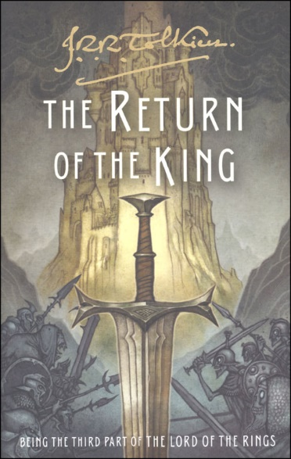Class 59: discuss film; read The Return of the King ch 1,2\*

Thanksgiving Break

Class 60: tRotK read ch 3

Class 61: tRotK read ch 4

Class 62: tRotK read ch 5,6

Class 63: tRotK read ch 7,8

Class 64: tRotK read ch 9,10, book VI ch1\*

Class 65: tRotK read ch 2

Class 66: tRotK read ch 3,4

Class 67: tRotK read ch 5

Class 68: tRotK read ch 6,7

Class 69: tRotK read ch 8,9 (end); start film LoTR: tRotK

Class 70: watch film LoTR: tRotK

Class 71: film LoTR: tRotK

Class 72: film LoTR: tRotK

Class 73: film LoTR: tRotK

Class 74: film LoTR: tRotK

Class 75: film LoTR: tRotK

Class 76: discuss film (Get Lewis books!)

