Finding Fact in Fiction IV
  - ~Reading Schedule ~
  - ~Upper Level Lit Course~ SRCS ~ mr. e

  - Class 1: intro; The Fellowship of the Ring
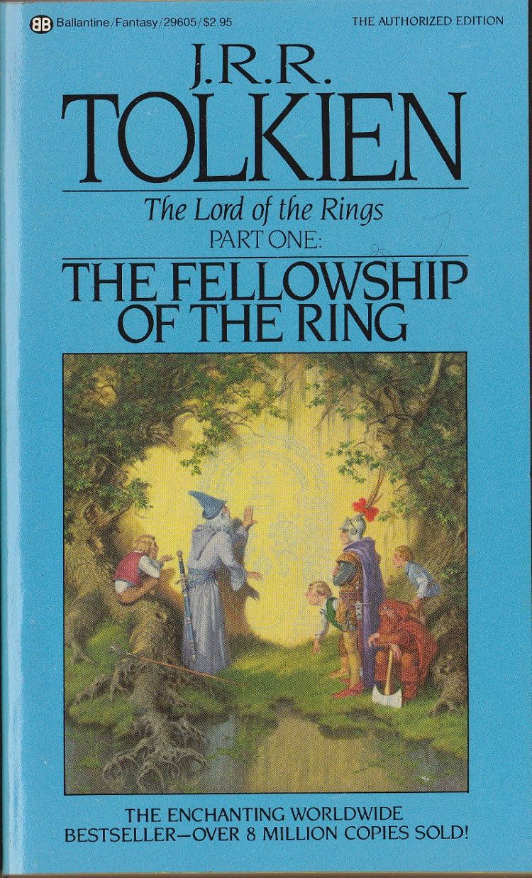Class 2: tFotR read prologue
  - Class 3: tFotR BOOK 1: read ch 1
  - Class 4: tFotR read ch 2
  - Class 5: tFotR read ch 3
  - Class 6: tFotR read ch 4,5
  - Class 7: tFotR read ch 6,7
  - Class 8: tFotR read ch 8
  - Class 9: tFotR read ch 9,10
  - Class 10: tFotR read ch 11
  - Class 11: tFotR read ch 12
  - Class 12: tFotR BOOK 2: read ch 1
  - Class 13: tFotR read ch 2
  - Class 14: tFotR read ch 3
  - Class 15: tFotR read ch 4
  - Class 16: tFotR read ch 5
  - Class 17: tFotR read ch 6
  - Class 18: tFotR read ch 7,8

  - Class 19: tFotR read ch 9,10
  - Class 20: watch film LoTR: tFotR
Class 21: watch film LoTR: tFotR
Class 22: watch film LoTR: tFotR
Class 23: watch film LoTR: tFotR
Class 24: watch film LoTR: tFotR
Class 25: watch film LoTR: tFotR; discuss
  - 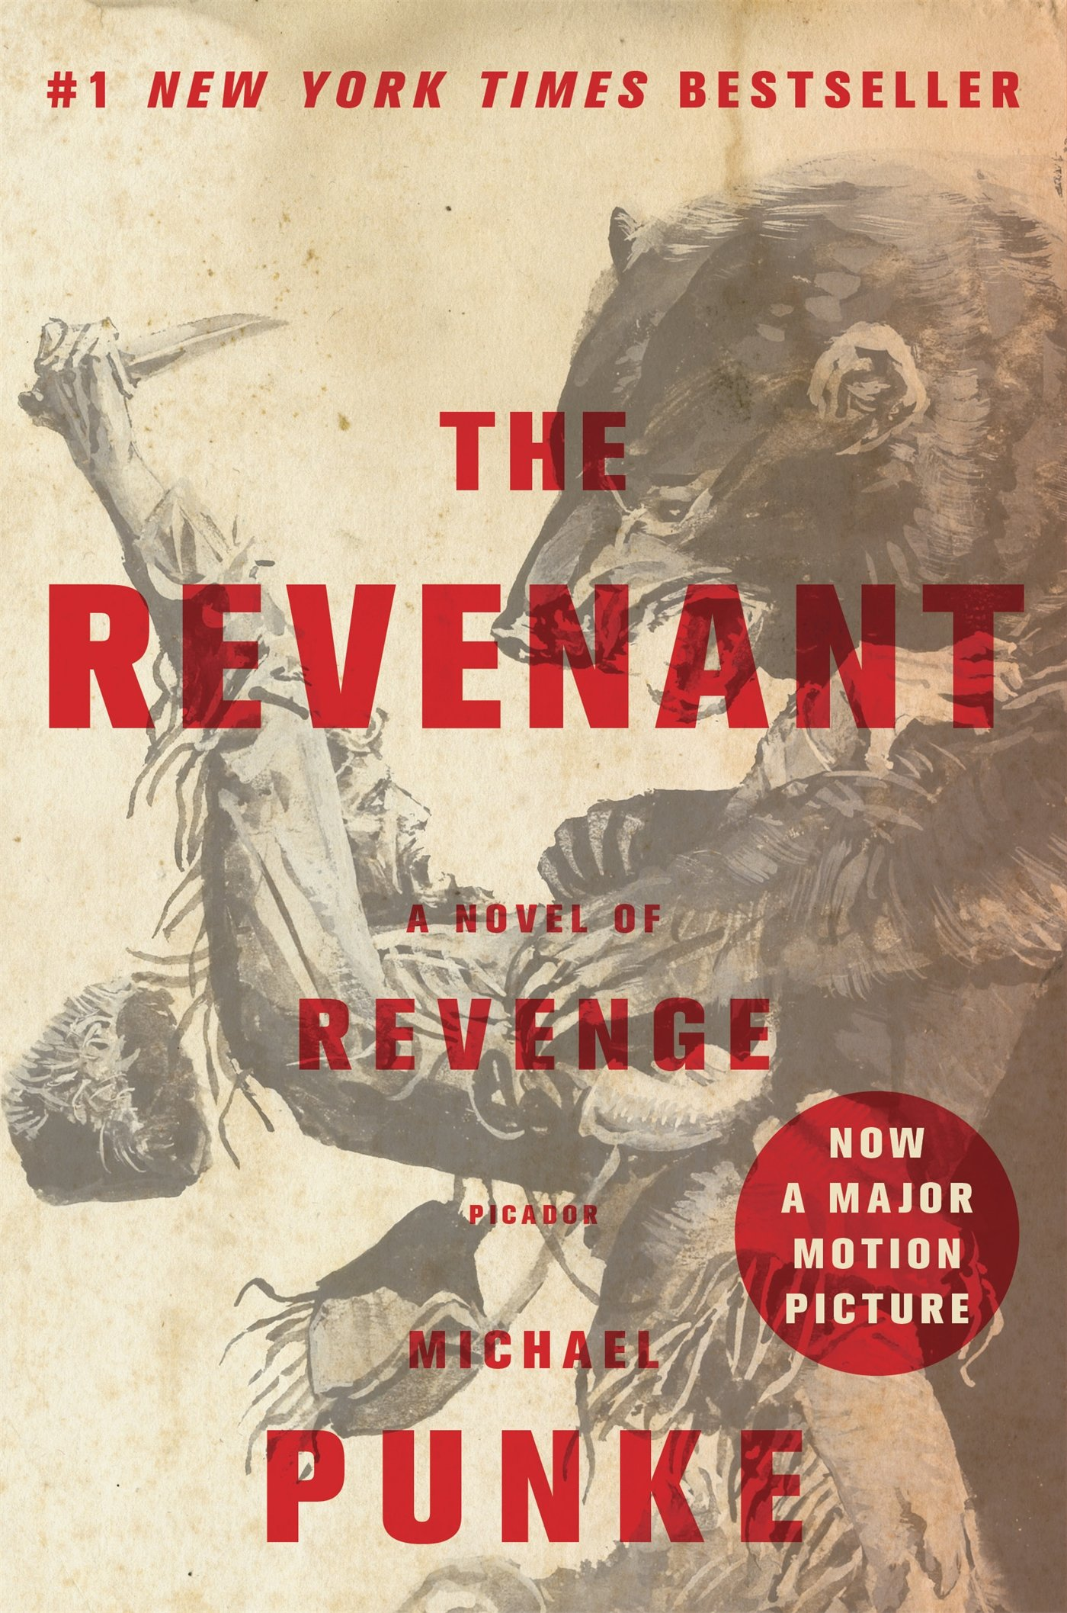Class 26: The Revenant read intro, ch 1,2

  - Class 27: tRread ch 3,4,5
  - Class 28: tR read ch 6,7
  - Class 29: tR read ch 8,9, 10
  - Class 30: tR read ch 11,12,13,14,15
  - Class 31: tR read ch 16,17,18
  - Class 32: tR read ch 19,20,21
  - Class 33: tR read ch 22,23,24

  - Class 34: tR read ch 25,26,27,28
  - Class 35: tR watch film (selectively edited)
Class 36: tR watch film
Class 37: tR watch film
Class 38: tR watch film
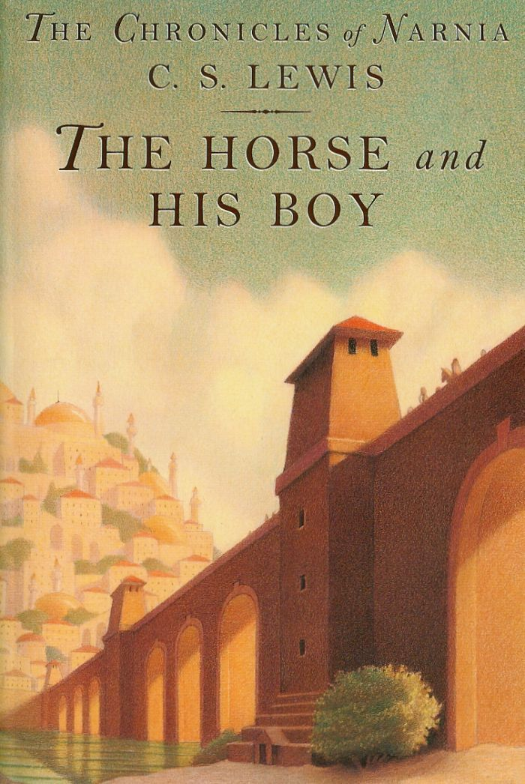Class 39: tHaHB read ch 1,2; one week to select and have choice book approved
  - Class 40: tHaHB read 3,4
  - Class 41: tHaHB read 7,8
  - Class 42: tHaHB read 9,10
  - Class 43: tHaHB read 11,12
  - Class 44: tHaHB read 13-15 (end)
Class 45: Choice book reveal; begin reading; pp 1-25
Class 46: CB read pp 26-50
Class 47: CB read pp 51-75
Class 48: CB read pp 76-100
Class 49: CB read pp 101-125
Class 50: CB read pp 126-150
Class 51: CB read pp 151-175
Class 52: CB read pp 176-200
Class 53: CB read pp 201-225
Class 54: CB read pp 226-250
Class 55: CB read pp 251-275
Class 56: CB read pp 276-300
Class 57: work on teaser
Class 58: work on teaser
Class 59: class presentations
Class 60: class presentations
Class 61: tV read pp 1-25 0
  - Class 62: tV read pp 26-50
  - Class 63: tV read pp 51-75
  - Class 64: tV read pp 76-100
  - Class 65: tV read pp 101-125
  - Class 66: tV read pp 126-150
  - Class 67: tV: read pp 151-175
Class 68: tV: read pp 176-200
Class 69: tV: read pp 201-225
Class 70: tV: read pp 226-250
Class 71: tV: read pp 251-275
Class 72: tV: read pp 276-300
Class 73: tV: read pp 301-325
Class 74: tV: read pp 326-350
Class 75: tV: read pp 351-375
Class 76: tV: read pp 376-404
Class 77: intro Red Rising; read pp1-25 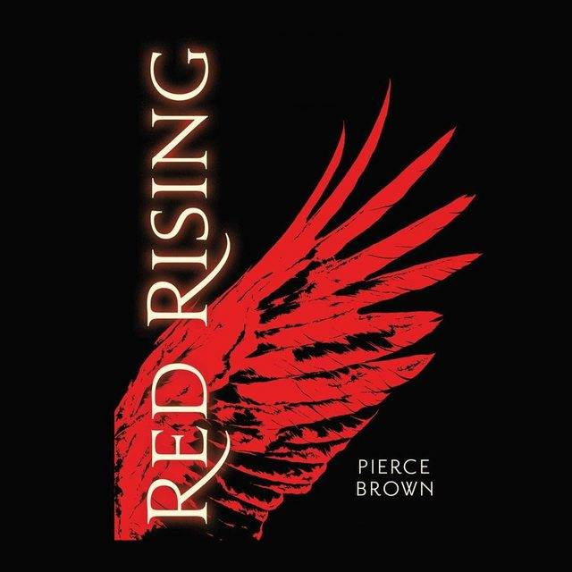
Class 78: RR: read pp 26-50
Class 79: RR: read pp 51-75
Class 80: RR: read pp 76-100
Class 81: RR: read pp 101-125
Class 82: RR: read pp 126-150
Class 83: RR: read pp 151-175
Class 84: RR: read pp 176-200
Class 85: RR: read pp 201-225
Class 86: RR: read pp 226-250
Class 87: RR: read pp 251-275
Class 88: RR: read pp 276-300
  - Classes 89,90/ slush days (RR: read pp 301-382)

