Finding Fact in Fiction III

~Reading Schedule ~

~Upper Level Lit Course~ SRCS ~ mr. e

Class 1: intro, syllabus/overview; the Wizard’s Gambit read in class; summarize The Cleric’s Sage

Class 2: tWG read ch 1,2

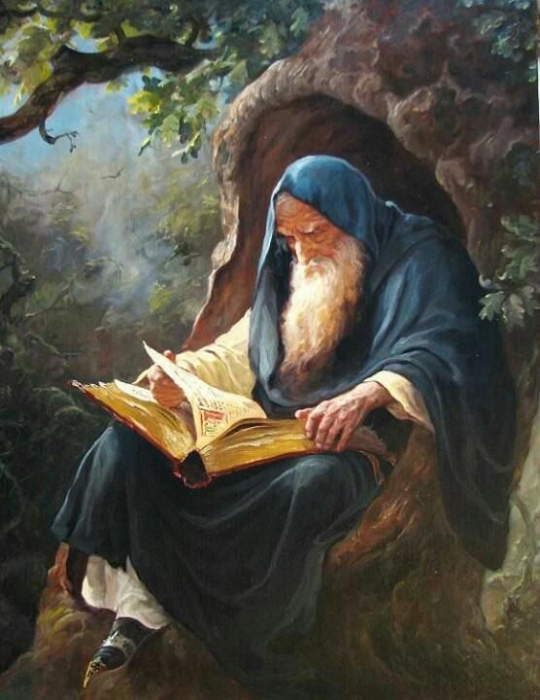

Class 3: tWG read ch 3,4

Class 4: tWG read ch 5,6

Class 5: tWG read ch 7,8

Class 6: tWG read ch 9,10

Class 7: tWG read ch 11,12

Class 8: tWG read ch 13,14

Class 9: tWG read ch 15,16

Class 10: tWG read ch 17,18

Class 11: tWG read ch 19,20

Class 12: tWG read ch 21,22

Class 13: tWG read ch 23,24

Class 14: tWG read ch 25,26

Class 15: tWG read ch 27,28

Class 16: tWG read ch 29,30

Class 17: tWG read ch 31,32

Class 18: tWG read ch 33/epilogue; discuss

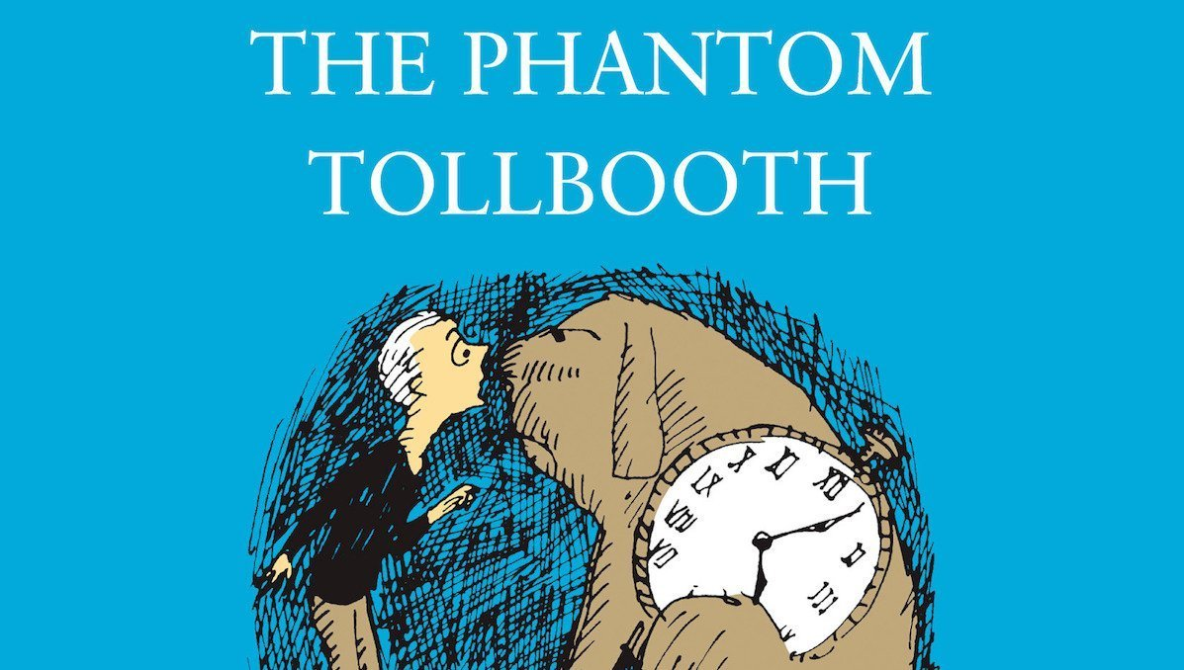

Class 19: TPT read to ch 3

Class 20: TPT read to ch 5

Class 21: TPT read to ch 8

Class 22: TPT read to ch 11

Class 23: TPT read to ch 13

Class 24: TPT read to ch 16

Class 25: TPT read to ch 18

Class 26: TPT read to ch 20

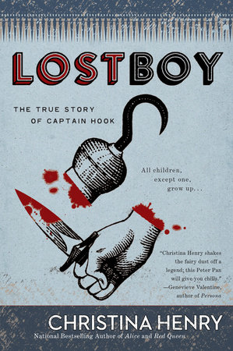

Class 27: LOSTBOY read ch 1

Class 28: LB read ch 2,3

Class 29: LB read ch 4,5

Class 30: LB read ch 6,7

Class 31: LB read ch 8,9

Class 32: LB read ch 10

Class 33: LB read ch 11,12

Class 34: LB read ch 13,14

Class 35: LB read ch 15,16

Class 36: LB read ch 17-19 (end)

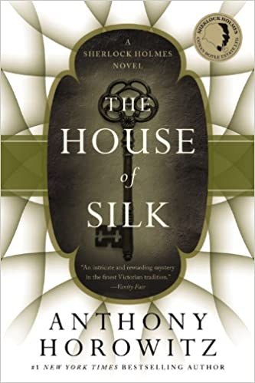

Class 37: Intro to Sherlock

Class 38: The House of Silk read pp 1-25

Class 39: tHoS read pp 26-50

Class 40: tHoS read pp 51-75

Class 41: tHoS read pp 76-100

Class 42: THoS read pp 101-125

Class 43: THoS read pp 126-150

Class 44: THoS read pp 151-175

Class 45: THoS read pp 176-200

Class 46: THoS read pp 201-225

Class 47: THoS read pp 226-250

Class 48: THoS read pp 251-275

Class 49: THoS read pp 276-296

Class 50: watch a Sherlock episode

Class 51: finish episode

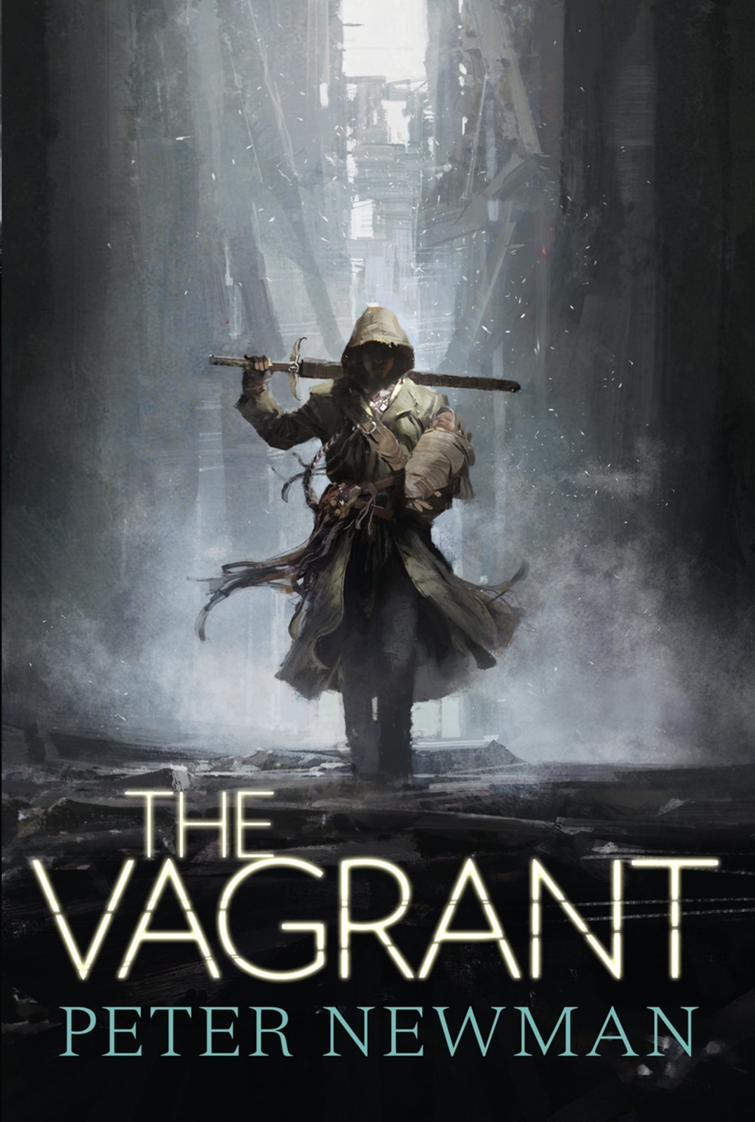Class 52: Intro to post-apocalyptic lit

Class 53: The Vagrant read pp 1-25

Class 54: tV read pp 26-50

Class 55: tV read pp 51-75

Class 56: tV read pp 76-100

Class 57: tV read pp 126-150

Class 58: tV read pp 151-175

Class 59: tV read pp 176-200

Class 60: tV read pp 201-225

Class 61: tV read pp 226-250

Class 62: tV read pp 251-275

Class 63: tV read pp 276-300

Class 64: tV read pp 301-325

Class 65: tV read pp 326-350

Class 66: tV read pp 351-375

Class 67:

Class 68:

Class 69:

Class 70: read pp

Class 71: read pp

Class 72: read pp 451-465

Class 73: read pp 466-480

Class 74: read pp 480-489 & Appendix I

Class 75:

Class 76: film

Class 77: film

Class 78: film

Class 79: film & discussion

Class 80: The Wizard’s Gambit read aloud

Class 81: tWG

Class 82: tWG

Class 83: tWG

Class 84: tWG

Class 85: tWG

Class 86: tWG

Class 87: tWG

Class 88: tWG

Classes 89,90/ slush days (tWG)