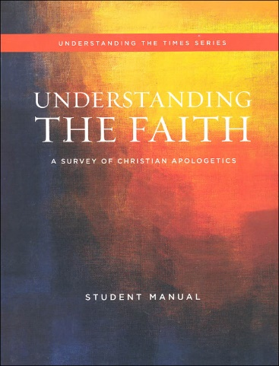



Understanding the faith

STUDY GUIDE CH 5 ~MR E

CHAPTER 5: Test Format: 15 mc/15 T&F/4 bible familiarity/ 2 0f 9 short answer

**Essential Questions:**

Q1. What is a “metanarrative?”

Q2. What are the key elements of a well-written story?

Q3. What is “historical narrative” and what part does it play in the Bible? Summarize the metanarrative of the Bible in One paragraph.

Q4. What are the major non-Christian worldview metanarratives?

Q5 SKIP

Q6. Define “myth.”

Q7. How does the Postmodernist regard Christianity?

Q 8,9 SKIP

Q10. What are the advantages of understanding Scripture’s metanarrative?

Q11 SKIP

Q12. What are some key differences between Genesis chapters 1 &2?

Q13 SKIP

Q14. What are some differences between biblical creation and pagan creation accounts?

Q15 SKIP

Q16/17. What are some implications of humanity being created in the “Image of God”/the creation account that contradict pagan ideas about cosmology & humanity (anthropology)?

Q18. What role did God assign human beings in creation?

Q19. What are implications of being made as male & female?

Q20. What aspects of God & creation remain unchanged despite the Fall?

**Key terms:**

metanarrative myth Atheism Polytheism Naturalism Pantheism Panentheism Astrology Deism Gnosticism Agnosticism Nihilism Neo-Darwinism asceticism God’s immanence God’s transcendence cosmology anthropology materialism postmodernism elements of a good story

**Bible familiarity:**

Genesis 1:26,27

Genesis 1:28-31

Genesis 2:18-25

Psalm 8:3-6

**Short Answer:** Answer two with complete sentences. Be sure to answer the prompt and discuss it in a way that reflects how we covered the topics in class. 10 points; 5 points each.

A. Share in a paragraph the metanarrative of Scripture (in 4 ACTS) as we discussed in class. End by sharing one benefit from seeing Scripture in this way.

B. What are the three elements of a well written story. How does God fulfill each of these in the Biblical story?

C. Share four major non-Christian metanarratives with at least a sentence each.

D. Explain three advantages of understanding Scripture’s metanarrative.

E. Cite three differences between Genesis chapters 1 and 2 as we discussed in class. Share how both chapters treat your chosen contrasts, that is, do not simply speak of one chapter and assume the reader should fill in the contrasting gap.

F. Share three implications of humanity being created in God’s image (that contradict pagan ideas about cosmology/man). Finish by stating two pagan ideas we must reject as a result. Stick to our notes on this!

G. Summarize the Cultural Mandate and explain its three parts more completely.

H. Share three implications we discussed of God creating man as male and female.

1. Share 3 of the 7 lies Christians believe about sex that Powell identified for us in the reading. Correct each lie.