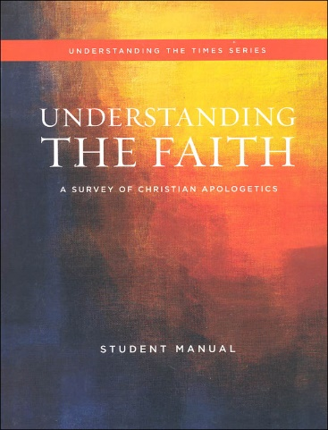



Understanding the faith

STUDY GUIDE CH 4 ~MR E

CHAPTER 4: Test Format: 15 mc/15 T&F/12 bible familiarity/ 2 0f 9 short answer

**Essential Questions:**

Q1. Into which four categories can America’s concept of God be arranged?

Q2. How does our view of God affect the way one lives?

Q3. Why is it true to say that every person is a theologian?

Q4. SKIP

Q5. Who is God?

Q6. If God is beyond our comprehension, how can we get to know Him?

Q7. What does it mean to say, “God is self-existent?’

Q8. What does it mean it mean to say, “God is spirit?”

Q9. What does it mean to say, “God is personal?”

Q 10. A Word about God’s traits...

Q11. What does it mean to say, “God is Holy?”

Q12. What does it mean to say, “God is eternal?”

Q13. What does it mean to say, “God is all-knowing?”

Q14. What does it mean to say, “God is all-powerful?”

Q15. How would you address the question, “f God is omnipotent, can He make a rock too big for Him to lift?”

Q16. What does it mean to say, “God is everywhere present?”

Q17. What does it mean to say, “God is unchanging?”

Q18. How, then, are we to understand the passages of Scripture that seem to communicate that God is changing His mind?

Q20. What does it mean to say, “God is righteous?”

Q21. What does it mean to say, “God is loving?”

Q22 What does it mean to say, “God is merciful and gracious?”

Q23. What does it mean to say, “God is Triune?”

Q24. How does the doctrine of the Trinity distinguish Orthodox Christian theism from other theistic worldviews?

**Key terms:**

Agape aseity communicable/incommunicable attributes deism desired will of God determinative will of God doctrine of the Trinity eternal eros grace heresy holy immanent immutable mercy modalism/Sabellianism monotheism new atheism omnibenevolent omnipotent omnipresent omniscient pantheism philos polytheism righteous theology/theologian transcendent Tri-theism wise

**Bible familiarity:**

Ecclesiastes 3:11

Deuteronomy 29:29

Jude 24,25

Isaiah 46:8-11

Jeremiah 32:17

Numbers 23:19

I Corinthians 13:4-7

John 11:33-36

I John 4:7-10

Matthew 3:16,17

**Short Answer:** Answer two with complete sentences. Be sure to answer the prompt and discuss it in a way that reflects how we covered the topics in class. 10 points; 5 points each.

A. SHre the four categories into which modern day Americans put God. Select two and describe what stance they take. Then choose one issue and generalize what their stance is because of their belief about God.

B. Define theology according to Frame and discuss why everyone is a theologian. Briefly share why Atheists fall into this category as well and finish by saying the three things theology ought to be.

C. Share the WSC Q4 answer to the question “Who IS God?”; pick two attributes and explain how each applies to God.

D. Explain what the terms ‘incomprehensible’ and incomprehendible’ mean, then apply them to a proper understanding of the relationship between God and our knowledge. Cite the verse we used as a proof text.

E. Explain what God’s self-existence means and share and discuss the three consequences of it we noted in class

F. What three things do we mean when we say, “God is personal?” How does Scripture show that it is the testament of God’s relationship with humanity?

G. We describe God as omnipresent, omniscient, omnipotent, and immutable. Pick two, define them and share, in more detail, something about each we discussed in class.

H. Pick a Scripture in which it appears as if God changes His mind. Using that story, share the perspective we gained from John Frame’s article in which he answers the question, “Does God change His mind?”

1. Define the orthodox doctrine of the Trinity with at least three statements. Pick a trinitarian heresy, name it, and show how it is deviant from orthodoxy.