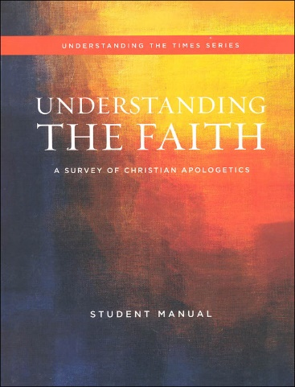



Understanding the faith

STUDY GUIDE **Ch 3** mr e ~ srcs

CHAPTER 3: Test Format: 15 mc/15 T&F/12 bible familiarity/ 2 0f 8 short answer

**Essential Questions:**

Q1. Is it ever okay to question authority?

Q2. What does it mean to confess “Jesus is Lord”?

Q3. What are a few assumptions Christians bring to the Bible?

Q4. How is the Bible composed?

Q5. What is the basis for the Bible’s authority?

Q6. SKIP

Q7. What role does external evidence play?

Q8/9. Be familiar with list of discoveries that confirm Scripture

Q 10. What are common objections to the Bible’s authority?

Q11/12. How do I deal with these objections to Scripture’ authority?

Q13. Sometimes the harrowing results of the “telephone game” are applied to the Bible. Why do they not apply to Scripture?

Q14. Is the Bible incomplete…have important books have been left out?

Q15: Why were the “Lost gospels” never canonized?

Q16. How far does God’s authority extend?

Q17. How far does the Bible’s authority extend?

Q18/19. Our reason & understanding of reality

Q20. Culture

Q21. Entertainment

Q22. Our senses

Q23. Our emotions

Q24. Our knowledge

Q25. Governments

**Key terms:**

anarchy authority transmission magisterial/ministerial view of Scripture

canon/canon of Scripture internal evidence of Scripture Dead Sea scrolls

external evidence of Scripture authorship objections to authorship

types of textual variants lost gospels Gnosticism derived authority

marks of canonicity (3) derived authority scope of God’s authority

Asceticism Docetism self-attesting nature of Scripture

**Bible familiarity:**

John 5:22

John 8:58

2 Timothy 3:16

Mark 2:8-12

John 14: 25,26

Romans 13:1,2

Luke 24:25

2 Peter 1: 20,21

Matt. 28:18-20

Proverbs 24:13-14

Philippians 4:8

Romans 1: 21-22

**Short Answer:** Answer two with complete sentences. Be sure to answer the prompt and discuss it in a way that reflects how we covered the topics in class. 10 points; 5 points each.

A. Is it ever okay to question authority? Give the three things to keep in mind when considering such a thing and share an example from history and justify it as either just or sinful.

B. If one confesses “Jesus is Lord”, what does that mean? Share its true consequence for our lives and a common misconception we talked about regarding this.

C. What was the purpose of historical Church/Ecumenical Councils? When was the first, where did it meet, and what was the central issue? Why did James decree what he did?

D. Contrast the Catholic view of the church’s role regarding the canon of Scripture with the Protestant view. What are the three marks of canonicity?

E. What are the three advantages we spoke of in living in God’s world as a child of His? Why does His Word concur with reality?

F. Share the three most common objections to the Bible’s authority. Select one and refute it adequately.

G. Describe Gnosticism (provide 2 of our talking points). How does the Infancy Gospel of Thomas fit in with the Lost Gospels? How is it gnostic and how does it fall prey to the motif of Classical Greek mythology?

H. Perhaps this has been common over the ages ever since governments have ruled the day, however, we live in an America that has politicized religion. What are three of the four things I said to keep in mind as we navigate political ideas with those around us?