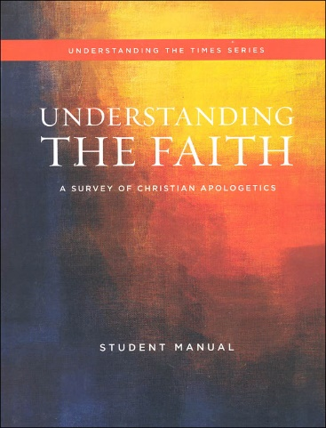



Understanding the faith

STUDY GUIDE **Ch 2** mr e ~ srcs

CHAPTER 2: Test Format: 10 mc/10 T&F/5 bible familiarity/ 2 0f 8 short answer

**Essential Questions:**

Q2. Which of these descriptors best reflects what the Bible is?

Q3. Has the Bible played a key role in shaping America or is this simply a Christian revision of history?

Q4. What are some important reasons to study the Bible?

Q5. Worldviews & ‘sacred’ texts (bold are considered sacred; others, inspirational)

Q6. How is the Bible different from other holy books?

Q7. Benefits from careful Bible study?

(Q8/9)“If the Bible is from God, what consequences result?

Q 10. What are the only Two Options to explain the origin of religion?

Q11. What does it mean to say God is personal and shares the qualities of personhood?

Q12. What are the two main ways God reveals Himself?

Q13. Is there a difference between saying “The Bible is the Word of God” vs. “The Bible contains the Word of God?”/What is the relationship b/w Scripture and Truth?

Q14. Can we trust the Bible’s accuracy?

Q15. What does it mean to say that the Bible is “inspired”?

Q16. What does it mean to say the Bible is “inerrant”?

Q17. What is the basis for knowledge?

Q18. How do the competing worldviews of ‘naturalism’ and ‘Christian theism’ compare as they relate to knowledge?

Q19. Is 100% certainty necessary for knowledge?

Q20. Can we know something with certainty if it hasn’t been scientifically proven?

Q20b. Are there limitations to the Scientific Method?

Q21. What is the “correspondence theory of truth”?

**Key terms:**

Correspondence theory of truth dead sea scrolls general revelation

special revelation inerrancy infallibility knowledge objective truth

subjective truth naturalism relativism scientism

self-refuting claim self-attesting ultimate criterion coherence

**Bible familiarity:**

Psalm 19:1-4

Romans 2:14-16

2 Timothy 3:16

Hebrews 1:1,2

Luke 1: 1-4

**Short Answer:**

A. Define both Special and General revelation. Contrast them in how they relate to salvation. Give an example of each.

B. Contrast theism and naturalism in at least three ways as a basis for knowledge.

C. What does it mean to say that God is personal? What consequences are there for humans?

D. Draw the 5 Venn Diagrams as to how Truth can relate to Scripture. Select the correct one and an incorrect one and write the one statement they are teaching for each.

E. Share two of the four Attributes of Scripture according to our class discussion. Define two more completely.

F. Define Scientism. How is Scientism self-refuting? Explain adequately in 2 or 3 sentences.

G. Share the three D’s of Tolerance presented by J. Warner Wallace. How does culture misunderstand this concept? How are Christians to respond when they disagree with someone (Explain the 3rd “D” more).

H. Share three ways the Bible has influenced society as we read and heard discussed.