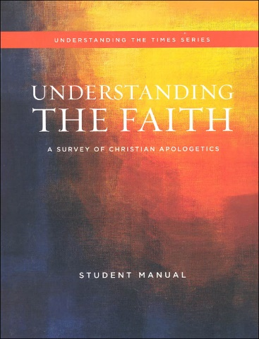

Understanding the faith



STUDY GUIDE **Ch 1** mr e ~ srcs

CHAPTER 1: Test Format: 10 mc/10 T&F/10 bible familiarity/ 2 0f 7 short answer

**Essential Questions:**

Q1. Why this curriculum?

Q2. What is the Result of the human search for answers?

Q3. How do ideas influence the direction of our lives?

Q4. Is there a principle we can use to make sense of the vast array of ideas?

Q5. 5 QUESTIONS with which every human ought grapple

Q6. How do answers to the above questions shape the answers to others?

Q7. Who were the Men of Issachar and why were they able to do what they did?

Q8. How do we know what we know? (including traditional epistemologies)

Q9. What is a secular humanist?

Q10. Should we as believers study worldly philosophies?

Q11. What is the “2-story concept of truth” & why is it so dangerous?

Q12. Problems with the split?

Q13. What does it mean to have authority?

Q14. What type of authority does God have/show?

Q15. Is doubt a good reason for not submitting to God’s authority?

Q16. What is biblical faith?

Q17. Can a person be saved and have doubts at the same time?

Q18. Is this generation prepared to defend the faith in the face of pluralism?

Q19. What areas might you feel embarrassed if you were to be challenged in your faith?

Q20. What is/are the “great battle(s) of our time?”

Q21. “What reasons can be given to show the Bible is the Word of God?

**Key terms:**

Epistemology faith hard authority soft authority Relativism

subjective objective universal extrinsic intrinsic epic

hierarchical skepticism pragmatism scientism secular humanism

empiricism

**Bible familiarity:**

Romans 12:2

2 Corinthians 10:5

Colossians 2:8

1 Chronicles 12:32

Ephesians 4 :17,18

Short Answer:

A. List the 5 questions with which every human ought grapple. Categorize each.

B. Share the “two-story” concept of truth that Francis Schaeffer mourned. Share one of its weaknesses.

C. Explain the difference between hard &amp; soft authority. Explain one way in which God expresses both.

D. Explain why doubts can be beneficial to the Christian walk and need not destroy faith.

E. Share two reasons the Bible is trustworthy as the Word of God.

F. Share two vital “takeaways” from Nabeel Qureshi’s testimony (“Seeking Allah, Finding Jesus”).

G. Share two reasons presented by William Lane Craig that support God’s existence. Discuss one more fully.