Finding Fact in Fiction I

~Reading Schedule ~

Surviving Other Worlds

~Upper Level Lit Course~ SRCS ~ mr. e

Class 1: intro, syllabus/overview; HPPoA read in class

Class 2: HPPoA read ch 1,2

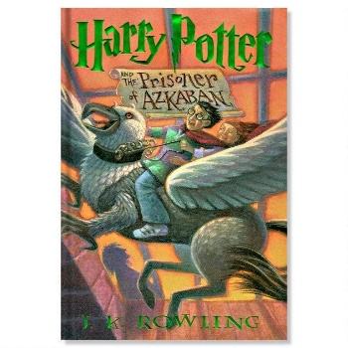

Class 3: HPPoA read ch 3,4

Class 4: HPPoA read ch 5,6

Class 5: HPPoA read ch 7,8

Class 6: HPPoA read ch 9,10

Class 7: HPPoA read ch 11,12

Class 8: HPPoA read ch 13,14

Class 9: HPPoA read ch 15,16

Class 10: HPPoA read ch 17,18

Class 11: HPPoA read ch 19,20

Class 12: HPPoA read ch 21,22

Class 13: film

Class 14: film

Class 15: film

Class 16: discuss; Rowling article

Class 17: start EG (introduction)

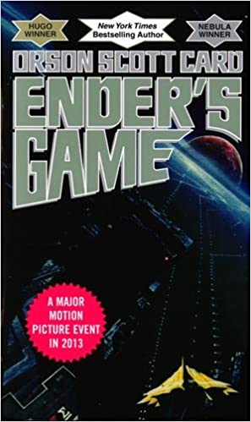

Class 18: EG read to ch 3 (not incl.)

Class 19: EG read to ch 5

Class 20: EG read to ch 7

Class 21: EG read ch 7

Class 22: EG read ch 8

Class 23: EG read ch 9

Class 24: EG read ch 10

Class 25: EG read ch 11

Class 26: EG read ch 12

Class 27 EG read ch 13

Class 28: EG read ch 14

Class 29: EG read ch 15

Class 30: discuss Hero’s Cycle

Class 31: film

Class 32: film

Class 33: film

Class 34: discuss; start LoP (author’s note)

Class 35: LoP read rest of author’s note to ch 7

Class 36: LoP read to ch 17



Class 37: LoP read to ch 27

Class 38: LoP read to ch 38

Class 39: LoP read to ch 46

Class 40: LoP read to ch 53

Class 41: LoP read to ch 61

Class 42: LoP read to ch 70

Class 43: LoP read to ch 83

Class 44: LoP reads to ch 91

Class 45: LoP read to ch 93

Class 46: LoP read to ch 100 (end)

Class 47: film

Class 48: film

Class 49: film

Class 50: discuss; Martel article

Class 51: begin The Martian



Class 52: tM pp 1-25 (incl.)

Class 53: tM pp 26-50

Class 54: tM pp 51-75

Class 55: tM pp 76-100

Class 56: tM pp 101-125

Class 57: tM pp 126-150

Class 58: tM pp 151-175

Class 59: tM pp 176-200

Class 60: tM pp 201-225

Class 61 tM pp 226-250

Class 62 tM pp 251-275

Class 63: tM pp 276-300

Class 64: tM pp 301-325

Class 65: tM pp 326-350

Class 66: tM pp 351-375

Class 67: tM pp 376-400

Class 68: tM pp 401-425

Class 69: tM pp 426-435 (end)

Class 70: Weir Article



Class 71: film

Class 72: film

Class 73: film

Class 74: film; discuss

Class 75: Selected Short

Class 76: Selected Short

Class 77: Student selected novel (from list)

Class 78: Student selected

Class 79: SS

Class 80: SS

Class 81: SS

Class 82: SS

Class 83: SS

Class 84: SS

Class 85: SS

Class 86: SS

Class 87: SS

Class 88: discuss

Classess 89,90/ slush days for FT or SGA activity