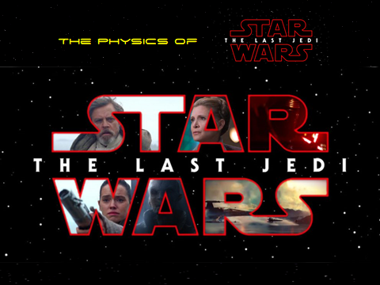

Take-Home Homework Questionnaire name:

date:

1. For which physical phenomenon did you already understand the underlying physics correctly? Describe.
2. Which physical principle totally took you by surprise? Explain how.
3. Starkiller base is the newest form of Planet-destroying tech the First Order unveiled in Episode VII (I realize that it is an old one…but it checks out). With the following givens, calculate the mass (in kg) of the average First Order trooper at the surface of Starkiller base.

force exerted between two objectsF=784 N (we will assume that they experience 1 g at the surface as we see them walking around normally)

m1= stormtrooper's mass (in kg; variable)

m2= 1.6 x 1022 kg (mass of Starkiller base[1])

G=6.67 x 10-11 N-m2/kg2 (Universal gravitational constant)

d= 330,000 m (distance from center of base to surface; also shown as *r* in the formula)

mass of object 1

If it helps, since you are solving for m1, the formula can be manipulated as follows:

Show all work below:

1. 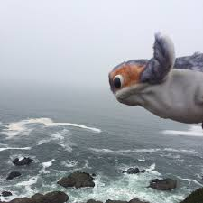Using the distance formula, calculate the height of the highest peak on Ahch To[2]. To do so, you observe that a porg takes 6.7 s to descend from its nest at the peak to the shoreline. Assume (1) its winged descent is the same as a mere fall, and (2) g is the same on Ahch To as it is on earth.

d = 1/2gt2

Show all work below:

1. Because of its astounding ability to melt blast doors, the lightsaber is a far more dangerous weapon than most imagine. Suppose we go with a heat output of 1.69 GJ (that's gigajoules[3]), calculate how much ice a simple plunge of the sword into a solid block of 0oC ice would melt. Express answer in kg.

Q = m Lf

Q = 1.69 GJ (which works out to be 403,920,000 calories--use this #)

mice = ? kg

Lf = 80 cal/g

Show all work to the right:

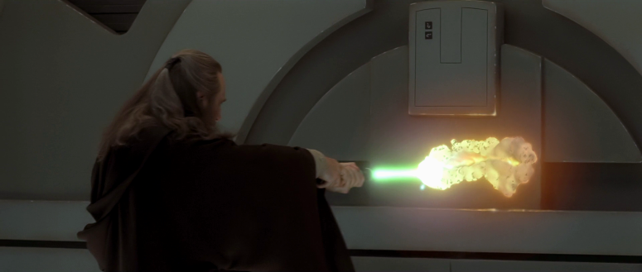

1. What would the momentum of the Millennium Falcon be if it were traveling at near light speed?

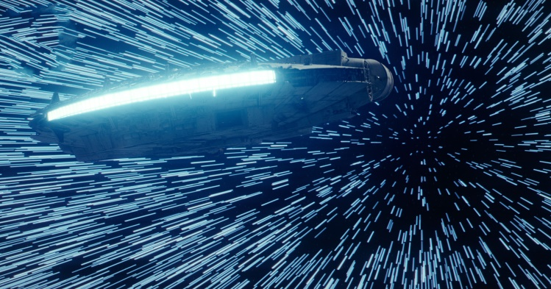

p = mv

m = 2.5 X 107 kg (mass of YT-1300 modified freighter)[4]

v = 296,794,533 m/s (99% the speed of light (c))

Show work to the below:

1. We watched a video explaining why Chewie's bowcaster is more powerful than any blaster. From this data emerges our final, non-bonus calculation. Considering the law of the conservation of momentum, calculate the recoil velocity of the bowcaster once fired (in m/s) to fully appreciate Han's surprise when using it in Episode VII. Neglect the mass of the Wookie and use the following formula and data[5]:

*p*before = *p*after *p* = mv Show all work here:

mb.q. = 0.5 kg (mass of bowcaster quarrel)

mb = 8.0 kg (mass of bowcaster[6])

vq = 60 m/s

vb = ? m/s

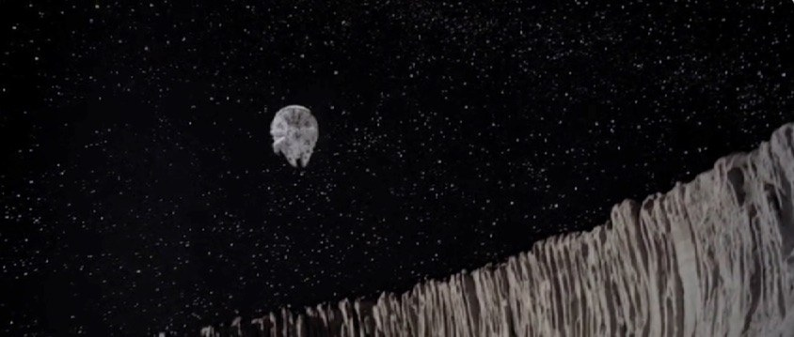BONUS: A look at the past…

The Millennium Falcon is, perhaps, the most iconic ship in the Star Wars galaxy. In ***The Empire Strikes Back,*** Han does a nice little loop. Using the data and formulas given, calculate the g forces (in # of g's) experienced by the crew as they escaped the Imperial forces and entered the asteroid.

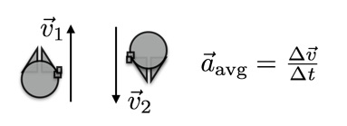

v1 = 267 m/s

v2 = ? [7] m/s

t = 2.17 s

g = 9.8 m/s2

Show all work here:

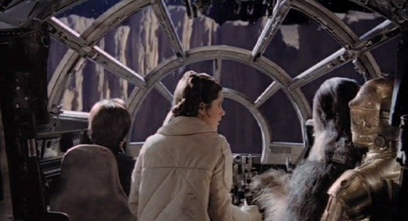

Is it realistic to have Leia standing during the loop? Why?

1. https://sites.wustl.edu/fictionomics/2017/11/29/starkiller-base-cost/
2. Calculated from actual filming location; slope of highest peak and air resistance is not taken into account. Also, no porgs were harmed in the solving of this question.
3. <https://futurism.com/how-many-batteries-would-it-take-to-power-star-wars-tech-infographic/>; assume also that the ice simply melts as opposed to the probable vaporization, melting, hot water scenario that would likely ensue.
4. http://whs.wsd.wednet.edu/faculty/busse/mathhomepage/busseclasses/apphysics/studyguides/chapter5/gravitationalmotion.html
5. <https://www.youtube.com/watch?v=0siMG2IzyzE>; Because Science vid titled "Why Chewbacca's Bowcaster Is More Powerful Than Any Blaster." Also the velocity of the quarrel was deduced from Mythbuster's "Could A Star Wars Blaster Bolt Be Dodged?" Episode: https://www.youtube.com/watch?v=Ni3WtNcuZ4Q
6. http://starwars.wikia.com/wiki/Bowcaster/Legends
7. Be careful. Don't make the mistake I have seen many physics students make. The mistake is to say that since v1 and v2 are the same, the change in velocity (and thus the acceleration) is zero. No. This is wrong. The velocities ARE NOT the same, the speeds are the same. Acceleration depends on the change in velocity, not the change in speed. If I just want to find the vertical component of the acceleration, the initial velocity would be positive and the final would be negative. Formula, data, pic and caveat above taken from https://www.wired.com/2014/12/many-gs-millennium-falcon-pull-empire-strikes-back/