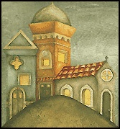Acts, Epistles, & Systematics Study guidE

Mr. e ~SRCS~BiBLe 10 Name:

midterm: ACTS ~ CHAPTERs 1-28

Format: 100 multiple choice questions

Vocab:

'chief cornerstone' (ch 4)

The Way (ch 9)

People & Places

Theophilus (ch 1)

Matthias (ch 1)

Jerusalem (ch 1)

Judas Iscariot (ch 1)

The Beautiful Gate (ch 3)

Herod (ch 4)

Pontius Pilate (ch 4)

Ananias (ch 5)

Sapphira (ch 5)

Gamaliel (ch 5)

Moses (ch 7:20-22)

Stephen (ch 7)

Mount Sinai (ch 7)

Saul (ch 8)

Simon the Sorcerer (ch 8)

Ethiopian eunuch (ch 8)

Barnabas (ch 9)

Cornelius (ch 10)

Agabus (ch 11)

James the brother of John (ch 12)

Peter (ch 9 ff; vision & interp)

Antioch (ch11:26)

Herod (ch 12)

David (ch 13)

Bar-Jesus (ch 13)

Lystra (ch 14)

Iconium (ch 14)

Council of Jerusalem (ch 15)

Silas (ch 15)

Philippi (ch 16)

Timothy (ch 16)

Possessed slave-girl (ch 16)

Philippian jailer (ch 16)

Athens (ch 17)

Thessalonica (ch 17)

Jews of Achaia (ch 18)

Aquila (ch 18)

Priscilla (ch 18)

Apollos (ch 18)

Sons of Sceva (ch 19)

Ephesus (ch 19)

Demetrius (ch 19)

Diana (ch 19)

Gaius (ch 19)

Aristarchus (ch 19)

Eutychus (ch 20)

Roman Soldiers (ch 21)

Ananias the High Priest (ch 23)

Pharisees (ch 23)

Sadducees (ch 23)

Paul’s nephew (ch 23)

Felix (ch 23)

Herod’s Praetorium/palace (ch 23)

Tertullus (ch 24)

Felix (ch 24)

Drusilla (ch 24)

Porcius Festus (ch 24)

Caesar (ch 25)

Agrippa (ch 26)

Malta (ch 28)

Key Concepts:

1. At Pentecost, the Christians were accused of being __________ by the outsiders. (ch2)

2. Details of the Holy Spirit's coming at Pentecost (ch 2)

3. According to Acts chapter two, did the early Christians in Jerusalem continue to worship in the Temple?

4. God heals, it seems in Acts (& the Gospels too) when what central ingredient is demonstrated? (eg. lame man, ch 3:16)

5. Christ was likened to what in Peter's 'building' metaphor as he quoted psalm 118 before the Sanhedrin? (ch 4)

6. Peter and John before the council (ch 4)

7. What is Gamaliel's advice to the Sanhedrin in ch 5?

8. According to Acts chapter six, what did the Apostles believe their specific duties should include?

9. Members of the synagogue accused Stephen of what? (ch 6)

10. Stephen's trial and death

11. For what did Simon (the Sorcerer) offer the Apostles money? (ch 8)

12. What book of the Old Testament was the Ethiopian eunuch reading? (ch 8)

13. Circumstances of Saul's conversion. (ch 9)

14. Circumstances of Peter's vision. (ch 10)

15. Interpretation of Peter's vision (ch 10)

16. Where were believers first called Christians? (ch 11)

17. Circumstances of Peter's escape from prison. (ch 12)

18. How did Herod die? (ch 12)

19. John the Baptist preached the baptism of ___________ (ch 13)

20. Since the Jews rejected this teaching, to whom did Paul say he would turn his teaching? (ch 13)

21. Paul and Barnabas being mistaken for gods

22. Circumstances surrounding Paul's stoning in Lystra (ch 14)

23. Circumstances surrounding the Council of Jerusalem; problem/debate/edict. (ch 15)

24. The decrees that the early Christians were to keep were determined by whom? (ch 16)

25. The demon-possessed slave-girl in ch 16 was used by her owners in which way? Why?

26. Circumstances of the Philippian ‘jail-break’. (ch 16)

27. What was the inscription on the altar Paul used as a bridge for the Gospel in Athens? (ch 17)

28. What two things did Paul state necessary for Christ to do? (ch 17)

29. According to Acts chapter eighteen, what did St. Paul do at Cenchrea to bring to a close a vow he had taken?

30. According to Acts chapter nineteen, by whose name did some itinerant Jewish exorcists (sons of Sceva) expel evil spirits?

31. Know the circumstances of the silversmiths and the idols in Ephesus (ch 19)

32. What was Paul willing to do in Jerusalem if need be? (ch 21)

33. To what did Paul appeal once he was going to be flogged & questioned by the Romans? (ch 22)

34. Paul was from which Jewish religious sect? (ch 23)

35. Contrast what the Pharisees believe with what the Sadducees believe. (ch 23)

36. Paul called the High priest Ananias what? (ch 23)

37. Felix would have released Paul if he…? (ch 24)

38. Why was Festus willing to send Paul to Jerusalem? (ch 25)

39. Paul before King Agrippa (ch 25)

40. According to Festus in Acts chapter twenty-five, what were the questions Paul’s accusers

raised against him?

41. Paul's shipwreck (ch 27)

42. How many people were died on the voyage according to in Acts chapter twenty-seven?

43. What animal bit Paul in Malta? (ch 28)

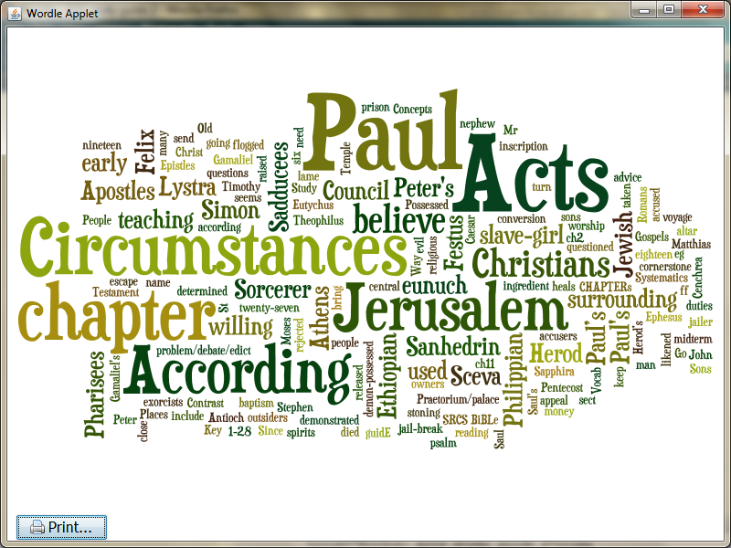

Here is a “word cloud” of this study guide! Go to <http://www.wordle.net/> and create your own!