Ch 21: chemistry name:

Study Guide

**Vocab**

*chemistry*

*chemical change*

*physical change*

*nucleons*

*intensive property*

*element*

*compound*

*reactants*

*products*

* *(yields)*

*precipitate*

*law of mass conservation*

*fluid (2 forms)*

*density*

*aqueous*

*(s), (l), (g), (aq)*

*Mendeleev*

*Synthesis/combination rxn*

*Decomposition rxn*

*single displacement rxn*

*double displacement rxn*

*combustion*

*Moseley*

*Valence e-*

*periodicity*

*Chemical symbol*

*Atomic number*

*Atomic mass*

*isotope*

*P+, no, e-*

*Alkali metals*

*Alkaline earth metals*

*Halogens*

*Atom/element/compound*

*Ionic bond*

*Covalent bond*

*Ion*

*e- dot notation (Lewis)*

*Law of definite proportions*

*Law of conservation of mass*

*Precipitate*

*Coefficients & subscripts*

*Lavoisier*

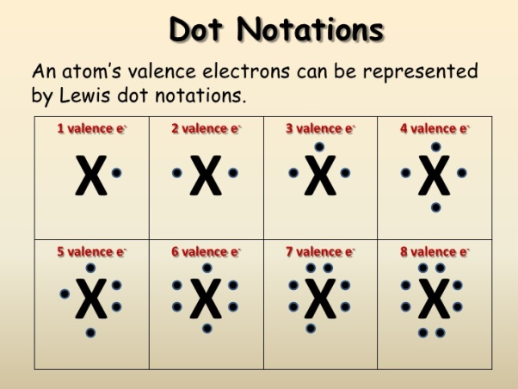**Formulae**

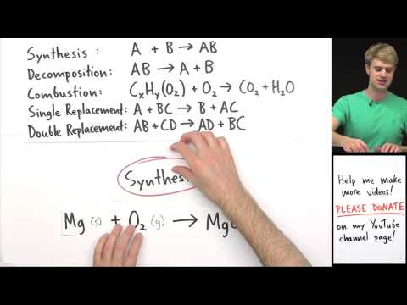

**Things you MUST know:­­­­­**

1. Vocab
2. Visualizations/models of three states of matter.
3. Relationship between shape and V of three phases.
4. Application of density of three phases and compressibility.
5. Identify key historical figures on the basis of ideas/contributions to Chem.
6. Distinguish between physical and chemical changes.
7. Distinguish between the three states of matter in terms of motion. (How do their molecular motion compare?)
8. What typically suggests a chemical change has occurred?
9. What *must* happen in every chemical change? (Bonds must be broken & atoms rearranged…)
10. Are the properties of product similar to or different from the properties of their reactants?
11. T = avg KE; If 2 atoms are at the same T, which has more KE, the larger or smaller? Which has more speed?
    1. They both have the same KE b/c they are at the same T (see definition of T).
    2. The smaller atom. (Relate to Momentum…the smaller mass must travel faster to equal the E of the larger--think Coach MacDougal/Coach Bowman analogy)

M v = Momentum = m V

Larger, slower atom KE smaller, faster atom

1. Be able to identify all the components of a typical box on the Periodic Table.
2. Vocab. Yes, I will say it again.
3. Why is the atomic mass for most elements a decimal (ie. Not a whole number)?
4. 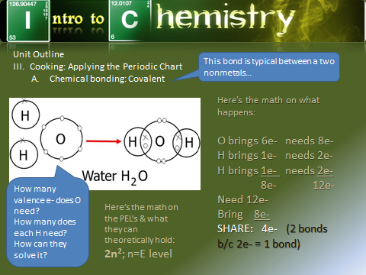Identify the major groups on the Periodic Table.
5. Be able to select the appropriate e- dot notation for any "A group" element.
6. Recognize the Law of Mass conservation if stated.
7. Predict the ions that the A groups will form (recognizing that not all form ions) based on their valence e-.
8. Be able to predict how two nonmetals will bond covalently based on our "e- to the party" method--see slide to right for example 🡪
9. Who formulated the law of mass conservation?
10. *Why* does one balance chemical equations?
11. *How* does one balance chemical equations?
12. Why must one leave the subscripts untouched when one balances chemical equations?
13. Be able to calculate density given mass & V.
14. What if a chemical equation cannot be balanced?--what does this mean?
    1. try harder
    2. The reaction does not occur in nature/lab as stated

18. Be able to balance chemical equations.

20. Be able to identify reaction types.