Ch 11: electricity name:

Study Guide

**Vocab**

*ion*

*coulomb's law*

*direct current*

*electric power*

*voltage*

*coulomb*

*ohm's law*

*ampere*

*electrical resistance*

*charge*

*ohm*

*alternating current*

*electric current*

*electrically polarized*

*watts*

*parallel circuit series circuit* grounding

overloading static electricity attract/repel

[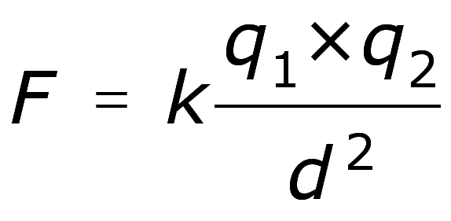](http://www.google.com/url?sa=i&rct=j&q=&esrc=s&source=images&cd=&cad=rja&uact=8&ved=0ahUKEwiZzrXGwP_KAhXIlx4KHVhcAsIQjRwIBw&url=http://www.stylepinner.com/coulomb-symbol/Y291bG9tYi1zeW1ib2w/&psig=AFQjCNFyPtAVt4dE8xUiYvklwEyBOQrM3g&ust=1455822752101445)**Formulae**: (units)

l l

Voltage= PE/charge

Current= V/resistance *or* Amperes= volts/ohms

Power= current x voltage *or* Watts= amperes x volts

**Things you MUST know:­­­­­**

1. Relationship between charges (2 Rules)
2. Characteristics of an atom & nature of subatomic particles
3. Coulomb's law & how to use it to solve for any variable
4. Electric current (be able to explain cause and calculate formula)
5. Charge and Polarization: explain each and their causes
6. Voltage (be able to explain cause and calculate formula)
7. Electrical resistance (be able to explain cause and calculate formula)
8. Ohm's law (what does it measure) and how does it affect current & voltage?
9. The nature of a circuit (eg. why do birds not experience shock when landing on a high V wire?)
10. Direct and alternating current: similarities & differences
11. Electric Power (be able to define and calculate formula)
12. Series circuit and Parallel circuit (what if one bulb goes out?--what happens to the rest?)
13. The concepts of grounding & overloading circuits
14. Electrical & Gravitational forces: differences & similarities (strength, direction, repulsivity/attractivity)
15. Powder Monkeys and static electricity's dangerous role
16. Formulas for math section as mentioned above (these will be provided)