Acts, Epistles, & Systematics Name:
Mr. e ~SRCS~BiBLe 10 Date:

RZIM: “Bridging two worlds” Acts 24
Where has God placed you in life? Who could you reach out to with the love of Christ? God puts us in places in life where we can impact others and Paul shows us how God uses our past and our future to impact the present.

Acts 24: Paul before Felix, Festus& Agrippa

Intro

- Describe how absolute freedom is an illusion.

- As Christians we live in this world conflicted—dreaming of a society “utterly dedicated to Christ” and yet we cannot merely legislate Christianity. How then is God’s Kingdom to come? What are we praying when we ask “Thy Kingdom come”?

Read Acts 24

Paul before Felix

- How is Paul “abnormally born”? Contrast his knowledge of Christ with every other disciples’. How do you think this shaped his perspective on life and theological debate?

- Consider Chancellor Conrad Adenauer’s source of hope to rebuild a war torn Germany (finish the quote). “Outside the ____________ of Jesus Christ, I know of no other ________ for mankind.”

- Zacharias described Felix and Drusilla in this way: ‘All that was dishonourable in mankind was rtepresented in this union.” Explain.

- God is truly a God of contrasts. Look up Luke 3. Contrast what was expected with what Israel got.

- Paul brings 4 Worldviews into focus; describe how & origin:
culture who what worldview

  - Greek:

  - Jewish:

  - Roman:

  - Christian:

- How does each of these prepare Paul for this event (specifically)?

- Contrast the two reigning philosophies of Rome (Epicureanism & Stoicism) in Paul’s day:

Stoicism Epicureanism

Flattered its ___________ Gratified its _____________

In accordance with __________ nat’l character In accordance with its __________ decay & corruption

Turned higher aspirations _______________ _______________ higher aspirations
(indulgence of the moment)
Feelings became extinct through ______-_________ Every passion was _______________ and the worship of _______________ was its ideal

- Both of these worldviews contributed to the degradation of Roman society. Share three ways these philosophies did so:

- Journalist Steve Turner’s creed is printed on the last page of this study guide. Follow along as Dr. Zacharias reads it. React to the following prompts:
  - What is Turner’s point?

  - Why is Zacharias quoting this now?

  - Which stanza speaks most to you? Justify your choice.

- Zacharias explains truth on 3 levels:
Level examples function
- theory: __________
- drama: __________
- casual conversation: __________

- Categorize the following (t/d/c): Plato ____. Dr. Phil ____, Seinfeld ____
Existence of God ____, LOST ____ , Oprah ____; story of Abraham/Isaac _____

- In which direction ought the truth flow? What happens when you toss out levels 1 and 2? When someone immediately takes you to level 3, what must you do? What is the best way to do so?

15. Culture source of meaning adequate?
  - Greek:
  - Jewish:
  - Roman:
  - Christian:

- Zacharias shares the uniqueness of Christ by reading of contrasts united in the mystery of Divine personality. Share a few below:

- Let’s trace Paul’s Method before Felix:
Method purpose Paul with Felix
1. P_____of R_________: find a bridge; immediate focus R _______________

- R _____________: explore their side/story J_________ → S__________
(source) (means)

- D______________: unsettle them lovingly

- What do we tend to do with #3? Why is it so hard to do properly if at all?

- “When one cannot deal with the message—one will seek to destroy the _______________.”

When has this happened in history? Explain the situation briefly.

When has this happened in fiction? Explain the situation briefly.

20. What if Paul had not gone to Rome? Does this have consequences for him? Rome? Europe? Americas? SRCS?

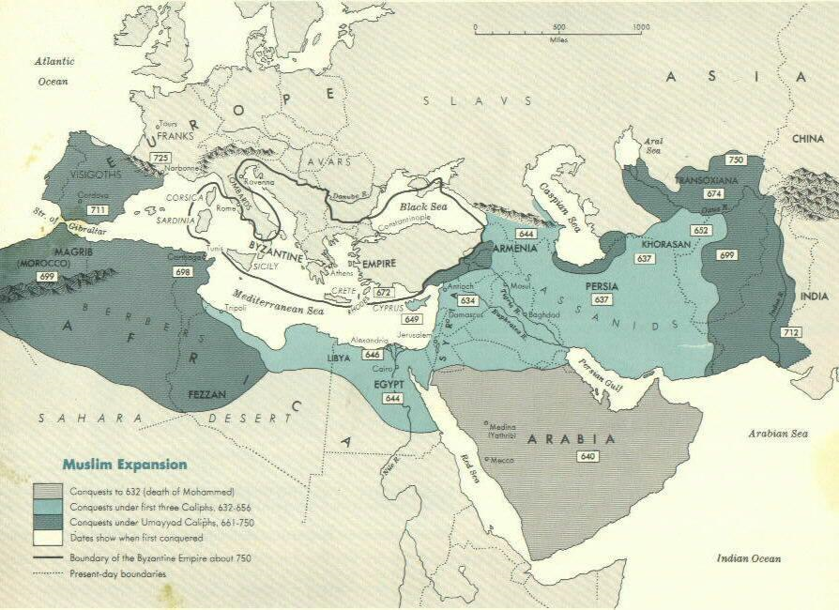
Muslim Expansion: by 8th century
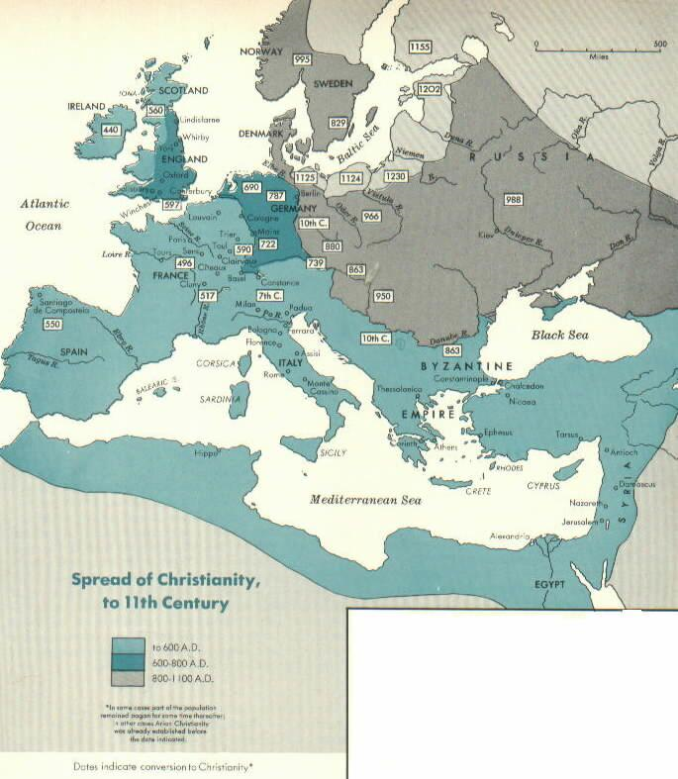
21. What are the lessons from this?
Christian Expansion: by 11th century
1.
2.
3.
Turner's Creed
This is an excerpt from Ravi Zacharias' book.
"Can Man Live Without God?"
Creed
by Steve Turner
We believe in Marx, Freud and Darwin
We believe everything is OK
as long as you don't hurt anyone
to the best of your definition of hurt,
and to the best of your definition of knowledge.
We believe in sex before, during, and after marriage.
We believe in the therapy of sin.
We believe that adultery is fun.
We believe that sodomy’s OK.
We believe that taboos are taboo.
We believe that everything's getting better
despite evidence to the contrary.
The evidence must be investigated
And you can prove anything with evidence.
We believe there's something in horoscopes
UFO's and bent spoons.
Jesus was a good man just like Buddha,
Mohammed, and ourselves.
He was a good moral teacher though we think
His good morals were bad.
We believe that all religions are basically the same-
at least the one that we read was.
They all believe in love and goodness.
They only differ on matters of creation,
sin, heaven, hell, God, and salvation.
We believe that after death comes the Nothing
Because when you ask the dead what happens they say nothing.
If death is not the end, if the dead have lied, then its compulsory heaven for all
excepting perhaps Hitler, Stalin, and Genghis Kahn
We believe in Masters and Johnson
What's selected is average.
What's average is normal.
What's normal is good.
We believe in total disarmament.
We believe there are direct links between warfare and
bloodshed.
Americans should beat their guns into tractors .
And the Russians would be sure to follow.
We believe that man is essentially good.
It's only his behavior that lets him down.
This is the fault of society.
Society is the fault of conditions.
Conditions are the fault of society.
We believe that each man must find the truth that is right for him.
Reality will adapt accordingly.
The universe will readjust.
History will alter.
We believe that there is no absolute truth
excepting the truth that there is no absolute truth.
We believe in the rejection of creeds,
And the flowering of individual thought.
If chance be the Father of all flesh,
disaster is his rainbow in the sky
and when you hear:
State of Emergency!
Sniper Kills Ten!
Troops on Rampage!
Youths go Looting!
Bomb Blasts School!
It is but the sound of man worshipping his maker.

