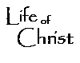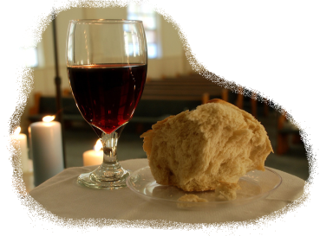 Name:

**~ Gospel of John ~**

**ch 1-11**

**Life of Christ Study Guide**

9th grade Bible

Part I: the Gospel of John: People & Places MATCHING

Jesus John the Baptist Jerusalem

Nicodemus Mary (mother of Jesus) Samaria

John (disciple/author) the Prophet Mt. Gerazim

Woman at the well Moses Cana of Galilee

Nobleman Cripple w/ 38 yr. condition (beside pool) Peter

Pool of Siloam Bread of Life Andrew

Lazarus Judas Nathaniel

Martha

Part II: the Gospel of John; “Who Said It?”

You will have to match the following persons to their quote(s) from the Gospel of John. When the passage involves more than one person, you will focus on the speaker of the **bold-faced** portion. I would suggest perusing the gospel in order to study--but the best preparation was merely paying close attention while we read and discussed the gospel in class.

a. Jesus f. Martha k. Mary (mother of Jesus)

b. Peter g. Nicodemus l. Thomas

c. Narrator (John/Holy Spirit) h. Adulterous woman m. the Jews (hearers)

d. Andrew i. John the Baptist n. Man born blind

e. Samaritan Woman j. Pharisees

Part III: the Gospel of John: Reformed Doctrine of Salvation Summary

There will be a matching section covering the 5 points of reformed doctrine we studied. Study the 5 points of Calvinism as we studied them.