Anatomy & Physiology STUDY GUIDE

mr e ~ SRCS chapter11 test

83 multiple choice

**A&P chapter 11: the Muscular System**

**vocab**

origin

insertion

synergist

fixator

agonist/prime mover

anatagonist

lever

fulcrum

effort

load

fascicle alignment/shape

parallel

triangular

oval/circular

pennate(uni/bi/multi) fusiform

all the muscle names stressed in class

TABLE 11.2

**THINGS you MUST know:**

1. vocab, vocab (well, you know by now)

2. Distinguish between classes of levers.

3. Distinguish between functional names for muscles (agonist/antagonist).

4. Benefits of stretching…

5. Categories by which muscles are named.

6. Main muscle for breathing?

7. The many clinical connections (see slides in ppt or blue boxes in textbook)

8. All the muscles listed in bold in the diagrammatic slides in the ppt (listed on last slide of class notes ppt) by name/location (eg. be able to identify); see diagrams below to help orient the diagrams used.

9. The actions any one of the bold-faced muscles; I will select ones we highlighted or are obvious based on location.

10. Order of the 3 anterolateral abdominal layers from superficial to deep or vice versa.

11. Vocabulary associated with muscles or muscle group actions (eg. a rough familiarity with TABLE 11.2)

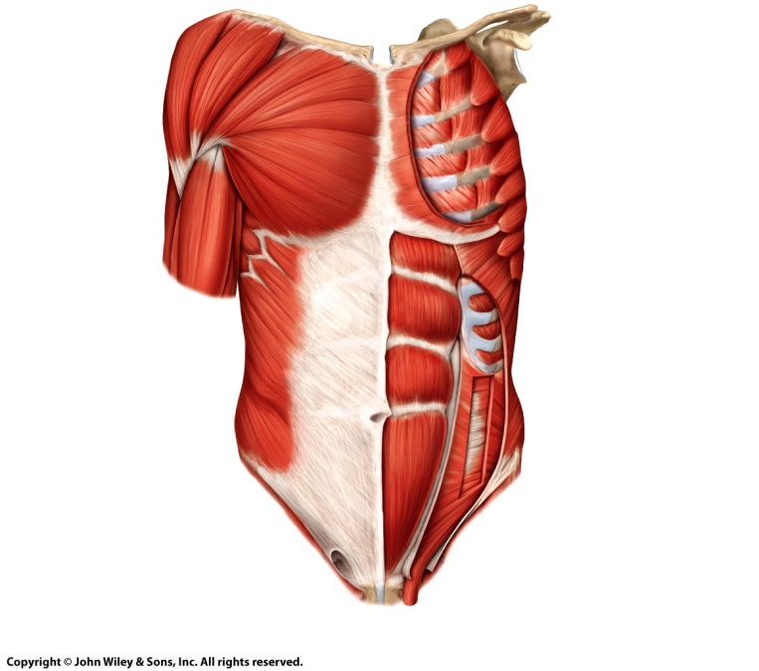FIGURES with WHICH to be FAMILIAR:

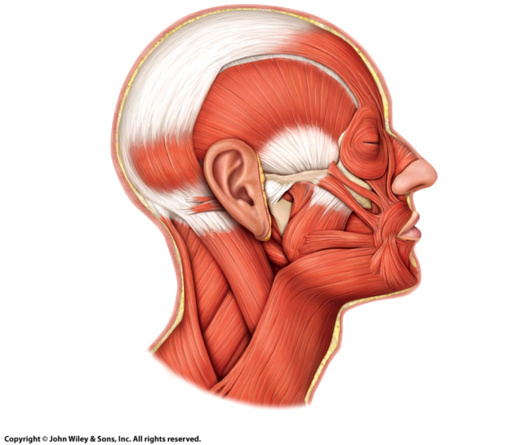

LEFT: lateral view of head & neck; RIGHT: anterior trunk

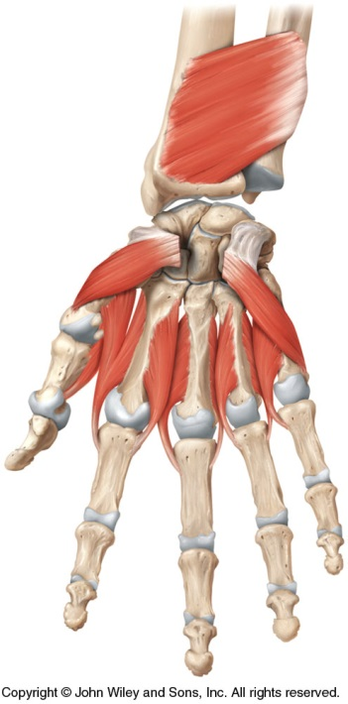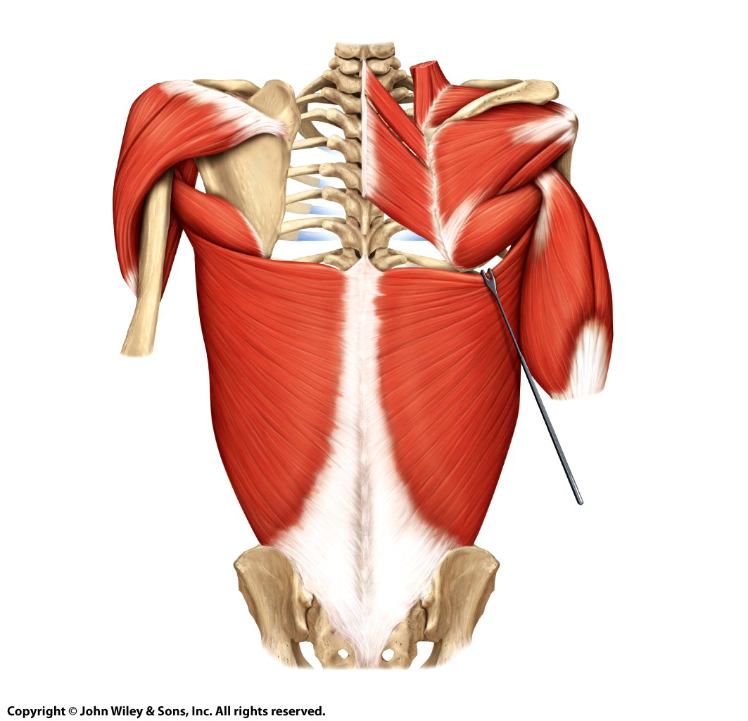

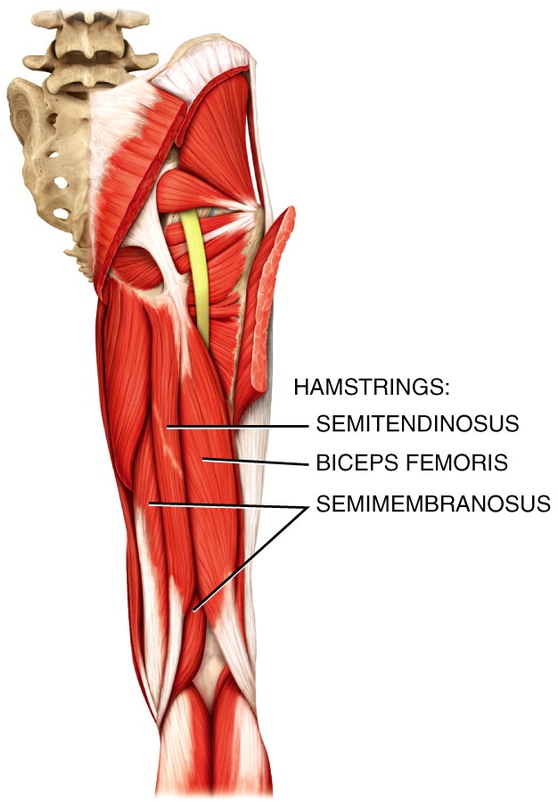

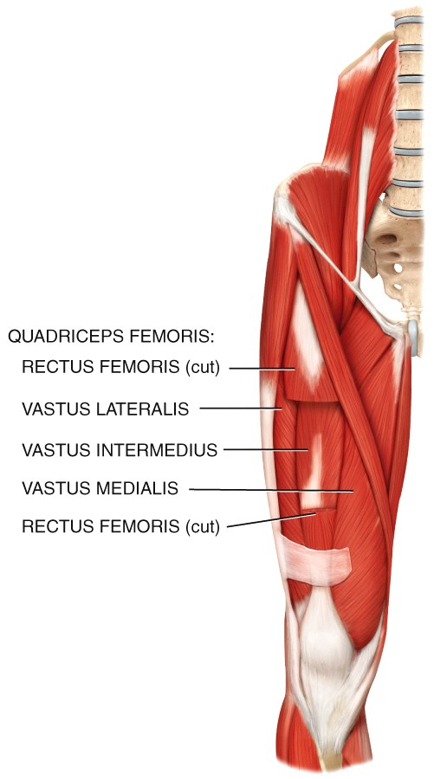

UPPER LEFT: posterior trunk (back)

UPPER RIGHT: deep anterior view of hand

LOWER RIGHT: posterior right leg

LOWER RIGHT: anterior right leg

NEXT PAGE:

LEFT: frontal; superficial view

RIGHT: posterior; superficial view

