Physical Science Project Name:

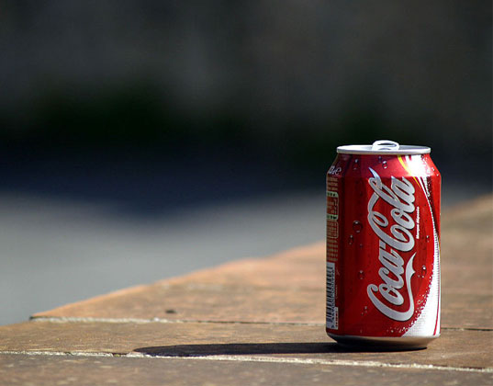ch 10: heat transfer ~ mr.e Date:

**Can your Can keep the heat?**

*Thermodynamic*

**What?** We will be taking part in a thermodynamic competition to see whose can holds heat the best and whose bracket takes all!

**Where?** Room 305 (your sanctuary for thermodynamic study and experimentation)

**Why?** Because it's cool (or should I say 'cooling?'). Actually, we are going to see the simplicity of insulatory methods at work and determine which is best.

**When?** You are responsible for bringing in said can, finished, on May _____ a _________________.

**How?** Rules: 1. You must use a regular 12 fl oz. aluminum soda can

2. You may insulate it in any way you wish except the insulation may **not** a) cover **top** or **bottom** of can b) act as a heat source in any way

3. Brackets must be filled out prior to first 'fill and cool'; bracket placement will be solely determined by God through your intuition (no exp/skill-based seeding, in other words)

**Instructions for brackets:**

1. Obtain 19-team brackets: theoretical & actual (supplied by mr e).

2. Continue working on your **theoretical** bracket until it is completely filled out. Don't forget to choose a champion; tie breaking will be based on looks (not really).

3. As competition ensues, *fill in insulatory material in actual bracket beneath each competitor*.

4. Also fill in actual bracket as competition progresses.

5. Fill in Points per round and Accuracy percentage once finished (in data table below).

6. Answer questions & hand in on: _________________

Bracket Data

|  |  |
| --- | --- |
| Round | Points |
| Round of 16 | of 48 |
| Elite 8 | of 48 |
| Final 4 | of 48 |
| Dynamic duo | of 48 |
| Champion | of 48 |
| Total points | of 240 |
| Percentage | ______ /240 = % |

Questions:

1. Which insulator seemed to work best? Propose a scientific reason as to why it did so.
2. Which insulator surprised you the most?
3. Did the actual insulator or the manner in which the insulator was applied matter more? How could you tell?
4. What would you change about your insulator and the manner in which it was applied in order to improve your results?