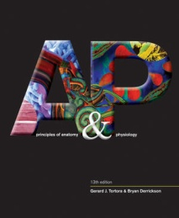Anatomy & Physiology STUDY GUIDE

mr e ~ SRCS chapter10 test

70 multiple choice

**A&P chapter 10: Muscle Tissue**

**vocab**

Excitability/irritability

contractile

elastic

extensible

voluntary/involuntary

striated

peristalsis

isometric contraction

isotonic

concentric

eccentric

muscle belly

epimysium

perimysium

endomysium

fascicle

myofiber

myofibril

actin/myosin

neuromuscular junction (NMJ)

motor unit

synaptic end bulb

synaptic cleft

Acetylcholine (ACh)

Ca2+ ion flexion

Sarcoplasmic reticulum

sarcomere

action potential

proteins

contractile

regulatory

structural

H zone

ATP-producing rxns

Creatine P rxn

Anaerobic cell. resp.

Aerobic cell. resp.

Twitch contraction

Wave summary

Unfused tetanus

Fused tetanus

Refractory period

Muscle tone

flaccid

atrophy

hypertophy

motor unit recruitment

fiber types

slow oxidative (SO)

fast oxidative-glycolitic (FOG)

fast glycolytic (FG)

all-or-none principle

hyperplasia

fibromyalgia

myasthenia gravis

exercise-induced muscle damage

myogram

rigor mortis

creatine

anabolic steroids

cramp

spasm

fibrillation

fasciculation

neurotransmitter

thin/thich filaments

muscle types

skeletal

smooth

cardiac

**THINGS you MUST know:**

1. vocab, vocab (well, you know by now)

2. By mass, we are typically _____% muscle..

3. Distinguish between 3 types of muscle tissues.

4. Functions of muscle tissue.

5. Characteristics of muscle tissue.

6. Distinguish between 2 types of muscle contraction; distinguish between 2 types of isotonic..

7. The many clinical connections (see slides in ppt or blue boxes in textbook)

8. Structural breakdown from belly to myofibril to actin/myosin.

9. The science of generating an action potential to generating a muscle contraction in the sarcomere (to the level of multiple choice…)

10. Why is it that muscle cancer is rarely spoken of, that is, what is it about muscle cells that keep cancer from becoming a likely possibility?

11. Which ion gets stored in the SR in order to ensure the contraction takes place (sliding filament mechanism) .

12. Distinguish between thin & thick filaments of the sarcomere.

13. Brief familiarity with neurotransmission over the synaptic cleft.

14. vocabulary.

15. Which three reactions are responsible for the production of ATP during muscle contraction?

16. Associate how time energy (in units of time (sec. or min.) each of the reactions in #15 above offer the muscle fiber.

17. Distinguish between the three fiber types (SO, FOG, FG).

18. Which muscle tissue type is self-stimulating (autorhythmic)?

19. Be able to select which region of the myogram below by description.

20. The events of rigor mortis (on a molecular level) in order.

21. Side effects of creatine supplementation.

22. Interpret the contractile figure below (boy with book).

23. Side effects of steroids on males and females.

24. Differentiate between the abnormal contractions (clinical connection: spasm, cramp, tic, fasciculation, fibrillation)

25. the locations of where the fiber types are concentrated (SO, FOG, FG)

26. Be able to order the steps of muscle contraction (Reactivation 🡪 Attachment 🡪 Powerstroke 🡪 Detachment)

FIGURES with WHICH to be FAMILIAR:

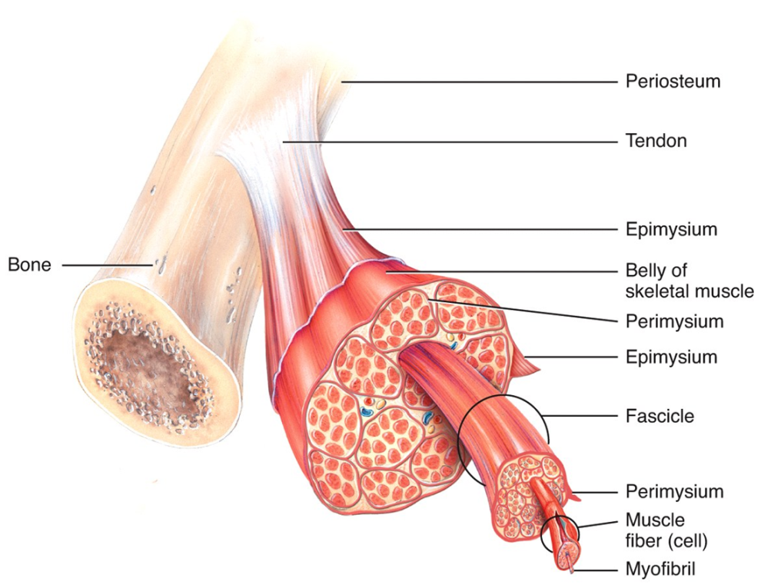

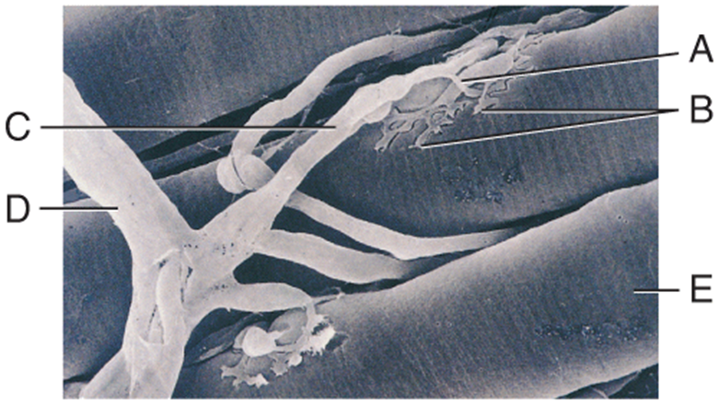

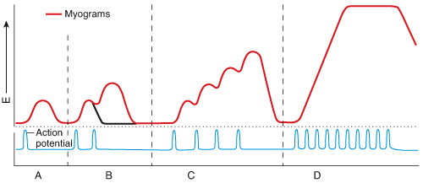

LEFT: structure of muscle tissue (Macro to micro).

UPPER RIGHT: Micrograph of a neuromuscular junction.

RIGHT: myogram of varying contractions.

LOWER RIGHT: contractile differentiation.

