Rat Attack Name:

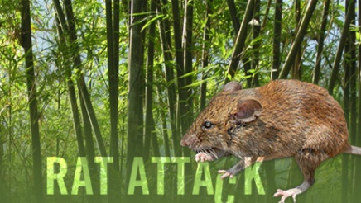Biology ~ mr e ~ SRCS

**Program Description**

Once every 48 years, bamboo forests in parts of northeast India go into exuberant flower. Then, like clockwork, the flowering is invariably followed by a plague of black rats that appear to spring from nowhere to spread destruction and famine in their wake. For the first time on film, NOVA and National Geographic capture this rat population explosion in vivid detail

Go to my website (considerthis2.net) and find the link on the biology page for NOVA's "Rat Attack" and view the documentary while answering the following questions with complete sentences (it is available on youtube, Netflix, and NOVA season 5 on amazon prime instant video as well):

1. 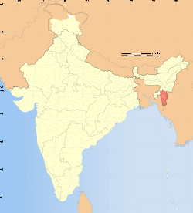What seemed to be the problem? Where was this taking place?
2. Mizoram, the state in India where our story takes place (circled to the right) is predominantly which religion?
3. Describe the government program developed to address the plague. Was it successful?
4. Why are rats said to have "opportunistic" strength--that is, what about them makes them so biologically successful?
5. Jot two strengths of the black rat over other species of rats:

b.

1. The scientists uncovered journals documenting the agricultural history of the area. What pattern was noted in one journal particularly that led them to narrow the true culprit?

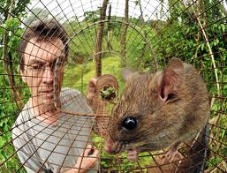

1. Why don't modern scientists take the bamboo-flowering theory seriously? Why is important that Ken Aplin (our friendly Australian Wildlife Collector) do his research NOW?



1. Supposing Mr. Aplin is correct--1 burrow per square yard. How many burrows did he say per acre? How many rats per acre?
2. What is the timeline between the bamboo flowering and the rat attack?
3. What will the rat parents do when food is scarce--besides reproduce infrequently?
4. One mother is capable of producing up to __________ rats in several months of fruiting.
5. Take 50 reproductive females. They could produce over __________rats during that time.
6. 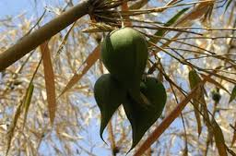Describe briefly this "manna from heaven" that comes only during this 48 year bamboo-flowering cycle:
7. This "Mautam" or "bamboo death" as translated into English could drop as many as _____ tons of fruit for the rats to consume.
8. Why not simply harvest the fruits or destroy the bamboo fields and prevent the onslaught?
9. List a few of the reasons bamboo is so important to the Mizo people:

b.

c.

1. Why is it that Bamboo is so hearty (even able to survive the atomic bombs dropped in Japan)?
2. While it makes sense that the elaborately connected rhizomes would give rise to plants that fruit and die at exactly the same time--what happens to the timing of the fruiting/dying when you take a cutting and plant it in another continent even?
3. Any student of the Bible is familiar with the ways in which famine can alter the plans of a people group. What national effect did the last mautam (bamboo fruiting/death) have on the nation of Mizoram?

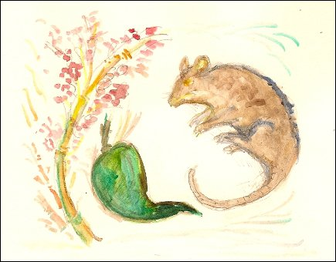

1. Was the population growth of rats gradual as Kaplin predicted? How did the rise actually come about?
2. Understanding that an unpreserved dissection is a bit grisly, why don't you occupy yourself with this query: Most rat females space their reproductive cycles-say 1 week beteween weaning & breeding again. What did the mautam female rats do?
3. It is near the eve of the fourth surge of mautam and Mr. Kaplin has a dilemma on his hands. What is his dilemma?
4. How does Moya (sp?) and wife & neighbors harvest the rice (explain how they get it from a plant in the field to loose grain in the basket)?

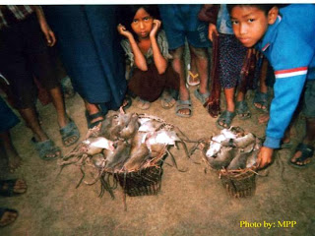

1. It seems that Moya miraculously escaped a famine by a day or two. What was proof at the nearby farm that a fourth pulse of rats had, in fact, emerged?

b.

1. What does the ratio of adults to juveniles look like (generally) at the neighbor’s farm? What does this mean for the survival of the population? Why?
2. What did Mr. Kaplin discover to be the reason Moya’s crops were not devastated while, in Zamwan, the fourth pulse destroyed the crops just before the rice heads were ripe?
3. While bamboo is a necessary crop—as are their rice crops, what can Mizoram farmers do to ‘parry’ the inevitable mautam and fourth pulse?

