Name:
Date:

Title: "How Good is Your Sense of Humerus?" Lab

Problem: To validate the following equation relating humerus length to body height

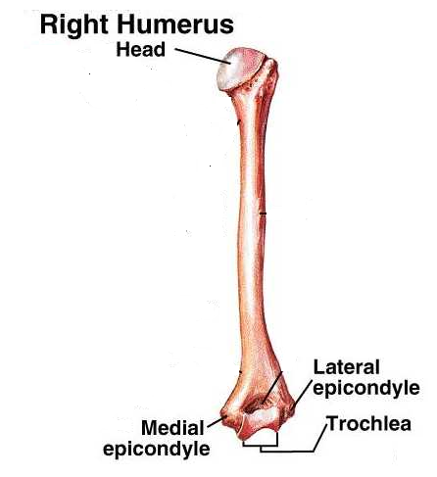
h = 2.75x + 71.48 h: body height in cm.; x: length of humerus in cm.

Procedure:
- Title the lab with a fitting and creative title.
- Place you & your partner’s name in the data table
- Measure (in cm. to the tenths) from the highest point of the head (proximal, lateral) of the humerus to the lowest lateral point parallel to the lateral & medial epicondyles (distal).
- Record data in data table.
- Calculate theoretical height; show all work below
- Measure actual height (in cm. to the tenths)
- Calculate % error; show all work below
- If % error is higher than 5%, reform formula by changing coefficient only (2.75…keep 71.48 constant) to fall within 5% of your own actual height so that you have 0% error (hint: use algebra to solve!); show all work below; box in answer.
- Extra credit: reform formula for maximum accuracy for both you and your lab partner; show all work below

Work:

% error = h_{actual} - h_{theoretical}
h_{actual}

Data Table: Humerus & Height Data

 | Length of humerus  name | Body height |  | % error
 | Length of humerus  name | h_{theoretical} | h_{actual} | % error
Student 1
Student 2

Original formula
h = 2.75x + 71.48 h: body height in cm.; x: length of humerus in cm.

Reworked formula table (if previously above 5%)
student | original % error | Reworked formula | New % error | New h_{theoretical}

Discussion & Analysis: (complete sentences only)

- Many in class will have a % error greater than 5%. Why might this be? Share a few factors that could contribute to this.

- Extra credit: Rework the problem to be most accurate for both you and your lab partner; (box the new formula). Show work here…

