This page will explain how to correctly complete and submit Mr. Eckart's Quizlet homework.

1. Go to the webpage at <http://considerthis2.net/>

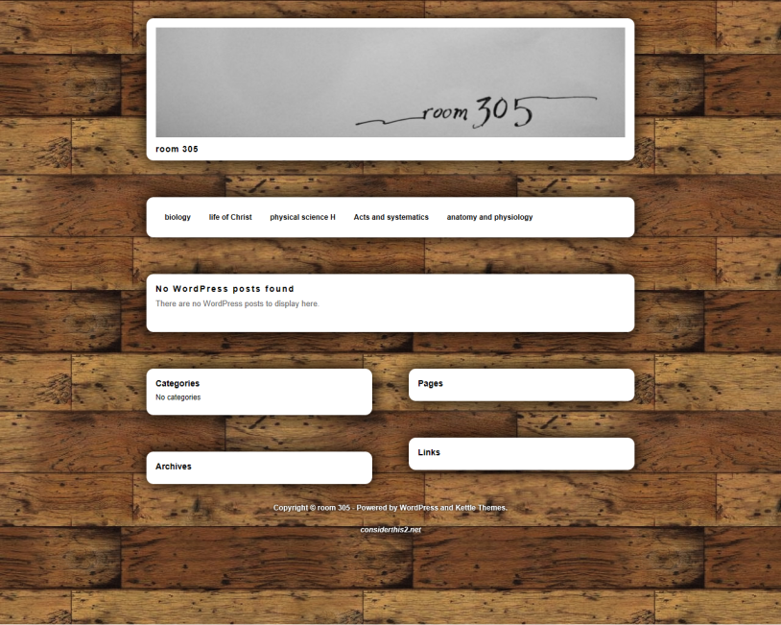

1. Click the biology page link, then click the correct chapter.

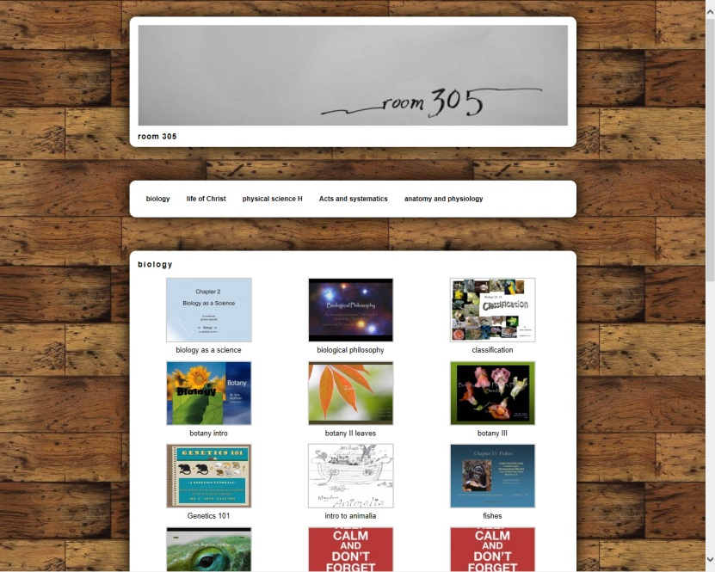

1. Click on the corresponding Quizlet link.

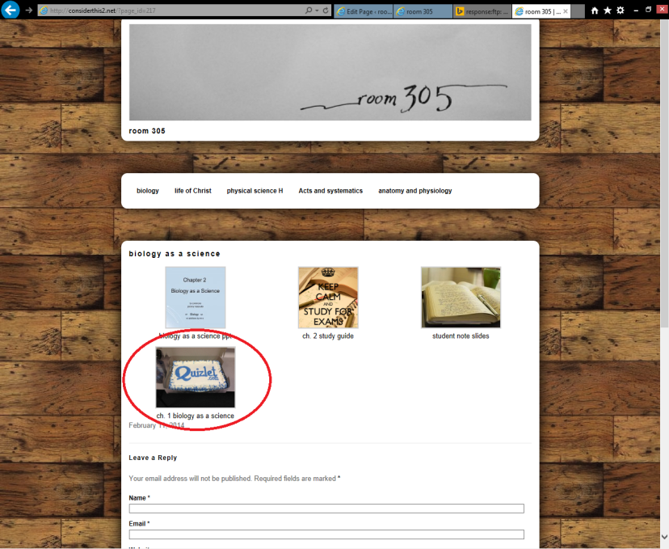

1. Take the quiz.

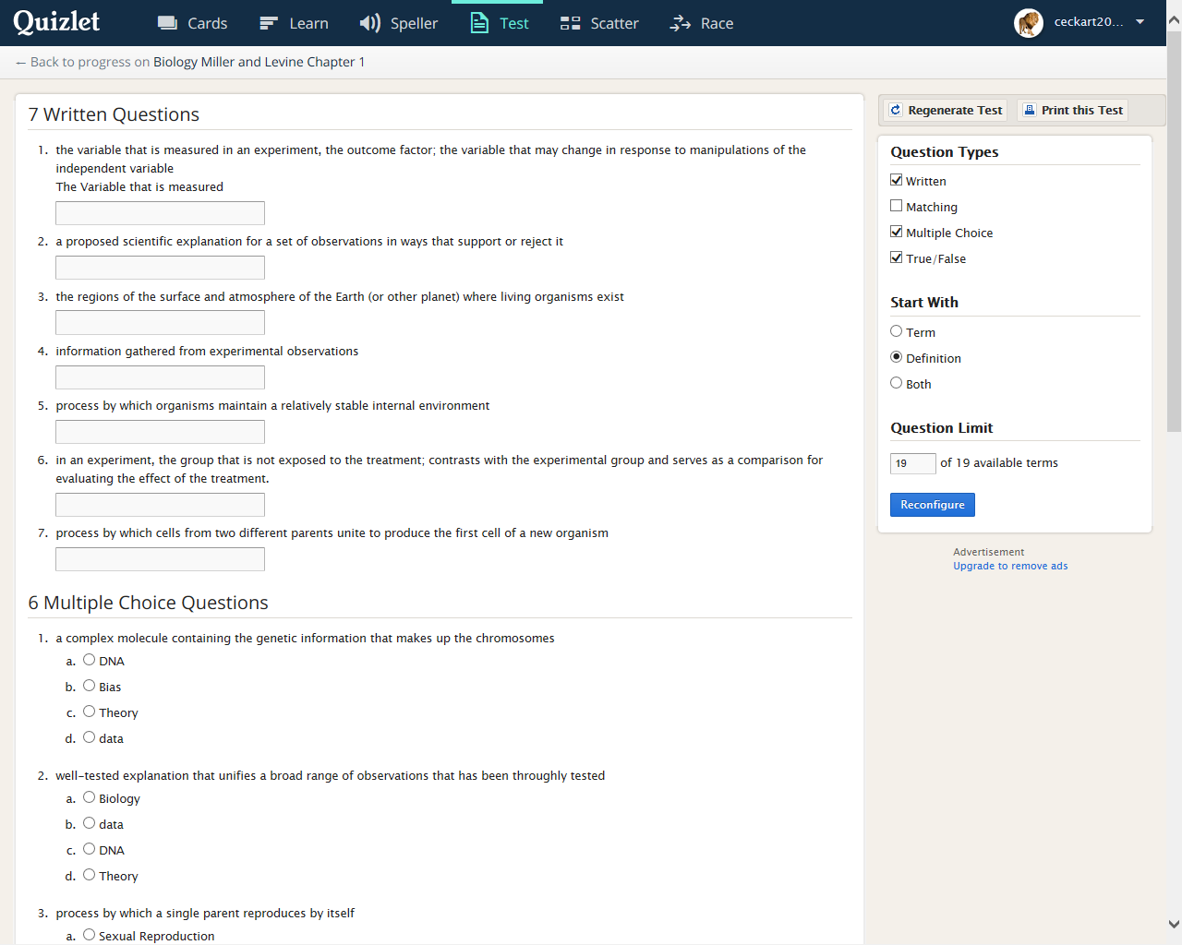

1. Type your initials into one of the circled areas on the following picture

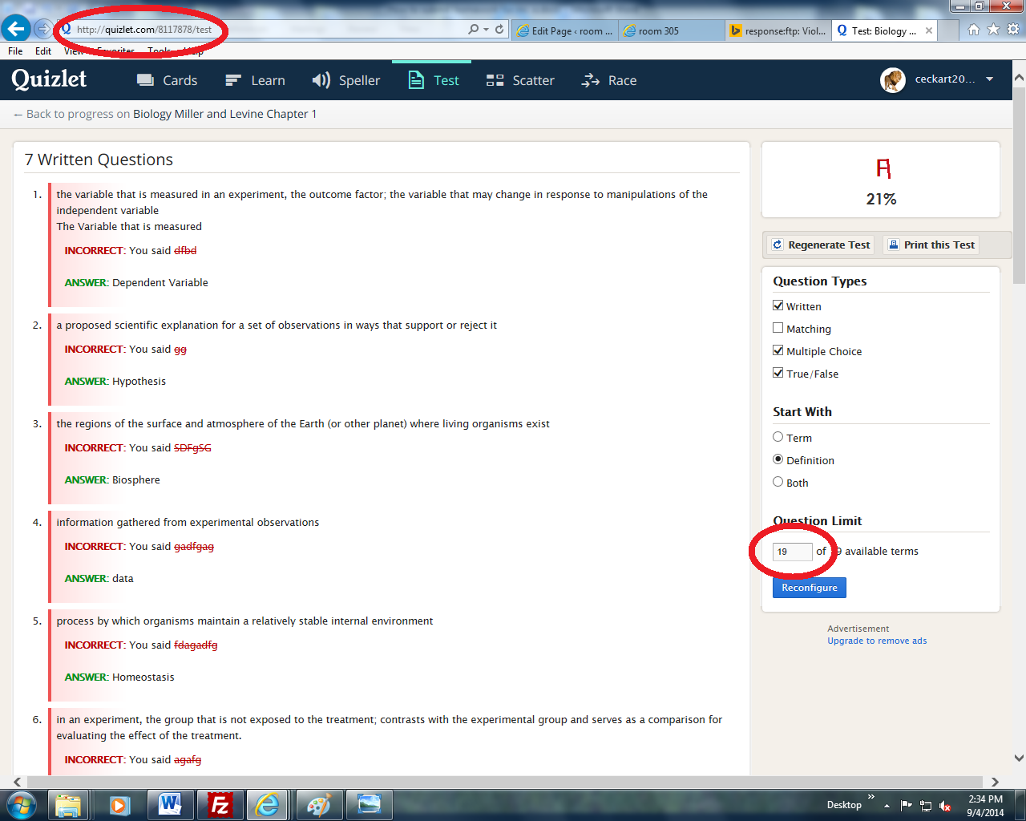

1

1. Screenshot the final product by pressing shift + prt scr.

PC:

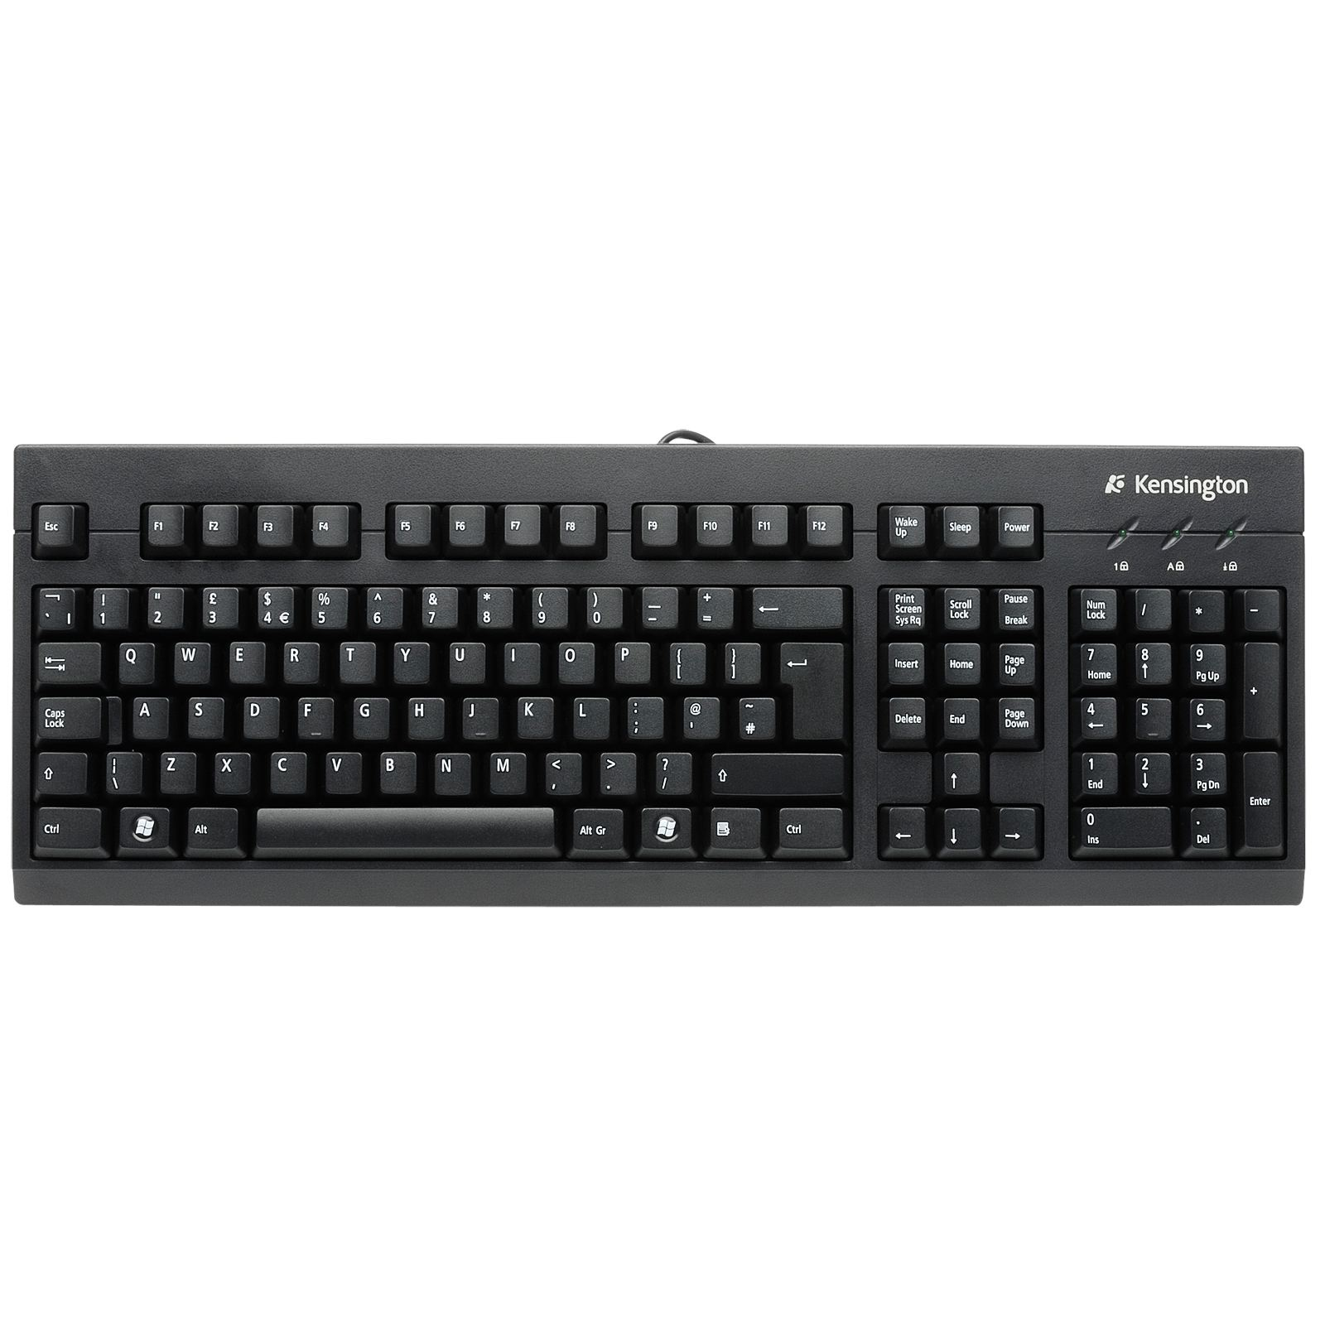

Note: some keyboards are different :P

iPad: Press



yufkytfghkf

Hold

1. Email the picture to Mr. Eckart.
2. Good job you are done.