**A&P Name:**

**Ch 9: joints lab**

**Take the Wet Test: Learning Your Foot Type**

**A simple wet test can tell you if you have flat or high arches, and how to choose your running shoes accordingly.**

You can go a long way toward discovering what you need in a running shoe by looking at your feet. There are three basic foot types, each based on the height of your arches. The quickest and easiest way to determine your foot type is by taking the "wet test," below.

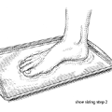  
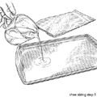  
  
1) Pour a thin layer of water into a shallow pan 2) Wet the sole of your foot.

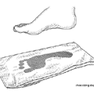  
  
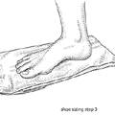  
  
3) Step onto a shopping bag or a blank piece of heavy paper. 4) Step off and look down

5) Before the imprint dries, outline it with a Sharpie. Write your name, date and foot type on the brown bag/imprint. Use the data below to assess. Answer questions below with complete sentences.

Observe the shape of your foot and match it with one of the foot types at the bottom of the page. Although other variables (such as your weight, biomechanics, weekly mileage, and fit preferences) come into play, knowing your foot type is the first step toward finding the right shoe for you.

|  |
| --- |
| **Normal (medium) Arch**  Wet TestIf you see about half of your arch, you have the most common foot type and are considered a **normal pronator**. Contrary to popular belief, pronation is a good thing. When the arch collapses inward, this "pronation" absorbs shock. As a normal pronator, you can wear just about any shoe, but may be best suited to a stability shoe that provides moderate arch support (or medial stability). Lightweight runners with normal arches may prefer neutral-cushioned shoes without any added support, or even a performance-training shoe that offers some support but less heft, for a faster feel. |
| **Flat (low) Arch** Wet TestIf you see almost your entire footprint, you have a flat foot, which means you're probably an **overpronator**. That is, a micro-second after footstrike, your arch collapses inward too much, resulting in excessive foot motion and increasing your risk of injuries. You need either stability shoes, which employ devices such as dual-density midsoles and supportive "posts" to reduce pronation and are best for mild to moderate overpronators, or motion-control shoes, which have firmer support devices and are best for severe overpronators, as well as tall, heavy (over 165 pounds), or bow-legged runners. |
| **High Arch** Wet TestIf you see just your heel, the ball of your foot, and a thin line on the outside of your foot, you have a high arch, the least common foot type. This means you're likely an underpronator, or **supinator**, which can result in too much shock traveling up your legs, since your arch doesn't collapse enough to absorb it. Underpronators are best suited to neutral-cushioned shoes because they need a softer midsole to encourage pronation. It's vital that an underpronator's shoes have no added stability devices to reduce or control pronation, the way a stability or motion-control shoe would. |

Questions

1. Which foot arch type are you?
2. As for pronation--which type are you?
3. Which type of athletic/running shoe is recommended for you based on the information you have now? Why?

A Step Further…

Excerpted from <http://runninglifestyle.blogspot.com/2011_06_01_archive.html>

A runner's blog

…rule number 1: **Get the right shoes!**

Perhaps the part I enjoy most in my job is getting to fit people of all shapes, sizes, and skill levels for shoes. I have seen THOUSANDS of feet and gaits and bunions and fallen arches and let me tell you, *your feet are not as messed up as you think*. But I will tell you this, no matter the case, you have to get fit for the right pair of shoes, it makes the world of difference!

Before I dive right in and explain about the different kind of shoes, I want to go ahead and explain a few terms:  
**Gait-** the motion your foot goes through when it is in contact with the ground  
**Pronate-** (aka over-pronate) the inward rolling of your ankles/feet toward each other  
**Supinate-** (aka under-pronate) the outward rolling of your ankles/feet away from each other  
**Neutral-** the ability of your ankles/feet to stay straight without pronating throughout your gait cycle

[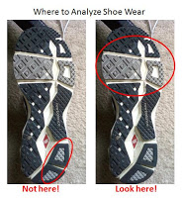](http://3.bp.blogspot.com/-npZhhoqalO0/Tf-1jsAj5HI/AAAAAAAAAAg/Z_79jC1cmnM/s1600/Shoe+Wear.jpg)  
Alright, now that we know some key terms, let me tell you what you need to know to get the right pair of shoes. If you don't have access to a running specialty store like Run On!, here are some tips you can use to diagnose your gait.

Grab your current running shoe, we are going to analyze the wear pattern on the bottom. The picture on the right shows where we are going to be looking on our shoes to determine if we pronate, supinate, or have neutral gait. The reason I point out to not look at your outside heel is because EVERYBODY has wear right there. In general, most people are heel strikers and when you strike on your heel, you land on the outside, not centered like most would believe. Time and time again I have had people tell me they supinate because they saw wear on the outside heel. When I break it to them that everybody wears right there and the real spot to look is on the forefoot, they tend to not believe me at first, but then I show them what I mean.

[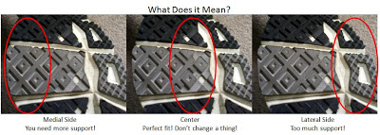](http://4.bp.blogspot.com/-YqAqiL0G_Kc/Tf-lfHh-czI/AAAAAAAAAAQ/g8S-NhMAdM8/s1600/Wear+Analysis.jpg)

When looking at the forefoot of a used running shoe, you want to pay attention to where the outsole looks particularly lower than the rest. If most of the wear is on the medial (inside) side of the shoe, then you need to get a shoe with more support. If most of your wear is in the center, congratulations! You are already in a great shoe! You don't need to change anything! Lastly, if you see most of the outsole worn on the lateral (outside) side of the shoe, you have too much support and you need to change shoes ASAP. Too much support in a shoe pushes you to the outside of your foot which causes increased strain on the lateral side of your leg and knee. As a note, *it is worse to have too much support than to have too little, so when in doubt, go with less support.*  
Now you might be asking yourself, "this information is useful and all, but how do I know what shoes have more support and which ones have less?" That is a very good question, and I'm glad you asked. Below is a table to help you know what to do next with your new found information.

[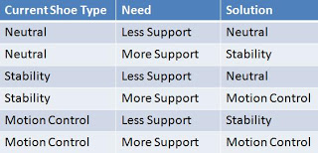](http://4.bp.blogspot.com/-MKt78suNcKo/Tf-pNhL85jI/AAAAAAAAAAU/FJiQ2dehCF4/s1600/Shoe+Transfer+List.jpg)

TABLE 9.1

After looking at this chart, a few questions might pop into your head. **"So if I need less support and I'm already in a neutral shoe am I just out of luck?"** Yes, honestly. You have almost too efficient of a gait. Now that's not a bad thing, but for the most part, if you supinate a neutral shoe will do just fine. **"If I need more support and I'm in a motion control already do I just stay with what I have?"** There are a couple  of motion control shoes that have more support than others, so if you find you are in this scenario, try the *Brooks Beast*, it has that name for a reason. **"If I'm in a neutral shoe and I need more support, how do I know if I need to go all the way to motion control or vice versa?"** If you have been in the exact opposite category that you need, you don't want to take that jump all at once, that kind of new correction will make you sore in places you didn't know could even be sore. So you need a middle ground to let you get adjusted to the new kind of support before you make the switch.   
**"How do I know what shoe to get if I need a stability (or neutral, or motion control)?"**  
[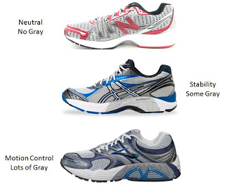](http://2.bp.blogspot.com/-Zmed3pSaQoc/Tf-tHoHaaxI/AAAAAAAAAAY/_qqUJvtF2AE/s1600/Stability+Visual.jpg)A good way to tell if a shoe is stability or not is if it has a gray posting on the medial side of the shoe. In almost all running brands, this posting is a dual-density foam to keep you from pronating. It is denser than the rest of the shoe, making it impossible for your foot to roll across it. Generally the amount of gray determines how much correction the shoe offers. So if a shoe has no gray at all on the medial side, then it is neutral. If it has some, but not an overwhelming amount, that is a stability shoe. If the medial side of a shoe looks really built up or runs almost the length of the shoe, that is a motion control shoe.  
So what is the next step after we know what kind of shoe we need and what the shoe looks like? Now we just have to go to the store and try some on! Once you know what kind of shoe you need, you're golden. At this point everything in that category is pretty much the same shoe structurally, so the fun part is going to the store and deciding which one is most comfortable. I have consolidated the performance running shoes from several brands so you can have a place to start and know what to look for.

[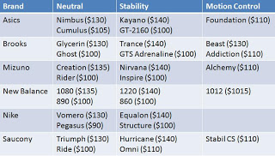](http://1.bp.blogspot.com/-BCd_QSp3sSE/Tf-wveujfGI/AAAAAAAAAAc/1dCJVPVKM7g/s1600/Shoe+Grid.jpg)

TABLE 9.2 (Note these are 2011 styles. Brands still apply though…)

One thing people often forget is to size their feet. This is especially important with running shoes. When you run, your feet swell, so you need to have a little bit of room for your feet to grow. With that being said, you want to go up about a full size from what you measure in the store. So if you measure a size 9, go with a size 10. If you already ran that day, only go up about a half size because chances are your feet are still swollen from your workout. That is why it is good to go get shoes at the beginning of the day, so your feet aren't already swollen from the day's activities.

Questions 2.0

1. Fill in the Data Table below based on TABLE 9.1: assessing your situation and need. (*if you do not own or even come close to ever having a sneaker remotely assessable by these parameters, find someone who does, complete this exercise for them; write their name below)

[](http://4.bp.blogspot.com/-MKt78suNcKo/Tf-pNhL85jI/AAAAAAAAAAU/FJiQ2dehCF4/s1600/Shoe+Transfer+List.jpg)

|  |  |  |
| --- | --- | --- |
|  |  |  |

1. Go online and find a reasonably priced pair of shoes best suited for your properly assessed foot type. You may use table 9.2 or other research online. Print the page of the shoes you would consider ordering and attach it)