Anatomy & Physiology MIDTERM STUDY GUIDE

mr e ~ SRCS chapter 1-6

100 multiple choice

**A&P chapters 1-6: Midterm Study Guide**

**vocab**

anatomy

physiology

homeostasis

feedback system

receptor

effector

control center

anatomical position

(directional terms)

(body cavities)

(body planes)

(types of medical imaging)

growth

differentiation

positive feedback system

negative feedback system

Plasma membrane

phospholipid

selective permeability

concentration gradient

diffusion

facilitated diffusion

osmosis

active transport

passive transport

hypo/iso/hyper tonicity

exocytosis

endocytosis

pinocytosis

phagocytosis

chromosomes

mRNA/tRNA

DNA

protein synthesis

mitosis (I.P.MATC)

cytokinesis

Cell structures/organelles

Integral proteins

mutation

Atrophy/dystrophy/hypertrophy

codon/anticodon

epithelial tissue (defined /types)

connective tissue (defined/types)

liposuction

tissue engineering

components of blood

(cells /matrix)

Membranes (types)

Apical surface

Basal surface

Basement membrane

Muscle tissue types

Action potential

Neurotransmitter

Epidermis/dermis/hypodermis

Melanin

Keratin

Collagen

Keratinocyte

Langerhans cell

Merkel cell

Epidermal layers (order)

Sweat

Sebum

Lanugo

Sebaceous gland

Sudoriferous gland

Eccrine sweat gland

Apocrine sweat gland

Stratum germinivium

Dermal papillae

Reticular layer

Epidermal ridges

Arrector pili muscle

Eponychium

Hyponychium

Cuticle

Rule of nines

Critical burn

Non-critical burn

Freckles

Pallor

Jaundice

alopecia

Vitiglio

Albinism

Acne

goosebumps

fractures: open

comminuted

impacted

greenstick

stress

Colles'

Epiphysis

Diaphysis

metaphysis

red marrow

yellow marrow

periosteum

osteon

osteocyte

Volkmann's canal

trabeculae

compact bone

spongy bone

endochondral ossification

intramembranous ossification

hematopoiesis/hemopoiesis

osteomalacia

osteopenia

osteoporosis

acromegaly

erythema

**Things you MUST know:**

1. Vocab, vocab, vocab!
2. Key components to a homeostatic feedback system.
3. Recognize proper anatomical position.
4. Be familiar with anatomical terms (directional/body planes and cavities) to be able to discern them one from another when verbally described and pictured.
5. Recognize medical imaging by its description.
6. How is 'generic' growth accomplished (various ways)?
7. Structure of a phospholipid bilayer.
8. Transport processes across a membrane by description. (all active, passive, endo- or exo- cytotic)
9. Recognize cell parts/organelles by their description and/or function. (see Fig. 1 below)
10. Be able to determine the mitotic phase as described.
11. Know the key parts of the process of protein synthesis. (codon, anticodon, amino acid, t RNA/ mRNA).
12. Determine what will happen to a cell depending on its tonicity and that of its environment.
13. How many amino acids make up a protein molecule if a particular # of nucleotides are given? (be able to calculate, given the # of nucleotides)
14. Functions of the 4 main tissue types.
15. Recognize epithelial tissue types by location and pic.
16. Functions of connective tissue types.
17. Where is adipose tissue found as it relates to the skin?
18. Composition of blood (cell types)
19. Distinguish between the different gland types (endocrine vs exocrine)
20. Distinguish between the different types of membranes.
21. Know the main functions of the 3 types of muscular tissues.
22. Which cells in the body are considered to be excitable?
23. Distinguish between the different cell types within skin (Merkel cells, keratinocytes, basal cells, Langerhan's cells, melanocytes)
24. Distinguish between the layers of the epidermis and order them.
25. The particular secretions of the glands of the skin.
26. Distinguish between the glands of the skin.
27. Functions of the integumentary system.
28. Which layer of the skin endures the tanning process and remains to make leather garments and sports equipment?
29. Know the labeled integument cut away (see Fig. 3 below) and epidermal cross-section (see Fig. 4 below)
30. Know anatomy of the nail (see Fig. 5 below)
31. Be able to apply the Rule of Nines to assess TBSA burned and nature (critical or noncritical)
32. How much of an individual hair is living?
33. How much of our skin is living?
34. Vocab!
35. What are "goosebumps" and how are they formed?
36. Parts of a long bone. (see Fig. 6 below)
37. Parts of bone tissue close up (see fig. 7 below)
38. Know each of the bone cells and be able to differentiate between them by description, and function.
39. Which two minerals are essential to bone growth?
40. Be familiar with the different types of fractures so as to distinguish by both verbal and drawing/x-ray.
41. Study the diagrams below as any structure is fair game.
42. Clinical connections: be able to distinguish between each condition-by verbal description or photo (if discernable).
43. Major functions of the skeletal system.

**Diagrams With Which To Be Familiar**

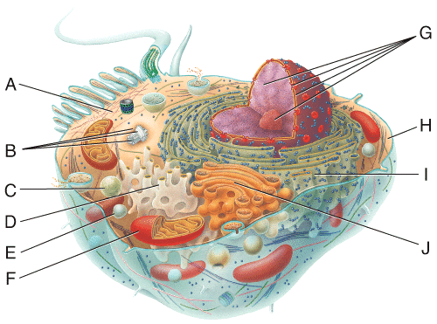

**Fig. 1 Cell**

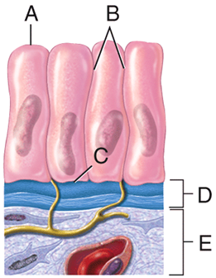

**Fig. 2 Epidermal close-up (LEFT)**

**Fig. 3 Integument cut-away Fig. 4 Epidermal cross-section**

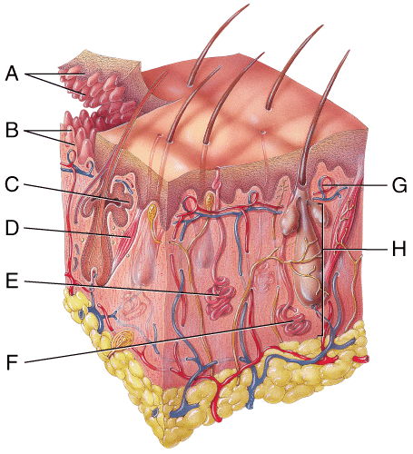

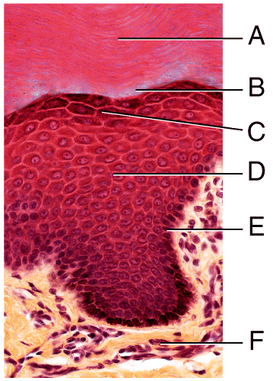

**Fig. 5 nail anatomy**

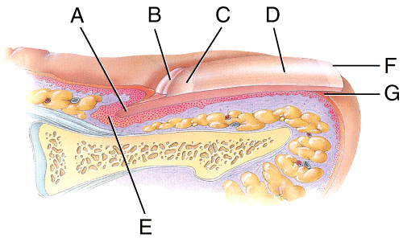

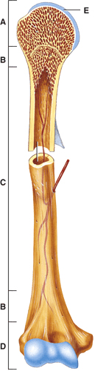

**Fig. 6 Long bone anatomy**

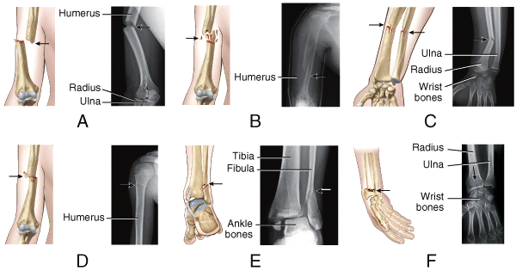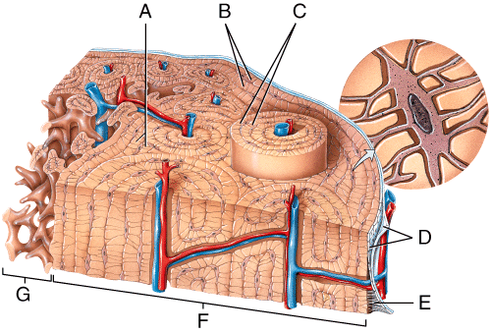**Fig. 7 Bone tissue close up**

**Fig. 8 Fracture types**