Anatomy & Physiology Name:

ch 5: Integument Date:

mr e ~ SRCS 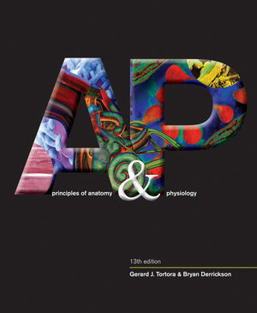

**Assessing the Burn Victim: Critical or not?**

*Using the Rule of Nines to make a first aid assessment*

**Discussion:** The rule of nines assesses the percentage of burn and is used to help guide treatment decisions including fluid resuscitation and becomes part of the guidelines to determine transfer to a burn unit.

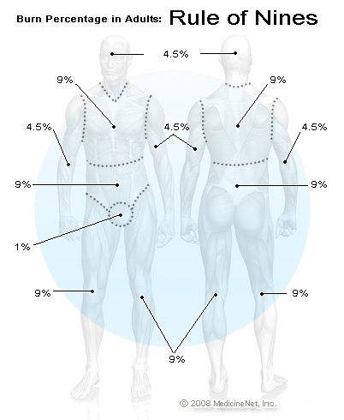You can estimate the total body surface area (TBSA) on an adult that has been burned by using multiples of 9. Each area of the body is broken up into 9% or divisions or multiples thereof.

An adult who has been burned, the percent of the body involved can be calculated as follows:

As an example, if both legs (18% x 2 = 36%), the groin (1%) and the front chest and abdomen (18%) were burned, this would involve 55% of the body.

**Assessing the nature of a burn**

There are three things, initially to assess:

1. Severity of the burn ( 1st, 2nd, or 3rd degree)
2. Extent of the burn (BSA of each degree)
3. Patient diagnosis: critical or not critical.

**Severity**

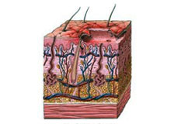Burns are classified as first-, second-, or third-degree, depending on how deep and severe they penetrate the skin's surface.

* 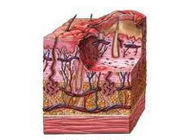**First-degree (superficial) burns**   
  First-degree burns affect only the epidermis, or outer layer of skin. The burn site is red, painful, dry, and with no blisters. Mild sunburn is an example. Long-term tissue damage is rare and usually consists of an increase or decrease in the skin color.
* 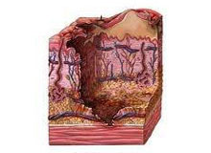**Second-degree (partial thickness) burns**   
  Second-degree burns involve the epidermis and part of the dermis layer of skin. The burn site appears red, blistered, and may be swollen and painful.
* **Third-degree (full thickness) burns**   
  Third-degree burns destroy the epidermis and dermis and may go into the subcutaneous tissue. The burn site may appear white or charred

**Patient diagnosis**

Once these are added, a TBSA can be achieved and a final diagnosis of critical (major burn) and not critical is determined.

Critical burns are the most serious and should be treated in a specialized burn unit of a hospital. These are defined as **second-degree burns covering more than 25% of an adult's body** or more than 20% of a child's body, or a **third-degree burn on more than 10%** BSA. In addition, **any third-degree burns involving the hands, feet, face, or genitals** (perineum) are considered critical. We will only be dealing with adult burn scenarios.

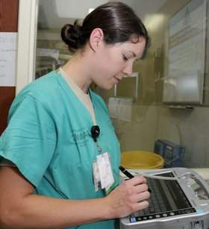**Instructions:** Read each scenario and fill out the table for each body area, calculate the total body surface area % (TBSA), and determine the critical nature of the victim and justify your choice.

**SCENARIO 1:** A nurse is estimating the extent of a burn using the rule of nines for a patient who has been admitted with partial-thickness burns of the posterior trunk and full right arm. What percentage of the patient's total body surface area (TBSA) has been injured? Specify percentages, degree(s), and assess final diagnosis. **__________________**

**A**nterior or

Specifics: body area **Posterior** or **B**oth % degree

TBSA: ________ % Diagnosis: (Circle) critical non-critical

Rationale:

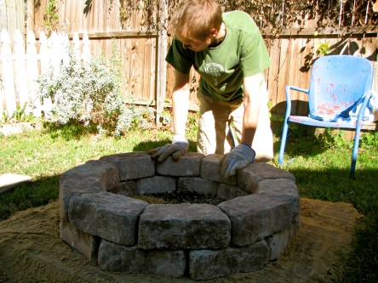

**SCENARIO 2:** A father's burn pit got out of control he suffered blistering burns on both arms (fully) and charring of his hands. What percentage of the patient's total body surface area (TBSA) has been injured? Specify percentages, degree(s), and assess final diagnosis. **__________________**

**A**nterior or

Specifics: body area **Posterior** or **B**oth % degree

TBSA: ________ % Diagnosis: (Circle) critical non-critical

Rationale:

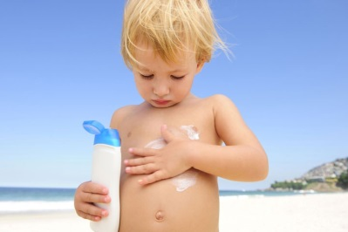

**SCENARIO 3:** A lady decided she needed a tan and so napped outside for 4 hours in a 2-piece bathing suit without sunscreen. She now has superficial redness over her entire posterior except for her head (covered by hair) and perineum (covered by bathing suit). What percentage of the patient's total body surface area (TBSA) has been injured? Specify percentages, degree(s), and assess final diagnosis. **__________________**

**A**nterior or

Specifics: body area **Posterior** or **B**oth % degree

TBSA: ________ % Diagnosis: (Circle) critical non-critical

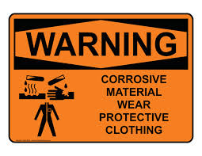Rationale:

**SCENARIO 4:** A man has chemical burns that are partial-thickness burns on his face, the anterior of his left arm, anterior right leg, and abdomen. What percentage of the patient's total body surface area (TBSA) has been injured? Specify percentages, degree(s), and assess final diagnosis. **__________________**

**A**nterior or

Specifics: body area **Posterior** or **B**oth % degree

TBSA: ________ % Diagnosis: (Circle) critical non-critical

Rationale: