Anatomy & Physiology Name:

mr e ~ SRCS Date DUE:

chapters 7&8

**A&P chapters 7&8: the Skeletal System lab**

In an effort to get to know the bones of your body…you will be sketching and labeling the bones of YOUR body.

Procedure: You will be given half a class period in which to partner up (identical gender pairs), roll out newsprint paper, and outline each other's bodies in anatomical position, cut the sheet, and roll them up (write name on outside of roll). Then, on a separate occasion, you will draw and label the bones of your body from an anterior view. Be sure to include all bones, parts, or markings in the list below. Use your coloring plates for aid with scale and details.

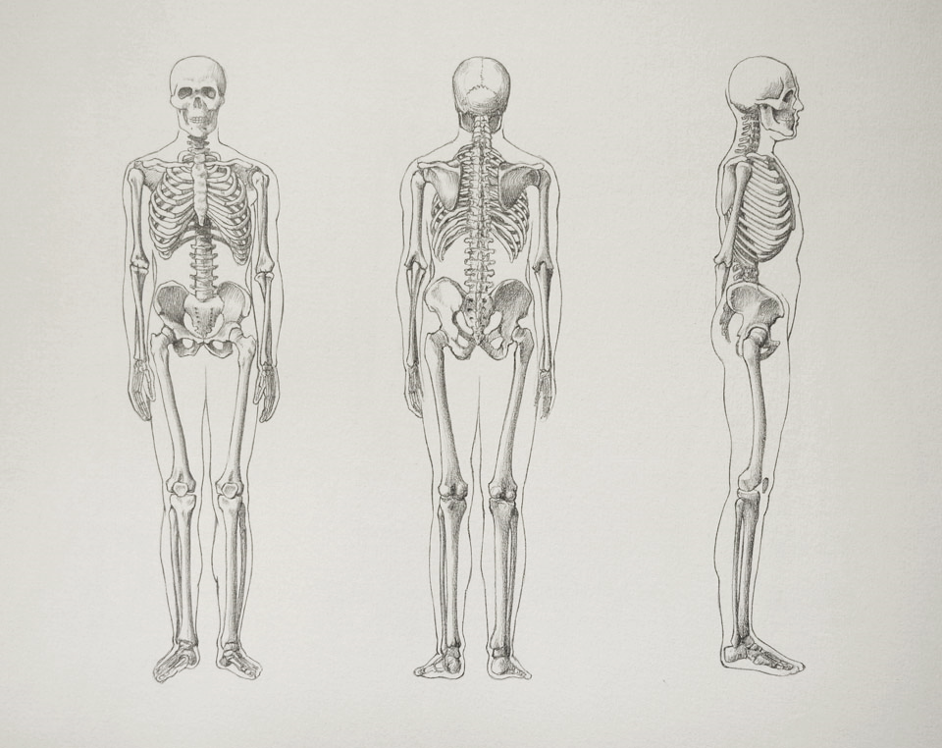

Required labeled Structures:

Frontal bone

Parietal bone

Temporal bone

Sphenoid bone

Zygomatic bone

Nasal bone

Orbit

Maxillary bone

Mandible

Cervical vertebrae

Thoracic vertebrae

Lumbar vertebrae

Sacrum

Coccyx

Pubic symphysis

Ilium

Pubis

Ischium

Femur

Greater trochanter

Patella

Tibia

Fibula

Metatarsals

Tarsals

Calcaneus

Hallux

Clavicle

Scapula

Sternum

Humerus

Note: hands are not pictured here in anatomic position

Radius

Ulna

Carpals

Metacarpals

Phalanges (hand)

Pollex

True ribs

False ribs

Floating ribs

Obturator foramen

Sternoclavicular joint

Glenohumeral joint

RUBRIC for Required labeled Structures:

-.5 -.5 -.5 -1

sp. needs mislabel missing

bracket (label or struc) structures neatness

|  |  |  |  |
| --- | --- | --- | --- |
|  |  |  |  |
|  |  |  |  |
|  |  |  |  |
|  |  |  |  |
|  |  |  |  |
|  |  |  |  |
|  |  |  |  |
|  |  |  |  |

Frontal Bone GRADE: ____ + ____

Parietal bone 86 14

Temporal bone

Sphenoid bone total

Zygomatic bone %

Nasal bone

Orbit

Maxillary bone

|  |  |  |  |
| --- | --- | --- | --- |
|  |  |  |  |
|  |  |  |  |
|  |  |  |  |
|  |  |  |  |
|  |  |  |  |
|  |  |  |  |
|  |  |  |  |
|  |  |  |  |

Mandible

Clavicle

Scapula

|  |  |  |  |
| --- | --- | --- | --- |
|  |  |  |  |
|  |  |  |  |
|  |  |  |  |
|  |  |  |  |
|  |  |  |  |
|  |  |  |  |
|  |  |  |  |
|  |  |  |  |

Sternum

Sternoclavicular joint

Cervical vertebrae

Thoracic vertebrae

Lumbar vertebrae

True ribs

False ribs

Floating ribs

Obturator foramen

Sacrum

Coccyx

Pubic symphysis

Ilium

|  |  |  |  |
| --- | --- | --- | --- |
|  |  |  |  |
|  |  |  |  |
|  |  |  |  |
|  |  |  |  |
|  |  |  |  |
|  |  |  |  |
|  |  |  |  |
|  |  |  |  |

Pubis

Ischium

Greater trochanter

Femur

Patella

Tibia

Fibula

|  |  |  |  |
| --- | --- | --- | --- |
|  |  |  |  |
|  |  |  |  |
|  |  |  |  |
|  |  |  |  |
|  |  |  |  |
|  |  |  |  |
|  |  |  |  |
|  |  |  |  |

Metatarsals

Tarsals

Calcaneus

Hallux

Humerus

Glenohumeral joint

Radius

|  |  |  |  |
| --- | --- | --- | --- |
|  |  |  |  |
|  |  |  |  |
|  |  |  |  |

Ulna

Carpals

Metacarpals

Phalanges (hand)

Pollex