Anatomy & Physiology STUDY GUIDE

mr e ~ SRCS chapter 9 test

71 multiple choice

**A&P chapter 9: Joints**

**vocab**

Articulation/Arthrosis

Arthrology

Kinesiology

Fibrous joints

Suture

Syndesmosis

gomphosis

Interosseus membrane

Cartilaginous joints

Synchondrosis

Symphysis

Synovial joints

Articular capsule

Articular cartilage

Articular discs/menisci

Synovial fluid

Ligaments

Synovial membrane

Articular fat pads

Bursae

Labrum

“double-jointed”

Synarthrosis

Amphiarthrosis

Diarthrosis

ACI (autologous chondrocyte implantation)

Aspiration of synovial fluid

Arthroscopy

Sprain/Strain/(treatment:

PRICE)

bursitis

tendon sheaths

Synovial joint types

Plane

Hinge

Pivot

Condyloid

Saddle

Ball-and-socket

Body Planes (to make sense of motions below); see ch 1; FIG 1.7, p. 16

Movements

Gliding

Angular

Flexion

Lateral flexion

Extension

Hyperextension

Abduction

Adduction

Circumduction

Rotation

Special

Elevation

Depression

Protraction

Retraction

Inversion

Eversion

Dorsiflexion

Plantar flexion

Supination

Pronation

Opposition

Range of Motion (ROM)

(be familiar with TABLES 9.3 & 9.4 to identify & distinguish b/w joints)

Dislocation

Rotator cuff injury

Separated shoulder

Torn glenoid labrum

Tennis elbow

Little-league elbow

Dislocated elbow

Swollen knee

“unhappy triad”

Dislocated knee

Arthroplasty

Partial/total hip replacements

Knee replacements

Partial/unicompartmental

rheumatism

arthritis

osteoarthritis

rheumatoid arthritis

gout

gouty arthritis

Lyme disease

Ankylosing spondylitis

Arthralgia

Bursectomy

Chondritis

Subluxation

Synovitis

**THINGS you MUST know:**

1. vocab, vocab (well, you know by now)

2. Distinguish between structural joint classifications (by desc. & eg). [F,C,S]

3. Distinguish between functional (degree of movement) joint classifications (by desc. & eg). [S,A,D]

4. Distinguish between functional (type of movement) joint classifications (by desc. & eg). [P,H,Pi,C,B&S]

5. The Subcategories of structural joint types (Sutures, Syndesmoses; snchondroses, symphyses)

6. Characteristics of Synovial joints.

7. The many clinical connections (see slides in ppt or blue boxes in textbook)

8. Motions at joints (see TABLE 9.1)

9. The science of knuckle cracking…

10. Functions of the menisci, bursae & synovial fluid.

11. Factors affecting ROM.

12. Recognize motions at a joint based on pictures (text pp. 296-300)

13. Particulars of the selected joints of the body –partic. knee (TM, Shoulder, **Knee**, Elbow, Hip)

14. vocabulary.

FIGURES with WHICH to be FAMILIAR:

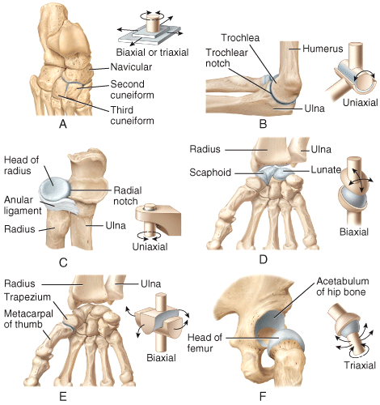

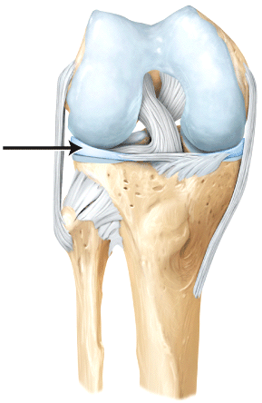

LEFT: types of Synovial joints

RIGHT: anatomy of the Knee (see FIG. 9.15 in text, p 317 for aid.