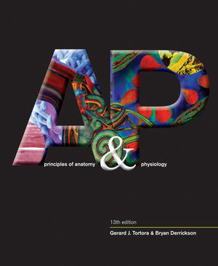Anatomy & Physiology STUDY GUIDE

mr e ~ SRCS chapter 4 test

67 multiple choice

**A&P chapter 4: Tissues**

**vocab**

epithelial tissue

connective tissue

muscle tissue

nervous

tight junction

gap junction

adherens junction

desmosomes

hemidesmosomes

gap junctions

histology

tissue

basal surface of cell

basement membrane

simple

pseudostratified

stratified

squamos

cuboidal

columnar

transitional epithelium

extracellular matrix

ground substance

isotonic

hypotonic

hypertonic

crenate

hemolyze

concentration gradient

fibers:

collagen

reticular

elastin

apical surface

diabetic retinopathy

fibroblasts

chondricyte

adipocyte

osteocyte

leucocyte

erythrocyte

thrombocyte

liposuction

Marfan syndrome

Loose CT

Dense CT

stem cells

areolar CT

adipose tissue

reticular CT

dense irregular CT

dense regular CT

elastic CT

cartilage

ciliated/nonciliated

goblet cells

collagen

excitable cells

action potential

organ

mucous membrane

serous membrane

cutaneous membrane

synovial membrane

endocrine glands

exocrine glands

parenchyma

stroma

atrophy

hypertrophy

adhesion

tissue repair

**Things you MUST know:**

1. Vocab, vocab, vocab!
2. Know the main tissue types of the human body and be able to discern the one oddball if a list of as certain type is given.
3. Distinguish between intracellular junctions by pic, name, and verbal description.
4. Main functions of each tissue type.
5. Name epithelial tissue if pictured--whether by drawing or actual micrograph (text pp, 118-126).
6. Associate specific epithelial tissue type with a general function and location based on said function.
7. Which fiber(s) are secreted by fibroblasts?
8. Know any medical procedures or conditions/syndromes taught.
9. Distinguish between the types of CT.
10. Know the functions of CT.
11. Associate functions of types of CT with specified location in the body. (slide 56)
12. What effect does the poor vascularization of cartilage and tendons ave on these parts when injured?
13. Recognize cell types by name (eg. any word ending in "-cyte").
14. Categorize membrane types as Epithelial, or Connective, or Muscular, or Nervous.
15. Distinguish between the classes of glands.
16. Identify mature CT by micrograph. (text pp 133-138)
17. Identify muscular tissue types by micrograph. (text pp 142-144)
18. Discern between muscular tissue types based on verbal description of function.
19. Which tissue types are capable of electrical excitability?
20. Identify nervous tissue by micrograph. (text p 145)
21. Distinguish between the membranes on the basis of location and function.
22. Know the medical procedures & conditions! (again!)

