This document will explain how to submit Bible homework for mr. e.

1. Log into RenWeb.

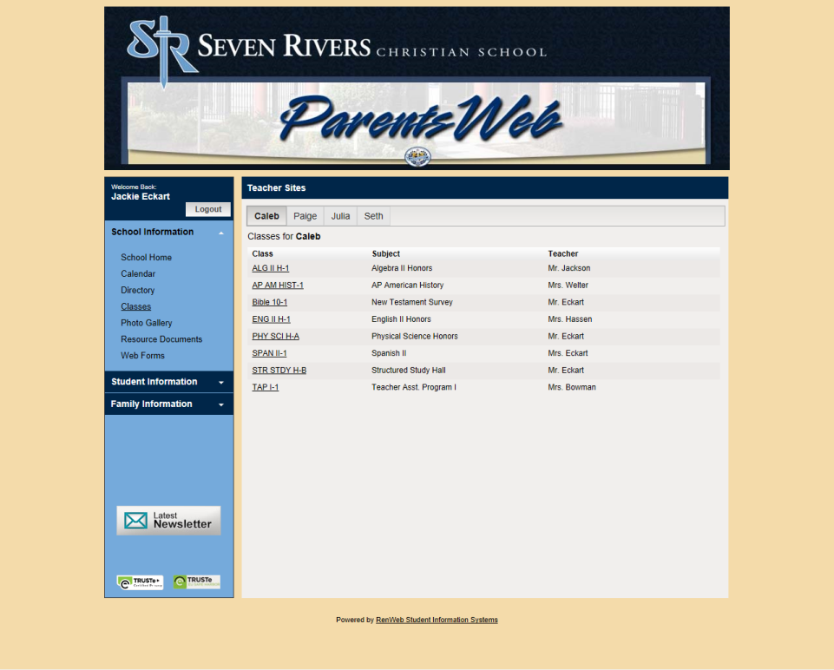

1. Select your class from the classes tab.

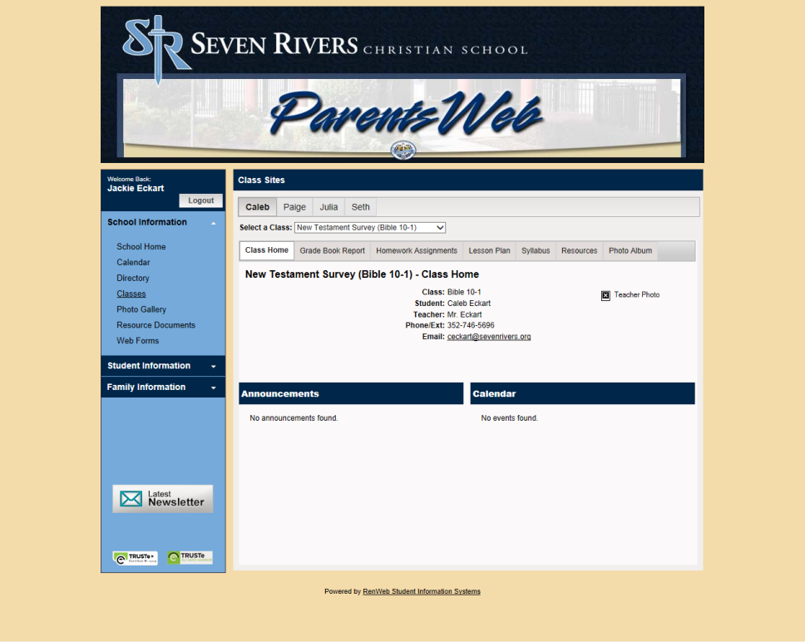

1. Click the resources tab.

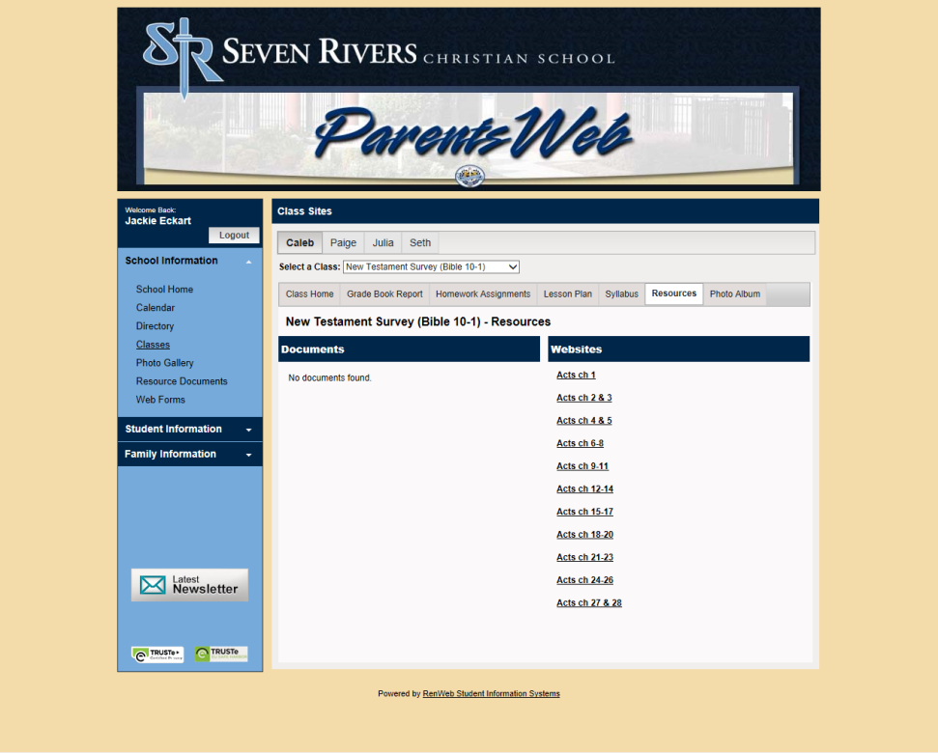

1. Select the correct chapter. Note: this example is for Acts and systematics. For Life of Christ this will look different. Insert full name and email in the boxes provided.

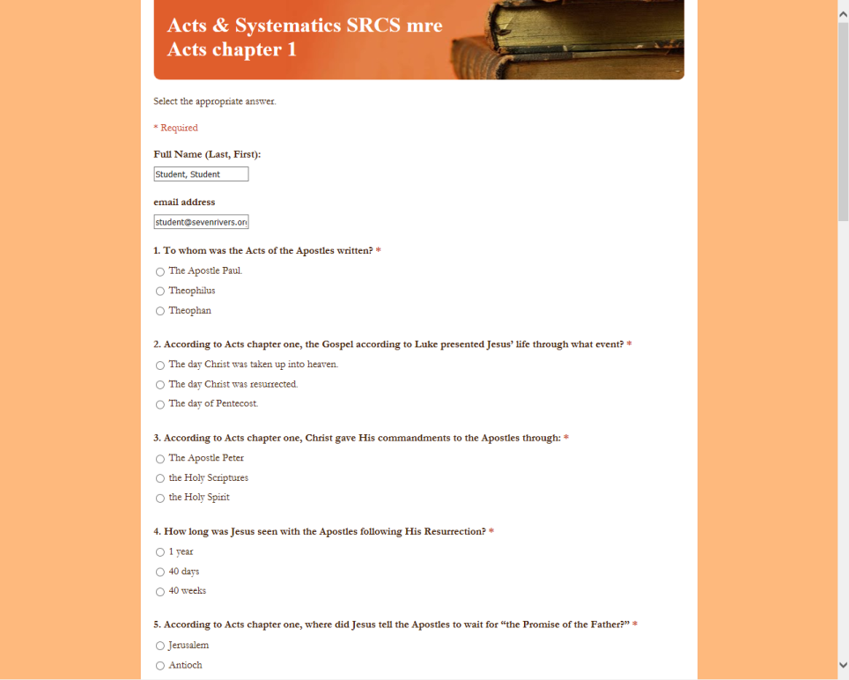

1. Complete the quiz and click submit.
2. If it says this, good job; you are done. If it doesn't, keep reading.



1. If it looks something like this, it means that you need to answer all the questions.

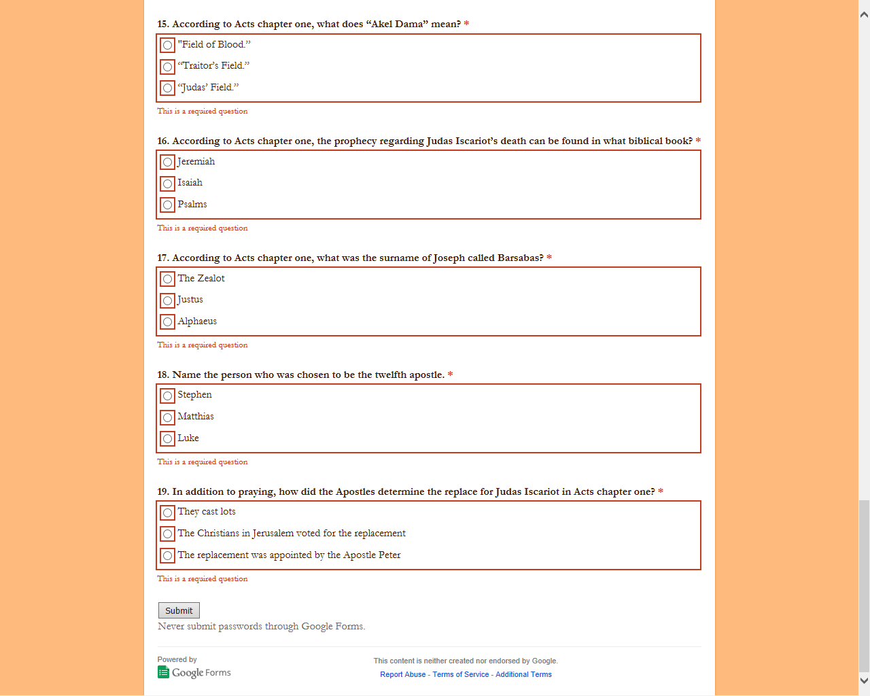

1. Good job! You have successfully completed the homework assignment.