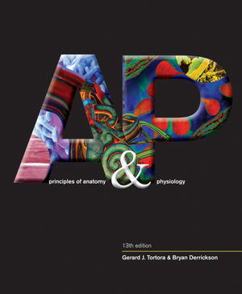Anatomy & Physiology STUDY GUIDE

mr e ~ SRCS chapter 3 test

80 multiple choice

**A&P chapter 3: The Cell**

**vocab**

eukaryotic cell

plasma membrane

organelles

cytoplasm

fluid mosaic model

phospholipid bilayer

hydrophilic

hydrophobic

polar

nonpolar

selectively permeable

simple diffusion

facilitated diffusion

osmosis

endocytosis

exocytosis

phagocytosis

pinocytosis

transcytosis

passive transport

active transport

tonicity

isotonic

hypotonic

hypertonic

crenate

hemolyze

concentration gradient

cytoskeleton

centrosome/ centrioles

cilia

flagella

smooth/rough endoplasmic reticulum (SER & RER)

Golgi complex

cisternae

nuclear envelope

nucleus

nucleolus

lysosome

mitochondria

cristae

chromosomes

chromatids

RNA

DNA

intron

exon

ribosome

amino acid

peptide bonds

mitosis

(phases: IPMATC)

mitotic spindle

meiosis

protein synthesis

transcription

translation

codon

anti-codon

nucleotide

tRNA

mRNA

integral proteins

peripheral protieins

Tay Sachs disease

leukemia

Progeria/Werner syndrome

lymphoma

neoplasm

melanoma

sarcoma

mutation

atrophy

hypertrophy

anaplasia

hyperplasia

dysplasia

necrosis

apoptosis

**Things you MUST know:**

1. Vocab, vocab, vocab!
2. Composition of Eukaryotic cell (3 main parts; each significant organelle)
3. General description of fluid-mosaic model of plasma membrane.
4. Structure and nature of a phospholipid.
5. Functions of membrane proteins; also match type of membrane protein with function.
6. Discern any particular cell process (passive or active) from its description.
7. Be able to identify the direction materials will flow through a membrane based on concentrations.
8. Identify cell organelles from their anatomy or physiology (medieval metaphor is included!); vice versa--that is, discern the function of any particular organelle.
9. Know **where** each stage of protein synthesis occurs.
10. Be sure to know the vocab of the processes and components of protein synthesis…
11. What is the main function of mitosis? What is the primary function of meiosis?
12. Be able to describe each phase of mitosis/meiosis.
13. Be able to identify cell organelles numbered on a cell diagram and match them to their functions.
14. Varying tonicities will be pictured. Be able to describe the overall direction of flow.
15. The process of Transcription will be pictured in numbered stages. Be able to match a verbal description of each stage to its proper stage.
16. The process of Mitosis will be pictured in numbered photos. Be able to match a verbal description of each phase to its proper photo.
17. Discern endo & exocytotic processes from drawings.
18. Match any particular disease or syndrome we studied to its description.
19. How many nucleotides code for 1 amino acid? Be able to calculate how many amino acids would result from any given number of nucleotides.
20. Solve these two types of DNA riddles:
    1. Corresponding mRNA codons from a DNA base triplet.
    2. Corresponding tRNA anti-codons from a mRNA codon.
21. Associate cell types (blood, nervous, spermatozooic, and cuboidal) with functions/adaptations.
22. How many cells does the human body have? How many different cell types?

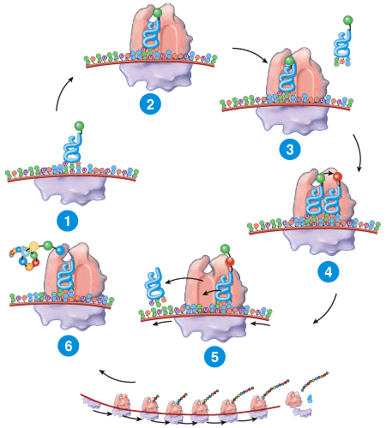

Translation in its glorious stages…