Ch "2": biology as a Science: blossoming, budding, & having babies name:
Format: 22 mc/T/F; 11 matching vocab; 6 stimulus or response; parts of a microscope.; process interp.;3 short answer

Study Guide
Vocab

irritability
stimulus
response
limit of resolution
sexual reproduction
asexual reproduction
growth
fecundity
specialization/differentiation
fertilization
anabolism
catabolism
unicellular
multicellular
ethology
centrifugation (cell fractionation)
cell
botany

homeostasis germination life span
(parts of a compound light microscope)

Things you MUST know:
- Advantages/disadvantages of a compound light microscope.
- Apply concept of homeostasis to real-life situations (recognize when it is being described).
- What happens to a female's ability to reproduce as they age (considerably)? (*note: skip this question and come back to later if you happen to study with mom/grandma, etc.!)
- Advantages/disadvantages of asexual reproduction.
- Advantages/disadvantages of sexual reproduction.
- In what three major ways can growth occur?
- Be familiar enough with what the biological specialties study in order to match their titles with what they study or what they are alternately called if they go by another name.
- In a word, the responses of all organisms to their environments are directly related to survival.
- Recognize all aspects of fecundity we noted:
  - Time leading to sexual maturity
  - Longevity/Span of ability to reproduce (t within sexual maturity)
  - Rate of reproduction
  - Number of young per birth/hatching/etc.
- Is it possible to have conditions become "too favorable" for a given population and lead to population decrease? If so, suggest a scenario in which this could occur?

- Be familiar with the levels of biological study in order to match a scenario to its appropriate level of study.
- Associate gamete and gender symbol ( ) with their appropriate gender.
- List the threefold function of flowers:
  - Protect reproductive organs
  - Attract pollinating agents
  - Beautify the earth
- Identify the portion of a situation (cause and effect) as either stimulus or response.

Applications in Science

Using the terminology below, be able to label a similar scope's parts.

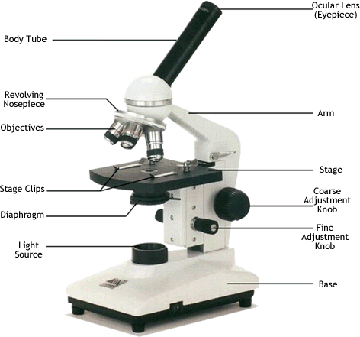

Science Skills

Be familiar with the Aurelian (jellyfish) lifecycle to be able to label each stage using these terms: budding (asexual reproduction), growth & development, fertilization (fusion of gametes; sexual reproduction), maturation (gamete formation).

What advantages are there to including a free-swimming larval stage?
- dispersal
- reduce competition
- chances of survival (less likely to experience mass loss due to predation b/c they are spread out)

Polyps instinctively anchor. Why would these organisms be designed to do this?
- Establish population
- Limit population (eventual competition keeps it in check)
- Predictable food source for predators

