Anatomy & Physiology FINAL STUDY GUIDE

mr e ~ SRCS chapter 7-11

124 multiple choice

**A&P chapters 7-11: Final Study Guide**

**vocab**

axial/appendicular skeleton

Bone shapes

Long

Short

Flat

Irregular

Sesamoid

sutural

fossa

meatus

tuberosity

trochanter

head

process

foramen

condyle

crest

True/false ribs

Floating ribs

spinal curves

cervical

thoracic

lumbar

sacrum

fontanels

anterior

posterior

anterolateral

posterolateral

spinous process

scoliosis

osteoarthritis

kyphosis

lordosis

spina bifida

glenoid cavity

carpals

metacarpals

phalanges

pubic symphysis

acetabulum

pelvic girdle

pectoral girdle

calcaneus

epicondyles of knee

condyles of knee

patella

trochanter (greater/lesser)

glenohumeral joint

sacroiliac joint

sternoclavicular joint

clawfoot

clubfoot

flatfoot

Fibrous joints

Cartilaginous joints

Synovial joints

Suture

Movements

Gliding

Angular

Flexion

Lateral flexion

Extension

Hyperextension

Abduction

Adduction

Circumduction

Rotation

Special

Elevation

Depression

Protraction

Retraction

Inversion

Eversion

Dorsiflexion

Plantar flexion

Synovial joint types

Plane

Hinge

Pivot

Condyloid

Saddle

Ball-and-socket

Range of Motion (ROM)

Relaxin (hormone)

excitability/irritability

contractility

elasticity

extensibility

muscle belly

epimysium

perimysium

endomysium

actin/myosin

neuromuscular junction (NMJ)

motor unit

sarcomere

Twitch contraction

Wave summary

Unfused tetanus

Fused tetanus

Muscle tone

flaccid

atrophy

hypertrophy

hyperplasia

motor unit recruitment

muscle types

skeletal

smooth

cardiac

isometric contraction

isotonic contraction

concentric

eccentric

fiber types

slow oxidative (SO)

fast oxidative-glycolitic (FOG)

fast glycolytic (FG)

sarcolemma

origin

insertion

synergist

fixator

agonist/prime mover

anatagonist

lever

fulcrum

effort

load

fascicle alignment/shape

parallel

triangular

oval/circular

pennate(uni/bi/multi) fusiform

all the muscle names stressed in class TABLE 11.2

hernia

strain

sprain

Bell's Palsy

Intubation

Incontinence

Shin splint

**Diagrams With Which to be Familiar:**

Bones of the Skull & Fontanels

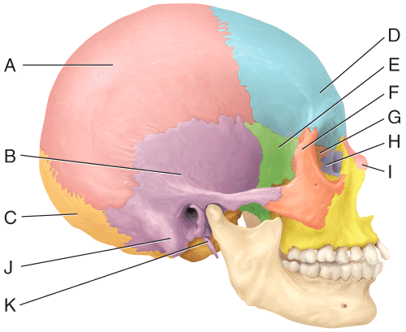

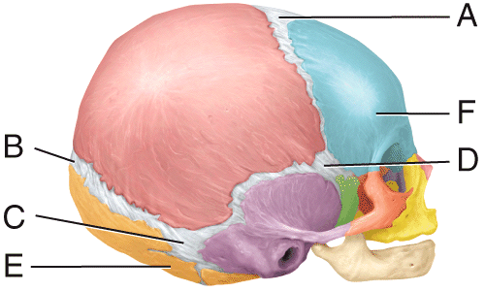

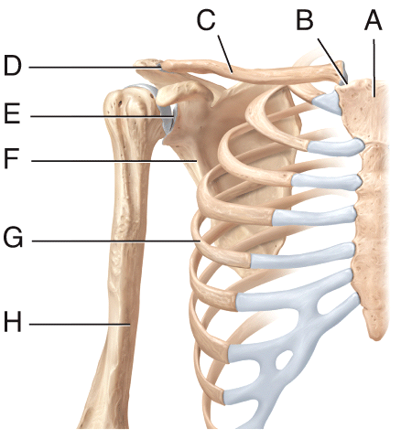

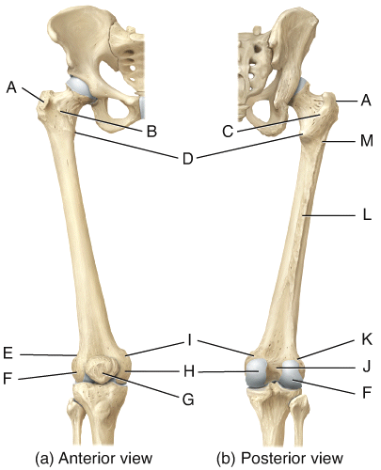

Bones of the Shoulder girdle

Parts of the Femur; Knee Joint

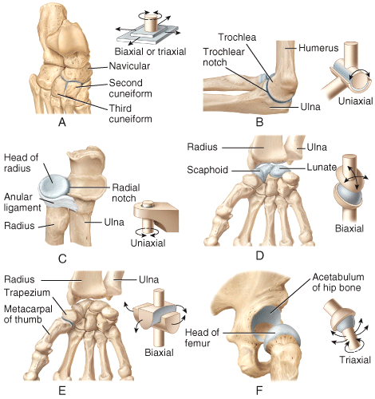

Pelvic Comparison based on Gender

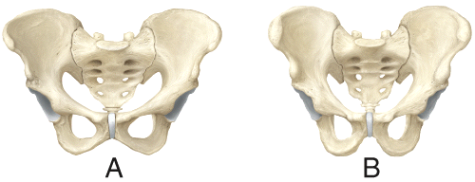

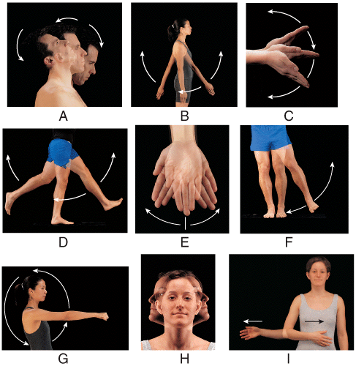

Synovial Joint Types

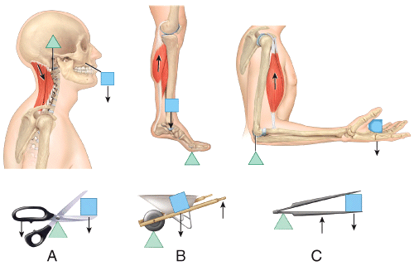

Special Movements

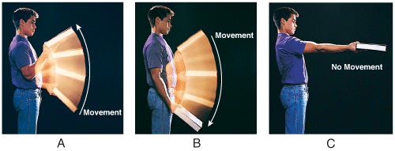

Levers: Physics of movement

Muscular Contractions

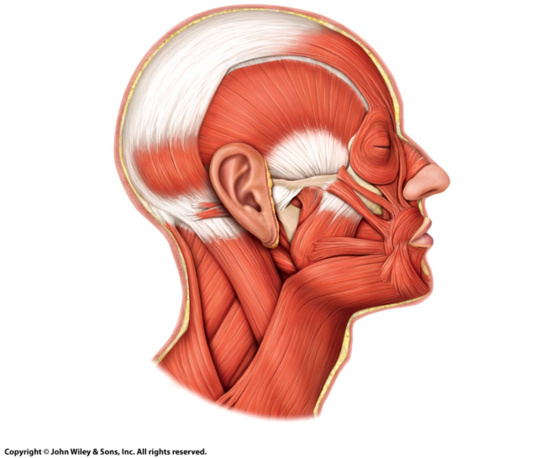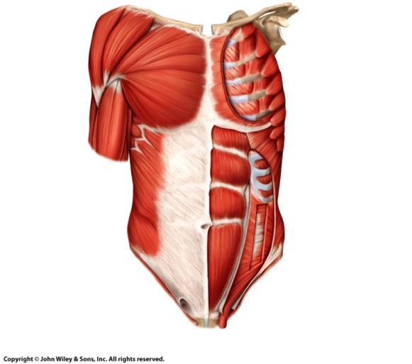

Muscles of Anterior Trunk

Muscles of Head/face

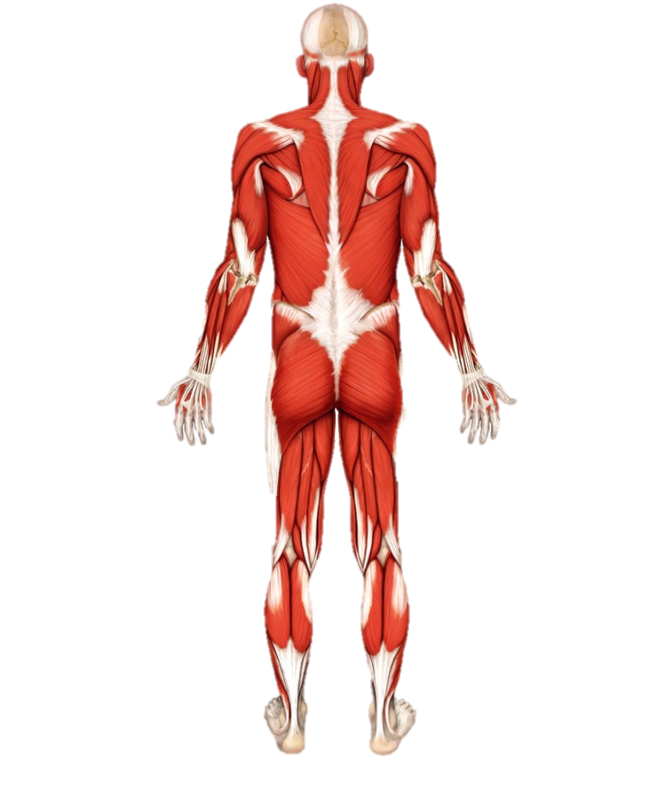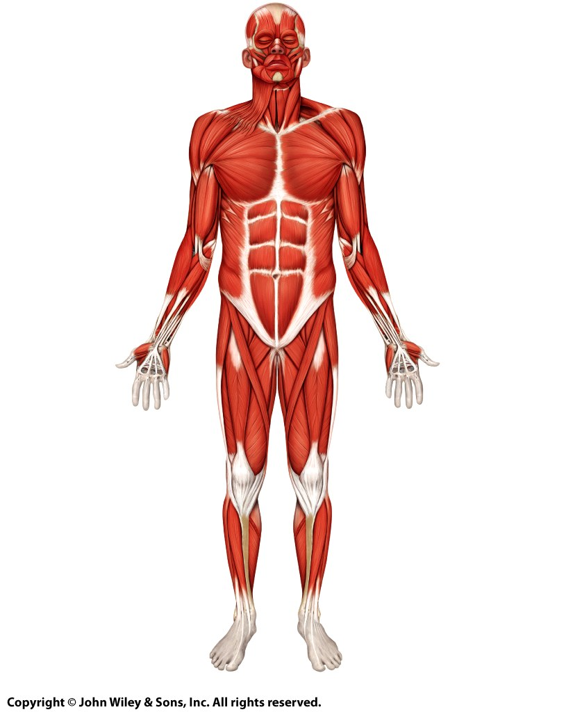

Muscles of the Body!

**THINGS you MUST know:**

1. vocab, vocab (well, you know by now)
2. How many bones are in the human skeleton?
3. Axial & Appendicular skeletal divisions.
4. Associate a bone with its bone type.
5. Know marking well enough to pick a few out when verbally described.
6. Facial vs. cranial divisions.
7. Clinical connections associated with Skeletal system.
8. Rib divisions (True, False, floating).
9. Curves of the spine; development thereof.
10. Bones of skull (see pic above).
11. Function of vertebral spinous processes.
12. Bone inventory of human hand (number of carpals, metacarpals, phalanges)
13. Bones of the Skeletal system and parts of certain bones (see pics above)
14. Types of Joints (physical & functional classifications).
15. Special movements.
16. Types of synovial joints (see pic above).
17. What affect does disuse of a limb have on the affected joint?
18. The hormone relaxin does what..when?
19. Characteristics & functions of muscle tissue.
20. Anatomy of muscle tissue (Outer layer to inner filamental proteins).
21. How is muscle tone maintained?
22. Muscle tissue clinical connections.
23. Distinguish the three muscle fiber types.
24. How is a neural action potential generated?
25. Order the 4 general steps of muscle contraction.
26. What distinguishes the types of muscle tissue from each other?
27. Distinguish between classes of levers.
28. Distinguish between functional names for muscles (agonist/antagonist).
29. Main muscle for breathing?
30. All the muscles listed in bold in the diagrammatic slides in the ppt (listed on last slide of class notes ppt) by name/location (eg. be able to identify); see diagrams above.
31. Order of the 3 anterolateral abdominal layers from superficial to deep or vice versa.
32. The clinical connections from the muscles (ch11)
33. Categories by which muscles are named.

Muscles of the Body!