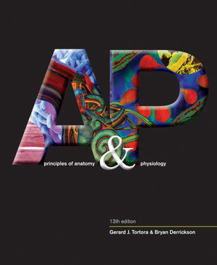Anatomy & Physiology STUDY GUIDE

mr e ~ SRCS chapter 1 test

**A&P chapter 1: Intro to the Human Body**

**vocab**

anatomy

physiology

cell

tissue

organ

system

organism

palpation

auscultation

percussion

sign

symptom

anabolism

catabolism

metabolism

homeostasis

autopsy

differentiation/spe-cialization

(system names; TABLE 1.2)

ECF

Interstitial fluid

ICF

Stimulus

Response

Receptor

Control center

Effector

positive feedback system

negative feedback system

anatomical position

(cavity names; FIG. 1.9)

(plane names; FIG. 1.7)

(directional terms; FIG. 1.6)

select membranes; FIG. 1.10)

pericardium

pleura

mediastinum

dura mater

peritoneum

select regional terms

cervical

gluteal

femoral

cephalic

thoracic

inguinal

subspecialties of A&P (TABLE 1.1)

s selected quadrant lines (FIG 1.12)

subcostal line

midclavicular line

transtubercular line

growth

responsiveness

reproduction

movement

pathology

immunology

**Things you MUST know:** see above for book figures and tables associated with particular concepts.

1. Vocab, vocab, vocab!
2. Which systems are the chief regulators in that they control other systems?  
   a. Endocrine: secretion of hormones

b. Nervous: electrical impulses; brain

1. Distinguish between the 3 main components of a feedback system by a description of its function.
2. Be able to pick out a positive feedback system from a list of negative ones.
3. Describe anatomical position.
4. Be able to identify the cavity in which key organs reside.
5. Functions of a serous membrane.
6. Identify planes on basis of description, result, and/or image.
7. Be able to use directional terms while referencing 2 organs.
8. Be able to identify body regions on a diagram.
9. Be familiar with the subspecialtiesof A&P in order to match their descriptions/job description.
10. Be able to discern which cavity a particular major organ would reside by labeled figure.
11. Know the four lines that make up the anterior quadrants (thoracic/abdominopelvic).
12. Be familiar enough with the types of medical imaging to be able to match an image and title with a description as to how it is obtained.
13. Associate bodily processes with their definition or example.
14. Name the levels of structural organization in ascending or descending order.

