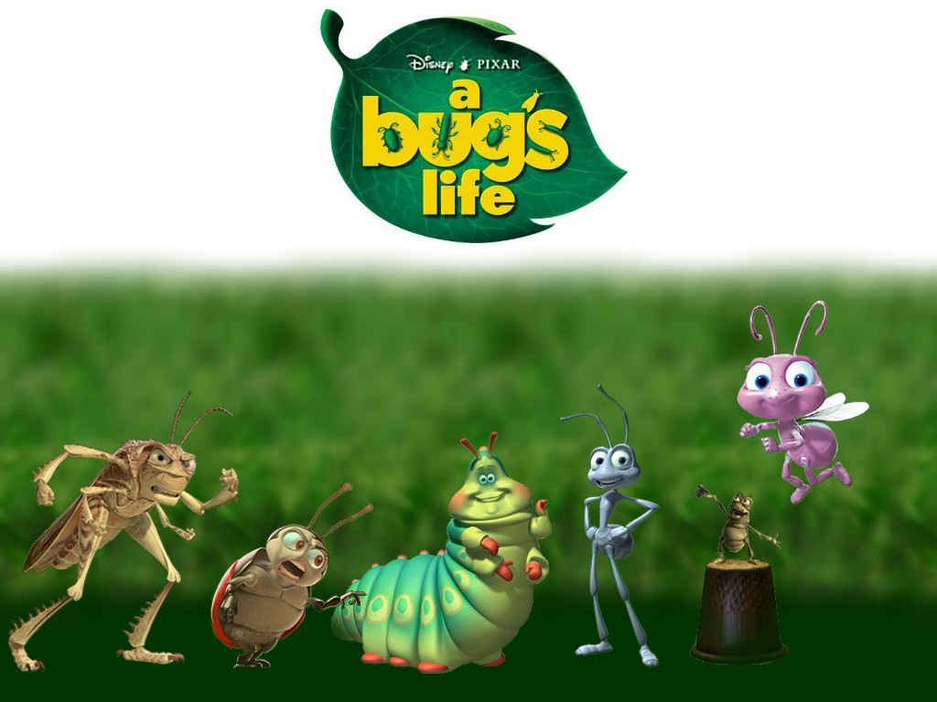
Biology Study Guide Name:
Midterm Exam Date:
Bio as science, classification,
philosophy, & intro to botany
& leaves
mr. eckart

Vocabulary:
Life span Deciduous Vector
Dendrology Evergreen Fertilization
Omnivore Development Pollination
Asexual organism Differentiation Cladistics
Sexual organism Germination Irritability
Gametes Experimental variable Interpopulational
Specialization Control group Intrapopulational
Qualitative data Experimental group Eukaryote
Quantitative data Stimulus Prokaryote
Autotroph Response Fecundity
Heterotroph Decomposer Species
Frugavore Anabolism Catabolism
Herbivore Carnivore Sessile
Insectivore Pubescent Petiole
Herbaceous (stem) Woody (stem) Cuticle
Fibrous/Taproot Stomata Vector (pollen or seed)
Palisade mesophyll Spongy mesophyll Chloroplast

- If you don't know this already, review the vocab!
- Distinguish between the branches of study in biology
- Be familiar with the key historical figures we studied in biological philosophy.
- Know the main leaf margin types
- Distinguish between monocots and dicots
- Most fundamental group of plants to man’s survival: ___________________
- Root types (fibrous vs. taproot)
- Plant adaptations worksheet (know adaptations given the situation)
- Sexual vs. asexual reproduction (distinguish between)
- Know how many structures of the plant are consumed
- Be able to identify whether a portion of a statement is a stimulus or a response
- Know the microstructure of a dicot leaf
- Where are chloroplasts in a leaf more densely packed?
- Why do flowers disappear?
- Leaf adaptations: eg. if a tree is in a climate where the nights are dry and the days humid, what will its stomata do to deal with this situation?
- Which is the dependent process: fertilization or pollination
- Binomial nomenclature (Linnaeus’ means of classification/“What is a scientific name?”)
- Linnaeus’ hierarchy (7 tier system: K.P. COFGS)
- 2 characteristics of acceptable systems of biological classification: a. universality b. biological meaning
- 18th century universal scientific tongue?
- Know key taxonomists (Aristotle, Linnaeus, Whittaker)
- Know which sugars are made by, transported through, and stored in the plant
- Kingdom summary: be able to place a described organism in its appropriate kingdom
- Hot spot for new species?
- Associate gamete with gender (sperm; eggs)
- 4 fundamental questions every human should face (know categories & questions)
- Which category is most fundamental (in # 28)?
- Can one categorize 2 different types of organisms as the same species?
- What functions does a seed coat perform?
- Group of Nitrogen-fixings plants are called ____________.
- Rules of binomial nomenclature
- Which taxon is the most diverse? How do you know?
- Be able to list the Linnaean groups (funnel) from the most inclusive (general) to the most exclusive (specific).
- Distinguish between analogous structures and homologous structures
- What does it mean to be warm-blooded? (not T of blood, but how they regulate it…internal vs. external)
- Functions of flowers
- Distinguish various processes as either catabolic or anabolic
- Know characteristics by which organisms get their scientific names and be able to divine them from a given Genus species name

