Life of Christ: The Passion of the ChrisT name:
Due:

Film Viewing/Discussion Permission Form
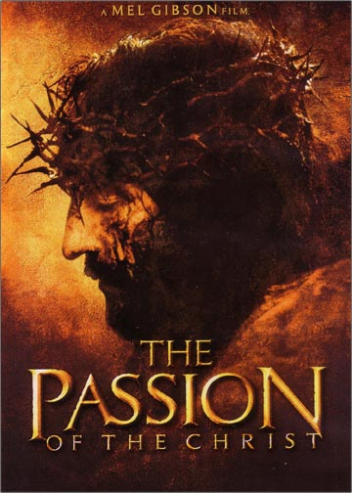
As we have made our way through the Life of Christ, John's gospel particularly, I supplement the study of Christ’s Passion week with Gibson’s own version of the Passion. Ground-breaking in its depiction and interpretation, it is also a most sobering watch—perhaps not for all students of this age.

I want to take this opportunity to grant you, the parent—who knows your child best, the privilege of determining the extent of their exposure to such things.

If you do wish to have them view the film, sign this form, return it, and make a point to engage them both before and after we take it in. If you do not, write this in the comments section and I will support you and clamp down on any disrespect from their classmates.
I thank you for your time and the freedom to engage you and your child in this most redemptive event.

I/we the parent(s)/guardian(s) of ________________________, grant
student
permission for them to view the film _Passion of the Christ___,

rated __R______ for the following reasons:

- Sequences of graphic violence

Parental/Guardian Signature: ______________________________________

Parent Comment:

I would be glad to answer any questions you may have regarding my selection and our ensuing discussion. School phone: 352-746-5696; email: ceckart@sevenrivers.org

Mr. Christopher Eckart
Upper School Bible Teacher

ps. Students not granted permission will be viewing television's Jesus of Nazareth for the duration of the Passion film. Students without a signed form will be placed there also until the form arrives.

