Reptiles Study Guide

Vocab

vertebrate cloaca biomimetics
cold-blooded setae pit organ
amniote internal fertilization binocular/ stereoscopic vision
oviparous estivation carapace
ovoviviparous endotherm piscivore
Scales ectotherm Jacobson’s organ
tetrapod dewlap ‘third eye’

Concepts

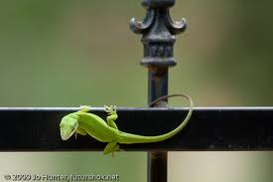
- Distinguish between Four Orders: Crocodilia, Sphenodonita, Squamata, Testudine; be able to match organism to Order
- Know key characteristics of reptiles.
- Identify advantages of amniotic eggs.
- Identify advantages of scales.
- Know the disadvantage of a splayed stance.
- Distinguish between the two types of shedding.
- Know advantages and disadvantages of reptile jaw design.
- Know why anole might display.
- Distinguish between nocturnal & diurnal snakes; also between venomous & non-venomous snakes.
- Know why solid-colored adult snakes often have patterned young.
- Know the “two” venomous lizards of the world.
- Be able to distinguish between terrestrial and aquatic turtles.
- Know basic snake anatomy; know basic turtle anatomy.
- Know how turtles swim.
- Be able to match a picture of a reptile to its common name.

