Biology Name:
Ch 31: Fishes Study Guide
SRCS ~ mr. e

“Let the water teem with living creatures…” genesis 1:28

Format: 35 multiple choice/ T or F

Vocab

roe dorsal fin Ampullae of Lorenzini
cold-blooded caudal fin operculum
viviparous anal fin opercular pump
oviparous external fertilization piscivore
ovoviviparous internal fertilization school/shoal
pectoral fin cloaca cycloid/ctenoid/ganoid/placoid
pelvic fin flatfish concurrent/countercurrent flow
heterocercal tail fusiform gonad

homocercal tail lateral line swim bladder
carnivore herbivore

Concepts

- Be able to identify common fish covered in lecture.
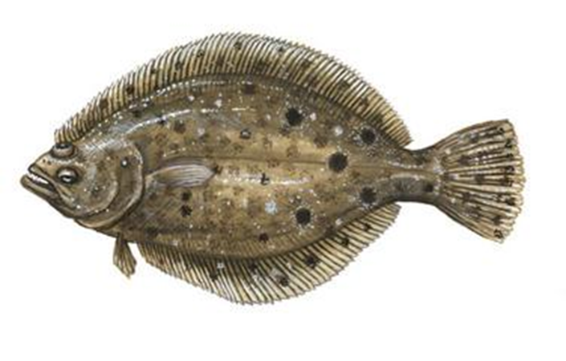
- Identify the basic characteristics of fish.
- Know vocabulary well enough to distinguish between them through examples (examples of fish or applications of terms)
- Identify key members of Chondricthyes & Osteicthyes so as to classify them as one or the other.
- Demonstrate a basic understanding of how fish breathe (eg. shark, ray, & typical bony fish).
- Know the functions of Ampullae of Lorenzini (sharks) and the lateral line.
- Explain the basics of shark dentition--how does it work, esp. if one loses several teeth? How long does this continue to happen?

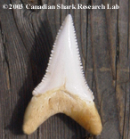
- What is the shape and style of a Porbeagle shark's tooth?
How about a Great white's?
- Know how the shape of a shark is beneficial for its movement in water. 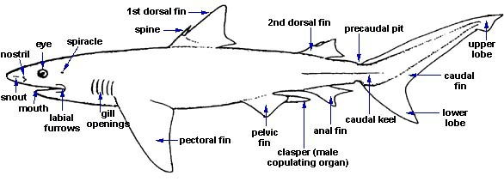
- Distinguish between heterocercal and homocercal tails in sharks.
- Know basic fish anatomy (internal/external) to be able to answer T or F or Q about their structures.
- Be able to distinguish between each of a fish's fins by name and function. 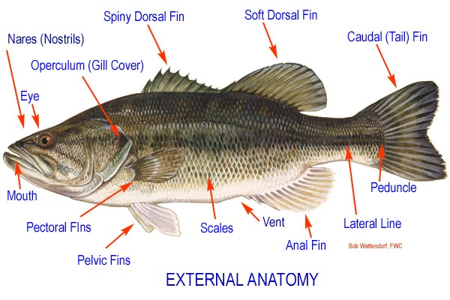
- Keep in mind that there are practically innumerable colors underwater borne by the environment and creatures that live there.
- Know the advantages if schooling.
- Be able to categorize a fish as a fast swimmer or slow swimmer based on body type and caudal motion.
- Be able to distinguish between each type of scale we studied (cycloid/ctenoid/ganoid/placoid)--that is, know its verbal definition and overall shape.
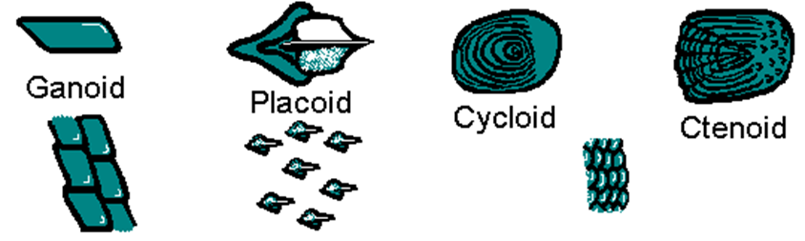
- Do fish need oxygen to survive? Why or why not?
- Which taxonomic class of fishes has the greatest diversity?
- Be able to explain how God designed gills to work on order for fish to survive. Explain scientifically which flow between the blood and water is better (countercurrent or concurrent) and why. (see graphic below
