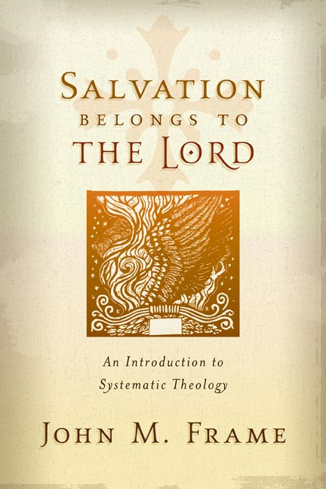**SYSTEMATICS~anthropology Name:**

**Chapter Seven ~ Man, the Image of God** Mr. E ~ SRCS

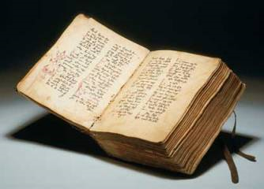1. Frame spends time in the opening of this chapter speaking to the sensitive topic of Gender & language. Find a Scripture verse (other than Genesis 5:2) that uses the term ‘man’ to represent both male and female. Write it out here:

**Anthropology:**

“We are clay images-a powerful lesson in humility-but we are also images of God- creatures of wondrous value and dignity. ” Richard Pratt, *Designed for Dignity*, pg. 13.

**Creatures, with Dignity**

2. Name the two levels of being In God’s economy (in other words, all reality): a.

b.

3. In the third full paragraph Frame very succinctly describes what it is to glorify God. Write out that statement below:

“To Glorify God is to _____________________________________________________________

____________________________________________________________________________________”

Choose one of the verses that follow this definition and write it out below (reference and verse):

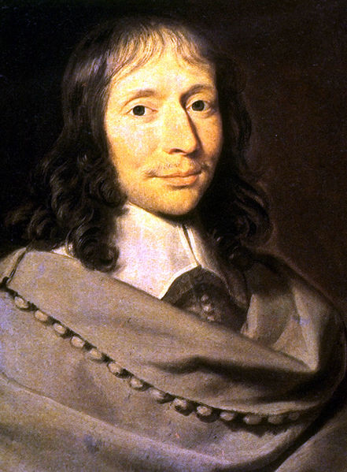4. Ever feel like you are practically invincible one instant and painfully frail the next. We are a strange mix of humility and dignity. The french renaissance scientist, philosopher, & theologian Blaise Pascal once wrote the paragraph to the right. How true! Frame, at this point however, is viewing man in terms of level of being—without regard for sinner or not. Describe how frame shows where man’s humility & dignity is rooted (p.86):

“What a Chimera is man! What a novelty, a monster, a chaos, a contradiction, a prodigy! Judge of all things, an imbecile worm of the earth; depository of truth, and sewer of error and doubt; the glory and refuse of the universe.”

Blaise Pascal (1623-1662)

Humility:

Dignity:

**BONUS**: Go to <http://www.youtube.com/watch?v=SXh7JR9oKVE> then <http://www.youtube.com/watch?v=X3iFhLdWjqc&feature=aso>. Watch the videos and tell me what you enjoy about each. Then, as specifically as you can, share how God is being enjoyed in each video.

Video#1

Video#2

5. Write out the WSC Q &A 1 below:

Think of something you thoroughly enjoy. Share it. How is God enjoyed through this thing or activity? (ever wonder what it means if God doesn’t sanction what you ‘enjoy?’ it, essentially, detracts from His glory—that is the glory you’re to give Him and the enjoyment you were meant to have!

**Creation & Evolution**

6. List 2 evidences against evolution from Scripture

1.

2,

7. Define the term ***microevolution***:

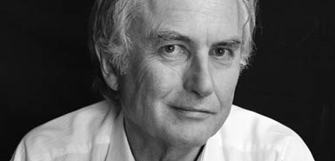8. Self-proclaimed atheist Richard Dawkins himself says that we live in a universe which has

‘no design, no purpose, no evil and no good, nothing but blind, pitiless indifference’. Dawkins, R., River out of Eden, Weidenfeld and Nicolswi, Chapter 4, 1995.

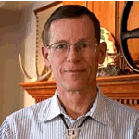In similar vein, another atheist, Professor William Provine, Cornell University, said,

‘ … There are no gods, no purposes, no goal-directed forces of any kind. There is no life after death. When I die, I am absolutely certain that I am going to be dead. That’s the end for me. There is no ultimate foundation for ethics, no ultimate meaning to life, and no free will for humans, either.’ Provine, W.B., Origins Research **16**(1):9, 1994.

There are only two options: Supernatural creation or Self-Created materialism. One is correct, the other, false. One is true while the other is irrational. On which side do you find yourself and why?

9. Self-professed atheist, Thomas Nagel, Professor of Philosophy at New York University, put it rather candidly:

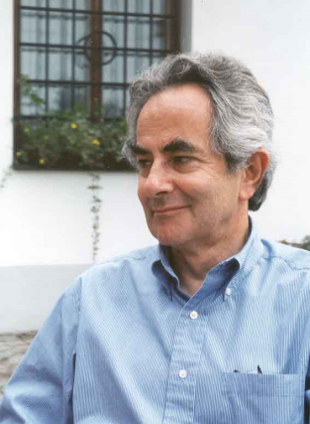‘I want atheism to be true and am made uneasy by the fact that some of the most intelligent and well informed people I know are religious believers. It isn’t just that I don’t believe in God and naturally, hope there is no God! I don’t want there to be a God; I don't want the universe to be like that.’

Nagel, T., The Last Word, Oxford University Press, New York, 1997, p. 130.

Why would Nagel be inclined to say this? How Is this bias explainable from a Christian point of view?

**Man, the image of God**

10. As a biologist, I’m tempted to find the image of God in man physically (reflected somewhere by the body)…and as a theologian, I’m tempted to find this image metaphysically (psychologically or spiritually perhaps) but Frame makes a subtle but profound distinction that recenters the Image of God Biblically:

“The Bible doesn’t say that there is an image of God *in* man; rather, it says that man *is* the Image of God.” (p88)

11. What pitfall does this primarily avoid? (hint…read Frame’s sentence just prior to the quote above)

12. Now, with this in mind, what ethical ramifications does this protect us from?



13. Does this mean that there is no difference between us & God?

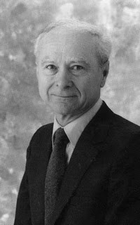14. What are Dr. Kline’s Three divisions of the Image of god? Answer the Questions that might arise…

a. P___________________: our bodies reflect primarily his

_______________ (eg. Eyes, arms, hands)

What could you say to someone who says that, because God does not Have a body, the Image of God cannot be Physical?

Dr. Meredith Kline

B. O __________________: as children of the King & stewards we are

V_________________, assisting him to have dominion over the earth.

Does this mean that He needs us or that He is incapable of dominion on His own?

C. E__________________: we reflect God in our K____________________,

R______________________, & H____________________.

“The image of God extends to our I__________________ C_____________________.” (p 89)

48 “Be perfect, therefore, as your heavenly Father is perfect.”

**Matthew 5:48**

Read Jesus’ words to the right. What does this say about God (in other words, does Jesus simply say this to frustrate humanity?)

(note: Although frame here is talking about groups of people and not parts of one individual, the second full paragraph on page 89 relates to question #12 above; refine your answer if you need to—especially paying attention to what he says about the ‘disabled.’)

15. List a few social issues that have been hotly debated that relate to what Frame (Scripture here) is saying about to whom the Image of God belongs…



16. Which denomination teaches that humans lost God’s image when we fell into Sin in the Garden?

Although it speaks of the uses of the tongue, write James 3:9 below underlining the part that repudiates the idea that we lost God’s image that day:

Denominational Herald known as __________ rose, who himself was invited to create a personal symbol to summarize his faith in the 1520’s. As his writings became increasingly popular, there was a desire on the part of the Wittenberg printers somehow to try to indicate what was an authorized publication of his works.

Reformer

Remember—our image-bearing was marred but not lost in the Fall!

17. How is biblical ethics an imitation of Christ?

“…sin is trying to be God, trying to put oneself on the throne. So, even the distortion of the image reflects God in an ironic way. Only a very special kind of creature can sin.”

Frame, SBtoG, p 89

18. Page 90 offers a few ways Scripture describes man. List four:

1.

2.

3.

4.

Circle your favorite of the four…

**Male & Female**

19. Read Ephesians 5:22-33. What is your gut-reaction to this passage?

Does your gender influence how you feel about this passage?

How does your initial reaction change once you read this section in the text?

20. Our society exposes its inability to honor the place of women and keep its men honorable and respected (insert here sitcoms & films that over-sensualize their female characters and reduce their males to gawking morons). How does Scripture call men & women to a different place (in other words, how does Scripture view women? Men? Include a passage reference for both male & female.

MAN:

WOMAN:

**The Human Constitution**

21. Answer these questions in regard to our **bodies** by circling true or false:

a. **T** or **F:** The Bible teaches that our bodies are evil.

b. **T** or **F:** we will lead a material existence (physical) in heaven.

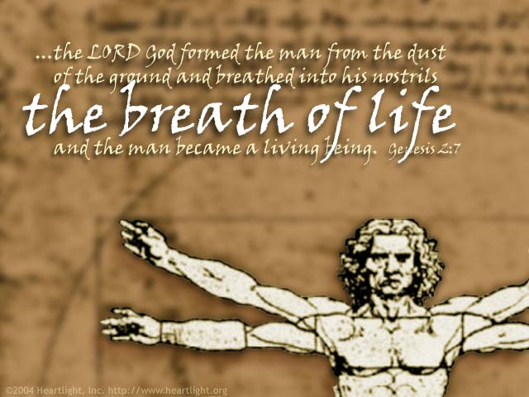 c. **T** or **F:** in heaven, there will be no food. (I just had to add this to see if you were paying attention)

22. Answer these questions in regard to our **souls** by circling true or false:

A. **T** or **F:** Scripturemakes a careful distinction between the terms ‘soul’ and ‘spirit.’

b. **T** or **F:** trichotomists typically divide human nature into body, soul, & spirit.

c. **T** or **F:** Traducianists believe that our souls are inherited from our parents.

23. Why doesn’t Frame side with the creationists (note that this term here applies only to souls and origin theories are not in view) or the traducianists?

24. Answer these questions in regard to our **minds** by circling true or false:

a. **T** or **F:** Thebible teaches that the will and emotions are subordinate to the intellect.

b. **T** or **F:** greek philosophy taught the equality of the emotions, will, and intellect.

25. What does Frame mean when he says that the three capacities of the mind (intellect, will, & emotions) are ‘mutually dependent?’ Explain.

25. Using the words below (left), redraw this concept in the box below (right) to represent A biblical model of **you**: (p93)

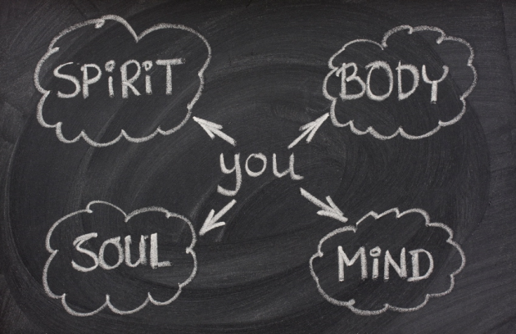

26. What term does Scripture use to unify the human nature? Define the term as God sees it.

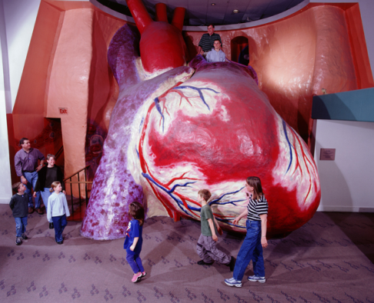

**Human Freedom & Responsibility**

27. Have you ever wondered about this apparent tension: God’s Sovereignty and our freedom? At the end of the day and when all defenses are down, how do you feel about this issue? (circle the line of thought that characterizes how you’ve felt…don’t worry, correctness should not influence your answer yet—just be honest!)

God is sovereign but it takes away our freedom

We are free and so God is not sovereign

God is sovereign and so I have freedom

28. This is pretty difficult to unpack so were going to fill in some main points as to what Scripture says: (p 95)

I. We are ________________ ___________________ agents.

II. There is no ___________________ between moral responsibility & God’s sovereignty.

III. God judges more severely those who have more ________________ (freedom) to do right. (Luke 12:47-48)

(class notes) Three positions on Freedom:

A. *Libertarianism:* free human acts are not caused by anything at all—they’re free, absolutely.

“holds onto a concept of free will that requires the individual to be able to take more than one possible course of action under a given set of circumstances, this viewpoint is based on the idea that nothing is determined.”

1. They’re not caused by:

Character:

God:

Desires:

2. Scripture teaches:

a. _____________ about this view.

B. Is not reflected in ______________.

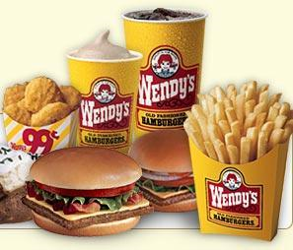 C. The contrary: God controls our thoughts, desires, and actions by controlling our character.

How is this position irrational?

(eg. Suppose you’re at wendy’s. What would you order?

Triple-stack? Why?

The Libertarian claims that reasons can’t influence your decision and that real desires can influence but cannot compel your decision—otherwise it’s not free. This position is called an **INCOMPATIBLIST** position.

consider these two terms…

If desires can *influence* but not **compel** (granting them this absurd arbitrariness), how then, do we make the final decision?

**in·flu·ence** /ˈɪnhttp://sp.dictionary.com/dictstatic/dictionary/graphics/luna/thinsp.pngfluhttp://sp.dictionary.com/dictstatic/dictionary/graphics/luna/thinsp.pngəns/ [http://sp.dictionary.com/dictstatic/g/d/dictionary_questionbutton_default.gif](http://dictionary.reference.com/help/luna/IPA_pron_key.html) [in-floo-uhhttp://sp.dictionary.com/dictstatic/dictionary/graphics/luna/thinsp.pngns],verb, -enced, -enc·ing. (used with object)

1. to exercise influence on; affect; sway: to influence a person.

2. to move or impel (a person) to some action

**com·pel** /kəmˈpɛl/ [http://sp.dictionary.com/dictstatic/g/d/dictionary_questionbutton_default.gif](http://dictionary.reference.com/help/luna/IPA_pron_key.html)[kuhhttp://sp.dictionary.com/dictstatic/dictionary/graphics/luna/thinsp.pngm-pel] verb, -pelled, -pel·ling. –verb (used with object)

1. to force or drive, esp. to a course of action

B. determinism: every event has a cause that makes it happen exactly as it happens.

Varieties: what determines our actions?

1. Ethical determinism (Plato): view of what is good

2. behavioral determinism (Skinner): environmental conditioning/stimuli (+/--)

3. physical determinism (Democritus/hobbes):

4. theological determinism (calvin etc): God; ‘Compatibilist’

(eg. Suppose you’re at wendy’s. you order a Frosty? Which flavor? Why?

1. Ethical determinism:

(everyone else here has ordered chocolate and so I don’t want to inconvenience the person by asking for vanilla….but, then again, if we all order the same flavor, they may have to refill the machine…oh, they ran out?) Ok I’ll take whatever’s left…

2. behavioral determinism:

It seems that this newer flavor is all the rage and everyone has told me that chocolate has a poor aftertaste—vanilla it will be!



3. physical determinism:

What is this sound? My stomach—it rumbles! My blood-sugar level must be synaptically communicating with my stomach to signal it is time for a frosty! Vanilla? Sure—would, you look at that: it has one more gram of that precious sugar my body has craved…

4. theological determinism:

MOM: Frosties for everyone kids! Our neighbor’s gave us some free frosty coupons…so what kind do you want? 3 chocolate and 3 vanilla? OK! Seth? Why did you choose ‘nilla? SETH: ‘Cause I love it so much!

C. Compatibilism: teaches that human actions are both caused and free.

A. Caused (Christians: because they are foreordained by God).

B. Free because I have the ability to do what I want to do.

NOTE: Scripture presupposes this position without directly defining or teaching us about it directly; it can be detected by how Christ works in our hearts (eg. Romans 6-8)

The Scriptures, however, teach a great deal about….

**Moral freedom**

29. Define this term: (p97)

(class notes) Augustine of Hippo, in his painful Confessions, laments:

"Non Posse Non Peccare" (I am not able not to sin).

Here’s the Latin first, English and explanation next:

NON = NOT - same word, pretty well  
POSSE = POSSIBLE - our word comes from the Latin  
PECCARE = TO SIN - we get our word “impeccable” from this, meaning “without fault”

He has suffered this troublesome situation and proposed **4 states of man** possibilities in relation to sin:

1. We’ll start with Adam and Eve in the Garden (innocence, before the Fall) . Here’s their situation:

*POSSE PECCARE*  
   
See what it means?

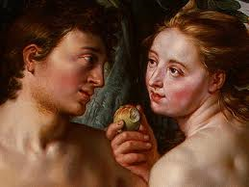  
   
  
2. Now humanity after the Fall—natural man (unbelievers):

*NON POSSE NON PECCARE* –

what does this mean?

  
  
3. Now, let’s try Regenerate man (Believers):  
  
*POSSE NON PECCARE* - It is possible for us not to sin.  
  
  
Why is this?

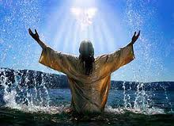  
  
4. Now, what about us in Heaven (Glorified man)?

*NON POSSE PECCARE* - It is not possible for man to sin.

What makes this possible?

Here’s a Summary

|  |  |  |  |  |
| --- | --- | --- | --- | --- |
| **state** | **Pre-Fall Man** | **Post-Fall Man** | **Reborn Man** | **Glorified Man** |
| ***latin*** | *posse peccare* | *non posse non peccare* | *posse non peccare* | *non posse peccare* |
| **english** | able to sin | unable to not sin | able to not sin | unable to sin |
| **description** | Perfect but able to fall | Sinner in need of redemption | Redeemed & struggling with sin | Perfected & unable to fall |
| **Proof text (verse)** |  |  |  |  |

REVIEW

I. Incompatibilist’s believe that human actions are uncaused—divorced entirely from our character & desires.

Critique:

1. Makes human experience a hash of absurdity

2. choices are (by necessity) random & accidental

3. destroys moral responsibility

II. Compatibilists believe that human actions are both caused and free

Critique:

1. Allows for reasonable freedom

2. Ascribes importance to human decisions

3. Maintains human moral culpability & God’s judgement

III. ‘hard’ Determinists: believe that human actions are completely caused as they have no choice

Critique:

1. removes human freedom (we are helpless bystanders at the whim of nature)

2. Human free will does not exist

3. often seeks to skirt moral responsibility

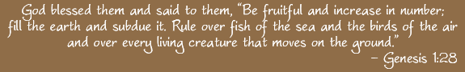**The Human Task**

30. What do we typically call this passage (Our task)?

The ______________ ___________________

Parts: A. Have ____________!

B. __________________out!

C. ________________ in Christ’s name (Glorify God by enjoying HIM)!

31. This command at man’s beginnings is closely linked with which New Testament Command?

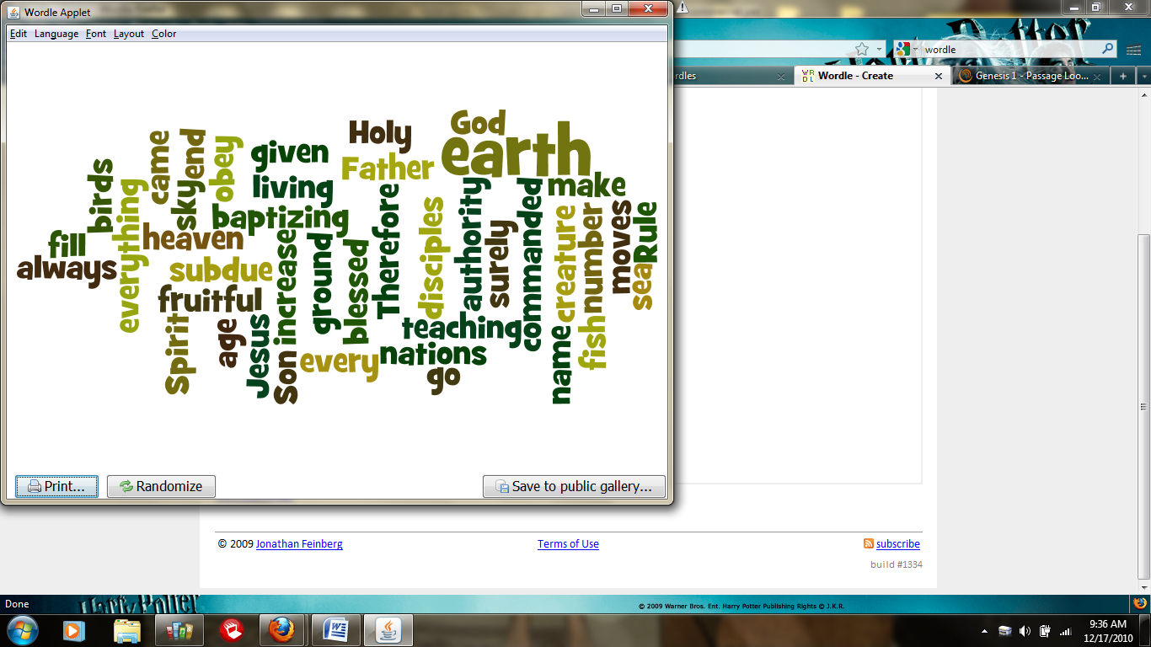 The _______________ ___________________________!



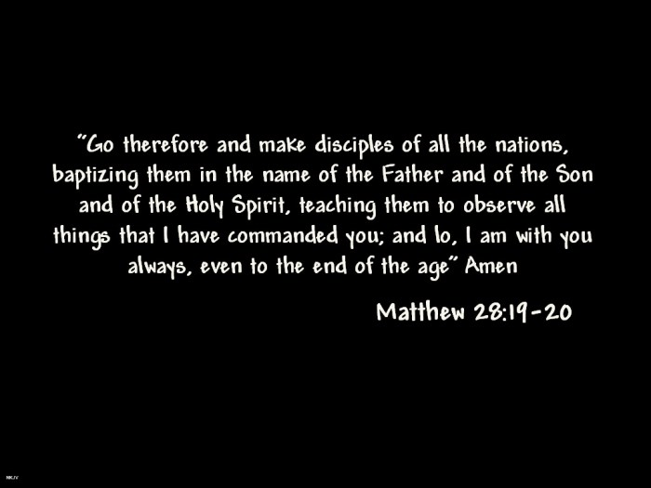(CLASS NOTES) Fulfilled:

Physically spiritually

1. 1.

2. 2.

3. 3.

Note: Jesus did not simply come to give you this:



 He came to redeem this:

**Putting it all together** (class notes)

32. A critique I have heard of Calvinism and its stress on sovereignty goes something like This…

“How can you believe that God sovereignly Saves and humans still need to go share the gospel?…if I believed that, there wouldn’t need to be missionaries…”

If God was not sovereign:

1. no one could be saved (enemies of God cannot choose Him; (Col. 1:19-22)

19 For God was pleased to have all his fullness dwell in him, 20 and through him to reconcile to himself all things, whether things on earth or things in heaven, by making peace through his blood, shed on the cross. 21 Once you were alienated from God and were enemies in your minds because of[[g](http://www.biblegateway.com/passage/?search=Colossians+1&version=NIV#fen-NIV-29487g)] your evil behavior. 22 But now he has reconciled you by Christ’s physical body through death to present you holy in his sight, without blemish and free from accusation

2. furthermore, there wouldn’t even be anyone here to save, in fact, there wouldn’t even be a ‘here!’

If the church did not Live/share the gospel (word & deed):

1. disobedient to Christ’s call (Matt 28)

2. no fruit=unsaved (I John 2:3-6)

3 We know that we have come to know him if we keep his commands. 4 Whoever says, “I know him,” but does not do what he commands is a liar, and the truth is not in that person. 5 But if anyone obeys his word, love for God[[a](http://www.biblegateway.com/passage/?search=1+John+2&version=NIV#fen-NIV-30556a)] is truly made complete in them. This is how we know we are in him: 6 Whoever claims to live in him must live as Jesus did.

“Historically, people have sometimes wondered why Calvinists, believing as they do in the sovereignty of God, do not take a passive attitude toward life. In fact, Calvinists have been hard workers, zealous missionaries, eager to transform themselves and society into God’s image.

This remarkable energy is not a contradiction of their belief in divine sovereignty, but an implication of it.

Calvinists serve a Lord who calls us to the utmost effort in His service. The results are in his hands, but we have the privilege of serving him in the greatest of tasks, that of bringing all of life captive to Christ.”

Frame, Intro to Reformed Faith, PT 2

**Covenantal Review**

We see 3 elements

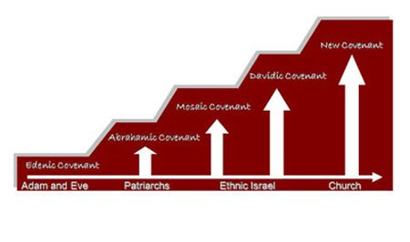 1. Seed 2. Land 3. Prosperity

**Noahic covenant**

How do we see the fulfillment of these 3 areas in Christ?

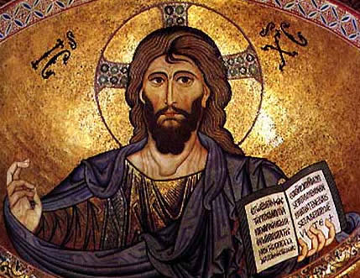1. Seed

Christ Pantocrator, Cathedral of Cefalù, Palermo, Italy, 1148

2. Land

3. Prosperity

Write out aQuestion you are Most Curious about concerning Sin as it relates to Man**:**



“Curiouser and curiouser”