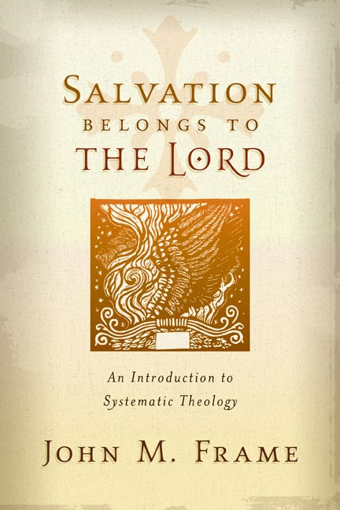**SYSTEMATICS~bibliology Name:**

**Chapter Four ~ The Word of God** Mr. E ~ SRCS

1. Why is this topic typically the first discussed in traditional systematic study?

**The Concept of the Word of God**

**Bonus:** on page 43 frame says, “God’s words through Jesus were many, certainly more than are found in the Bible.” Can you find Frame’s Biblical justification for this statement? Reference: ________________________

2. How does Frame define the Word of God? Why does he expand it from our traditional narrow view of ‘scripture?’

3. ThreeFold Perspective on what the Word ***is***:

A. God’s Word is P_________________; In short, what does this mean?

What is the danger of Words that are powerful but not personal?

B. God’s Word is A ________________; In short, what does this mean?

What is the danger of Words that are powerful but not authoritative?

C. God’s Word is S__________-E__________________; In short, what does this mean?

4. Key subordinate points (& in-class note space):

A. The Word _____________ God; (verse)…

B. Word and _______________ work together; (Summarize I THess.1:5)

C. God performs all His actions by ________________; (List a Few)

D. God is to be ___________________ from other ___________ by the fact that He speaks; (What are idols considered to be? What does this imply? cf.#3))

E. The persons of the ______________ are distinguished by their ________ in the Divine Speech;

(Father _____________; Son is the ___________; Spirit is the ____________ that carries the word to its destination)

F. The Speech of God has ____________ attributes; (List a few)

G. The Word of God is an object of __________________; (Read Ps. 56:4; What alone are we permitted to worship? Conclusion? Distinguish b/w idolatry and worshipping the word…)

H. The Word is __________; (not a separate person, but God’s speech is identified as God; Which passage is referenced here?)

The Work of the Word in the World

“If you get into the habit of taking the Word for granted, it will harden you rather than bless you. Since the Word is powerful, it never leaves you the same. It will leave you either better off or worse off.”

John Frame~p.50

5. What the Word ***Does***:

A. the Word _____________ the world.

B. The Word _______________ His Creatures.

C. The Word ______________ the LORD.

Media

6. What are the three means by which God Communicates to us (Media)?

Events

7. Give an example of each of the four means by which God reveals Himself through events:

Nature:

General History:

Redemptive history:

Miracles:

Words

8. Give an example of each of the four means by which God reveals Himself through Words:

Divine Voice:

Prophets & Apostles:

Written Word:

Preaching & Teaching:

Persons

9. Define these terms:

*Theophany:*

*Incarnation:*

*God’s image-bearers:*

*Illumination:*

BONUS: What is ‘regeneration’ theologically speaking? What is ‘sanctification?’ When Frame mentions regeneration & sanctification, why is it indispensible that he inserts this sentence: “This is not to say that He supplements the Scriptures with additional words to every believer?” (p. 57)

Regeneration:

Sanctification:

**Authoritative** God’s Words to us

Frame’s Threefold

Perspective

**authority**

**General Revelation**: God’s control over the universe

**Existential**: God’s Word in us

**control**

**Covenant Presence**

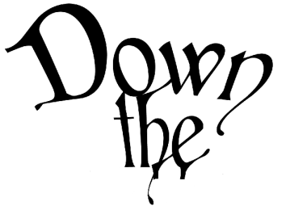

“Curiouser and curiouser”

Write out aQuestion you are Most Curious about concerning the Bible: