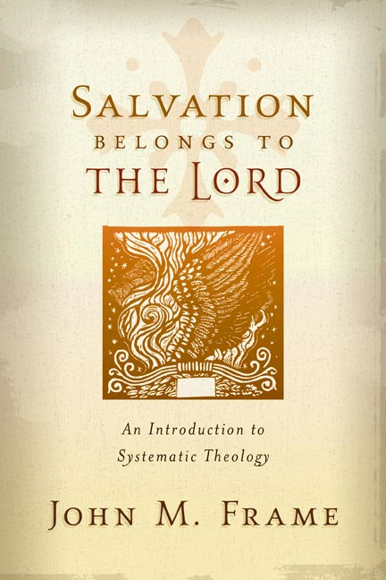**SYSTEMATICS~theo proper (pt i) Name:**

**Chapter Three ~ God Three in One** Mr. E ~ SRCS

* Father
* Son
* Holy Spirit

**Covenant Presence**

Inner Triune Life

1. Frame makes a cautionary statement in the first paragraph (sounds funny coming from a theologian who is known for his triads!); what is his caution?

2. List the 5 assertions of God’s triunity:

(1)

(2)

(3)

(4)

(5)

**God is One**

3. Write out verse and reference supporting the *Unity* of God:

**Bonus**: Can you guess the heresy this Tenet avoids?

**Bonus**: The first verse he mentions (Deut. 6:4) is a central doctrine of Judaism, from the time it was given to moses to today. Why would this tenet be so vividly stated and stressed in moses’ day?

**God is Three**

4. Can you find the divine triad within Isaiah 63:9, 10? Circle who you think qualifies…

9 In all their distress he too was distressed,   
       and the angel of his presence saved them.   
       In his love and mercy he redeemed them;   
       he lifted them up and carried them   
       all the days of old.

10 Yet they rebelled   
       and grieved his Holy Spirit.   
       So he turned and became their enemy   
       and he himself fought against them.

5. Write out your favorite passage in which the members of the trinity appear alongside each other:

**Bonus:** What beautiful element does three persons provide that a purely Judaistic god (singularly one) cannot?

**The Three Are God**

6. Sounds funny to say the previous tenet in reverse word order with a different conjugation of the verb “to be” sandwiched between...but its point cannot be overstressed. According to the church, what does this assertion mean?

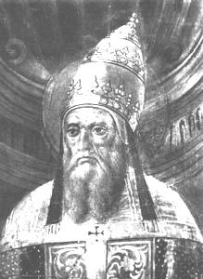

Hello, I’m Pope Callistus I and I finally excommunicated Sabellius in the 3rd century because he spread the heresy of modalism…

**Each of the Persons is Distinct from the Others**

7. a. What does *modalism* teach?

b. This heresy was rejected as scripture speaks of interactions within the trinity. Write out one such scripture verse below:

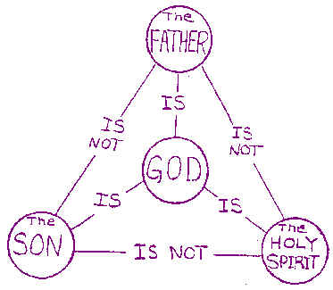

8. To the right is an orthodox diagram of the unity and distinctiveness within the trinity.

Which lines stress God’s unity?

Which lines stress the distinctiveness of the persons?

9. Define the term **CIRCUMCESSION:**

The doctrine of Circumcession is useful

(*a*) to guard the truth of the Divine U________

(*b*) to teach the unity of p_________, which must attend Divine activity—*e.g.*, in the plan of Redemption;

(*c*) to refute the error that the economy of one Person d___________ that of another in this world.

10. Place the persons of the trinity in the Lordship triad

Frame’s Threefold

Perspective

(as applied to the trinity)

_____________

**authority**

**control**

**Covenant Presence**

_____________

______________

11. In short, the actions of the trinity can be generalized to these foci:

A. the Father P______________

B. The Son E______________

C. the Spirit A_______________

**The Three Persons Are Related Eternally as Father, Son, and Holy Spirit**

12. A caution we are wise to remember: “Scripture gives us a G____________ of the Trinity, not a t________________.” SBL, 30

13. Although Scripture does not use terms such as ‘Trinity’ or ‘substance,’ Why do we as theologians use these terms? (see top of pp. 35 & 36)

14. write a brief idea summarizing these concepts as the church meant them to describe God:

Substance:

Person:

The **Ontological** (perspective on the) Trinity:

The **Economic** (perspective on the) Trinity:

The Eternal Generation of the Son:

Answers the question, “How did the [eternal] Son become the [incarnate, baby] Son?”

The Eternal Procession of the Spirit:

15. What are two possible risks of not keeping the Ontological trinity distinct from the Economic trinity?

a.

b.

16. Comment on the split between the Eastern & Western Churches in regards to the Doctrine of the Spirit.

**Trinitarian Models**

17. Fill in the table according to Frame’s assessment:

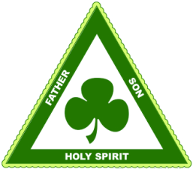 Originator Strength Model Weakness

stresses u_________; visual, accessible

easily separated; too concrete; loses personhood

St. P_________

loses t__________ & personhood

**Mind**: Knower, Known, Knowledge (psychological)

A_____________ stresses u_______

Familial: Father, Son, Holy Spirit (social)

loses u________

captures t__________ & personhood

C______________ F_____________

What is the trend with historical Trinitarian models (and all as a matter of fact)?

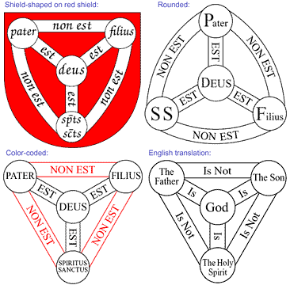

Latin version of ‘Trinitarian Shield’ English Translation

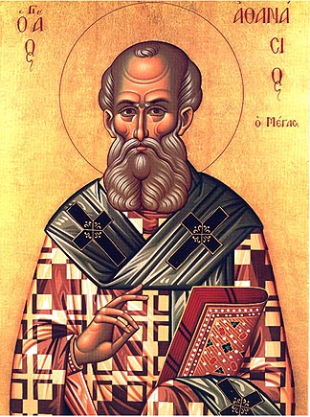

Howdy, I’m St. Athanasius and I fought hard in the 4th century to preserve the Biblical doctrine of the Trinity. I was unfairly exiled by both Constantine I and his son (under penalty of death with the latter!)…I suppose that last part had more warrant…I did accuse Constantius of being the precursor to the AntiChrist…

18. “How Practical is all this?” You ask. Although the terms of doctrine hold importance because they communicate the clarity of a particular truth, Athanasius was fighting primarily for the areas of Worship and Salvation. Comment below why Athanasius’ position on these issues is important to us as believers today!

Worship:

Salvation: