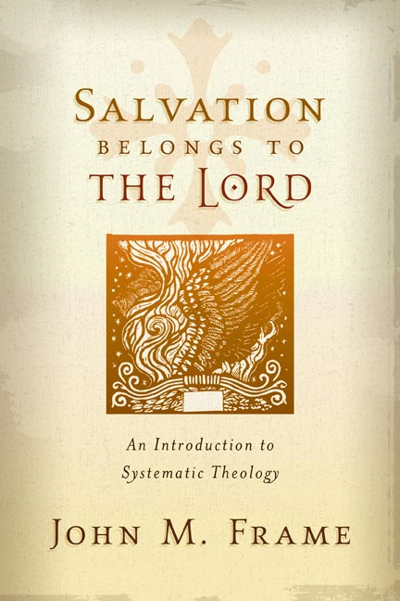
A Study Guide
in 3 parts


“Doctrine: the Breakfast of Christians”
Name:
An Intro to SYSTEMATICS Paul Winstead & Christopher Eckart RPC ~ spring 2013

Part I: chapters 1-8

Getting to know each other Name:
Ice-breaker Paul & Chris~ RPC
OPTION 1: Share the title of the last movie you watched & liked; share the title of the last movie you didn’t care for so much. What would you have changed to make it better?
OPTION 2: Take a moment, think about this one, and write down your answers…
If your house was burning down and all of your family members were safe, what three objects would you try to save?
1.
2.
3.

INTRO to the INTRO
1. What brought you here?
2. When in the past have you had experience with a conversation or teaching centered on the term ‘doctrine?’

Was it positive or negative? How so (describe)?

3. We will be covering chapters 1-8 or so…which include the following subjects:

Lordship of God: how it changes everything
Doctrine of God
Doctrine of the trinity: specifics about threeness & oneness
Doctrine of the Word of God
The authority of scripture
What is Theology?
Doctrine of Man
Doctrine of sin

Circle your seeming favorite. Box the one you are most curious about & would like to understand more deeply. Put a triangle around the chapter about which you know the least.
4. Peering through the topics listed above, write down one or two questions you have that stem from any of these topics.

1.

2.

A word on Format
Each week it is our desire that your understanding of the awesomeness of God grows—but we understand that it cannot be a mere academic exercise. As St. Paul reminds us in Corinthians, “If I have the gift of prophecy and can fathom all mysteries and all knowledge, and if I have a faith that can move mountains, but do not have love, I am nothing” and so we recognize that our discussions—however deep or profound, must find there expression in action—in a word: obedience. In this vein, we will use the following format:
10-15 minutes: opening chit-chat and social catch-up
30-40 minutes: lecture and interaction (Questions welcome)
20 minutes: “shoe-leather” & discussion

SYSTEMATICS ~ theo proper (pt 1) Name:
Chapter One ~ God, the Lord Paul & Chris~ RPC
1. How is Systematic Theology “topical?” When Frame says that systematic theology asks “Whole Bible questions,” what does he mean?

2. Why is the doctrine of God called “theology Proper?”

3. How does the Shorter Catechism (SC) define God? How does the Bible, through Moses, introduce us to God? Both means are helpful; share one way each is helpful.

4. While it is true that God revealed Himself to Adam from the Beginning—why does Frame consider Exodus 3 the real beginning of the Doctrine of God?

5. Names in Hebrew are pregnant with meaning. Look up what your name means and share it below (add the parent language if you can). Share the long form, short form, and very short form of God’s Name.

6. Summary of the Old Testament: “ ____________ ____ ___________ ”;
Summary of the New Testament: “ ____________ ____ ___________ ”; Write out an entire verse below where God refers to Himself as LORD (Include reference).

7. What does a secularist view mean when it says that the personal reduces to the impersonal? What does the Bible teach?

8. Summarize the Lordship Attributes (First of many triads frame employs) by naming and describing each.

9. How should the terms transcendence and Immanence be understood Biblically?

10. Frame ends the chapter by predicting audience objections to his focus of Lordship. Which one of the objections most resonates with you? Why? After writing it out, take a moment to pray about it—asking God to help you submit to His Lordship in this particular area.

Bonus: (Bottom p. 6) What does Frame mean when he says “…this is important, to Jesus Christ?” In other words, what makes it so important to apply this to the Son?

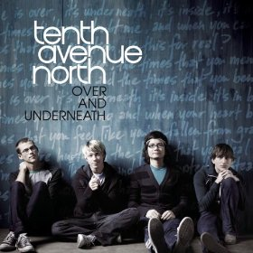
Bonus: Here are a few lyrics from tenth avenue north’s song “Hold My Heart”…At least two specific doctrines from this chapter are being addressed here (partic. In the chorus); underline the 2 best lines that connect to our study and briefly explain how both are involved.


hold my heart
How long must I pray
Must I pray to You?
How long must I wait
Must I wait for you?
How long ‘til I see your face
See you shining through
I'M ON MY KNEES
BEGGING YOU TO NOTICE ME
I'M ON MY KNEES
FATHER, WILL YOU TURN TO ME
ONE TEAR IN THE DRIVING RAIN
ONE VOICE IN THE SEA OF PAIN
COULD THE MAKER OF THE STARS
HEAR THE SOUND OF MY BREAKING HEART
ONE LIFE, THAT'S ALL I AM
RIGHT NOW I CAN BARELY STAND
IF YOU'RE EVERYTHING YOU SAY YOU ARE
WOULD YOU COME CLOSE AND HOLD
MY HEART


“Curiouser and curiouser”



I've been so afraid, afraid to close my eyes
So much can slip away before I say goodbye
But if there's no other way
I'm done asking why
I'M ON MY KNEES
BEGGING YOU TO TURN TO ME
I'M ON MY KNEES
FATHER, WILL YOU RUN TO ME
So many questions without answers
Your promises remain
I can't see but I'll take my chances
To hear you call my name
To hear you call my name
Write out aQuestion you are Most Curious about concerning God:





APPLICATION DISCUSSION SYSTEMATICS ~ theo proper (pt 1)
Chapter One ~ God, the Lord Paul & Chris~ RPC

1. Think on this past week. How has this doctrine (or specific within) impacted your life—whether you kept it in mind at the time, remember it now in reflection, or ignored it completely!

2. How will this doctrine (or specific within) impact your life this next week?

SYSTEMATICS~ theo proper (pt 2) Name:
Chapter Two ~ Who God Is & What He Does Paul & Chris ~ RPC
Attributes of
- Love (cov. Pres.)
- Knowledge (auth.)
- Power (Control)
Frame’s Threefold
Perspective
Authoritative descriptions

authority
- Miracles
- Providence
- Creation
- Decrees
God’s acts
- Father
- Son
- Holy Spirit
Inner Triune Life
control
Covenant Presence

God’s Acts
1. How does frame define ‘miracles?’ Why does he reject the sometimes heard definition of “exceptions to natural law?”

2. How are miracles Powers, signs, and wonders?

3. Does God still do miracles today? Offer both sides of the miracle ‘coin:’

4. If miracles are God working extraordinarily, what is providence? How does the Westminster shorter catechism define providence?

5. (page 18, 2nd Paragraph) Frame aptly reminds us the significance of the word ‘all.’ Choose the one aspect of god’s control (that frame lists in the paragraph) with which you struggle the most (whether through active resistance or neglect), write it below, and pray about it specifically.

6. Consider concurrence for a moment. Share two examples of God’s concurrence in your own life.

7. The doctrine of creation is foundational to reality—after all, it gave rise to what we call the universe—our home. Explain two ways we know that God created the world out of nothing even though the Bible doesn’t say it in those exact words.

BONUS: On page 20, Frame Profoundly draws a parallel between Creation ex nihilo and salvation. Describe how these are connected by telling what the latter echoes about the former.

8. The doctrine of creation is very foundational to theology (ours & frame’s); How important is the timeframe of creation to Frame? How does Satan use this to his own advantage?

9. Consider God’s decrees: fill in
A. God’s acts are P_____________--God has a r_____________ for all that He does and He is able to make everything work together for G________ and His G_________.
B. God’s Plan is E____________: they extend before time and continue forever
C. What is God’s most wonderful decree? _______________; write out either Eph. 1:4 or 1 Tim. 1:9 below; circle which reference you chose.

10. Consider God’s Descriptions
A. Names: pick a favorite name for God: ________________; what does it mean/signify about God? Why is it your favorite?

B. 1. Images: Choose an image of God mentioned in scripture (but not in the paragraph from SBL): ____________________________________: where is it in scripture and what does it teach us about God?

2. Images: Frame offers what I believe to be the best short answer to the question of why God is predominantly referred to as male. What would you say to someone who accused God of chauvinism/sexism to back up Scriptures’ perspective?

Frame’s Threefold Perspective

C. Attributes: Love, Knowledge, Power; Place these three divisions around the triad and justify each of their placements in its corresponding box:
_________________________
Authoritative descriptions

authority

_________________________
control
Covenant Presence
_________________________

APPLICATION DISCUSSION SYSTEMATICS ~ theo proper (pt 2)
Chapter Two ~ Who God Is & What He Does Paul & Chris~ RPC

1. Think on this past week. How has this doctrine (or specific within) impacted your life—whether you kept it in mind at the time, remember it now in reflection, or ignored it completely!

2. How will this doctrine (or specific within) impact your life this next week?

Attributes of Love
11. Explain God’s Love for you in terms of allegiance, Affection, and Action.

12. Circle and explain one of the following referencing a Bible verse:
A. Is God a god of love or of judgment?
B. Does God really hate Some people?
C. How could God be Jealous and love?
D. Does God love all equally?

Attributes of Knowledge
13. Summarize the Four aspects of God’s Knowledge:
His Speech:

His Truth:

His Knowledge:

His Wisdom:

Attributes of Power
Define each term then react to each statement:
14. A. 1. Omnipotence:

2. “God’s omnipotence means He can do anything”

B. 1. Decretive will:

2. Preceptive will:

3. Divine vocation:

Bonus: Answer this question biblically: “I read in I Timothy 2:3, 4, “³This is good, and pleases God our Savior, ⁴who wants all men to be saved and to come to a knowledge of the truth.” How does this square with the doctrine of election—particularly the aspect of reprobation, where god chooses who will be lost?”

15. Explain how God’s Lordship applies to each of these terms:
Infinity

Eternity

Immensity

16. Briefly define these terms as they relate to God:
Immutability (unchangeability):

Omnipresence:

Incorporeality:

Invisibility:

Glory:

Aseity

Impassibility:

17. In what four ways is God unchangeable?

“Curiouser and curiouser”
Write out aQuestion you are Most Curious about concerning the Trinity:

APPLICATION DISCUSSION SYSTEMATICS ~ theo proper (pt 2)
Chapter two ~ Who God Is & What He Does Paul & Chris~ RPC

1. Think on this past week. How has this doctrine (or specific within) impacted your life—whether you kept it in mind at the time, remember it now in reflection, or ignored it completely!

2. How will this doctrine (or specific within) impact your life this next week

SYSTEMATICS~theo proper (pt 3) Name:
Chapter Three ~ God Three in One Chris & Paul ~ RPC
- Father
- Son
- Holy Spirit
Covenant Presence
Inner Triune Life

1. Frame makes a cautionary statement in the first paragraph (sounds funny coming from a theologian who is known for his triads!); what is his caution?

2. List the 5 assertions of God’s triunity:
(1)
(2)
(3)
(4)
(5)

God is One
3. Write out verse and reference supporting the Unity of God:

Bonus: Can you guess the heresy this Tenet avoids?
Bonus: The first verse he mentions (Deut. 6:4) is a central doctrine of Judaism, from the time it was given to moses to today. Why would this tenet be so vividly stated and stressed in moses’ day?

God is Three
4. Can you find the divine triad within Isaiah 63:9, 10? Circle who you think qualifies…
⁹ In all their distress he too was distressed,
and the angel of his presence saved them.
In his love and mercy he redeemed them;
he lifted them up and carried them
all the days of old.
¹⁰ Yet they rebelled
and grieved his Holy Spirit.
So he turned and became their enemy
and he himself fought against them.
5. Write out your favorite passage in which the members of the trinity appear alongside each other:

Bonus: What beautiful element does three persons provide that a purely Judaistic god (singularly one) cannot?

The Three Are God
6. Sounds funny to say the previous tenet in reverse word order with a different conjugation of the verb “to be” sandwiched between...but its point cannot be overstressed. According to the church, what does this assertion mean?

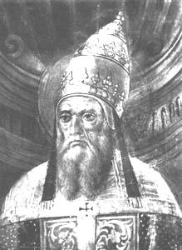
Hello, I’m Pope Callistus I and I finally excommunicated Sabellius in the 3rd century because he spread the heresy of modalism…
Each of the Persons is Distinct from the Others
7. a. What does modalism teach?

b. This heresy was rejected as scripture speaks of interactions within the trinity. Write out one such scripture verse below:

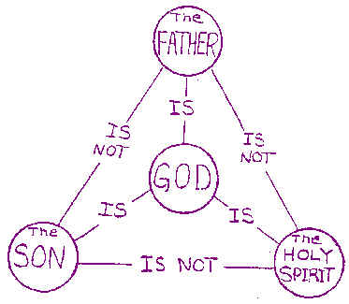
8. To the right is an orthodox diagram of the unity and distinctiveness within the trinity.
Which lines stress God’s unity?
Which lines stress the distinctiveness of the persons?

9. Define the term CIRCUMCESSION:

The doctrine of Circumcession is useful
(a) to guard the truth of the Divine U________
(b) to teach the unity of p_________, which must attend Divine activity—e.g., in the plan of Redemption;
(c) to refute the error that the economy of one Person d___________ that of another in this world.

10. Place the persons of the trinity in the Lordship triad
Frame’s Threefold
Perspective
(as applied to the trinity)
_____________

authority

control
Covenant Presence
_____________
______________

11. In short, the actions of the trinity can be generalized to these foci:
A. the Father P______________
B. The Son E______________
C. the Spirit A_______________
The Three Persons Are Related Eternally as Father, Son, and Holy Spirit
12. A caution we are wise to remember: “Scripture gives us a G____________ of the Trinity, not a t________________.” SLB, 35
13. Although Scripture does not use terms such as ‘Trinity’ or ‘substance,’ Why do we as theologians use these terms? (see top of pp. 35 & 36)

14. write a brief idea summarizing these concepts as the church meant them to describe God:
Substance:

Person:

The Ontological (perspective on the) Trinity:

The Economic (perspective on the) Trinity:

The Eternal Generation of the Son:
Answers the question, “How did the [eternal] Son become the [incarnate, baby] Son?”

The Eternal Procession of the Spirit:

15. What are two possible risks of not keeping the Ontological trinity distinct from the Economic trinity?
a.

b.

16. Comment on the split between the Eastern & Western Churches in regards to the Doctrine of the Spirit.

Trinitarian Models
17. Fill in the table according to Frame’s assessment:
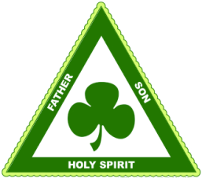
Originator Strength Model Weakness
stresses u_________; visual, accessible
easily separated; too concrete; loses personhood
St. P_________
loses t__________ & personhood
Mind: Knower, Known, Knowledge (psychological)
A_____________ stresses u_______
Familial: Father, Son, Holy Spirit (social)
loses u________
captures t__________ & personhood
C______________ F_____________

What is the trend with historical Trinitarian models (and all as a matter of fact)?

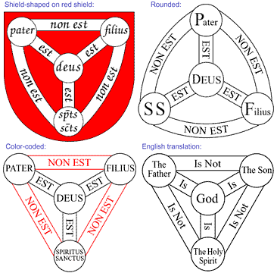

Latin version of ‘Trinitarian Shield’ English Translation
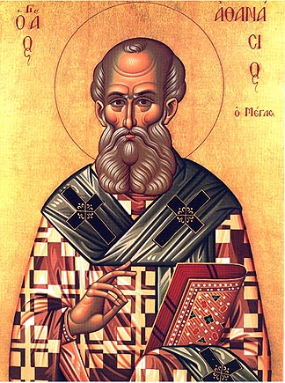
Howdy, I’m St. Athanasius and I fought hard in the 4th century to preserve the Biblical doctrine of the Trinity. I was unfairly exiled by both Constantine I and his son (under penalty of death with the latter!)…I suppose that last part had more warrant…I did accuse Constantius of being the precursor to the AntiChrist…
18. “How Practical is all this?” You ask. Although the terms of doctrine hold importance because they communicate the clarity of a particular truth, Athanasius was fighting primarily for the areas of Worship and Salvation. Comment below why Athanasius’ position on these issues is important to us as believers today!

Worship:

Salvation:

“Curiouser and curiouser”
Write out aQuestion you are Most Curious about concerning the Bible itself:

SYSTEMATICS~theo proper (pt 3)
Chapter Three ~ God Three in One Chris & Paul ~ RPC
1. Think on this past week. How has this doctrine (or specific within) impacted your life—whether you kept it in mind at the time, remember it now in reflection, or ignored it completely!

2. How will this doctrine (or specific within) impact your life this next week

SYSTEMATICS~bibliology Name:
Chapter Four ~ The Word of God Chris & Paul~ RPC
1. Why is this topic typically the first discussed in traditional systematic study?

The Concept of the Word of God
Bonus: on page 43 frame says, “God’s words through Jesus were many, certainly more than are found in the Bible.” Can you find Frame’s Biblical justification for this statement? Reference: ________________________
2. How does Frame define the Word of God? Why does he expand it from our traditional narrow view of ‘scripture?’

3. ThreeFold Perspective on what the Word is:
A. God’s Word is P_________________; In short, what does this mean?

What is the danger of Words that are powerful but not personal?

B. God’s Word is A ________________; In short, what does this mean?

What is the danger of Words that are powerful but not authoritative?

C. God’s Word is S__________-E__________________; In short, what does this mean?

4. Key subordinate points (& in-class note space):
A. The Word _____________ God; (verse)…

B. Word and _______________ work together; (Summarize I THess.1:5)

C. God performs all His actions by ________________; (List a Few)

D. God is to be ___________________ from other ___________ by the fact that He speaks; (What are idols considered to be? What does this imply? cf.#3))

E. The persons of the ______________ are distinguished by their ________ in the Divine Speech;
(Father _____________; Son is the ___________; Spirit is the ____________ that carries the word to its destination)

F. The Speech of God has ____________ attributes; (List a few)

G. The Word of God is an object of __________________; (Read Ps. 56:4; What alone are we permitted to worship? Conclusion? Distinguish b/w idolatry and worshipping the word…)

H. The Word is __________; (not a separate person, but God’s speech is identified as God; Which passage is referenced here?)

The Work of the Word in the World
“If you get into the habit of taking the Word for granted, it will harden you rather than bless you. Since the Word is powerful, it never leaves you the same. It will leave you either better off or worse off.”
John Frame~p.50
5. What the Word Does:
A. the Word _____________ the world.

B. The Word _______________ His Creatures.

C. The Word ______________ the LORD.

Media
6. What are the three means by which God Communicates to us (Media)?

Events
7. Give an example of each of the four means by which God reveals Himself through events:
Nature:

General History:

Redemptive history:

Miracles:

Words
8. Give an example of each of the four means by which God reveals Himself through Words:
Divine Voice:

Prophets & Apostles:

Written Word:

Preaching & Teaching:

Persons
9. Define these terms:
Theophany:

Incarnation:

God’s image-bearers:

Illumination:

BONUS: What is ‘regeneration’ theologically speaking? What is ‘sanctification?’ When Frame mentions regeneration & sanctification, why is it indispensible that he inserts this sentence: “This is not to say that He supplements the Scriptures with additional words to every believer?” (p. 57)
Regeneration:
Sanctification:

Authoritative God’s Words to us
Frame’s Threefold
Perspective

authority

General Revelation: God’s control over the universe
Existential: God’s Word in us
control
Covenant Presence

“Curiouser and curiouser”
Write out aQuestion you are Most Curious about concerning the Bible:

SYSTEMATICS~bibliology
Chapter four ~ the word of god Chris & Paul ~ RPC
1. Think on this past week. How has this doctrine (or specific within) impacted your life—whether you kept it in mind at the time, remember it now in reflection, or ignored it completely!

2. How will this doctrine (or specific within) impact your life this next week

SYSTEMATICS~bibliology Name:
Chapter Five ~ The Authority of the Bible Chris & Paul ~ RPC
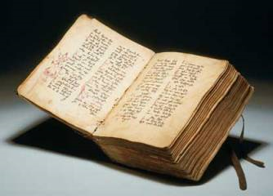
The Word of God:
“God’s powerful, authoritative
self-expression”
1. Defined (as it is to the right ) What three things does God’s Word do in the World?
A. as His decree:

B. as His address:

C. as His presence:

BONUS: Let’s suppose the Word of God were a boat (or, if you’re Doofenshmirtz, a “bo-at”)…What would happen if we believed that it contained even the slightest bit of error? Now, take Scripture and apply it to this metaphor.

The Authority of the Written Word
2. What the Bible says about itself:
A. God’s revelation, particularly Scripture, is ___________________ not momentary. (p. 59)
B. God’s revelation is to be G_____________________ and P____________________. (p. 60)
C. God’s revelation is to be D____________________ to all nations and generations. (p. 60)
D. God’s revelation is a W_____________________ of God to man and so carries His full authority. (p.61)

E. God’s revelation is intended to be valid and helpful throughout all T____________. (p. 62)
“ ‘Scripture says’ is, like ‘It is written,’ an authoritative citation.”
B.B. Warfield as paraphrased by Frame~ p.62
F. The religion of Both the Old and New testaments is essentially the same—both are centered on the W________ of God.
Pages 62-64 are so personal and written with encouragement in mind. Write one ‘take away’ (a favorite truth) from these pages:

Canon
3. True or False: The Church Determined which books should be in the Bible. Defend your answer Here:

4. Write out John 10:27 below and tell me how this verse relates to the canon:

Transmission of the Word
5. What is meant by the phrase ‘transmission of the word?’

6. Place the missing words in this “order of Transmission”:
“God-breathed”; He speaks the words of the Bible and the authors write organically

I_________________ C_______________
Original manuscripts are reproduced

7. What three things must someone who disbelieves the infallibility of God’s word because of mistakes made while copying consider?
a.

b.

c.

8. Frame very personally (and effectively, I might add) defends why God would involve humans in the process of transmission. Share the one reason that communicates most strongly to you.

9. Share and briefly describe three works of the Spirit involved in the transmission of the Word:
1.
2.
3.

Inerrancy
10. What does it mean to say that the Bible is inerrant?

11. distinguish between error and imprecision.

12. Give an original example of an imprecision that isn’t ordinarily considered erroneous.

13. Summarize the two potential arguments people use to say that the Bible contains errors:
A

B.

Clarity
14. What does the ‘clarity’ of Scripture mean and what does the historical Reformation have to do with clarity?

15. Write out one verse (& reference) that deals with Scripture’s clarity.

Necessity
16. What is meant by the ‘necessity’ of God’s Word?

17. What would you say to someone who tells you they believe in God but do not read or need the Bible…

Sufficiency
18. What is meant by the ‘sufficiency’ of Scripture?

19. Frame follows this doctrine to its logical conclusion in several areas. Choose one area and explain how this doctrine applies.

A quick overview
Inerrancy: God’s Word is without error; Infallible: God’s Word is incapable of error; “It is inerrant because it is infallible. There are no errors, because there can be no errors in the divine speech” (Frame, DWG). It is important to note that, while these terms can be distinguished, they should never be separated (Chicago Statement on Biblical Inerrancy, Article XI)
Authority: the words in Scripture are God’s words in such a way that to disbelieve or disobey them is to disbelieve or disobey God

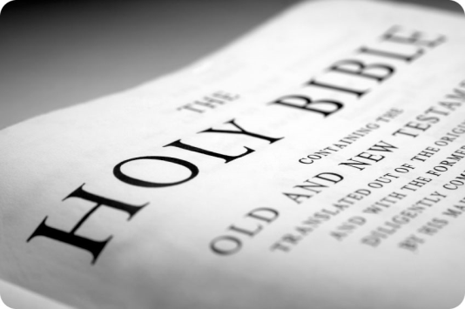
Canon: The term canon is derived from a Greek word that means “measuring rod,” or “standard”; The Church, in its fallibility, “received” the canon

Clarity: God’s Word is written in such a way that its central teachings are able to be understood by all who read it seeking God’s help & willing to follow it

Necessity: the Bible is necessary for knowing the Gospel, maintaining spiritual life, & knowing God’s will

Sufficiency: Scripture contained all of the words He intended at each stage of redemptive history and now it contains all we need for salvation & perfect trust & obedience

“Curiouser and curiouser”
Write out aQuestion you are Most Curious about concerning the study of theology :

SYSTEMATICS~bibliology
Chapter five ~ the authority the word Chris & Paul ~ RPC
1. Think on this past week. How has this doctrine (or specific within) impacted your life—whether you kept it in mind at the time, remember it now in reflection, or ignored it completely!

2. How will this doctrine (or specific within) impact your life this next week

SYSTEMATICS theo proper (pt 4) Name:
Chapter Six ~ What is Theology? Chris & Paul ~ RPC
1. In the opening paragraphs frame confesses that traditional systematicians cover this at the beginning of the journey. He uses very interesting logic to, in a sense, justify his delay. What two reasons does he give?
Theology:
“The application of Scripture to all areas of life”
A.

B.

2. As important as words are (esp. to professor frame), he suggests two ways to define ‘theology.’ Write these below:
A.
B.

BONUS: 1. According to his plea on page 73, can you suggest a third definition? Is it different enough from the other two? Also, a good test would be to have adequate justification (eg. An outside source suggesting a facet unreflected)

BONUS: 2. If you have been in my classes recently, you would perceive me to be both a science and a Bible teacher. It has not always been so. Years ago (some of you could, perhaps, consult your older siblings on this one) I taught these as well as courses in English lit, anatomy, philosophy, commercial art, & health! Using Kuyper’s profound statement from his Lectures on Calvinism, as a guide, If Mr.e had to choose but one course/subject to teach, which would he choose, and why?

Theology is Knowing God
3. Frame (p. 74) says this, finish the quote: “Eternal life, in the final analysis, is ___________ ______________ ______ __________ _________ ______________ ________.”
4. Do unbelievers know God?
Provide a proof text (scripture verse to justify):
How is an unbeliever’s knowledge of God different from a believer’s?

“You grow in knowledge of God as you know him more and more as Lord, as King.

First, he is the one who controls all things. You will grow in your knowledge of God as you see more and more things as under his control: the present, the future, your own life, your sin, your salvation. Perhaps you think now that there is some part of your life where you are in control. You will grow in your knowledge of God when you come to see that ultimately there is no part of your life that is controlled by anyone other than God, even that little part of your life.
Second, you come to know God as the one who speaks with such authority that you must
obey – in every area of your life: your social life, your moral life, even your intellectual life. You will grow in
your knowledge of God when you come to bring every thought captive to Christ (2 Cor. 10:5).
Third, you come to know God as you sense more and more his presence in your life. You can’t ever escape from him. You can’t do anything that he doesn’t see. And nothing shall ever separate you from his love.”
Frame~ p.75

5. As you read the above selection, which truth do you most appreciate? Why?

To which truth do you find yourself most resistant? Why?

6. Cite (write out fully) one scripture passage that teaches that:
(1) the knowledge of God produces obedience:

(2) Obedience leads to the knowledge of God:

(3) Obedience equated with knowledge:

(4) A litmus test for those who claim to know God:

(5) true knowledge must be gained in an obedient manner:

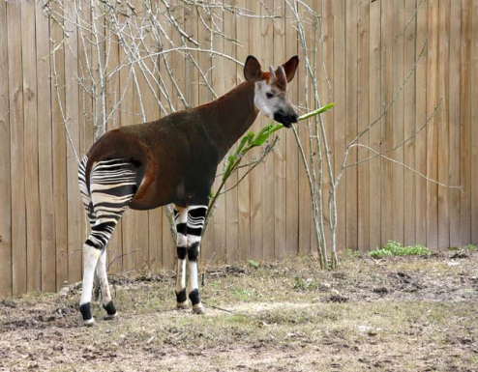
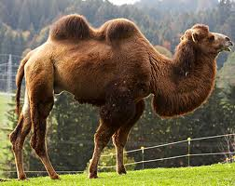
7. It’s subtle, but Frame references this aspect of knowing God by knowing His World--particularly His sense of humor. He then mentions two animals—one obscure (okapi, right) and one recognizable (camel, far right). Because I love both humor and biology, I cannot help but make note of this: Scripture may seem to lack (apparent) hilarity from the mouth of God but study zoology for but one day, and God’s sense of humor leaps from the page of creation making even the most ardent atheist break into laughter. As a means of exercising this essential but neglected muscle, find an animal or plant that bemuses you in some way (please, no domestic animals) draw it in the box below, write where you see God’s sense of humor and, unless your first name is Leonardo, be sure to label it.
Organism:

Justification:

8.
Normative: What does God’s revelation say?
Frame’s Threefold
Perspective:
Lordship attributes

authority

Existential: Who am I? (Self)
situational: what does the world mean?
control
Covenant Presence

I’ve presented this chart as a whole because it takes a few times around to get it right. I typically summarize it using the key words God, World, & Self—but Frame’s first full paragraph on page 78 explains it well. To show proof of your understanding, summarize the relationship between the three perspectives here:

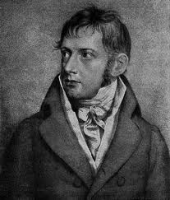
Theology is A Disciplined Study of God
9. Schleiermacher (right) defined theology as “Christian Doctrines are Christian religious affections set forth in speech.” How does this definition fall short?

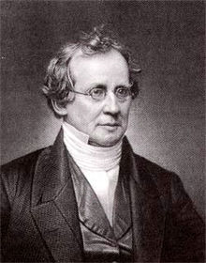
10. Hodge’s (left) definition is better: “…the exhibition of the facts of Scripture in their proper order and relation…” What does Hodge include that Schleiermacher does not?

What pertinent qualification does frame make to Hodge’s definition?

11. Why, then, do we need theology?

12. Using his perspectives, frame discusses well the problems the Pharisees had with their theology. What, in a nutshell, was their problem? Support it by discussing the context of one pertinent scripture reference.

Traditional Theological Programs
13. Place the three major programs & two subcategories into their respective descriptions:
_______________: A subdivision of Systematics; sees “how Scripture has been used in the past to help us do better in the future”

_______________: Application of the events of Scripture to our lives; God’s Word is studied as the history of redemption.

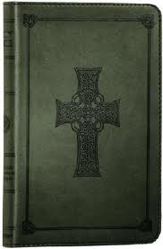
_______________: Application of God’s Word to all areas of life—what we should believe & how we should behave; God’s Word is considered holistically to see what it says in its entirety on a given subject.

_______________: Application of particular passages of Scripture to our lives; God’s Word is carefully combed, sentence by sentence, word by word.

_______________: A subdivision of Systematics; Asks how we should communicate the Word of God—through preaching, teaching, missions, evangelism, etc.

14. knowing a bit about yourself, if you were to engage in a particular programmatic perspective, which one would you choose & why?

15. Frame concludes this section with a word on how these perspective labels are somewhat misleading. What does frame say to this end?

Method in systematic theology
16. Fill in the form of the Question Systematic theology answers: “What does the _____________ _______________ teach about x, where x can be any ____________?”
17. Name at least two tools a student needs to pursue systematics appropriately: 1.
2.

18. One cannot overemphasize frame’s point to conclude the chapter (1st paragraph, page 84). Summarize his point here and justify why it is so significant.

Write out aQuestion you are Most Curious about concerning Man:

“Curiouser and curiouser”

SYSTEMATICS~theology proper (pt 4)
Chapter six ~ what is theology? Chris & Paul ~ RPC
1. Think on this past week. How has this doctrine (or specific within) impacted your life—whether you kept it in mind at the time, remember it now in reflection, or ignored it completely!

2. How will this doctrine (or specific within) impact your life this next week

SYSTEMATICS~anthropology Name:
Chapter Seven ~ Man, the Image of God Chris & Paul ~ RPC
1. Frame spends time in the opening of this chapter speaking to the sensitive topic of Gender & language. Find a Scripture verse (other than Genesis 5:2) that uses the term ‘man’ to represent both male and female. Write it out here:
Anthropology:
“We are clay images-a powerful lesson in humility-but we are also images of God- creatures of wondrous value and dignity. ” Richard Pratt, Designed for Dignity, pg. 13.

Creatures, with Dignity
2. Name the two levels of being In God’s economy (in other words, all reality): a.
b.
3. In the third full paragraph Frame very succinctly describes what it is to glorify God. Write out that statement below:
“To Glorify God is to _____________________________________________________________
____________________________________________________________________________________”
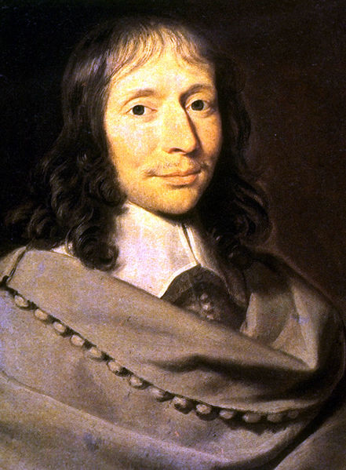
Choose one of the verses that follow this definition and write it out below (reference and verse):
“What a Chimera is man! What a novelty, a monster, a chaos, a contradiction, a prodigy! Judge of all things, an imbecile worm of the earth; depository of truth, and sewer of error and doubt; the glory and refuse of the universe.”
Blaise Pascal (1623-1662)

4. Ever feel like you are practically invincible one instant and painfully frail the next. We are a strange mix of humility and dignity. The french renaissance scientist, philosopher, & theologian Blaise Pascal once wrote the paragraph to the right. How true! Frame, at this point however, is viewing man in terms of level of being—without regard for sinner or not. Describe how frame shows where man’s humility & dignity is rooted (p.86):
Humility:

Dignity:

BONUS: Go to http://www.youtube.com/watch?v=SXh7JR9oKVE then http://www.youtube.com/watch?v=X3iFhLdWjqc&feature=aso. Watch the videos and tell me what you enjoy about each. Then, as specifically as you can, share how God is being enjoyed in each video.
Video#1

Video#2

5. Write out the WSC Q &A 1 below:

Think of something you thoroughly enjoy. Share it. How is God enjoyed through this thing or activity? (ever wonder what it means if God doesn’t sanction what you ‘enjoy?’ it, essentially, detracts from His glory—that is the glory you’re to give Him and the enjoyment you were meant to have!

Creation & Evolution
6. List 2 evidences against evolution from Scripture
1.

2,

7. Define the term microevolution:

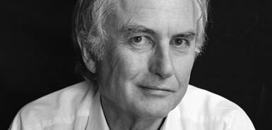
8. Self-proclaimed atheist Richard Dawkins himself says that we live in a universe which has
‘no design, no purpose, no evil and no good, nothing but blind, pitiless indifference’. Dawkins, R., River out of Eden, Weidenfeld and Nicolswi, Chapter 4, 1995.
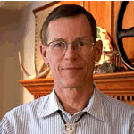
In similar vein, another atheist, Professor William Provine, Cornell University, said,
‘ … There are no gods, no purposes, no goal-directed forces of any kind. There is no life after death. When I die, I am absolutely certain that I am going to be dead. That’s the end for me. There is no ultimate foundation for ethics, no ultimate meaning to life, and no free will for humans, either.’ Provine, W.B., Origins Research 16(1):9, 1994.
There are only two options: Supernatural creation or Self-Created materialism. One is correct, the other, false. One is true while the other is irrational. On which side do you find yourself and why?

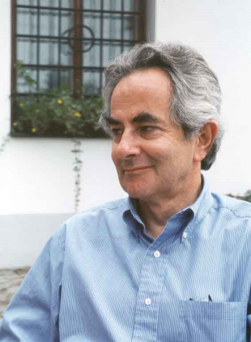
9. Self-professed atheist, Thomas Nagel, Professor of Philosophy at New York University, put it rather candidly:
‘I want atheism to be true and am made uneasy by the fact that some of the most intelligent and well informed people I know are religious believers. It isn’t just that I don’t believe in God and naturally, hope there is no God! I don’t want there to be a God; I don't want the universe to be like that.’
Nagel, T., The Last Word, Oxford University Press, New York, 1997, p. 130.

Why would Nagel be inclined to say this? How Is this bias explainable from a Christian point of view?

Man, the image of God
10. As a biologist, I’m tempted to find the image of God in man physically (reflected somewhere by the body)…and as a theologian, I’m tempted to find this image metaphysically (psychologically or spiritually perhaps) but Frame makes a subtle but profound distinction that recenters the Image of God Biblically:
“The Bible doesn’t say that there is an image of God in man; rather, it says that man is the Image of God.” (p88)

11. What pitfall does this primarily avoid? (hint…read Frame’s sentence just prior to the quote above)


12. Now, with this in mind, what ethical ramifications does this protect us from?

13. Does this mean that there is no difference between us & God?
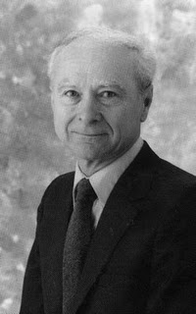
14. What are Dr. Kline’s Three divisions of the Image of god? Answer the Questions that might arise…
a. P___________________: our bodies reflect primarily his
_______________ (eg. Eyes, arms, hands)
What could you say to someone who says that, because God does not Have a body, the Image of God cannot be Physical?

Dr. Meredith Kline
B. O __________________: as children of the King & stewards we are
V_________________, assisting him to have dominion over the earth.
Does this mean that He needs us or that He is incapable of dominion on His own?

C. E__________________: we reflect God in our K____________________,
R______________________, & H____________________.
“The image of God extends to our I__________________ C_____________________.” (p 89)

⁴⁸ “Be perfect, therefore, as your heavenly Father is perfect.”

Matthew 5:48

Read Jesus’ words to the right. What does this say about God (in other words, does Jesus simply say this to frustrate humanity?)
(note: Although frame here is talking about groups of people and not parts of one individual, the second full paragraph on page 89 relates to question #12 above; refine your answer if you need to—especially paying attention to what he says about the ‘disabled.’)
15. List a few social issues that have been hotly debated that relate to what Frame (Scripture here) is saying about to whom the Image of God belongs…

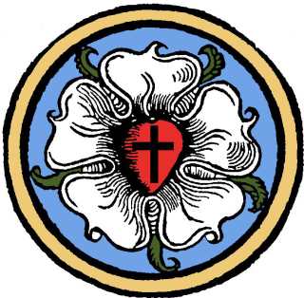
16. Which denomination teaches that humans lost God’s image when we fell into Sin in the Garden?
Although it speaks of the uses of the tongue, write James 3:9 below underlining the part that repudiates the idea that we lost God’s image that day:
Denominational Herald known as __________ rose, who himself was invited to create a personal symbol to summarize his faith in the 1520’s. As his writings became increasingly popular, there was a desire on the part of the Wittenberg printers somehow to try to indicate what was an authorized publication of his works.

Remember—our image-bearing was marred but not lost in the Fall!
Reformer
17. How is biblical ethics an imitation of Christ?

“…sin is trying to be God, trying to put oneself on the throne. So, even the distortion of the image reflects God in an ironic way. Only a very special kind of creature can sin.”
Frame, SBtoG, p 89
18. Page 90 offers a few ways Scripture describes man. List four:
1.
2.
3.
4.
Circle your favorite of the four…


Male & Female
19. Read Ephesians 5:22-33. What is your gut-reaction to this passage?

Does your gender influence how you feel about this passage?

How does your initial reaction change once you read this section in the text?

20. Our society exposes its inability to honor the place of women and keep its men honorable and respected (insert here sitcoms & films that over-sensualize their female characters and reduce their males to gawking morons). How does Scripture call men & women to a different place (in other words, how does Scripture view women? Men? Include a passage reference for both male & female.


MAN:


WOMAN:

The Human Constitution
21. Answer these questions in regard to our bodies by circling true or false:
a. T or F: The Bible teaches that our bodies are evil.
b. T or F: we will lead a material existence (physical) in heaven.
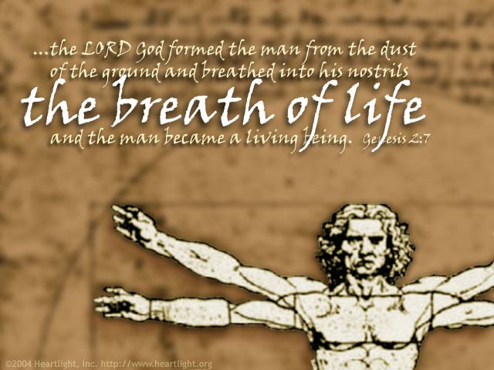
c. T or F: in heaven, there will be no food. (I just had to add this to see if you were paying attention)
22. Answer these questions in regard to our souls by circling true or false:
A. T or F: Scripture makes a careful distinction between the terms ‘soul’ and ‘spirit.’
b. T or F: trichotomists typically divide human nature into body, soul, & spirit.
c. T or F: Traducianists believe that our souls are inherited from our parents.
23. Why doesn’t Frame side with the creationists (note that this term here applies only to souls and origin theories are not in view) or the traducianists?

24. Answer these questions in regard to our minds by circling true or false:
a. T or F: The bible teaches that the will and emotions are subordinate to the intellect.
b. T or F: greek philosophy taught the equality of the emotions, will, and intellect.
25. What does Frame mean when he says that the three capacities of the mind (intellect, will, & emotions) are ‘mutually dependent?’ Explain.

26. Using the words below (left), redraw this concept in the box below (right) to represent A biblical model of you: (p93)

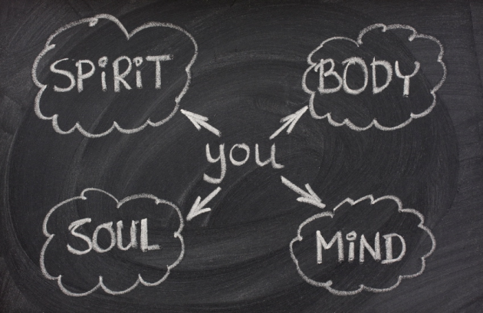

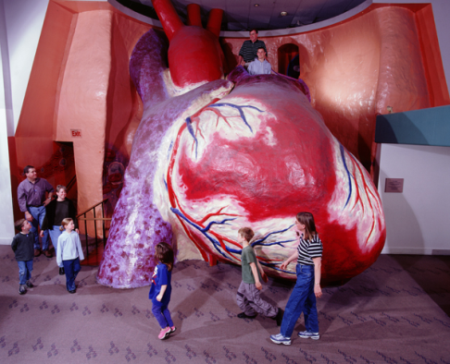
27. What term does Scripture use to unify the human nature? Define the term as God sees it.

Human Freedom & Responsibility
28. Have you ever wondered about this apparent tension: God’s Sovereignty and our freedom? At the end of the day and when all defenses are down, how do you feel about this issue? (circle the line of thought that characterizes how you’ve felt…don’t worry, correctness should not influence your answer yet—just be honest!)
God is sovereign but it takes away our freedom
We are free and so God is not sovereign
God is sovereign and so I have freedom
29. This is pretty difficult to unpack so were going to fill in some main points as to what Scripture says: (p 95)
I. We are ________________ ___________________ agents.

II. There is no ___________________ between moral responsibility & God’s sovereignty.

III. God judges more severely those who have more ________________ (freedom) to do right. (Luke 12:47-48)
SYSTEMATICS~anthropology
Chapter seven ~ man, the image of god Chris & Paul ~ RPC
1. Think on this past week. How has this doctrine (or specific within) impacted your life—whether you kept it in mind at the time, remember it now in reflection, or ignored it completely!

2. How will this doctrine (or specific within) impact your life this next week

(class notes) Three positions on Freedom:
A. Libertarianism: free human acts are not caused by anything at all—they’re free, absolutely.
“holds onto a concept of free will that requires the individual to be able to take more than one possible course of action under a given set of circumstances, this viewpoint is based on the idea that nothing is determined.”
1. They’re not caused by:
Character:

God:

Desires:

2. Scripture teaches:
a. _____________ about this view.
B. Is not reflected in ______________.
C. The contrary: God controls our thoughts, desires, and actions by controlling our character.
How is this position irrational?
(eg. Suppose you’re at wendy’s. What would you order?
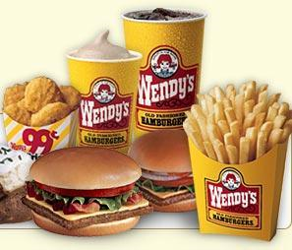
Triple-stack? Why?

The Libertarian claims that reasons can’t influence your decision and that real desires can influence but cannot compel your decision—otherwise it’s not free. This position is called an INCOMPATIBLIST position.

consider these two terms…

in·flu·ence [in-floo-uhns],verb, -enced, -enc·ing. (used with object)
If desires can influence but not compel (granting them this absurd arbitrariness), how then, do we make the final decision?
1. to exercise influence on; affect; sway: to influence a person.
2. to move or impel (a person) to some action

com·pel [kuhm-pel] verb, -pelled, -pel·ling. –verb (used with object)

1. to force or drive, esp. to a course of action

B. determinism: every event has a cause that makes it happen exactly as it happens.
Varieties: what determines our actions?
1. Ethical determinism (Plato): view of what is good
2. behavioral determinism (Skinner): environmental conditioning/stimuli (+/--)
3. physical determinism (Democritus/hobbes):
4. theological determinism (calvin etc): God; ‘Compatibilist’

(eg. Suppose you’re at wendy’s. you order a Frosty? Which flavor? Why?
1. Ethical determinism:
(everyone else here has ordered chocolate and so I don’t want to inconvenience the person by asking for vanilla….but, then again, if we all order the same flavor, they may have to refill the machine…oh, they ran out?) Ok I’ll take whatever’s left…

2. behavioral determinism:
It seems that this newer flavor is all the rage and everyone has told me that chocolate has a poor aftertaste—vanilla it will be!

3. physical determinism:
What is this sound? My stomach—it rumbles! My blood-sugar level must be synaptically communicating with my stomach to signal it is time for a frosty! Vanilla? Sure—would, you look at that: it has one more gram of that precious sugar my body has craved…
4. theological determinism:
MOM: Frosties for everyone kids! Our neighbor’s gave us some free frosty coupons…so what kind do you want? 3 chocolate and 3 vanilla? OK! Seth? Why did you choose ‘nilla? SETH: ‘Cause I love it so much!

C. Compatibilism: teaches that human actions are both caused and free.
A. Caused (Christians: because they are foreordained by God).
B. Free because I have the ability to do what I want to do.
NOTE: Scripture presupposes this position without directly defining or teaching us about it directly; it can be detected by how Christ works in our hearts (eg. Romans 6-8)
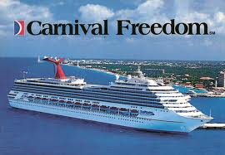
The Scriptures, however, teach a great deal about….
Moral freedom
30. Define this term: (p97)

(class notes) Augustine of Hippo, in his painful Confessions, laments:
"Non Posse Non Peccare" (I am not able not to sin).
Here’s the Latin first, English and explanation next:
NON = NOT - same word, pretty well
POSSE = POSSIBLE - our word comes from the Latin
PECCARE = TO SIN - we get our word “impeccable” from this, meaning “without fault”
He has suffered this troublesome situation and proposed 4 states of man

possibilities in relation to sin:

1. We’ll start with Adam and Eve in the Garden (innocence, before the Fall) . Here’s their situation:
POSSE PECCARE
See what it means?
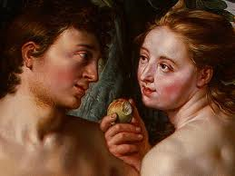
2. Now humanity after the Fall—natural man (unbelievers):
NON POSSE NON PECCARE –
what does this mean?


3. Now, let’s try Regenerate man (Believers):
POSSE NON PECCARE - It is possible for us not to sin.
Why is this?

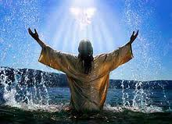
4. Now, what about us in Heaven (Glorified man)?
NON POSSE PECCARE - It is not possible for man to sin.
What makes this possible?

Here’s a Summary
state | Pre-Fall Man | Post-Fall Man | Reborn Man | Glorified Man
latin | posse peccare | non posse non peccare | posse non peccare | non posse peccare
english | able to sin | unable to not sin | able to not sin | unable to sin
description | Perfect but able to fall | Sinner in need of redemption | Redeemed & struggling with sin | Perfected & unable to fall
Proof text (verse)

REVIEW
I. Incompatibilist’s believe that human actions are uncaused—divorced entirely from our character & desires.
Critique:
1. Makes human experience a hash of absurdity
2. choices are (by necessity) random & accidental
3. destroys moral responsibility
II. Compatibilists believe that human actions are both caused and free
Critique:
1. Allows for reasonable freedom
2. Ascribes importance to human decisions
3. Maintains human moral culpability & God’s judgement

III. ‘hard’ Determinists: believe that human actions are completely caused as they have no choice
Critique:
1. removes human freedom (we are helpless bystanders at the whim of nature)
2. Human free will does not exist
3. often seeks to skirt moral responsibility

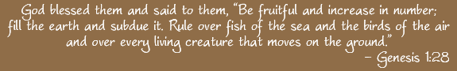
The Human Task

31. What do we typically call this passage (Our task)?
The ______________ ___________________
Parts: A. Have ____________!
B. __________________out!
C. ________________ in Christ’s name (Glorify God by enjoying HIM)!

32. This command at man’s beginnings is closely linked with which New Testament Command?
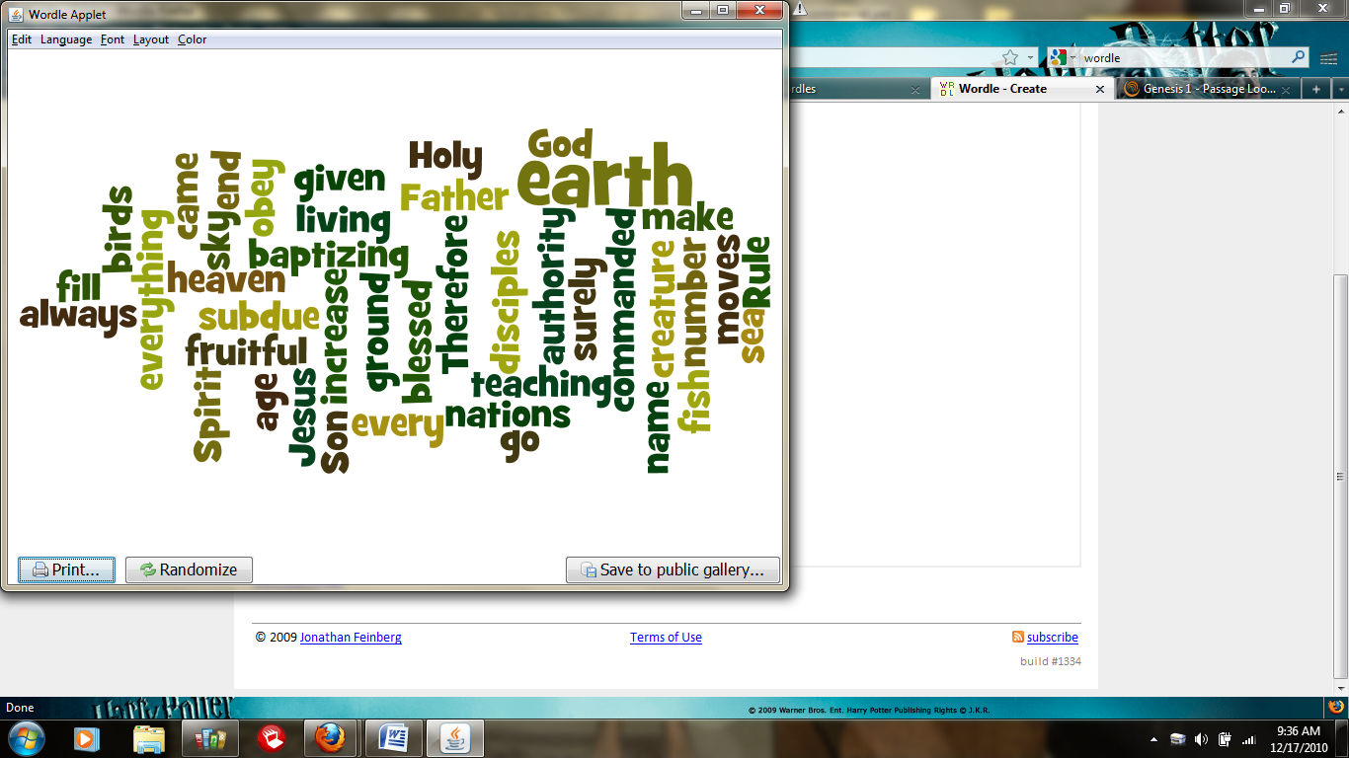
The _______________ ___________________________!


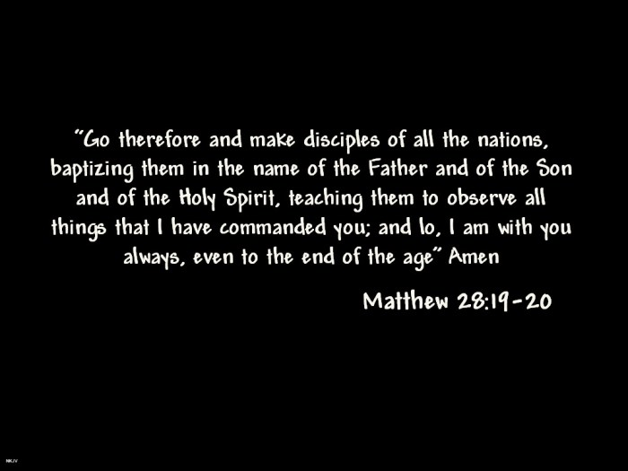
(CLASS NOTES) Fulfilled:
Physically spiritually
1. 1.
2. 2.
3. 3.

Note: Jesus did not simply come to give you this:
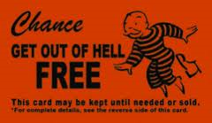

He came to redeem this:

Putting it all together (class notes)
33. A critique I have heard of Calvinism and its stress on sovereignty goes something like This…
“How can you believe that God sovereignly Saves and humans still need to go share the gospel?…if I believed that, there wouldn’t need to be missionaries…”

If God was not sovereign:
1. no one could be saved (enemies of God cannot choose Him; (Col. 1:19-22)
¹⁹ For God was pleased to have all his fullness dwell in him, ²⁰ and through him to reconcile to himself all things, whether things on earth or things in heaven, by making peace through his blood, shed on the cross. ²¹ Once you were alienated from God and were enemies in your minds because of^{[g]} your evil behavior. ²² But now he has reconciled you by Christ’s physical body through death to present you holy in his sight, without blemish and free from accusation
2. furthermore, there wouldn’t even be anyone here to save, in fact, there wouldn’t even be a ‘here!’
If the church did not Live/share the gospel (word & deed):
1. disobedient to Christ’s call (Matt 28)
2. no fruit=unsaved (I John 2:3-6)
³ We know that we have come to know him if we keep his commands. ⁴ Whoever says, “I know him,” but does not do what he commands is a liar, and the truth is not in that person. ⁵ But if anyone obeys his word, love for God^{[a]} is truly made complete in them. This is how we know we are in him: ⁶ Whoever claims to live in him must live as Jesus did.
“Historically, people have sometimes wondered why Calvinists, believing as they do in the sovereignty of God, do not take a passive attitude toward life. In fact, Calvinists have been hard workers, zealous missionaries, eager to transform themselves and society into God’s image.

This remarkable energy is not a contradiction of their belief in divine sovereignty, but an implication of it.
Calvinists serve a Lord who calls us to the utmost effort in His service. The results are in his hands, but we have the privilege of serving him in the greatest of tasks, that of bringing all of life captive to Christ.”

Frame, Intro to Reformed Faith, PT 2

Covenantal Preview
We see 3 elements
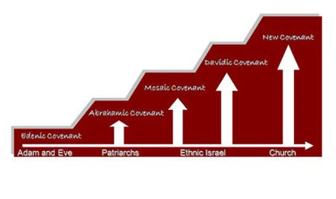
1. Seed 2. Land 3. Prosperity

Noahic covenant

34. How do we see the fulfillment of these 3 areas in Christ?
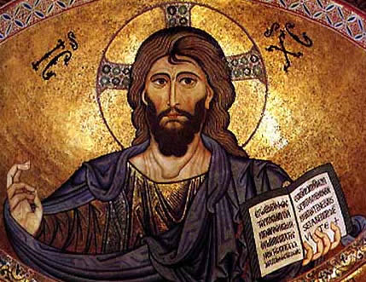
1. Seed
Christ Pantocrator, Cathedral of Cefalù, Palermo, Italy, 1148

2. Land
3. Prosperity

Write out aQuestion you are Most Curious about concerning Sin:

“Curiouser and curiouser”

SYSTEMATICS~anthropology
Chapter seven ~ man, the image of god Chris & Paul ~ RPC
1. Think on this past week. How has this doctrine (or specific within) impacted your life—whether you kept it in mind at the time, remember it now in reflection, or ignored it completely!

2. How will this doctrine (or specific within) impact your life this next week

A Study Guide
in 3 parts

“Doctrine: the Breakfast of Christians”
Name:
An Intro to SYSTEMATICS Christopher Eckart RPC ~ spring 2014

Part I: chapters 9-18

SYSTEMATICS~Theology Proper Part II Name:
Chapter Nine ~ God’s Covenants Mr. E ~ SRCS
1. In the opening paragraph, how did frame tie this topic to Lordship?
Covenant:
“A relation between the Lord and a people whom He has consecrated to Himself.” Frame p.115

2. What promise is at the heart of the covenant?

3. To understand how a Covenant differs from a contract, one must read, then reread a key sentence on p. 116. After rereading it, fill in the blanks: “The _____________________ is _________ the Result of a _____________________.; _________ imposes it ________________________.” (read the sentence over again)
4. What does God do by his Lordship attributes (Control, Authority, covenant presence)? Describe briefly how God works though each:
Control:

Authority:

Covenant presence:

The Covenant Document
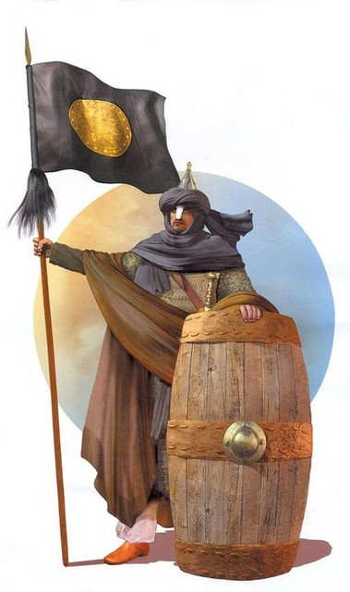
5. Archaeological evidence suggests that Suzerain-Vassal treaties were the norm in the Ancient near-east. Fill in the general pattern:
1. The ____________ of the Great King. (Suzerain)
2. The __________________ prologue. (Suzerain Benevolence)
3. The _____________. (Vassal responsibility)
a. General command (exclusive loyalty)
b. Specific Commands (outworkings of loyalty)
4. Sanctions (consequences)
a. Covenant ________________ for obedience.
b. Covenant ___________________ for disobedience.
5. ________________ administration of the covenant.

6. Fill in the following blanks from p.117:
“ _______ follows _____________. We don’t obey God in order to __________ our ____________________.” (We obey because we are given faith in future grace that God will bring the exact measure of grace we will need to serve and glorify him--john piper)
7. Frame says a true but difficult thing in the middle of p.118. He says, “That [god’s] presence is a great blessing, but sometimes it can lead to severe punishments.” Defend this statement.

The Covenant of Works
8. Fill in the chart to this pre-Fall covenant:
Suzerain: _____________ as LORD
Vassal: ________________ as representative of the human race
Law: Adam & Eve were to obey God perfectly—focused in that they were to do what?

Sanctions: threat :
Promise:

If Our God is a God of Grace, why is this covenant called (appropriately) called a covenant of works?

BONUS: How is that we are saved by works?

The Covenant of Works
9. BONUS: The Original Plan was to Redeem man. God does so by means of this covenant which historically unveils who he is and how he is choosing a people for himself. After reading the catechism (WCF) and confession (LC) insets, which doctrine stands tall, writ large (AKA is obvious) as a key component of both?

The Parties
10. We’ve been studying the profound connection between the Trinity and life as we know it (Life, relationships, etc.). What do the divine-human Covenants presuppose (assume) about the Trinity?

When, then, did God’s plan for Redemption (the Kingdom) have its ‘beginning’?

Who are the parties involved in this divine-human Covenant?

Blessings and Condition
11. What is the true covenant blessing? How is this more than ‘not dying?’

12. Resolve the apparent tension between the truths that Christians cannot lose their salvation and that some do leave the faith.

Historical Covenants
13. For each of the covenants, fill in the three aspects:

Adam
Divine benevolence (How did God show goodness to them?)

Human loyalty (what is required of them?)

Consequences
Blessing: (what blessings Are they promised?)

Cursing: (what punishments are promised?)

Noah
Divine benevolence
Human loyalty
Consequences
Blessing:
Cursing:
Abraham:
Divine benevolence
Human loyalty
Consequences
Blessing:
Cursing:
Moses:
Divine benevolence
Human loyalty
Consequences
Blessing:
Cursing:
David:
Divine benevolence
Human loyalty
Consequences
Blessing:
Cursing:

New Covenant:
Divine benevolence
Human loyalty
Consequences
Blessing:
Cursing:

unity
14. What is the central principle of all the covenants? What three elements do all the covenants speak of? Ultimately—what is the consistent message of the covenants, even the whole Bible?

Write out aQuestion you are Most Curious about concerning Jesus (Who He is):

“Curiouser and curiouser”

SYSTEMATICS~Christology Name:
Chapter ten ~ Who is Jesus Christ? Mr. E ~ SRCS
1. Fill in the Blanks: “When we talk about ________ [Christ] is, we are talking about the ______________ of Christ. When we are talking about __________ He did, we are talking about the ___________ of Christ.”
“The issue which faced the early church is the same which has faced the church ever since. It was overwhelmingly evident that Jesus of Nazareth was in many ways entirely different from any other person. Explaining this difference was a puzzle to those who heard him and to the church fathers of the early centuries. Consequently, the early church was filled with speculations about the nature and person of Jesus.” F. Zaspel

The Chalcedonian Declaration
2. Define the term nature as it relates to you as a being.

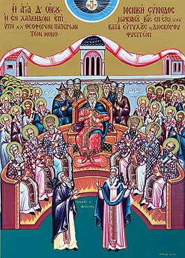
3. The following statements are teachings on the person of Jesus Christ. Select either True or False based on the Chalcedonian document:
T or F: Jesus is both fully God & fully Man.
T or F: Jesus has a divine nature and human person.
T or F: Jesus is one person with two natures.
The fourth ecumenical council, held in Chalcedon in AD 451, attempted to bring resolution to the heated Christological and trinitarian debates that had racked the first half of the fifth century. Producing what would become the Church's most concise Christological definition, the council did not itself end the discussions, but rather became the reference point for a new period of debate.

4. The relationship, intimacy, & interplay between the Deity and humanity of Christ is a mystery—one of the best!—but Frame puts it in such a way that makes a difficult truth sensible. Fill in the blanks as to how these two natures fit together:
A. God does not become _________ (and so lose His deity)
formula
1 person, 2 natures
B. man does not become ________ (and so lose His humanity)
C. God & Man do not merge into a third _________ (thus becoming something entirely different (and so losing both divinity & humanity)
D. Jesus' __________ natures are ______________ from one another (so preserving both His deity & humanity)
E. Jesus does not have two _____________.
F. Formula: Jesus has _______ ____________ & is ______ _______________.
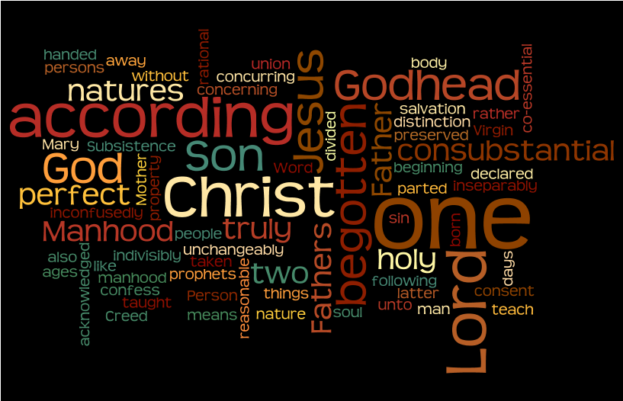
5.
A word cloud of the English translaton of the Chalcedonian creed. Which words appear most often? (select the top five by their size and list below)
1.
2.
3.
4.
5.
Why would this be so?
What was the significance? Why even formulate such things?

Heresies Regarding Christ’s Deity
• Heresies which deny the genuineness of Christ’s deity: Ebionism (1)
• Heresies which deny the completeness of Christ’s deity: Arianism (2)

Heresies Regarding Christ’s Humanity
• Heresies which deny the genuineness of Christ’s humanity: Docetism (3)
• Heresies which deny the completeness of Christ’s humanity: Apollinarianism (4)

Heresies which divide Christ’s person: Nestorianism (5)

Heresies which confuse Christ’s natures: Eutychianism (6)

Ebionism (1): An early heresy stemming from some Jewish Christian circles (Ebionite was the Hebrew word for “poor”; these may have been poor Jewish Christians). Strongly monotheistic, they denied that Jesus was God, rejected the virgin birth, and believed Jesus was born naturally. He was human but possessed of unusual gifts. They believed God’s power descended on him in a special way at his baptism.

Arianism (2): Named after Arius of Alexandria, a presbyter whose views were condemned by Athanasius and others at the Council of Nicea in AD 325. Saw God as absolutely unique and transcendent (inflexible monotheism). They believed God alone possesses attributes of deity; to share these with anyone would be to render God less than divine. Everything besides God is created and temporal. The Word was a created being, though the first and highest created being. He was a demigod, an intermediate being, not God (this is the theology of modern-day Jehovah’s Witnesses).

Docetism (3): Docetism is based on the Greek word for “seem” or “appear”--Jesus only seemed or appeared to be human; in reality he was God. An early heresy strongly influenced by Greek dualism which saw the invisible spiritual things as good, the visible, fleshly things as evil.

Apollinarianism (4): The views of Apollinarius, a close friend and associate of Athanasius, the leading champion of orthodox Christology (the one who defeated Arius at the Council of Nicea). He saw Jesus as a compound unity: some of Jesus was human, the rest was divine. Jesus was physically human, but psychologically divine (the divine Word took the place of his human soul). This view was condemned at the Council of Constantinople in AD 381.

Nestorianism (5): Named after Nestorius, the patriarch of Constantinople in 428. Nestorius had trouble with the idea that the divine and human natures were united in one person in Christ (he felt this obscured them both). He preferred to see them as a conjunction, operating in stages of Christ’s life, or distinctly side-by-side. This tended to divide the natures of Christ, render him somewhat schizophrenic.

Eutychianism (6): Eutyches, an elderly church leader in the 440s, apparently sought to counter Nestorius’s division of Christ by teaching the “one nature” formula. He saw Jesus’s humanity as completely absorbed into his divinity. A variant of this taught that Jesus’s nature was a hybrid of divine and human, and therefore a third, altogether new nature. “A theological way of saying yellow and blue makes green.” Stephen Nichols

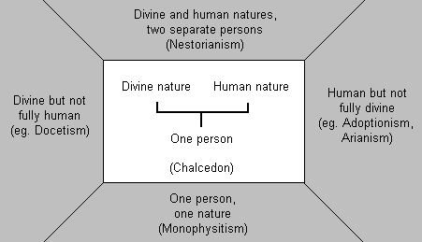

Not Divine
(eg. Ebionism)
Not human
(eg. Docetism)

(eg. Apollin- arianism)

(eg. Arianism)

(eg. Eutychianism/monophysitism)
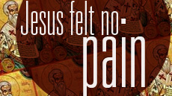

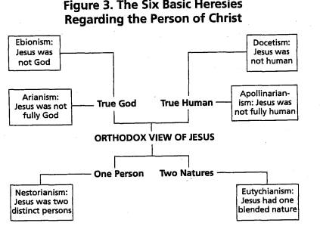
Chalcedon: w/o change
Chalcedon: w/o division

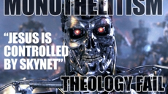
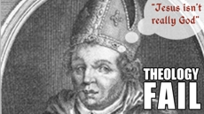
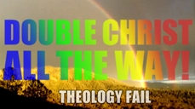
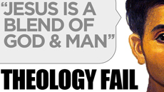

Chalcedon: w/o confusion
Chalcedon: w/o separation

Creed of Chalcedon
“We, then, following the holy Fathers, all with one consent, teach men to confess one and the same Son, our Lord Jesus Christ, the same perfect in Godhead and also perfect in manhood; truly God and truly man, of a reasonable [rational] soul and body; consubstantial [co-essential] with the Father according to the Godhead, and consubstantial with us according to the Manhood; in all things like unto us, without sin; begotten before all ages of the Father according to the Godhead, and in these latter days, for us and for our salvation, born of the Virgin Mary, the Mother of God, according to the Manhood; one and the same Christ, Son, Lord, Only begotten, to be acknowledged in two natures, inconfusedly, unchangeably, indivisibly, inseparably; the distinction of natures being by no means taken away by the unity, but rather the property of each nature being preserved, and concurring in one Person and one Subsistence, not parted or divided into two persons, but one and the same Son, and only begotten, God the Word, the Lord Jesus Christ; as the prophets from the beginning [have declared] concerning him, and the Lord Jesus Christ himself has taught us, and the Creed of the holy Fathers has handed down to us.” [emphasis mine]
6. Which Four words are central to the point of the Chalcedonian creed? when speaking of Christ's two natures?
Mixed Nature
Two natures
A. “i_________________”; without M______________
Maintains that Jesus always possessed both the divine from eternity and the human from the moment of his conception (2 natures); the error this view corrects is called monophysitism (one nature, presumably mixed)

Changed God/Man
True Man God
True God
B. “U_________________”; without C______________
Maintains that neither the divine nature nor the human nature was essentially changed in any way by the union of the two natures in the person of the Son of God.

Partly God
Partly Man
Fully Man God
Fully God
C. “i_________________”; without D______________
Maintains that each of Christ’s natures is full and complete without being divided into parts, such that the Son of God did not therefore assume a partial human nature such as a human body without a true human soul, mind, heart and will. It has in view the perfect completeness of each nature.

Two Persons God
One person
D. “i_________________”; without S______________
Maintains that, while the divine did not become human nor the human become divine, there was by unity of person an inner connection between them which was constant and which continues in Jesus Christ.

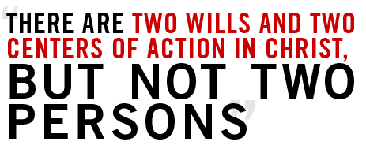
The Deity of Christ

7. The deity of Christ is not only present in Scripture, it is:
a. E_____________ :found in some form or another on every page in NT
B. V_____________: takes many forms
C. P ______________; comes from a position of certainty & strength
8. What does Frame find so amazing in the second full paragraph on page 131?

9. Why does frame suggest as the reason the writers of the Gospels rarely argued (formally) the deity of Christ?

Could there be a second reason? (hint: consider the way in which Scripture is written--particularly The gospels)

10. Fill in the following blanks showing how the Scriptures assume the deity of Christ:
a. E_______________ of Christ's teaching
³⁷ “Anyone who loves their father or mother more than me is not worthy of me; anyone who loves their son or daughter more than me is not worthy of me. ³⁸ Whoever does not take up their cross and follow me is not worthy of me. ³⁹ Whoever finds their life will lose it, and whoever loses their life for my sake will find it. Matt 10:38-39

B. A______________ of certain aspects: He never
1. w_____________ one of His statements
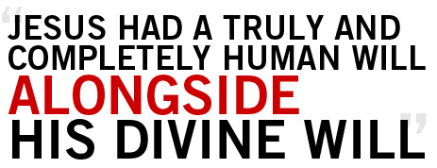
2. A______________
3. R_____________ of sin
4. S___________ human advice
5. A________ for prayer
C. Manner of Epistolary S_______________ & B_________________
¹ Paul, an apostle of Christ Jesus by the will of God, To God’s holy people in Ephesus,^{[a]} the faithful in Christ Jesus: ² Grace and peace to you from God our Father and the Lord Jesus Christ. Eph. 1
¹³ All God’s people here send their greetings. ¹⁴ May the grace of the Lord Jesus Christ, and the love of God, and the fellowship of the Holy Spirit be with you all. 2 Cor. 13

TITLES of CHRIST
Christ, the Lord
11. Consider the strongest expression of Christ's deity: "Christ is the L__________"
Some uses: A. S____________: Rom 10:9
⁹ If you declare with your mouth, “Jesus is Lord,” and believe in your heart that God raised him from the dead, you will be saved.
B. Lordship in I___________: Luke 1:43
⁴³ But why am I so favored, that the mother of my Lord should come to me?
C. Lordship over the S______________: Matt. 12:8
⁷ If you had known what these words mean, ‘I desire mercy, not sacrifice,’^{[a]} you would not have condemned the innocent. ⁸ For the Son of Man is Lord of the Sabbath.”
D. Denote 2nd person of T_____________: I Cor. 8;6
⁶ yet for us there is but one God, the Father, from whom all things came and for whom we live; and there is but one Lord, Jesus Christ, through whom all things came and through whom we live.
The SON of God
12. A. Can be used of F____________ beings (angels, priests, all people, believers)
- is used of Christ in a U_____________ way:

³ For what the law was powerless to do because it was weakened by the flesh,^{[b]} God did by sending his own Son in the likeness of sinful flesh to be a sin offering. Rom. 8:3

¹⁶ For God so loved the world that he gave his one and only Son, that whoever believes in him shall not perish but have eternal life. John 3:16

- Our Sonship is dependent--secured only through C____________!
- Son is a R___________ title: Christ as the son Shares in the Father's rule.
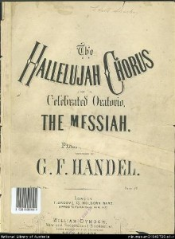
The Christ
13. Although the name “the Christ” acted as a means of distinguishing Jesus from other jesus’ (it was not uncommon)---it was more:
A. Christ is the greek equivalent of M____________
B. Christ means “A_______________ O__________”
C. Christ identifies jesus as God H_____________ promised to come through david’s royal line.
God
Which cult has repeated a 3rd century heresy by inserting an article (‘a’) before God (and lowercasing the g in ‘God’)?
What does this do to the Divinity of Christ?

14. Instances:
A. John 1:1
¹ In the beginning was the Word, and the Word was with God, and the Word was God.
B. John 20:28
²⁶ A week later his disciples were in the house again, and Thomas was with them. Though the doors were locked, Jesus came and stood among them and said, “Peace be with you!” ²⁷ Then he said to Thomas, “Put your finger here; see my hands. Reach out your hand and put it into my side. Stop doubting and believe.”
²⁸ Thomas said to him, “My Lord and my God!”
C. Note: although references to jesus as ‘God’ occur less frequently, the stronger term for deity ‘Lord’ is used quite often.
Other titles
15. A. Son of Man: often seen to promote Christ’s humanity—the title is tied to both Daniel’s reference (ch 7) and throughout Ezekiel as necessarily divine.
B. Word of God: Christ, as the perfect God-man, is the bridge between the spiritual and physical, between Creator and creature.
(See the graphic on the next page…some titles are tied to deity only—circle those you can detect)
Divine attributes
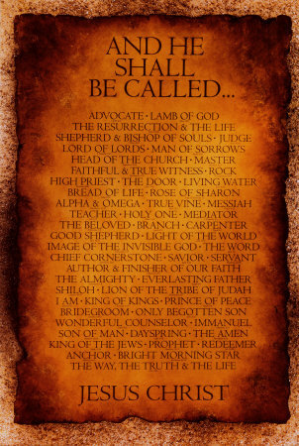
16. Main points
A. Characteristics that apply to G________ apply to Christ.
B. He is s__________________ (this means He was without sin in motive, word, or deed!)
C. Knowledge: o___________________; He knows 1. h___________ of people 2. F______________ 3. the F________________ 4. H_____________ 5. T__________________
D. Wisdom (He E________________ it!); Eternal; Unchangeable; glorious; Lord of
Divine Acts
17. Jesus does things only God can do:
He does A______ the Father does (John 5:19)
- C_____________ (Col. 1:15,16)
- Providence (Col. 1:17)
- M_____________
- F____________ sin (Mark 2:5-7)
- Final J_____________ of Living & Dead (2 tim 4:8)
Object of worship
18. Which commandment would this violate if Jesus was not divine?
Pick a passage which casts Jesus as the object of worship & answer the following:
- Reference:____________________
- Describe the Context (set up the story):

- Who, alone, is allowed to demand/receive worship?

- (See the proof/connection?)

"Problem Passages"
19. Pick a so called "Problem Passage" and cite the reference, explain the misunderstanding, and clarify it in light of the truth.
A. ref:

B. 'problem'

C. solution

20. Why is Christ's deity so important?
A. Unless our Savior is God, we are without H___________
B. Christ's Deity: 1. S________________ his humanity
2. gives W_________ to his sacrifice
3. Makes Salvation S_________ (think 'forgiveness'--and that the blood of animals could not cover sin; Hebrews)

The Humanity of Christ
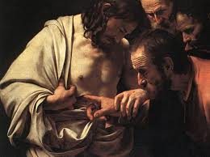
21. How important is the humanity of Christ? Consider the latter part of Hebrews 2:
¹⁰ In bringing many sons and daughters to glory, it was fitting that God, for whom and through whom everything exists, should make the pioneer of their salvation perfect through what he suffered. ¹¹ Both the one who makes people holy and those who are made holy are of the same family. So Jesus is not ashamed to call them brothers and sisters.^{[g]} ¹² He says,
“I will declare your name to my brothers and sisters;
in the assembly I will sing your praises.”^{[h]}
¹³ And again, “I will put my trust in him.”^{[i]} And again he says, “Here am I, and the children God has given me.”^{[j]}
¹⁴ Since the children have flesh and blood, he too shared in their humanity so that by his death he might break the power of him who holds the power of death—that is, the devil— ¹⁵ and free those who all their lives were held in slavery by their fear of death. ¹⁶ For surely it is not angels he helps, but Abraham’s descendants. ¹⁷ For this reason he had to be made like them,^{[k]} fully human in every way, in order that he might become a merciful and faithful high priest in service to God, and that he might make atonement for the sins of the people. ¹⁸ Because he himself suffered when he was tempted, he is able to help those who are being tempted.
Why was it so important?
- To make f_____ & F_________- Atonement for his children (elect)
- To s_______________ with our weaknesses
- To S____________ and help those who are T______________
22. In the earliest church, Christ's humanity was more hotly debated than His deity… for example
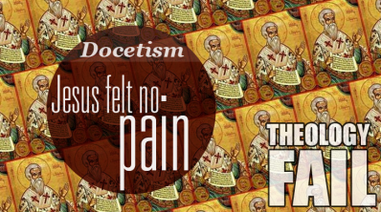
Orthodox teaching declares:
A. Jesus T________ suffered
B. Jesus came in the F_______
C. Jesus Was F________ human but without sin (Heb 2:17)

Docetism eliminates Jesus' humanity. Suggesting that Jesus only appeared to be human though he was in fact not, Docetism derives its name from the Greek word dokeo, which means “to seem or appear.”
The Gospel of Peter, an apocryphal book, illustrates a Docetic view. It says that during his crucifixion, Jesus “kept silence, as one feeling no pain,” which implied, as church historian J.N.D. Kelly notes, “that His bodily make-up was illusory.”

VS.

While on earth, Jesus experienced hunger (Matt. 4:2) and thirst (John 19:28), showed compassion (Matt. 9:36), was tired (John 4:6), felt sorrow to the point of weeping (John 11:35), and grew in wisdom (Luke 2:52). Yet, in all of his humanness, Jesus never sinned (Heb. 4:15).
Before we move on…
23. Explain how Christ could not be tempted..& how Christ could be tempted.

The Hypostatic Union
24. What is this?

25. we've dealt with the key heresies frame mentions here…but the second paragraph on page 144 deserves a look…
If Jesus is one person with two natures, an understandable difficulty arises when one contemplates how these natures relate.
What do Lutherans believe about Christ's two natures?

How does this influence their understanding of the sacrament of communion?

What do Reformed theologians believe?
How does this influence [our] understanding of the sacrament of communion?

Write out aQuestion you are Most Curious about concerning What Christ did (Christology):

“Curiouser and curiouser”

