Acts, Epistles, & Systematics Name:

Mr. e ~SRCS~BiBLe 10 Date:

Systematic Vocabulary Study sheet

BibliologY

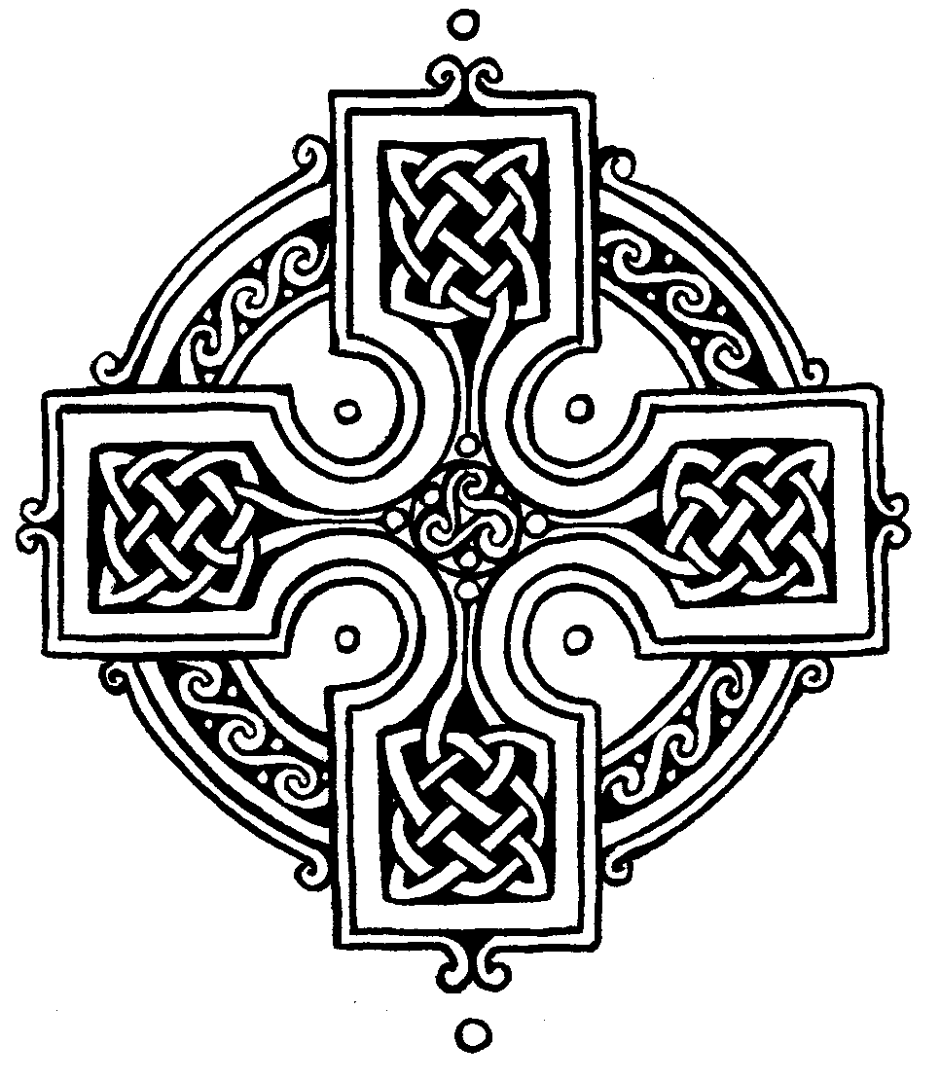

***General Revelation:*** God revealing Himself to all people at all times.

**Mediate Revelation:** God reveals Himself *through the medium* of creation (form of General).

**Immediate Revelation:** God implants an innate sense of Himself in humans (form of General).

***Special Revelation:*** God revealing Himself to a specific people at specific times.

***Insufficiency*:** Embodies the fact that General Revelation is unable to save or redeem man’s soul.

***Sufficiency:*** Scripture contained all of the words God intended at each stage of redemptive history and now it contains all we need for salvation & perfect trust & obedience

**Clarity:** Scripture’s ability to be understood by all who read it seeking God’s help & willing to follow it.

**Necessity:** The Bible is needed for knowing the Gospel, maintaining spiritual life, & knowing God’s will.

**Inerrancy:** The Scriptures in their original manuscripts are without error (and do not affirm falsity)

**Infallibility:** Scripture is ***incapable*** of error.

***Partial Inspiration:*** A view of inspiration which holds that some of God’s Word is inspired.

***Plenary inspiration:*** A view of inspiration which holds that all of God’s Word is inspired.

***Mechanical inspiration:*** God *dictated* the words of Scripture to the writers, their minds uninvolved.

***Dynamic inspiration*:** Minds of the writers of Scripture were *enlightened*—a heightened spiritual sense.

***Verbal inspiration:*** Doctrine of inspiration that extends God’s inspiration to every *word* employed

***Organic inspiration*:** God *illuminates* the writers of Scripture using their personalities, circumstances, etc.

**Canon:** The 66 books of inspired Scripture given to us from God as our authoritative rule for faith & practice; received/recognized not ‘created’ by the church.

**Apocrypha:** Ancient books not included in the Protestant understanding of the Canon.

**self-attesting:** Scripture authenticates itself; seen as illogically circular by some but this must be permitted for there is no more ultimate criterion which to appeal

**Hermeneutics:** The science of interpreting what an author has written.