Acts, Epistles, & Systematics Name:

Mr. e ~SRCS~BiBLe 10 Date:

Systematic Vocabulary Study sheet

AnthropologY

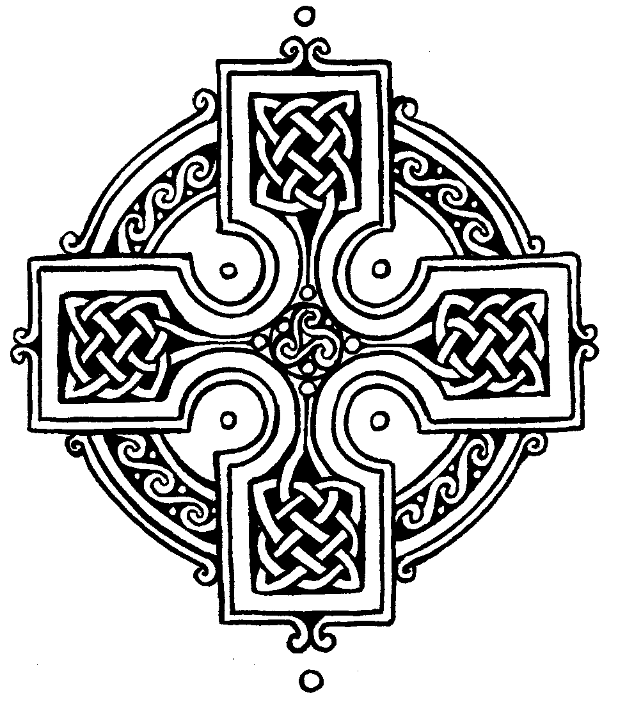

**Man:** uniquely created in God’s image and made up of material (body) and immaterial aspects (soul/spirit)

***Imago Dei:*** Latin phrase meaning “image of God” such that he is like God and represents God.

**dignity:** the aspect of Man’s nature inherently present because man in made in God’s image.

**humility:** the aspect of Man’s nature inherently present because man in made as God’s servant.

**microevolution:** The view that small developments occur within one species without creating new species.

**material naturalism:** The view that the material universe is all that exists.

***likeness:*** A term referring to something that is similar but not identical to the thing it represents.

**body:** Thematerial portion of man.

**soul:** The immaterial part of man; used interchangeably with “spirit.”

***creationism:*** The view that God directly creates all souls individually at the time of conception.

***traducianism:*** The view that the soul of a child is inherited from the baby’s mother and father at the time of conception.

***monism:*** The view that man is only one element, and that his body is the person.

***dichotomy:*** The view that man is made up of two parts, body and soul/spirit.

***trichotomy:*** The view that man is made up of three parts: body, soul, and spirit.

**mutual submission:** Phrase that proponents of egalitarianism use to describe the type of relationship they believe should exist between husband and wife, in which each is subject to the other in the same way; this undermines the unique authority that the Bible gives to the husband in the marriage relationship.

***primogeniture:*** The Old Testament practice in which the firstborn in any generation in a human family has leadership in the family for that generation.

***pre-existentianism:*** The idea that the souls of men existed in a previous state, and that something that happened then accounts for their present condition.

**Hamartiology**

**age of accountability:** The term used by some theologians to indicate a point in a person’s life before which (according to their view) he is not held responsible for sin and is not counted guilty before God.

**dualism:** The idea that both God and the material universe have eternally existed side by side as two ultimate forces in the universe.

**impute:** To think of as belonging to someone, and therefore to cause it to belong to that person.

**double imputation:** a doctrine related to Justification where, on the one hand, *our sins* are imputed to Christ who bore them on the cross. On the other hand, *Christ's righteousness* is imputed to believers whereby they are seen by God as cloaked in the righteousness of Christ.

**inherited corruption:** the sinful nature, or the tendency to sin, which all people inherit because of Adam’s sin (often referred to as “original pollution”). This idea entails that (1) in our natures we totally lack spiritual good before God; and (2) in our actions we are totally unable to do spiritual good before God.

**inherited guilt:** The idea that God counts all people guilty because of Adam’s sin (often referred to as “original guilt”).

**mortal sin:** In Roman Catholic teaching, a sin that causes spiritual death and cannot be forgiven.

**original sin:** The guilt and the tendency to sin which all people inherit because of Adam’s sin (often referred to as “inherited sin”).

**Pelagius:** A fifth-century monk who taught (Pelagianism) that man has the ability to obey God’s commands and can take the first and most important steps toward salvation on his own.

**propitiation:** A sacrifice that bears God’s wrath to the end and in so doing changes God’s wrath toward us into favor.

**sin:** Any failure to conform to the moral law of God in act, attitude, or nature.

**total depravity:** Sin is rooted in the core of our being so that there is no part of us that is left untouched by sin; explained by the term “radical corruption” in that our minds, our wills, and our bodies are affected by evil. This doctrine reveals man’s total lack of spiritual good and inability to do good before God (often referred to as “total inability”).

**unpardonable sin:** The unusually malicious, willful rejection and slander against the Holy Spirit’s work attesting to Christ, and attributing that work to Satan.

**venial sin:** In Roman Catholic teaching, a sin that can be forgiven, although perhaps after punishments in this life or in purgatory.