Physical Science Project Name:

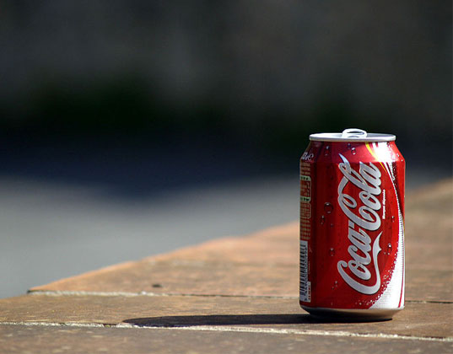
ch 10: heat transfer ~ mr.e Date:
Can your Can keep the heat?
Thermodynamic

What? We will be taking part in a thermodynamic competition to see whose can holds heat the best and whose bracket takes all!
Where? Your home (your sanctuary for thermodynamic study and experimentation)
Why? Because it's cool (or should I say 'cooling?'). Actually, we are going to see the simplicity of insulatory methods at work and determine which is best.
When? You are responsible for insulating said can, finished, week of 4.20-4.24
How? Rules: 1. You must use a regular 12 fl oz. aluminum soda can
2. You may insulate it in any way you wish except the insulation may not a) cover top of can b) act as a heat source in any way
3. Brackets must be filled out prior to testing; bracket placement will be solely determined by God (no skill-based seeding, in other words)
Instructions for brackets:
Place the name of the winner on the next horizontal line between two competitors. Champion goes in the box
1. Obtain thermo packet (posted online as ONLINE project on chapter 10 page); refer to 14-team brackets
2. Working on your theoretical bracket until it is completely filled out. Don't forget to choose a champion; tie breaking will be based on looks (not really); do this before you insulate can.
3. Insulate can & test (See below)
Instructions for project:
1. Insulate soda can in any way you can using things around the house.
2. Once finished, test personal can.
a. Bring water to boil (can use hot pot or stovetop)
b. Carefully pour ¼ cup of water (2 fl. Oz. or 59 ml--whichever is best for you to measure)into can
c. Record Temperature: start stopwatch (app on phone) as soon as you record; fill in data table below
d. When Temperature is exactly 100 C below initial Temp.; stop timer, record Temp; record both values (record time as min: seconds: tenths)
e. Send pic of Can Data table (directly below) next to can so I can both read the values clearly and see your project. (due 4.23 by 3 pm)

Can Data

Initial Temperature: ___________ ⁰C
Final Temperature: ___________ ⁰C
Elapsed time to cool 10⁰C : _____________minutes

3. Fill in actual bracket once I post results (on website, ch 10, next to thermo packet)
Cross out (with a red pen) any incorrect names; count point values at each round for those correct. Use values stated below.
5. Fill in Points per round and Accuracy percentage once finished (in data table below) by seeing where you were correct (count points) and incorrect (worth zero points)
6. Answer questions & hand in on: Mon, 4.27 by 3 pm

Bracket Data
Round | Points
Sweet 16 (worth 3 pts/correct name) | Of 48
Elite 8 (worth 6 pts/correct name) | of 48
Final 4 (worth 12 pts/correct name) | of 48
Dynamic duo (worth 24 pts/correct name) |  | of 48
Champion (worth 48 pts/correct) | of 48
Total points | of 240
Percentage | ______ /240 = %

Questions:
- Who did you pick to win?

- In which class did you have the more accurate predictions, your section or the other section?

- What would you change about your insulator and the manner in which it was applied in order to improve your results?

