Ch 10: heat transfer name:

Study Guide

**Vocab**

*conduction*

*convection*

*radiation*

*freezing*

*absorber/emitter of E*

*boiling*

*condensation*

*evaporation*

*absolute zero*

*sublimation*

*heat of fusion*

*heat of vaporization*

*melting*

*fluid (2 forms)*

*cold*

*reflector of E deposition*

**Formulae**; (units)

Q=*cm*t ; where Q (heat)= *c* (specific heat capacity) x mass substance x T (change in T)

Be able to calculate how much E is required to melt ice, bring water to a boil, vaporize water, etc. (sim to Problem1 p. 168)

**Things you MUST know:­­­­­**

1. Relationship b/w conductors & insulators.
2. Conduction: heat transfer b/w solids.
3. Convection: heat transfer b/w or w/in fluids
   1. Liquids
   2. gases
4. Behavior of warm vs. cool air: warm air rises; cool air sinks
5. Firewalking: works on basis of low thermal conductivity of coals?
6. If an object absorbs heat quickly--it will radiate/lose heat quickly; if an object absorbs heat slowly, it will release it slowly.
7. Thermal E/T changes:
   1. T Rise: Eabsorbed > Ereleased
   2. T Fall: Ereleased > Eabsorbed
   3. T remains the same: Eabsorbed = Ereleased
8. Best pot color to keep liquids hot? Shiny silver; Best pot color to cool liquids? Black
9. If an object reflects radiation well--it will absorb radiation poorly; if an object radiates poorly, it will absorb radiation well.
10. Warm air expands. If the same amount of warm air is expanded further (w/o adding E), it will cool.
11. T = avg KE; If 2 atoms are at the same T, which has more KE, the larger or smaller? Which has more speed?
    1. They both have the same KE b/c they are at the same T (see definition of T).
    2. The smaller atom. (Relate to Momentum…the smaller mass must travel faster to equal the E of the larger--think Dr. Wackes/Coach Bowman analogy)

M v = Momentum = m V

Larger, slower atom KE smaller, faster atom

1. Lowest *theoretical* T possible in nature? absolute zero
   1. -273 oC
   2. 0 K

13. Heat: 'cheapest' form of E (not easily reclaimed or transformed--least caloric worth); eg. E 'lost' due to friction (heat)

14. An object is a net absorber or emitter of radiant E based on its relationship with its surroundings (ambient T)

a. An object will **absorb** radiant E if it's T is lower than its surroundings.

b. An object will **release** radiant E if it's T is higher than its surroundings.

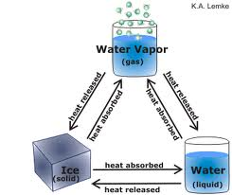note: darker objects emit more radiant E than absorb, lighter objects absorb more E than they emit.

15. Of the phase changes, which are cooling processes (b/c E is absorbed)? Evaporation, boiling, (melting)

16. Of the phase changes, which are warming processes (b/c E is released)? Condensation, (freezing)

17. Why does a water-filled paper cup not burn?

18. T ~ *f*requency (higher T emits higher *f* (shorter wavelengths); lower T emits lower *f* (longer wavelengths)

19. Ice is a good insulator! (just saying)

20. Relate changes in V (compression/expansion) to T changes in air.

21. The earth loses most of its heat by radiation.

22. Why do we feel different in environments at the same T but with different humidities?

23. Boiling water does not change T (until it is boiled off). Why?

24. How does elevation affect boiling points? (Take careful note of boiling's relation to pressure) How does this then affect cooking times?

25. Which is more dangerous--100 o C water or 100 o C steam? Why?

26. Be able to use c (specific heat capacity --of water in this case): 1 cal./goC (eg. raising 10g water 1 degree = 10 cal.; raising 1 g water 100oC = 100 cal.)

27. Practical Application section: steak eating, chicken-frying, warm-flooring, soup-cooling, fridge/freezer design, thermos.

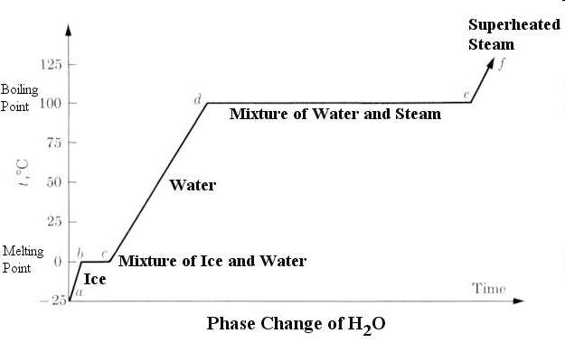28. Latent heat graph labeling

29. Triple point graph labeling

