
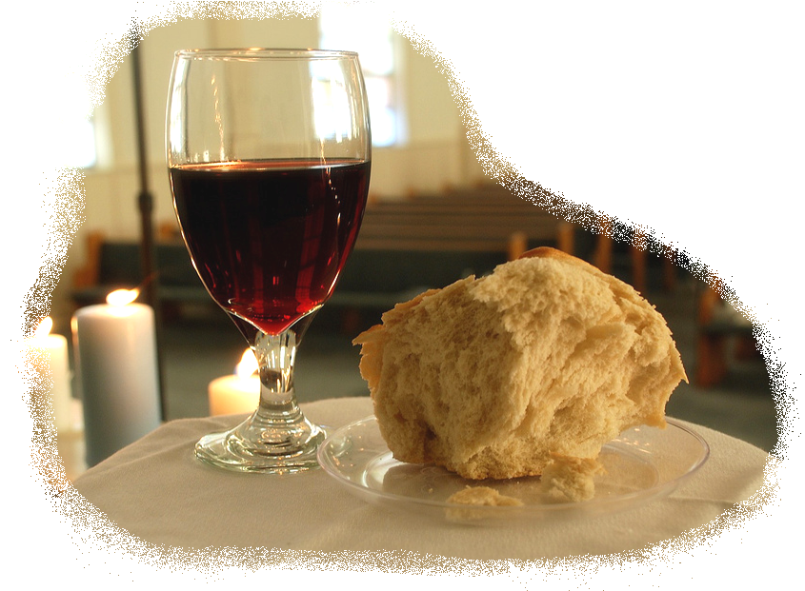
Study Guide Name:
~ Genesis 37-50 ~ Date:

Section I: Multiple Choice (look over ‘quizzes’; questions taken directly from these)

Section II: Matching (study key people and places)
Jacob Benjamin Joseph’s bros. Joseph’s steward Tamar
Joseph Pharaoh Potiphar Cup-bearer Rachel
Judah Reuben Potiphar’s wife Baker Onan
Egypt Canaan Goshen Mamre (cave @ Machpelah)
Shechem Dothan Timnah Beersheba

Section III: Short Answer (You will be asked questions formed from your “Rest of Genesis” packet lessons. Key questions will be paired up to create short answer similar to tests past. You may use your Bible on these.)

Five questions are provided, choose any two and share answers in a few brief, but complete, sentences. You may use your Bible on this section…& only this section…. of the Test. (5 points each; 10 points total)

1. Read Genesis 37:1–11.
God is about to work salvation through Jacob’s dysfunctional family. Each member brings something to the mix. What character flaws do we see in:
Joseph?

Jacob?

The brothers? (choose one)

What redemptive virtue do we see in:
Joseph?

Jacob?

The brothers? (choose one)

Even though your family may be dysfunctional at times, how have you seen God at work in it? (be specific)

2. Dreams play a dominant role in the shaping of key characters (namely, the baker, the cup-bearer, and Pharaoh) —yea, even history. Select two of the three and a. share their dreams b. share their interpretations c. evaluate how it changed them.

3. Review Genesis 42—45.
What are the signs that Joseph’s brothers have had a guilty conscience for thirteen years about selling their younger brother to the Ishmaelites, who took him to Egypt? (42:21, 28; 44:16)

How has God provided a way for us to deal with our guilt? (Refer specifically to one of the following verses (Ps. 32:1–7; 51:1–12; Heb. 9:14; 1 Jn. 1:9)

Jacob still doesn’t know of his ten sons’ evil crime but continues to believe Joseph was killed by some wild beast. What is the evidence that his grief makes him protective? (42:4, 36–38)

Now the tables are turned, and it is Joseph who has the upper hand. Describe how Joseph “plays” his brothers. (Scan chapters 42–44.) Why do you think Joseph is doing this?

4. Read Genesis 46:1–7
In verse 3, God tells Jacob not to be afraid to go down to Egypt. Try to put yourself in Jacob’s place and imagine how the following facts might have made him fearful:

a. Jacob is an old man.
b. Egypt is a very pagan country.
c. Egypt holds bad memories for Jacob. (Gen. 12:10–20)
d. Jacob has been warned of future hardships. (Gen. 15:13)

How does God reassure Jacob that his move to Egypt is part of his plan? (2–4)

- Read Genesis 50

How is Joseph’s question, “Am I in the place of God?” (v. 19b) evidence of the character he has shown in both happy and hard circumstances? (Pr. 9:10; 15:33)

For what act of faith does the writer of Hebrews praise Joseph? (Heb. 11:22)

Some commentators see 50:20 as a key verse for the whole book of Genesis: “You intended to harm me, but God intended it for good to accomplish what is now being done, the saving of many lives.” There have been many occasions in Genesis when human sin seemed to threaten God’s plan to preserve a seed and create a people. God has always used those circumstances to further his plan. Is there one instance that has really stood out for you?

How does Genesis 50:20 fit the events at the heart of God’s plan of redemption? Find one place in Genesis where one (any person) meant something for evil and God used it in His redemptive plan. (Acts 2:22–24, 36–39)

