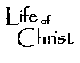
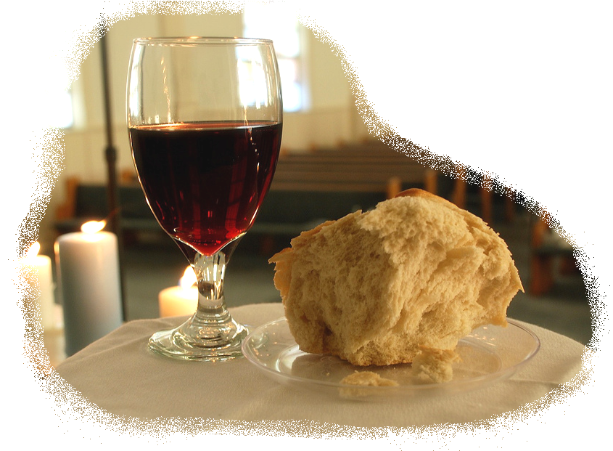
Study Guide Name:
~ Genesis 12-23 ~ Date:

Section I: Fill in the Blank (key verses with pivotal words removed; reread Genesis 12-23 to prepare; key verses are below)

Section II: Matching (study key people and places (below))

Section III: Short Answer
Eight questions are provided, choose any four and share answers in a few brief, but complete, sentences. You may use your Bible on this section…& only this section…. of the Test. (8 points each; 32 points total)

- As Abraham deals with Lot (chapter 13) we see a Biblical model for making difficult decisions. In our notes, we touched on four key factors in Biblical decision-making—discuss three of the four factors as we discussed them in class.
- Contrast Abraham with his nephew in at least three ways.
- Who is Melchizedek—that is, how is he unique? Explain his significance, the future significance of the gifts he brings to Abraham, and what Abe gives to him after Abe rescues Lot.
- Abramic Covenant (chapter15): Describe the covenant event. What is significant about how it was done, Who passed through the pieces, and who kept it? What deeper meaning does this foreshadow/have for believers today in regards to Christ and salvation?
- In chapter 17, God instituted the sign of the Abramic Covenant. What is the sign? Who had to be circumcised? Connect circumcision to baptism in one way to Christ and His life/work in the NT.
- What are the purposes of prayer? Whose will is Sovereign? Whose will changes? (answer with reference to/quoting Abe’s experience here in chapter 18:16-33)
- Was the Lord gracious to Lot and his family? Share 3 ways using Genesis 19 to support your argument.
- Take a look at chapter 20: What did Abraham do? Why did Abraham do this (again)? Describe Abimelech. How was his nation judged—why were they judged? What end results did this have for Abraham?
- Consider Abraham’s test in chapter 22. After sharing how a test is different from temptation, share three similarities between this event and Christ’s experience on the cross.

Chapter 12
People: LORD, Abram, Sarai, Pharaoh
Places: Canaan, Egypt
Verses: 1-3

- Why did Abram go to Egypt? How would this affect the Israelites for whom Moses was writing? Why?
- Know the events surrounding Abe, Sarai, & Pharaoh.

Chapter 13
People: Abram, Lot, herdsmen
Places: Mamre, near Sodom
Verses: 14-17

- Contrast Lot and Abram in regards to their separation.
- Why did they separate? Significance (remember God’s promise to Abe)?
- As Abraham deals with Lot we see a Biblical model for making difficult decisions. In our notes, we touched on four key factors in Biblical decision-making—offer three of the four factors as we discussed them in class.

Chapter 14
People: Abram, Lot, King of Sodom, Melchizedek
Places: Sodom
Verses: 18-20

- Who is Melchizedek? Connect and explain his office, gifts, and Abe’s response to Melchizedek to the future/Christ.

Chapter 15
People: LORD, Abram
Places: (Promised Land) ‘Canaan’
Verses: 12-18

- Abramic Covenant: Describe the covenant event. What is significant about how it was done, who passed through, and who kept it? What deeper meaning does this have for believers today?
Chapter 16
People: LORD, Abram, Sarai, Hagar
Places: Desert (wilderness), Beer Lahai Roi (“I have seen the One Who sees me.”)
Verses: 9-12

- Whose idea was it to use Hagar as the mother of Abe’s line? What resulted? With whom would the Israelites identify?
- Ishmael results and the Angel prophesies both good and bad. What’s good?...What’s bad? (connect it to our modern day)

Chapter 17
People: LORD, Abram→Abraham, Sarai → Sarah
Places: undisclosed (land of Canaan promised)
Verses: 3-5, 9,10, 13-15

- What does the sign of circumcision represent? Who had to be circumcised? Connect this to Christ in the NT.
- Through whom would the covenant be fulfilled (Isaac: child of Promise)
- Note significance of the name change.

Chapter 18
People: LORD, Abraham, three visitors (2 angels; theophany (pre-incarnate Christ)), Sarah
Places: Mamre (plains/great trees); “Sodom”
Verses: 13,14, 31-33

12. What are the purposes of prayer? Whose will is Sovereign? Whose will changes? (reference Abe’s experience here)

Chapter 19
People: LORD, Abraham, two visitors (2 angels), Lot/wife/daughters/future son’s in law; Moab, Ben-Ammi
Places: Sodom, “Gomorrah”, Zoar
Verses: 12-14, 36-38

- Was the Lord gracious to Lot and his family? Share 3 ways using the text.
- Are there consequences to sin? Use Lot, his daughters and their offspring (and the current Israelites) to support your argument?

Chapter 20
People: LORD, Abraham, Sarah, Abimelech
Places: Gerar
Verses: 3-5, 17, 18

- What did Abraham do? Why did Abraham do this (again)? Describe Abimelech. How was his nation judged—why were they judged? What end results did this have for Abraham?

Chapter 21
People: LORD, Abraham, Sarah, Isaac, Hagar, Ishmael, Abimelech
Places: (Hagar/Ishmael flee to wilderness)
Verses: 6, 7

- Consider the conflict between Ishmael & Isaac. Does this surprise you? Why? Contrast Isaac with Ishmael.

Chapter 22
People: LORD, Abraham, Isaac, angel, ram
Places: Mt Moriah (future center of Jerusalem)
Verses: 6-8, 12
- Consider Abraham’s test. Describe Isaac’s attitude and Abraham’s response. What significance does this have for us (our salvation and our walk)?
- Compare the experience of Isaac with Jesus. Share 3 similarities.

Chapter 23
People: LORD, Abraham, Sarah, Ephron/Hittites
Places: Hebron
Verses: 17-20

19. From this chapter, share 2 proofs of Abraham’s love for his wife Sarah.

