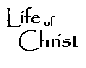
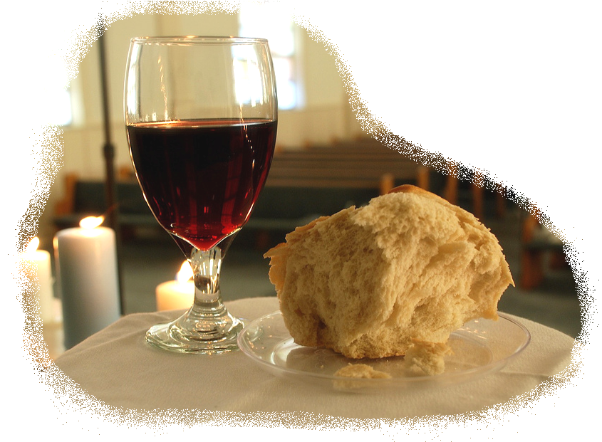
Study Guide Name:
~ Genesis 1-11 ~ Date:

Section I: Fill in the Blank (key verses with pivotal words removed; one can simply reread Genesis 1-11 to prepare)

Section II: Matching (study key people and places)

Adam
Babel
Noah
Lamech
Ararat
Canaan
Enoch
Cultural Mandate
Abel
Seth
Serpent
Eve
Tree of life
Eden
God

Section III: Short Answer
Eight questions are provided, choose any five and share answers in a few brief, but complete, sentences. You may use your Bible on this section…& only this section…. of the Test.

- Outline the 7 Days of Creation by correlating the day with what was created.

- Compare a key similarity and contrast a key difference between General and Special Revelation. Discuss their forms and how they relate to Salvation.

- Define a covenant Biblically speaking (eg. “Cut not made” ) Briefly explain the three parts of a typical Suzerain Vassal treaty.

- Choose either the Adamic or Noahic Covenant and share how in Scripture an example for each of the three aspects of a Divine covenant was given. To finish, share the covenant’s particular sign.

- Share and explain the four divorces that man’s Fall brought on mankind.

- Explain the key participants in Genesis 3:15 and how it is the thesis for Redemptive history.

- What is the Cultural Mandate? Relate this to the tower of Babel then relate Babel to the Holy Spirit’s coming at Pentecost.

- Answer one of these two questions:
    - Explain how banishing Adam & Eve from the Garden an act of mercy.
    - How was God faithful to the Serpent by placing a mark on Cain?

