Ch 8: Projectiles name:

Study Guide

**Vocab**

*orbit circular orbit*

*satellite elliptical orbit*

*escape speed parabola*

*projectile*

*vertical component horizontal component*

**Formulae**; (units)

Speed: v=d/t ; (m/s) orbital speed (circular): vorbital = d/t = 2pi r/t; (m/s)

distance of free fall; d**= ½ gt2**; (m); g=10m/s2

**Things you MUST know:**

1. Be able to describe how the 2 components of motion (vertical/horizontal) act for projectiles.
   1. 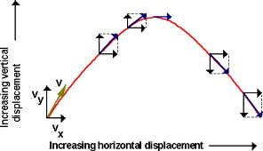horiz: stays the same b/c g acts vertically
   2. vert: decreases as object rises; increases as object falls
   3. v: speed is highest/equal at endpoints; lowest at apex
2. Be able to calculate falling d (free fall); d formula.
3. When do horizontally fired/thrown objects begin to fall? Moment they leave barrel/hand--g affects them.
4. 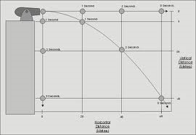Understand the relationship between the distance an object falls with g beneath its straight path line (no g); in free fall this is always d**= ½ gt2 because g is the only F acting on the projectile once released.** See right 🡪

5m

5m

1. Apply #4 to **firing** bullets at angles vs. **dropping** them: Which bullet will hit the ground first?

45 m

20 m

45m

20 m

* 1. Q: Fired upward? A: dropped
  2. Q: Fired downward? A: fired

1. For projectiles thrown upward, a (acceleration) is always directed in which direction? (AKA n which direction does g (acceleration due to gravity) always point?) downward
2. Apply g (10m/s2) to starting speeds of projectiles to figure out hang time (time in air)

3s

* 1. 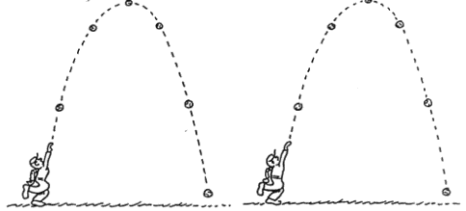Draw parabola

10m/s m

10m/s m

2s 4s 4s

* 1. start projectile at given speed (0 seconds)
  2. deduct 10m/s from speed until you reach apex (0 m/s vertical component--which would constitute all of a vert. thrown object)

20m/s m

20m/s m

0 s 6s

1s 5s

* 1. draw fall identical to rise adding 10 m/s until you reach original v

30m/s

30m/s m

* 1. Atop a vertical path (that is a projectile fired vertically (90o to the horizontal), a=10m/s2

1. Use distance formula to logically calculate distances for hang time.
2. Once an athlete jumps, neglecting air R, how many F are acting on him or her? What is his or her acceleration in midair?
3. Identical projectiles fired at complimentary angles have equal ranges. Their hang times will differ, however. Why? Which component determines hang time? Which hang time is greater, for example, a ball fired at a 30 o or the same ball fired at a 60o angle? Why? (Note: any complementary angles have the same range!)
4. Some key speeds: 8 km/s : minimum for circular orbit

9 km/s: minimum for elliptical orbit

11.2 km/s: minimum escape speed

(note: these are stage points, the ranges in between apply to the previous stage; eg. 9.5 km/s is elliptical; 8.7 km/s is circular)

1. Why are satellites at least 100 km above the surface of the earth?
2. Why doesn't the moon crash into the earth?
3. 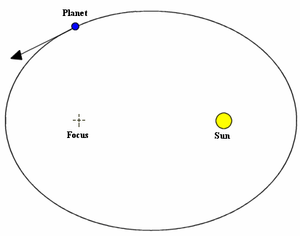Note the minimum and maximum speed positions of a satellite when in elliptical orbit around a body off it's elliptical center (see right)
4. If a satellite were a moon's distance away from the earth, how long would a singular orbit last (note: satellite would remain geostationary--that is visually appear as if it is stationary relative to the earth's surface from a particular point.